**Homework 5**

Name__________________________

1) A doctor measures the systolic blood pressure of 14 people taking part in a clinical trial.

The data is as follows:

111, 123, 90, 95, 97, 82, 129, 101, 140, 100, 98, 122, 120, 120

Produce a 5 figure summary for the data and draw a boxplot.

2) Below is an excerpt from a BBC article:

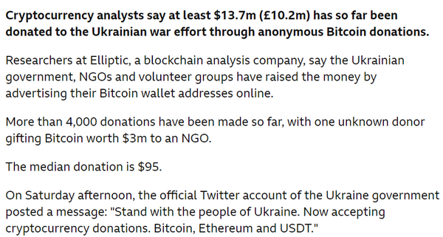

Explain why the BBC chose to quote the median donation amount, rather than the mean.

3) Below is a precedence table for a project.

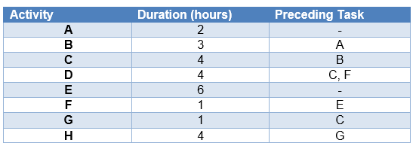

Display this in a diagram.

What is the shortest amount of time the whole project can be completed in?

_____________  hours.

4) Bobby reads the news and sees that the crime has reduced in his local area by 15% from last year. The report says there were 3,560 crimes committed this year.

Bobby says, "Last year there were 4094 crimes committed."

Explain why Bobby is wrong.

5) A conical container is filled with water. The largest part of the cone is at the bottom of the container; imagine an upside down ice-cream cone. Sketch a graph showing how the height of the water changes over time.

6) How many bouncy balls could fit into your Higher Apps classroom. State any assumptions you make and show all of your working.

7) Hayley is conducting a medical trial which collects different types of data from patients.

Patients' ages, as of their last birthday, are recorded.

What is this type of data? Select all that apply.

Choose all that apply:

1. Categorical
2. Numerical
3. Discrete
4. Continuous

8) The patients were given a peak flow test, and the result was recorded.

What is this type of data? Select all that apply.

Choose all that apply:

1. Categorical
2. Numerical
3. Discrete
4. Continuous

Key:

1.

2.

3. 14

4. 5700

5.

6.

7. B, C

8. B, D