**Anstruther PS**

**School Travel Plan**

**2024/25**

Headteacher: Mrs Easton

School address: St Andrews Road

Anstruther

KY10 3JS

Telephone No: 01334 659355

Social Media/Website: [Website](https://blogs.glowscotland.org.uk/fi/anstrutherps/)

**Contents Page**

**3: 1.0 WHY HAVE A SCHOOL TRAVEL PLAN**

**3.: 2.0 BENEFITS OF HAVING A SCHOOL TRAVEL PLAN**

**4: 3.0 Current Travel Habits**

**3.1 Family Questionnaire Data**

**8: 3.2 Staff Questionnaire Data**

**10: 4.0 ROUTE AUDIT OF KEY ROUTES TO SCHOOL**

**4.1 Access Arrangements**

**11: 5.0 ACTION PLAN**

**12: 6.0 MONITORING AND EVALUATION**

**12: 7.0 DISTRIBUTION OF SCHOOL TRAVEL PLAN**

**13: APPENDIX 1 – ROUTE AUDIT REPORT**

**1.0 Why have a school travel plan**

School-related traffic congestion and the risks congestion poses to the safety of the pupils, teachers, parents, residents, and motorists in and around school locations is a significant problem in communities around Fife.

The most obvious cause of traffic congestion around our schools is vehicles, and the biggest source of those vehicles is parents’ dropping off and picking up their children from school.

Statistics highlight that 1 in 4 cars during the hours of 8:30 to 9:15 and 2:30 to 3:15 is primary school traffic.

Our annual Hands Up Survey highlights that 23%, that’s **5562** primary school children are driven to the school gate each day with a further 17% opting to Park and Stride. That is an additional **4111** pupils being driven in and around the school streets.

Fife Council’s Road and Transportation Service are working with schools in Fife to develop School Travel Plans and support Junior Road Safety Officers to develop campaigns such as Walking Buses, Park n Stride sites, Parking Pledges, available routes to school maps, delivery of Bikeability as well as looking at any engineering works that may be required to make active travel to school your first choice of travel.

**2.0** **BENEFITS OF HAVING A SCHOOL TRAVEL PLAN?**

The benefits of encouraging active travel are clear and a school travel plan can ensure that your school has a long–term vision with aid to support Junior Road Safety Officers with delivering campaigns to;-

* Improve health and well-being by reducing harmful emissions and increasing activity levels.
* Improve safety through engineering measures and increasing road safety education.
* Improve access and opportunity by developing pupils’ skills for safe and independent travel.
* Improve the environment by reducing pollution and CO2 emissions.
* Gain school accreditations such as Fresh Air Frankie STP Awards, Active School Award Eco School Award, Cycle Friendly School Award
* Have access to additional funding and support.

**All work associated with School Travel Planning has been designed to fit into the Curriculum for Excellence.**

**3.0**  **CURRENT TRAVEL HABITS**

Each year all Fife schools undertake the Hands Up Survey which gives a true reflection of how pupils are travelling to school and the latest results show that 67% of pupils are actively travelling to school with a further 26% being driven.

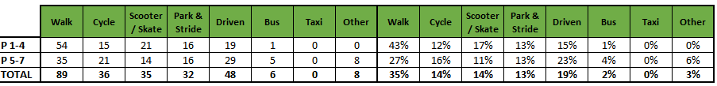

**3.1 Family Questionnaire**

families answered the school travel plan online questionnaire, and the results are detailed in the graphs and text below.

**What school year is your child in?**

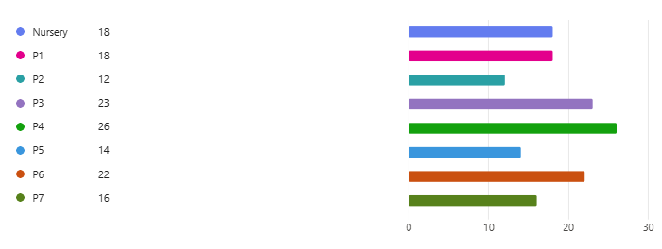

**How do you normally travel to and from school?**

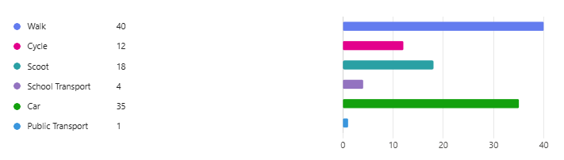

**Those parents who are already actively travelling to school were asked if they would like to volunteer to help the school set up a walking bus.**

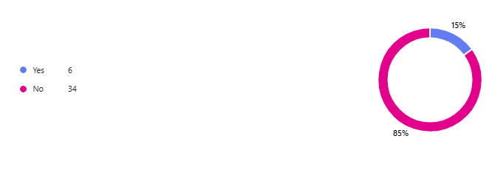

**All parents who stated that they drive to school were asked if they would consider using a Park and Stride Site away from the school gate to help with congestion.**

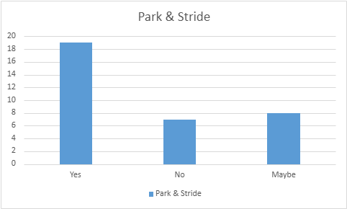

**Those parents were then asked what could they do to help with safety concerns with regards to parking around the school gate?**

* Use the turning circle as a drop off area and don’t allow parents to stop elsewhere unless parked properly.
* If families say they can walk to school, then when they do the child can get a Road Safety sticker or something like that. A bar chart in class to see how often a child walks to school over a term might encourage the children to encourage their parent to walk.
* We already park at Bankie and walk to the school
* Drop off point sounds great
* More space
* I don't park at the school
* We sometimes park and walk from Bankie which is a good compromise. There are limited spaces though.
* We park further away to avoid congestion and take scooters/bikes
* Walk or cycle to school/ Nursey
* More PE classes (not cancelled), our kids also take part in extra-curricular activities most days after school, so they are exercising daily
* Please see comment above re. where I park.
* Walk to school more often than we presently do, or park further from the gate and walk in.
* Teachers parking in the Waid car park would free up many spaces for parents and carers. I have a disability badge for my child and I often can't get into a space as others use this - without a badge on display. The only way it is fair to all is to stop ALL parking at the school. Bankie park car park is also too small with no other parking near the school other than Waid academy parking which would result in walking across the grass which I am sure will eventually be an issue. There actually isn't a big issue at the school for parking - I've been at this school for over 15 years collecting children. The only problem is often people park on the corner stopping the bus from turning. Cones would fix this.
* Our drop off point is Bankie most days & School car park, however Bankie park often gets very congested with cars parking on double yellow lines at pick up/drop off. Road users at Bankie are not the best.
* School bus with a monitor to guide the children
* Pathway behind the rugby posts on the Waid playing field.
* In winter I think it okay by car as we both have asthma and the cold wind can affect our asthma but in the warmer weather we do walk to school usual with her bike or scooter
* My child gets plenty of exercise when we walk dog after school plus weekend, I have disabilities and cannot walk far
* I drop my child off on the way to work so probably not much.
* Don't park in silly places and cause problems to even move about.
* A 'Walking Bus'. I have a friend in west Fife and her children's' school do this and it has been successful. However, this would require parent volunteers. My children get plenty exercise after school at various extra-curricular sports activities.
* Add and enforce double yellow lines.
* Park further away and walk in
* My child gets regular exercise as we live on a farm & being self-employed I am generally fitting in school runs in between work. On days I have more time or simply cannot get parked at the school due to it being so busy I will park in a nearby street and walk.
* They are dropped at breakfast club on my way to work, not during a busy time for the school gates.
* A walking/wheeling bus could be an idea to encourage more walking and cycling. I use the breakfast club and drop children en route to work, so car is the only option. 2 days a week they walk or cycle with their other parent.
* Make them walk
* Walking busses?
* Ensure they get their 2 hrs of gym every week
* Give them more PE classes in school.
* Some staff at dedicated drop off points to ensure children get from a more distant drop off point to school gate safely

**Parents were then asked if they wanted to add anything else about their journey to school.**

* Waid staff often park in the staff car park at APS which adds to traffic that shouldn't be there.
* Initially my son was terrified of the lollipop man but really enjoyed getting to meet him when he came to the nursery and now he LOVES seeing him
* The bike rack can sometimes be a bit crowded in the infant playground.
* Wider pavements
* If parents and carers came into the playground even just around the inside edge it would cause less congestion trying to get in and out
* When no longer pregnant, we tend to walk to and from school. When driving, I always avoid parking at the school as it is always very congested. I agree that the congestion problem needs addressed.
* School crossing patrol officer has been excellent and has played a key role in safely brining my children to school and nursery.
* I live 10 miles away now and I have to travel by car. I also work in Anstruther.
* Very happy to have the school bus in operation, it makes a real difference
* We plan to walk when the better weather comes, but the journey does incorporate other work journeys/clubs etc
* Very narrow path on Crail Road. Always worried when HGV’s or buses go past that their mirrors are going to catch you.
* I have concern regarding the inconsiderate parking.
* We’re very lucky that our journey to school is very straight forward and don’t even need to cross a road so from a selfish point of view we wouldn’t change anything
* On rainy days, the congestion for pick up is much worse. Effecting bus access as well. Maybe there’s a way to stagger kids exiting on these days or at least have an area where kids are sheltered from heavy rain if parents are running late?
* Limited by our own work commitments so we walk to school as often as possible but would not be able to commit to a routine walking bus sadly
* Bus late so after 9am my son arrives at school
* The bus tends to be quite late. Only arriving at pick up at 0850. It would be beneficial for it to arrive slightly earlier to ensure not being late for arrival at school.
* Fast cars come very close to path on Crail Road
* happy to always walk
* We also walk, cycle and use car depending on weather
* You should start fining people that drive up the disabled bit at the Waid or name and shame them on the Facebook page
* There is a lot of congestion coming back from school with cars and people
* Bad weather or after school clubs make us use the car instead of cycling but that will improve as the weather gets better and the nights get lighter
* My children will be walking/cycling to school when the weather gets better.
* My child varies from walking to school to predominantly getting a lift as part of a journey to my work.
* My child walks to school if the weather is suitable
* Cycle trains would be great
* The crossing patrol officer is very polite and friendly.
* School crossing supervision on Crail Road is critical to children's safety
* The car park at the school is being used by staff & visitors to Waid which makes the area even more congested
* The number of parents dropping kids off at school is the biggest danger posed to people at Anstruther PS. It is complete laziness for some as there’s ample parking. Parents also drive up the pedestrian access at Waid which is supposed to be for disabled access only. This should be a safe route to school and at present there are far too many parents and grandparents using this as a short cut.
* So many adults needing to get their cars as close to the school gate at 9am & again at 3pm is extremely dangerous with a very bad accident waiting to happen. The way they drive up the disabled road at Waid also
* The new shared paths are excellent.
* We are lucky to live nearby with direct access to cycle path
* My child is disabled, she has a lung condition, and sometimes the walk to and from school can be a bit tricky for her. If there were benches available perhaps, it might help my daughter with the journey and subsequently her day at school.
* Leaving school is difficult with a bike, there are so many people walking you can't move easily
* Any additional cycle/traffic awareness training at school would be beneficial
* Re question 2. - we use a variety of travel methods, not the same every day. My child often walks but if I will also drop off in a car when on my way to or from work, and if weather is bad collect in car.
* We are fortunate that we mainly take the cycle path from Dreelside but do occasionally walk the main road way and crossing at the roundabout is a nightmare.
* The number of cars parked in silly places and blocking school buses etc. at 3pm is atrocious.
* We live in St Monans now so too far to walk
* Regarding question 4 above, can you confirm where a Park N Stride site is?
* If my child uses the school bus they are normally late to school in the morning
* Would love to see more people being active for the daily school commute instead of driving
* I think it may be an idea for the children to create a banner to try and stop parents sitting outside the school with their engines running as pollution is a concern
* The whole area of the bus route around Fowler St seems too busy/fast, and a lot of children out on their own darting across the road.

**3.2 Staff Questionnaire**

**How far do you travel for work?**

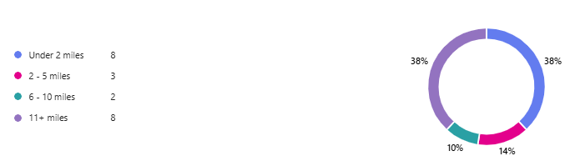

**How do you travel to work?**

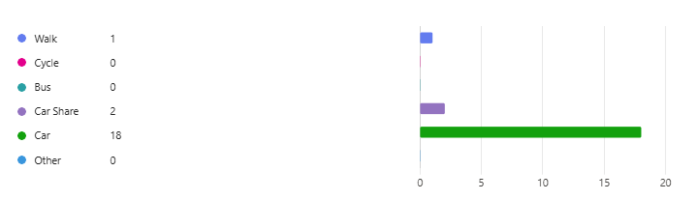

**Staff were also asked if they would like to consider car sharing??**

* No responses

**They were also asked if they would like to undertake Bikeability training to deliver cycling in school??**

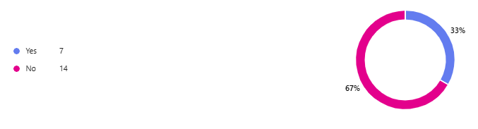

**When asked what would encourage them to consider an alternative mode of transport to work, they replied.**

* Car share
* Quicker bus routes from St.Andrews 😀
* Charging points
* Due to the rural location of my house, I need to bring a car. I also work between schools so need to be able to use my car through the day sometimes.
* Better cycle path between Anstruther and Pittenweem.
* If public service bus were free and brought were earlier!
* None I walk
* Guaranteed nice weather 😂
* Better weather
* No other mode available due to the distance
* Better public transport. Coming from Dundee is a long journey and public transport timings and speed make this longer. I do car share to cut down on cars travelling in.
* If someone laid on free travel for me I’d happily get in a taxi or bus (if it came to my door to collect me!)
* Decent public transport
* Nicer weather to walk!
* Due to distance away from school and what I need to bring to school, the car is my best option
* I live too far away for cycling.
* Nothing, I don't really like public transport and cycling on these roads would be terrifying
* Living closer to school

**Finally, when asked are there any improvements you could make to your journey to ensure the routes to school are less congested?**

* I travel the country roads to work so i don’t believe so
* I don’t think so 😀
* Car sharing
* Parents parking in the car park can mean that staff have no spaces. I know parents are already discouraged from parking in and around the school.
* Park and walk, which i do sometimes.
* I start before 9am so i miss that.
* Possibly car share
* Signs around the front office to limit cars parking at the front of the school. It’s very unsafe during busy times
* No, my route isn’t congested and there is no public transport going that way which i could use.
* I already use the least used road to come to work
* Walk to work more days
* I can use the back roads instead of the main roads.
* I try and leave earlier to avoid heavy school traffic

**4.0 MAPPING WORK AND ROUTE AUDIT**

A mapping exercise was carried out within the school to identify the routes pupils travelled. These were then analysed and then categorised as active travel routes (green).

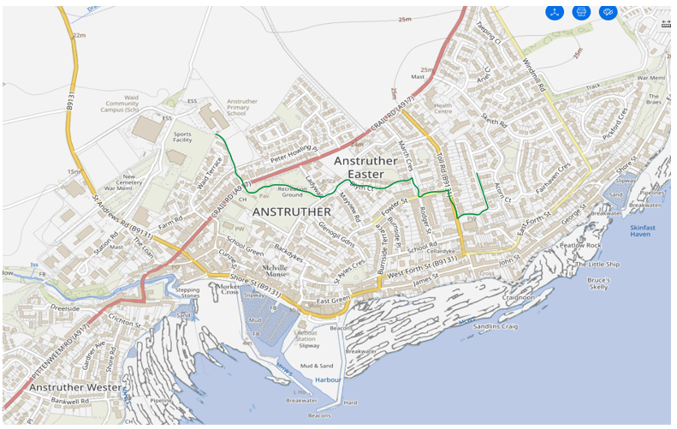

**4.1 Access Arrangements**

There is one main entrance to the school, which is reached by a long driveway from St Andrews Road passing the rear of the new Waid Academy. In addition there is disabled access via the driveway to the front of the new Waid Community Campus building. There is a footpath and a cycle path alongside this driveway. This path leads to the main entrance and also to the P4-7 playground.

The second access is by footpath from Crail Road. This footpath leads directly into the P1-3 playground and continues on to the main front entrance. We have two official entrances to the school building for pupils, one leading from the P4-7 playground and one from the P1-3 playground.

Parking

There is a large turning circle at the front of the school with visitor parking along one side. This has two spaces reserved for the disabled. This turning circle is used as a drop off point and becomes very congested at 9am and at 3pm. We have a staff car park to the left of the school building and also a stopping place for one of the two school buses.

**5.0 ACTION PLAN**

|  |  |  |
| --- | --- | --- |
| **Action** | **Solution** | **Action Owner** |
| Promote School Travel Plan | * Upload plan to website and social media pages * Create a FACT notice board or story board * Create articles for school newsletters, social media, and assemblies, * Keep the school travel plan team updated on all work carried out to include in the Fresh Air Frankie termly newsletter. | School |
| Travel Tracker | * Update the travel tracker every day | School |
| Local and National Campaigns | **Term 1**   * Hands up Survey Active Travel * Cycling Competition * Bike Week * Interschool Active Travel Challenge     T**erm 2**   * Launch #dontparkhere Campaign * Parking Letter to Parents * Road Safety Week * Be Bright Be Seen Competition   T**erm 3**   * Create an active travel leaflet for the new starts that can be included in the school induction pack.   T**erm 4**   * Walk to School Week * Scoot to School Week * Active Travel Treasure Hunt * Bike to School Week | School    School/Travel Plan Team |
| Reduce congestion | Consider developing the following:-   * Parking Pledge * Park N Stride Site * Walking Bus | School/Travel Plan Team |
| Bikeability | Deliver Bikeability | School/Bikeability Team |
|  |  |  |
| Awards | Work towards gaining the Fresh Air Frankie School Travel Plan and  Active Schools Award | School/Travel Plan Team |

**6.0 MONITORING & EVALUATION**

The JRSO will continue to meet periodically to monitor progress.

Specific progress will be monitored by participation in the “Hands Up Travel Tally” each year and a repeat of the full travel survey will take place in 2028. The school’s ongoing commitment to travel planning will be publicised in the school handbook, the school newsletters, the Parent’s notice board and through assemblies.

**7.0 DISTRIBUTION OF SCHOOL TRAVEL PLAN**

The following bodies will receive a copy of the School Travel Plan:

• Fife Council Roads and Transportation via the Travel Plan Team

• Fife Council Education Service

• Fife Council School Estates Team

• Parent Partnership

• Active Schools

• Copies will also be made available to the parents from the School Office and via

the school information site.

**Route Audit**

The Route Audit took place on Tuesday 29th April 2024 by Trudy Brown (School Travel Plan Co-Ordinator), Marta Ramage (School Travel Plan Co-Ordinator), and 7 members of the FACT group.

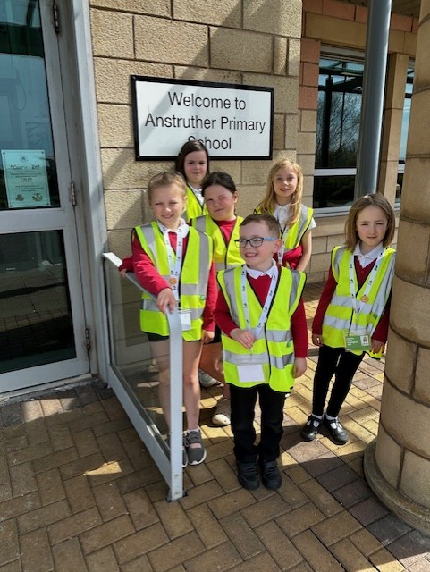

The streets that were audited were as follows:

**Crail Road**

**Current Situation**

The path linking the school to Crail Road has been upgraded in recent years, making this a better walking/cycling route for children. Crail Road is a very busy road, however there is a School Crossing Patrol Officer to help children cross safely.

**Action**

A reminder to pupils that although this is a quiet road, it is still a road leading from the school to Crail Road and that care should be taken.

**Bankie Park**

**Current Situation**

Bankie Park has been update in recent years as park of an active travel route. There is a multi-use path that has been installed linking Crail Road to Mayview Avenue. This has made a big difference to the route to school.

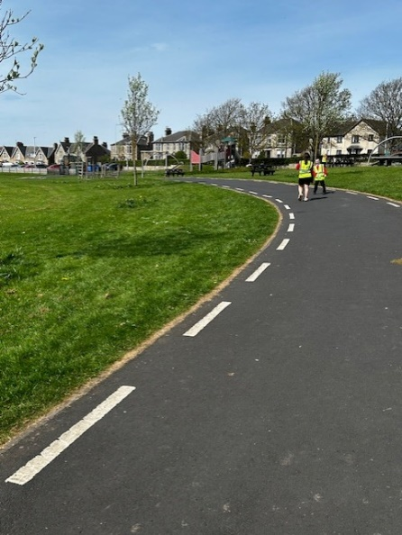

**Action**

Children must remember when entering Bankie Park to walk around the car park and not through it. To also be careful for vans and cars reversing up against the path when parking.

**Mayview Avenue/Fowler Place and Toll Road**

**Current Situation**

The residential streets listed above have a good network of paths. There are a lot of parked cars that need to be navigated and in some places paths are narrower than others. It was observed that some children are so comfortable with travelling these routes that basic road safety knowledge is forgotten e.g. When crossing the road, children were stepping out to look for cars rather than finding a safe place on the pavement.

**Action**

The FACT group could do a road safety presentation to other children in school on how to cross the roads safely.

**Summary**

The routes audited were identified by the FACT group as being the busiest routes around the school. Issues that were raised in the Parent Questionnaire with regards to other streets will be investigated through the relevant team within Roads and Transportation.