**Child Protection in my school** 

**Keep us safe is everyone’s responsibility**

**My school’s Child Protection Coordinators are:**

**Mrs** **Sharon Easton Mrs Michelle McNeill**

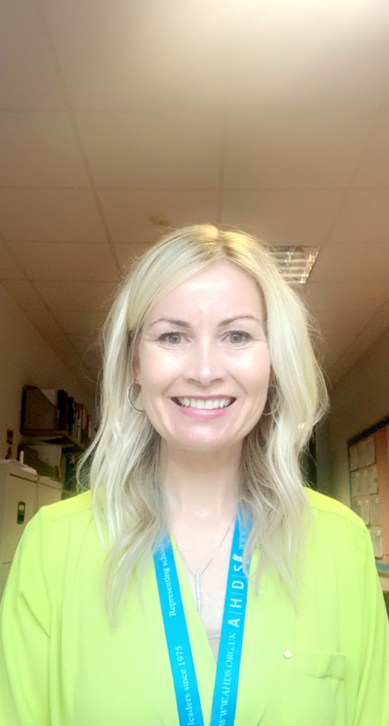

**If you have a concern about a child:**

**Report it as soon as possible and tell them about your concerns. If you consider a child or young person to be in IMMEDIATE danger then call Police Scotland on 999.**

**For non-emergency calls, you can call Police Scotland on 101 or the Social Work Contact Centre on 03451 551503 or email** [**sw.enquiries@fife.gov.uk**](mailto:sw.enquiries@fife.gov.uk) **You can report anonymously.**