Anstruther Nursery Website Update

September Events:

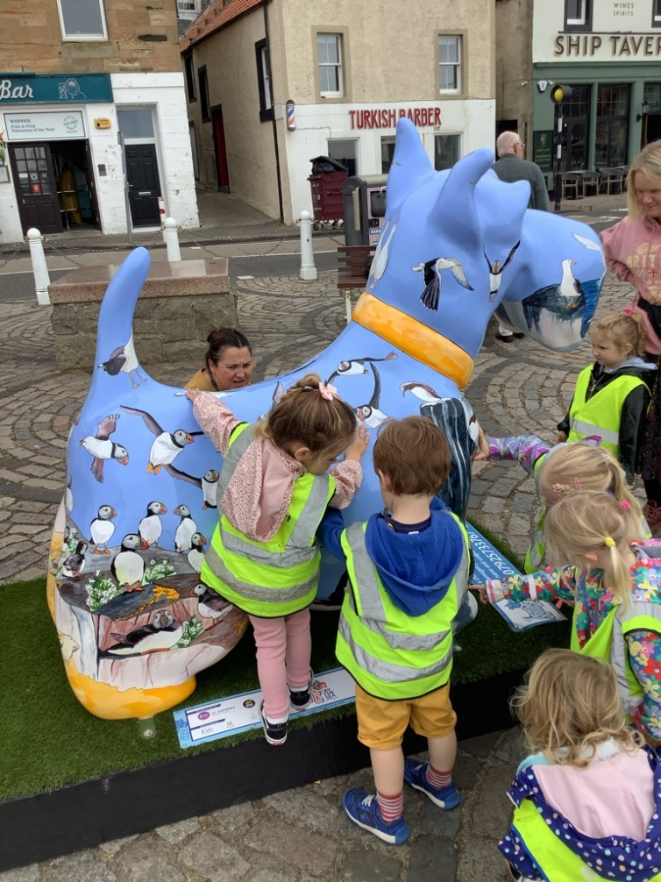

The nursery children spoke about visiting some of the ‘Scotties by the Sea’ sculptures with their families. We decided to take a walk down the street with some of the children to look at the sculpture at the Anstruther Harbour.

*(SOC 0-07a - I explore and discover the interesting features of the local environment to develop an awareness of the world around me)*

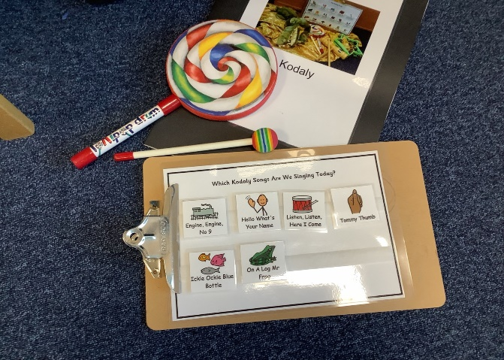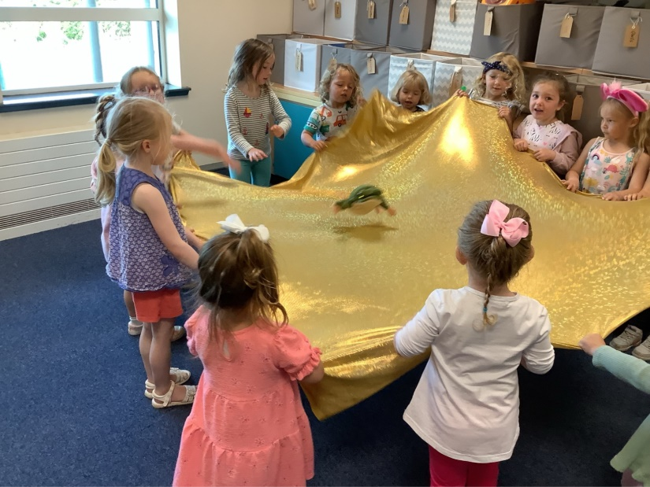

In September we started offering Kodaly sessions. We had lots of fun saying hello to Mr Froggy, learning to keep a steady beat and working together as a team using the lycra.

*(LIT 0-01a/ 0-11a/ 0-20a – I enjoy exploring and playing with the patterns of language, and can use what I learn)*

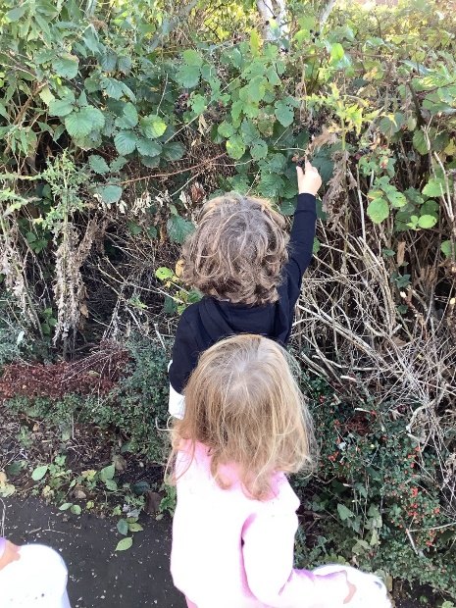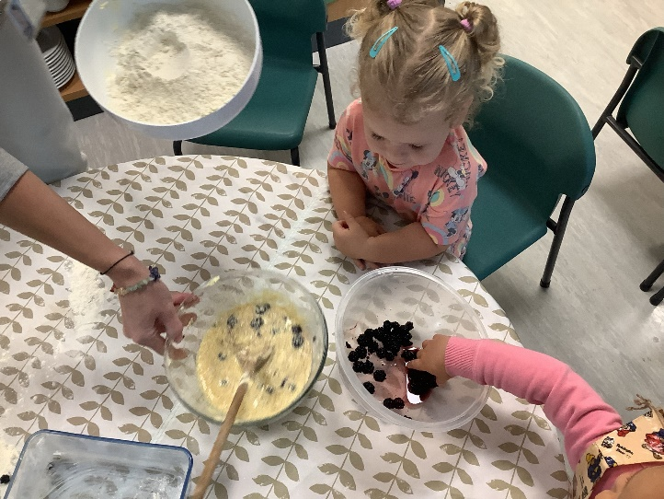

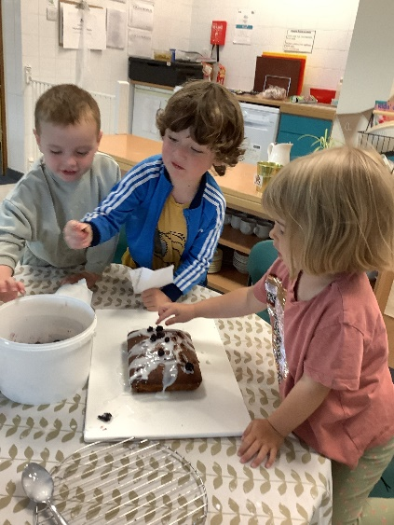

Some of the children noticed brambles growing next to the path they walk along to the nursery in the mornings and asked if they can make ‘bramble cakes’. We went looking for brambles in our local environment and collected these in a tub. The children helped to measure out ingredients to make a sponge cake and mixed the brambles into the mixture. After taking a bit home to enjoy after nursery we had good feedback from one of our nursery children: “It was yummy, it was tasty.”

*(HWB 0-35a – I explore and discover where foods come from as I choose, prepare and taste different foods)*

October Events:

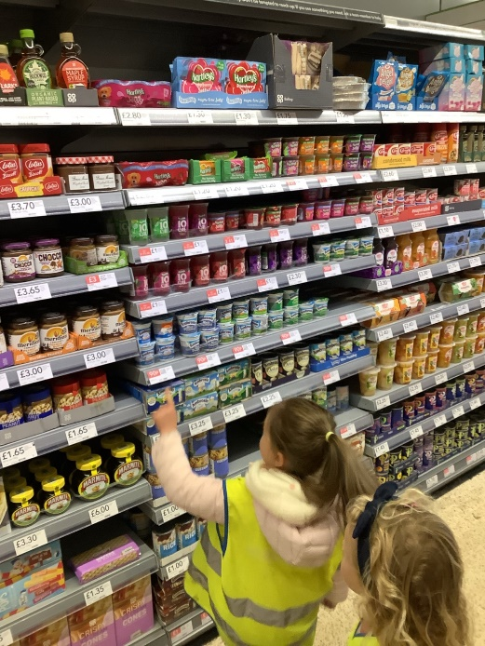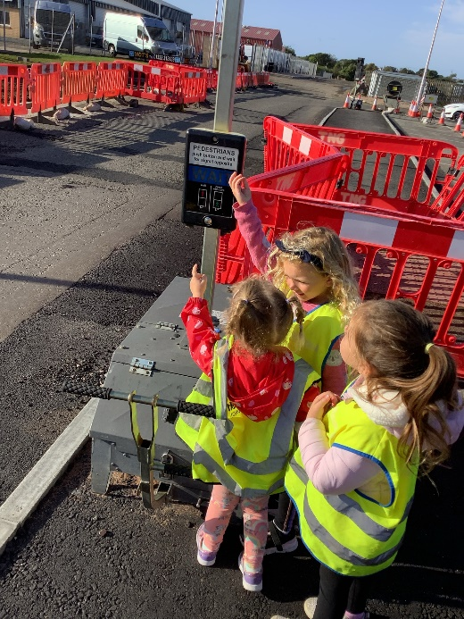

The children learn road safety skills from real life experiences when going out and about. They know that a high-viz vest will help to keep them safe by helping motorists to see them from far away, and they use safe walking practices by staying near an adult and holding onto a friend’s hand when walking. The children learn about safe places to cross the road, looking and listening for oncoming traffic and waiting for the green light at pedestrian crossings*.*

*(HWB 0-18a - I know and can demonstrate how to travel safely)*

After an interest in “Halloween” from our intentional promotion table, we went on a hunt for some pumpkins. We ventured down the street to look out for some pumpkins in the local shop window displays. We then walked to the co-op where we purchased some ingredients to make some yummy gingerbread men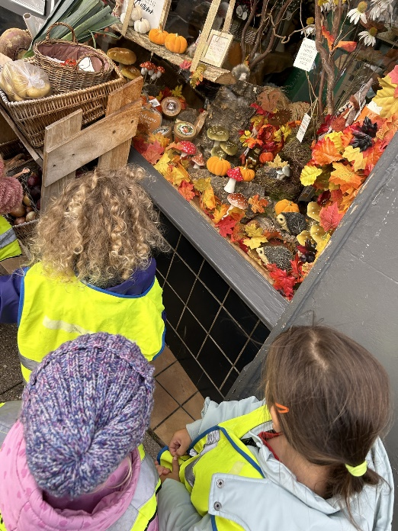.

*(HWB 0-11a – I share my interests and enjoy finding out more about them)*

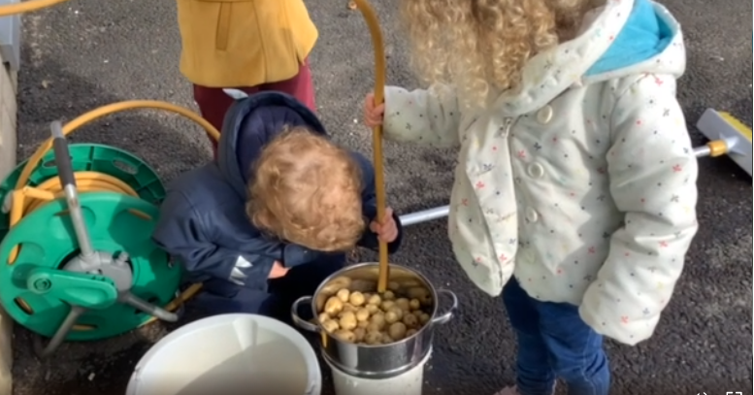

The children harvested potatoes which they planted in a potato sack earlier in the year. They washed the potatoes, helped prepare them for cooking, and enjoyed these as a healthy addition to their normal snack.

*(HWB 0-35a – I explore and discover where foods come from as I choose, prepare and taste different foods)*

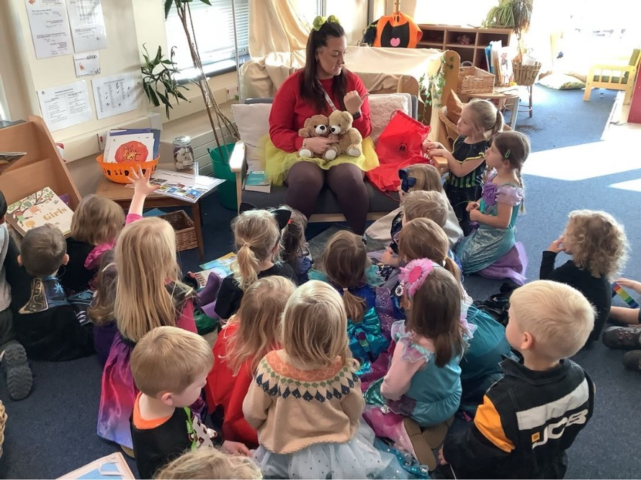

We have introduced ‘Play, Care, and Share Bears’ into our nursery to link our Nursery Values to the children’s home environments. The children had a chance to vote for their favourite names with the help of their parents and carers, and our bears are now named Bingo, Bob, and Freddie! Each week 2 children from the AM session and 1 child from the PM session will be taking a bear home with them to help them practice our nursery values in their home environment. The bears will help them to remember to **Play, Care, and Share** at home, and parents and carers are encouraged to share their children’s learning with the nursery.

*(HWB 0-05a – I know that friendship, caring, sharing, fairness, equality, and love are important in building positive relationships. As I develop and value relationships, I care and show respect for myself and others)*