People dealing with life’s challenges are being encouraged to look after their mental wellbeing with the support of Mind to Mind.
The website, hosted on NHS Inform, features over 30 videos of people talking about their own mental wellbeing challenges in a bid to help others who may be going through a similar thing. Covering topics including dealing with anxiety and panic, coping with money worries, handling stress, improving sleep, lifting mood and moving through grief, each contributor shares practical advice on what has worked for them.
The website also features commentary from a range of professionals and signposts where people can access further help and support. For help and advice visit: www.nhsinform.scot/mindtomind

Cost of Living website for help with all areas affected by the cost of living, includes a Fife benefit checker.
Cost of Living Support (fife.scot)

Cost of Living website for help with all areas affected by the cost of living,

The Well offers the community a single
point of access for their health and
social care enquiries. If you are working
with a client 16+ who would benefit
from speaking to us about their health
and wellbeing, you can refer them by
If you have any questions or require Well leaflets to share with services users please
Further information about The Well is
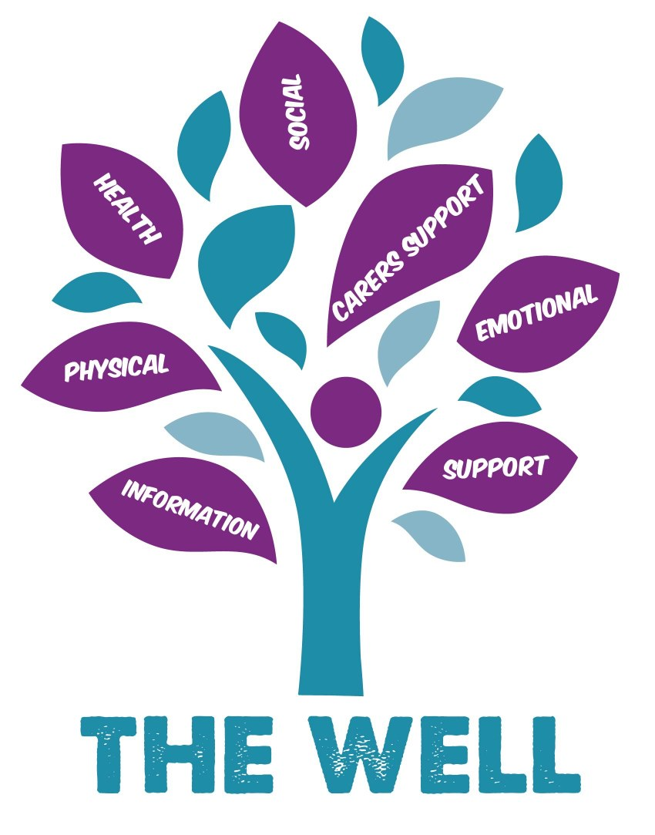
The Well offers the community a single
point of access for their health and
social care enquiries. If you are working
with a client 16+ who would benefit
from speaking to us about their health
and wellbeing, you can refer them by

A place for local people to find out information and receive general advice to help
them stay well and independent within their community.

Look at our website and Facebook page for future updates.

Fife Kinship Team facilitate support groups across Fife, you’re welcome to attend any group. If you would like support to attend or find out more, please feel free to call our duty number Monday to Friday 9am till 5pm 01592 583554. POSTER is attached to email

