Primary 3 have been really busy recently with our learning!

This term, we have been looking at comparing mainland life to island life through the Katie Morag stories.

First, we looked at a map of Scotland. We learned how we have 8 cities in Scotland. We placed these on a map. We then spoke about how we live in Methil in Fife. We noticed that Fife looks like a dog’s head on the map!

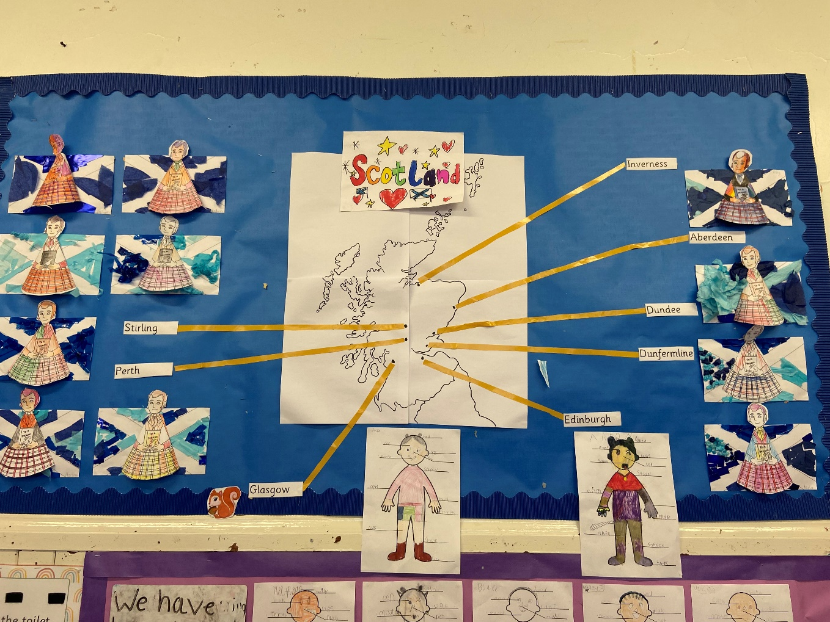

We have enjoyed learning about the similarities and differences between mainland and island life. We created venn diagrams to compare them.

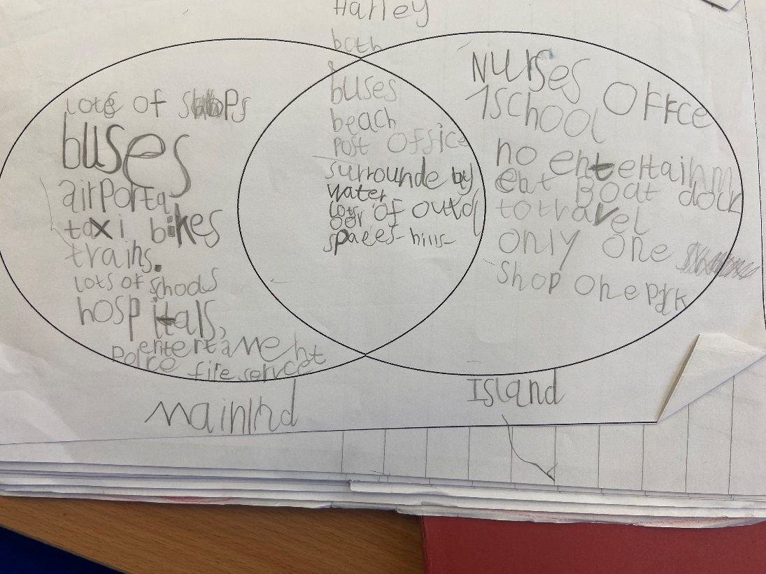

We have written letters to a school on the Isle of Orkney. We cannot wait for our replies!

We have taken part in lots of other fun activities with this topic, such as

* Learning Scottish dances
* Making tartan
* Making and tasting porridge
* Learning about the Scots language

Here are some more pictures of our fabulous work.

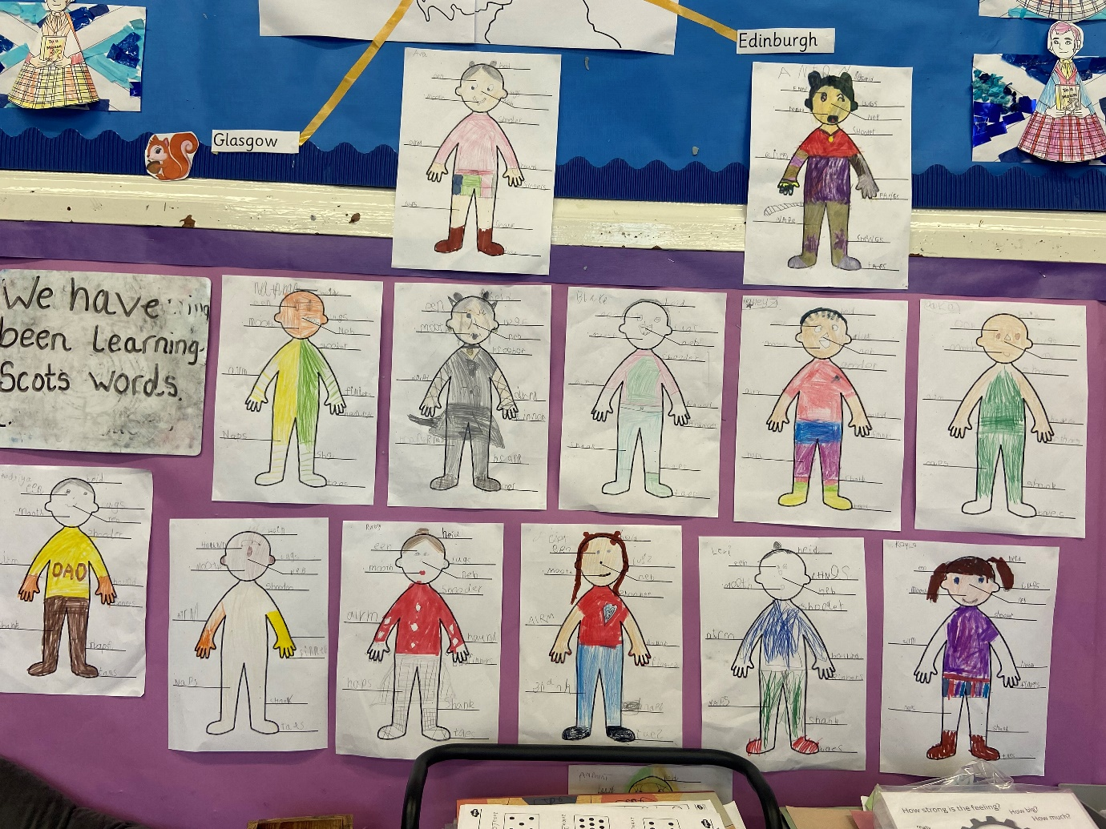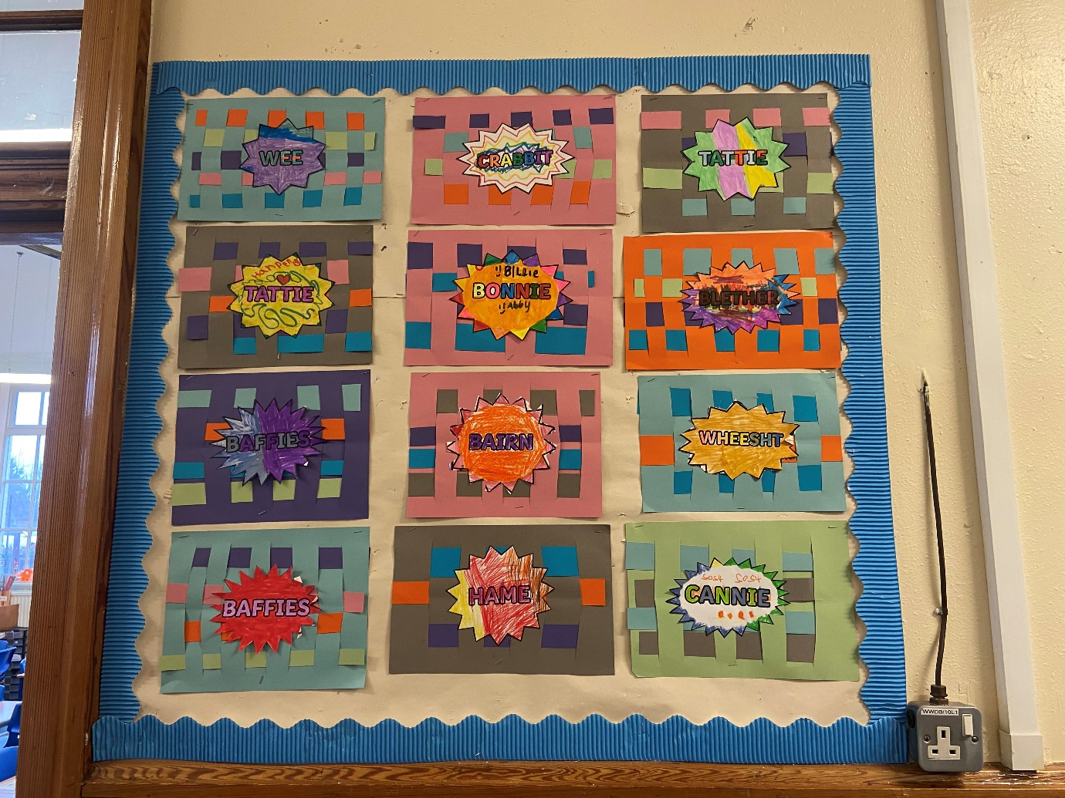

We will soon be moving on to our next topic, which will be ‘Spring and Easter’. Keep a watch out to see what we learn!

**Numeracy**

We have been looking at multiplication, and what strategies we can use to help us. We have been looking at skip counting, making groups of, arrays, and repeated addition. We are practising our 2, 5- and 10-times tables.

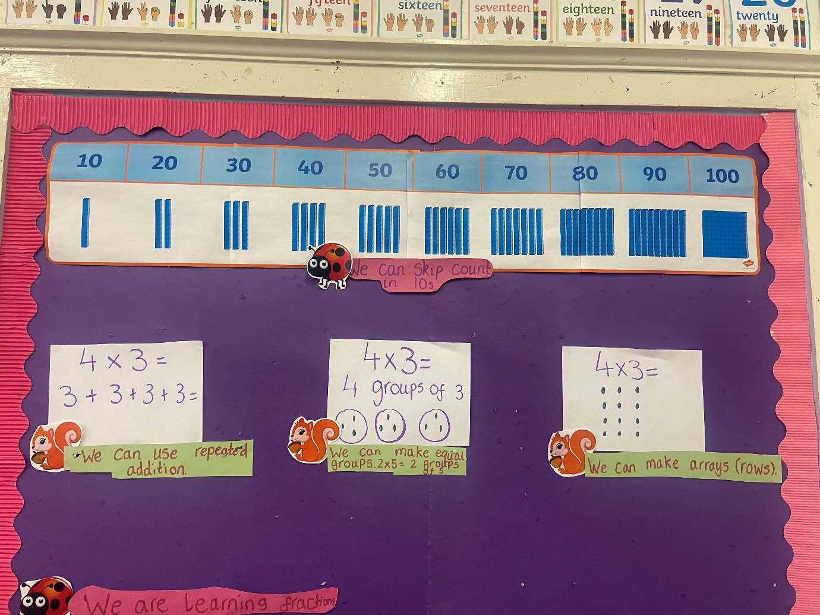

**Writing**

Our focus this term is procedural writing, or writing for a function. Currently, we have been focussing on writing instructions. We spoke about how, when writing steps or instructions, we have to use time connectives so we know what order to complete the steps. These are first, next, then, after that, and finally.

We then got to make empire biscuits in class (yum!).

After we made (and ate!) our biscuits, we began writing our instructions. We first ordered the steps, then wrote a list using bullet points, and then we wrote our instructions. Have a look at how we did!

