In primary 2 this term we have been working on procedural writing by writing instructions for different tasks. The class really enjoyed making jam sandwiches which they then wrote the instructions for. This has made for a fantastic display in our classroom that the learners can use to help them with their procedural writing.

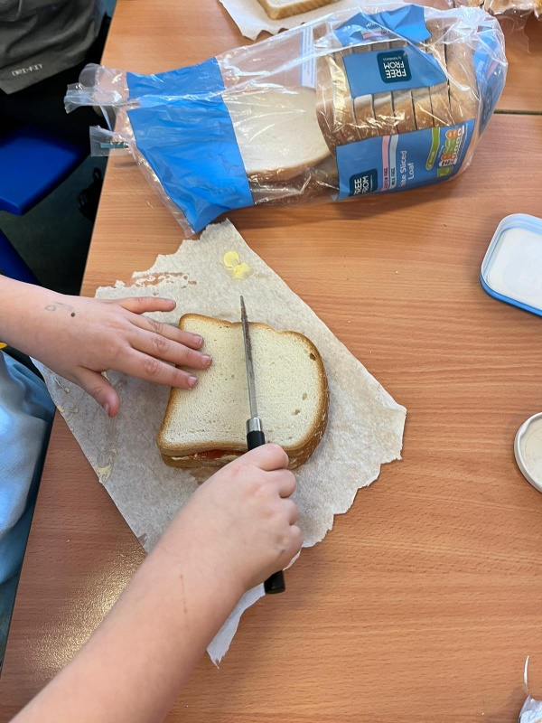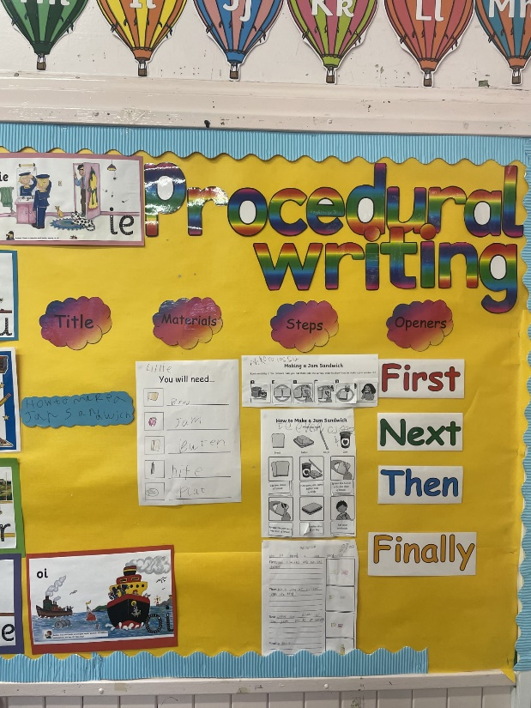

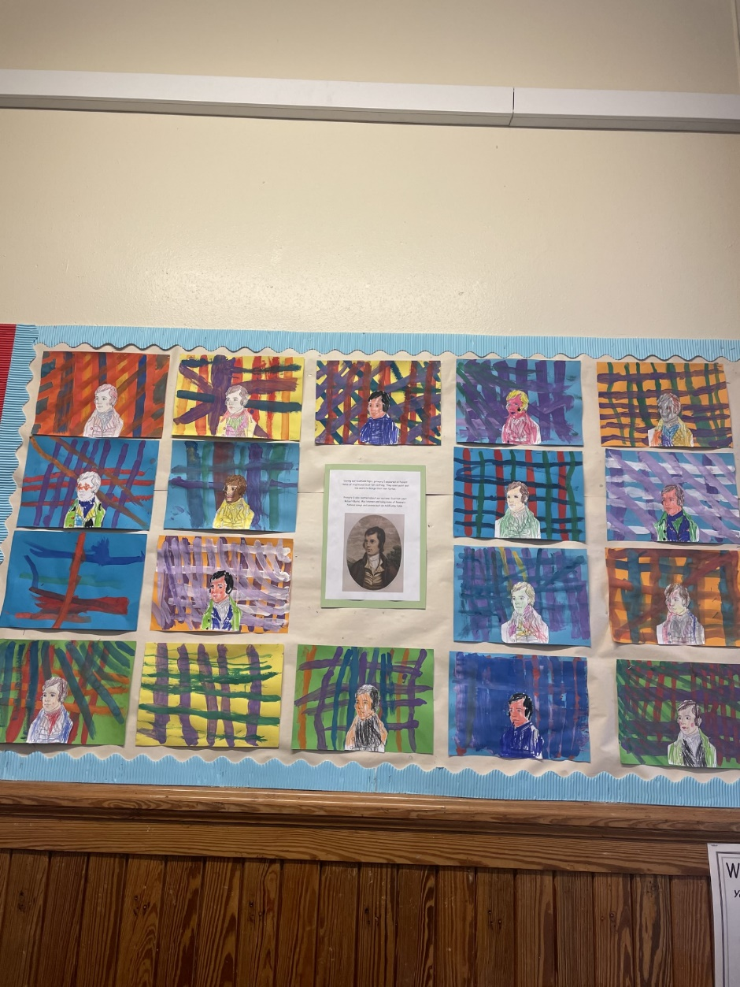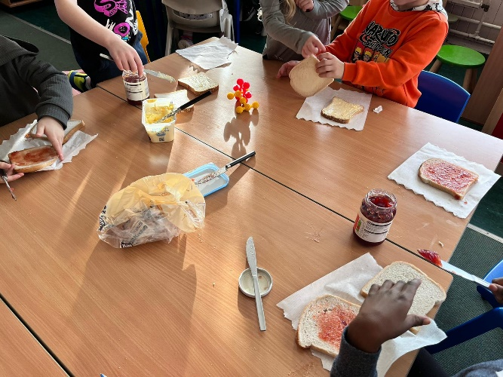

At the start of the term During our Scotland topic, primary 2 explored different items of traditional Scottish clothing. They used paint and line work to design their own tartan. Primary 2 also learned about our national Scottish poet Robert Burns. We listened and sang some of Rabbie’s famous songs and poems such as Auld Lang Syne.

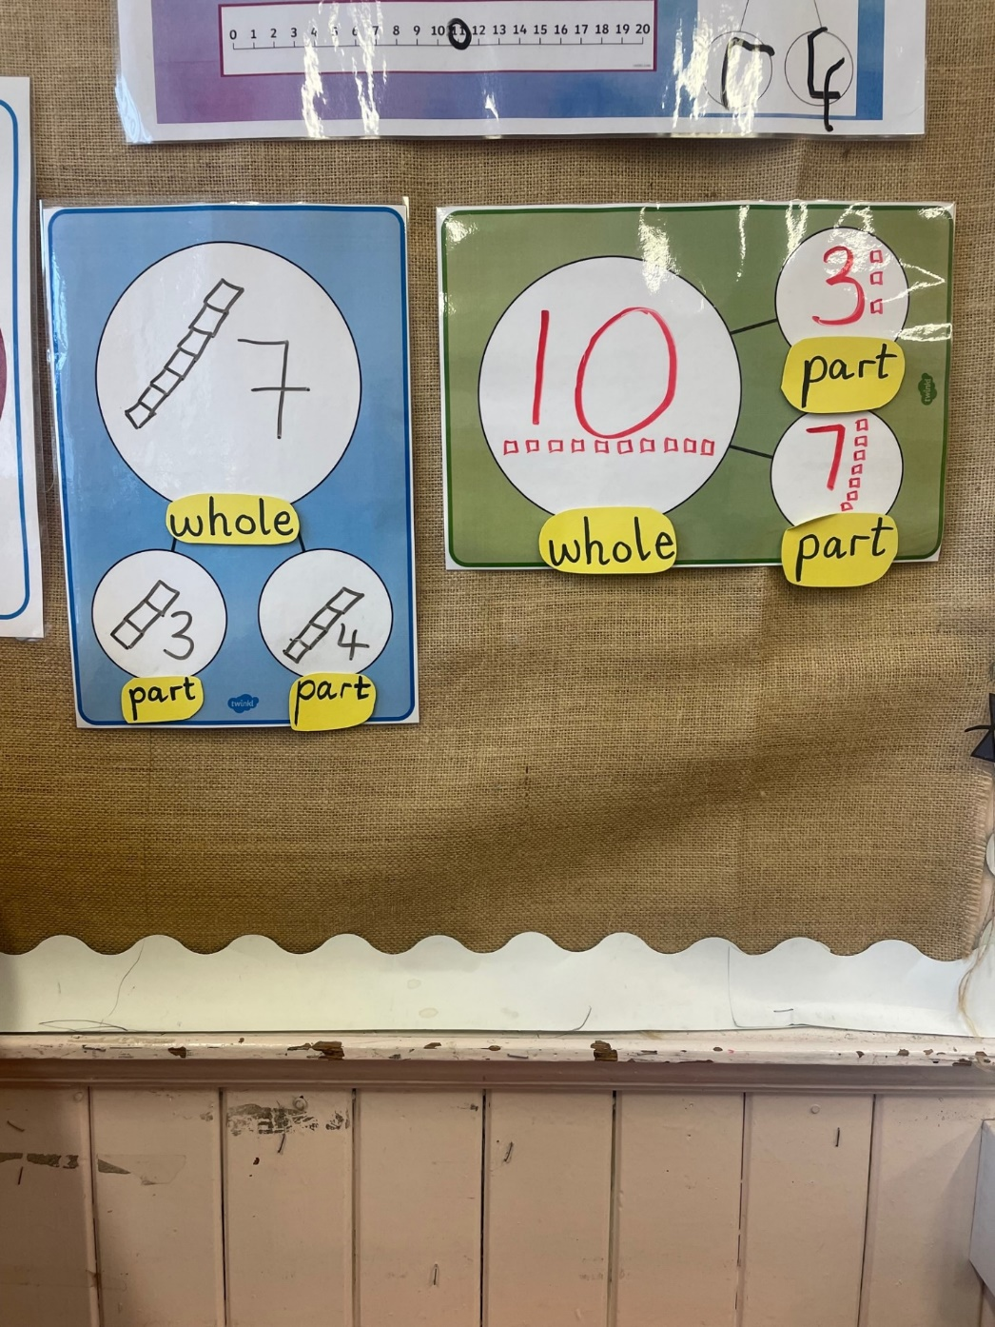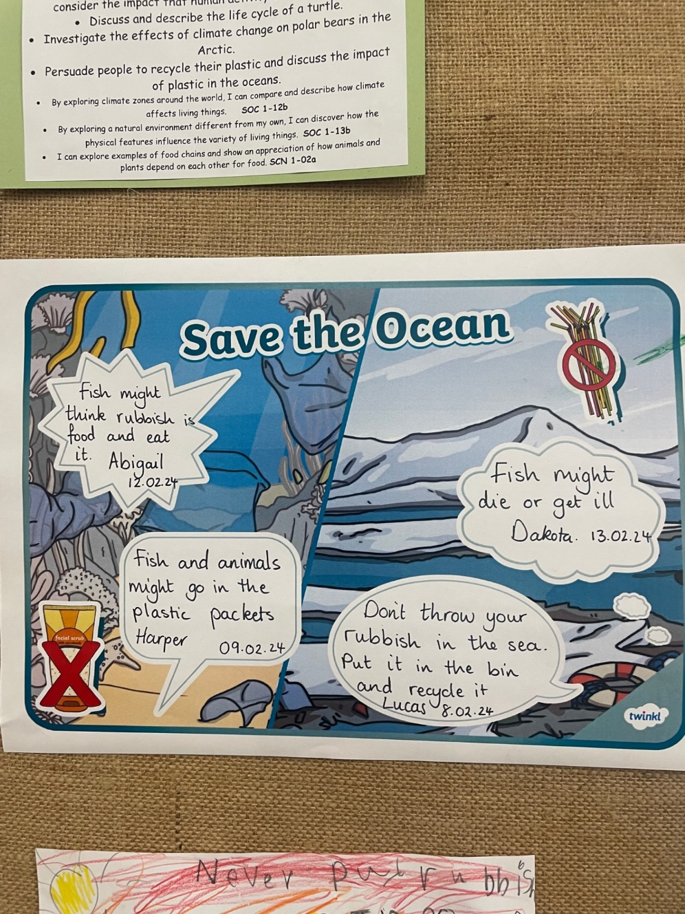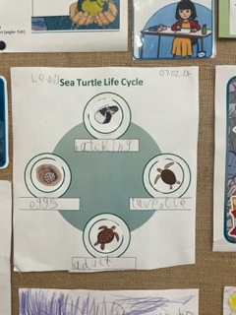

Currently in maths we are learning to tell the time. We are using analogue clocks to tell the time to the hour, half past and beyond! We are also learning about days of the week and how to use a calendar.

In numeracy, we have been learning different strategies to add larger numbers, such as counting on, part-part-whole and making ten.

Our current topic in Primary 2 is Under the Sea! We have loved learning about the life cycle of turtles and are learning the importance of recycling plastic so that it doesn’t pollute our oceans.