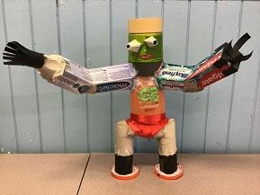**Water**

Our Water journey.

**In the beginning:**

When we did our Environmental review and we discovered that the school community didn’t have a good understanding of water, the water cycle and the impact of their water use.

**What we did:**

We organised a whole school ‘Week for Water’

Each stage took part in learning on a specific water topic over the course of a week.

Infants – The Water Cycle

Middle – Water Pollution

Upper – Water Footprint

Links to the science curriculum were identified and each stage were given the most appropriate planners for their stage and work.

Each class planned they learning that suited their class and interests and provided evidence of the work and learning that was achieved.

**Result:**

Each class provided evidence of their learning and we made a whole school display to show our collective learning and help others learn about the importance of water and our use of water.

There were lots of interesting facts and information that were very surprising especially for the Water Footprint that surprised teachers especially.

**Next Steps:**

Continue to encourage sensible use of water in all areas of the school.

hold a ‘Week for Water’ regularly or widen it to have a focus that includes different aspects of responsible natural resources use.

**Water Cycle**

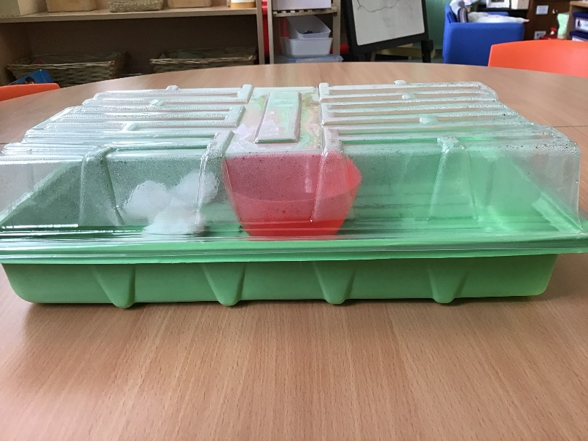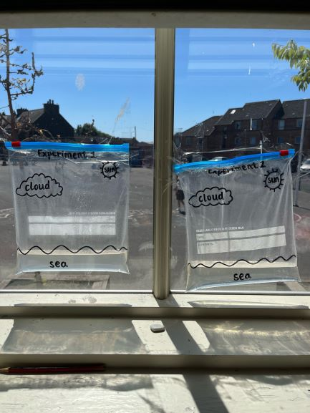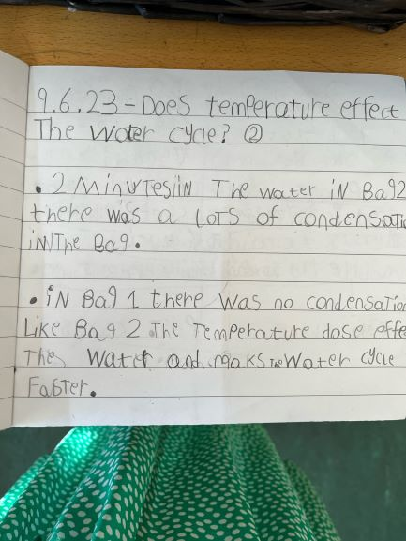

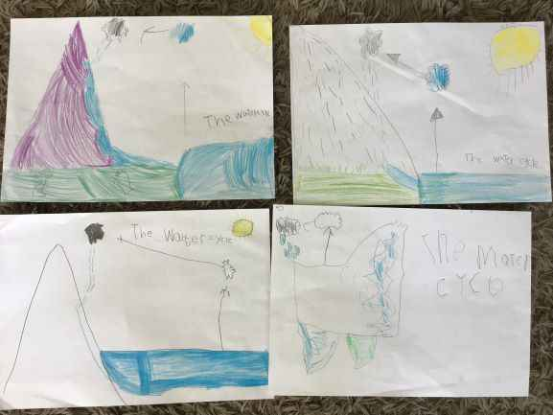

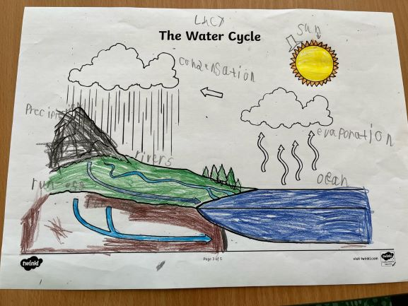

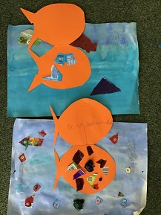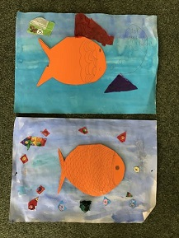**Water Pollution**

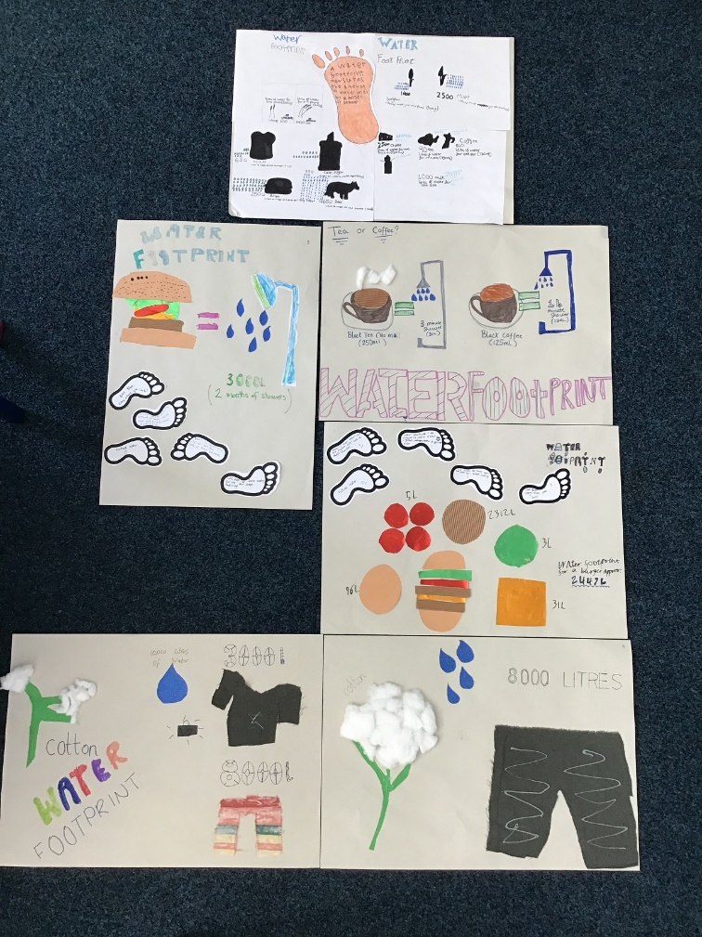**Water Footprint**

