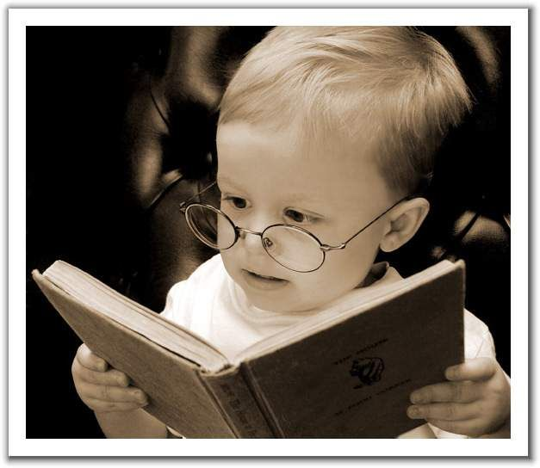
Reading to Inspire

Decent Teen / Young Adult Reads:

Northern Lights Trilogy – Phillip Pullman
The Knife of Never Letting Go – Patrick Ness
Noughts and Crosses – Malorie Blackman
Hoot – Carl Hiaasen
Watership Down – Richard Adams
Sandman: Seasons of Mists – Neil Gaiman
Stardust – Neil Gaiman
Twilight – Stephanie Meyer
Lucas – Kevin Brooks
Alice’s Adventures in Wonderland – Lewis Carroll
The Card Turner – Louis Sachar
Lord of the Rings – JR Tolkien
The Curious Incident of the Dog in the Night-Time – Mark Haddon
Eragon - Christopher Paolini
I am the Cheese - Robert Cormier
Maximum Ride: The Angel Experiment – James Patterson
The Princess Bride – William Goldman

More Challenging / Adult Novels:

Atonement – Ian McEwan
The Bell Jar – Sylvia Plath
The Book of Dave – Will Self
The Book Thief – Markus Zusak
Brave New World – Aldous Huxley
Catch 22 – Joseph Heller
The Catcher in the Rye – JD Sallinger
A Clockwork Orange – Anthony Burgess
Cloud Atlas – David Mitchell
Cold Mountain – Charles Frazier
The Collector – John Fowles
The Color Purple – Alice Walker
The Cone Gatherers – Robin Jenkins
Captain Corelli’s Mandolin – Louis De Bernieres
Dune – Frank Herbert
East of Eden – John Steinbeck
Everything is Illuminated – Jonathan Safran Foer
Fahrenheit 451 – Ray Bradbury
The Five People You Meet in Heaven – Mitch Albom
Girl With a Pearl Earring – Tracy Chevalier
Great Expectations – Charles Dickens
The Great Gatsby – F Scott Fitzgerald
The Handmaid’s Tale – Margaret Atwood
Heart of Darkness – Joseph Conrad*
The Help – Kathryn Stockett
The Hitchhiker’s Guide to the Galaxy – Douglas Adams
The Hound of the Baskervilles – Conan Doyle
I Know Why the Caged Bird Sings – Maya Angelou
It – Stephen King
Jane Eyre – Charlotte Bronte
The Joy Luck Club – Amy Tan
The Kite Runner – Khaled Hosseini
Last Orders – Graham Swift
Les Miserables – Victor Hugo
Life of Pi – Yann Martel
Little Women – Louisa May Alcott
A Long Way Gone: Memoirs of a Boy Soldier – Ishmael Beah
The Lovely Bones – Alice Sebold
Memoirs of a Geisha – Arthur Golden
The Memory Keeper’s Daughter – Kim Edwards
My Sister’s Keeper – Jodi Picoult
On the Road – Jack Kerouac
One Day – David Nicholls
One Flew Over the Cuckoo’s Nest – Ken Kesey
One Hundred Years of Solitude – Gabriel Garcia Marquez
A Portrait of an Artist as a Young Man – James Joyce*
A Prayer for Owen Meany – John Irving
Pride and Prejudice – Jane Austen
Quite Ugly One Morning – Christopher Brookmyre
The Road – Cormac McCarthy
Roll of Thunder, Hear my Cry – Mildred D. Taylor
Things Can Only Get Better – John Farrell
Things Fall Apart – Chinua Achebe
To Kill a Mockingbird – Harper Lee
Water for Elephants – Sarah Gruen
Wolf Hall – Hilary Mantell

Non Fiction:

Angela’s Ashes – Frank McCourt
A Child Called It – David Pelzer
Fermat’s Last Theorem – Simon Singh
In the Heart of the Sea –Nathaniel Philbrick
The Perfect Storm – Sebastian Junger
The Diving Bell and the Butterfly - Jean-Dominique Bauby
A Short History of Nearly Everything – Bill Bryson

