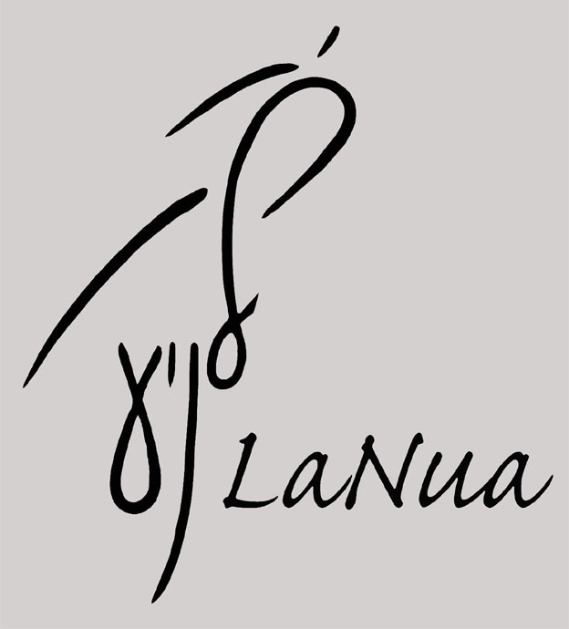

LaNua – Movement and Improvisation

enso by LaNua
site specific installation and dance performance and workshops for schools

Suitable for ages 7+, Learning levels 1-3 (as outlined in Curriculum for Excellence)

Available to book between 1 October and 12 October, or 23-26 October 2012

Booking options

1. Performance plus one workshop (£250)
Here is a link to video of Enso (performed in 2 different spaces: Royal Botanic Gardens and Dovecot Studios) http://vimeo.com/30840732

Artistic Director and choreographer: Merav Israel
Music: Various including original composition and arrangement by Nik Padget-Tomlinson

Enso is inspired by Zen art forms: calligraphy, gardens and poetry (Haiku). Enso means 'circle' in Japanese and also refers to the famous circle calligraphy practised daily by Zen masters. It deals with the form and the formless, space and motion of body and mind, relationship to landscape and between people.

Zen arts call for stillness and quite observation but also for travel and exploration. Many Zen masters travel the country and write/draw in response to the landscape they travel through and to.

The Enso performance calls for both stillness and travel. The audience is seated around the landscape as they would do in a Zen garden. They are invited to travel through the installation/garden and place a stone that they chose within the installation/garden, making their own mark on the space. The Japanese love to commemorate places with poems incised into large stones sets along the paths.

Enso includes an installation of paper, fabric and stones, music and 4 dancers. The collaboration between visual art, text, sound and dance is blended into a quiet meditative performance that is beautiful to watch.

Performance running time: 40-45 minutes.
Workshop running time: 40- 60 minutes (to fit within the school’s timetable)

2. Lecture demonstration (£200)
For schools, some elements of the performance could be delivered as a lecture demonstration, involving work created by the children and discussing the creative inspiration for the piece and the decisions and challenges that the choreographer had to realise her vision.

Running time: 45- 60 minutes

3. Lecture demonstration plus workshop – (£250)

4. Half day of workshops plus a performance or Lecture/Demonstration for £400

Themes in performance and workshops are linked to Curriculum for Excellence: physical activity, cultural and historic studies, environmental awareness, multi disciplinary practices, creativity and more.

All prices are negotiable

Workshop themes

Haiku – is a 17 syllable poem from which moments of natural wonder and encounters with people are captured and feelings applied.
We will explore the classic work of Basho – Japan’s most famous Haiku poet whose Haikus are known to all Japanese people. And we will refer to contemporary Scottish haiku poets such as Alan Spence.

Paper birds – The moon swiftly fleeting,
their shadows Branches still holding
flying - Alan Spence The rain-drops. - Basho

Poems created by the children could be used within the performance or lecture demonstration.

Calligraphy – the art of making a mark with ink on paper.
We will explore the abstract element of making marks in space or on paper with different mediums – body, objects and pencils.

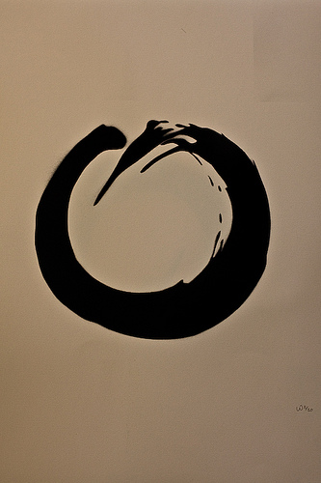

An exhibition of the children’s work could be displayed within the school.

Gardens - The Japanese rock garden or "dry landscape" garden creates a miniature stylized landscape through carefully-composed arrangements of rocks, moss, pruned trees and bushes, and uses raked gravel or sand to represent water. Classical zen gardens were created at temples of zen Buddhism in Kyoto, Japan during the Muromachi Period. They were intended to imitate the intimate essence of nature, not its actual appearance, and to serve an aid to meditation about the true meaning of life.

The Enso installation creates an environment reflecting the zen garden using materials such as fabric, paper and stones.

In the workshops the children and young people will explore making small models of zen gardens and relate to their creation in movement.

"Nature, if you made it expressive by reducing it to its abstract forms, could transmit the most profound thoughts by its simple presence," (Michel Baridon )

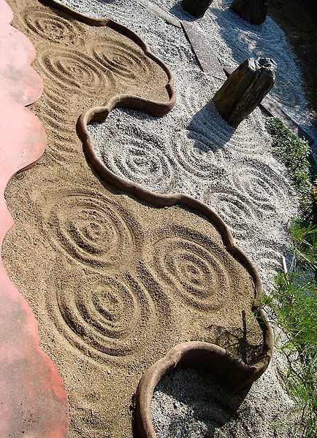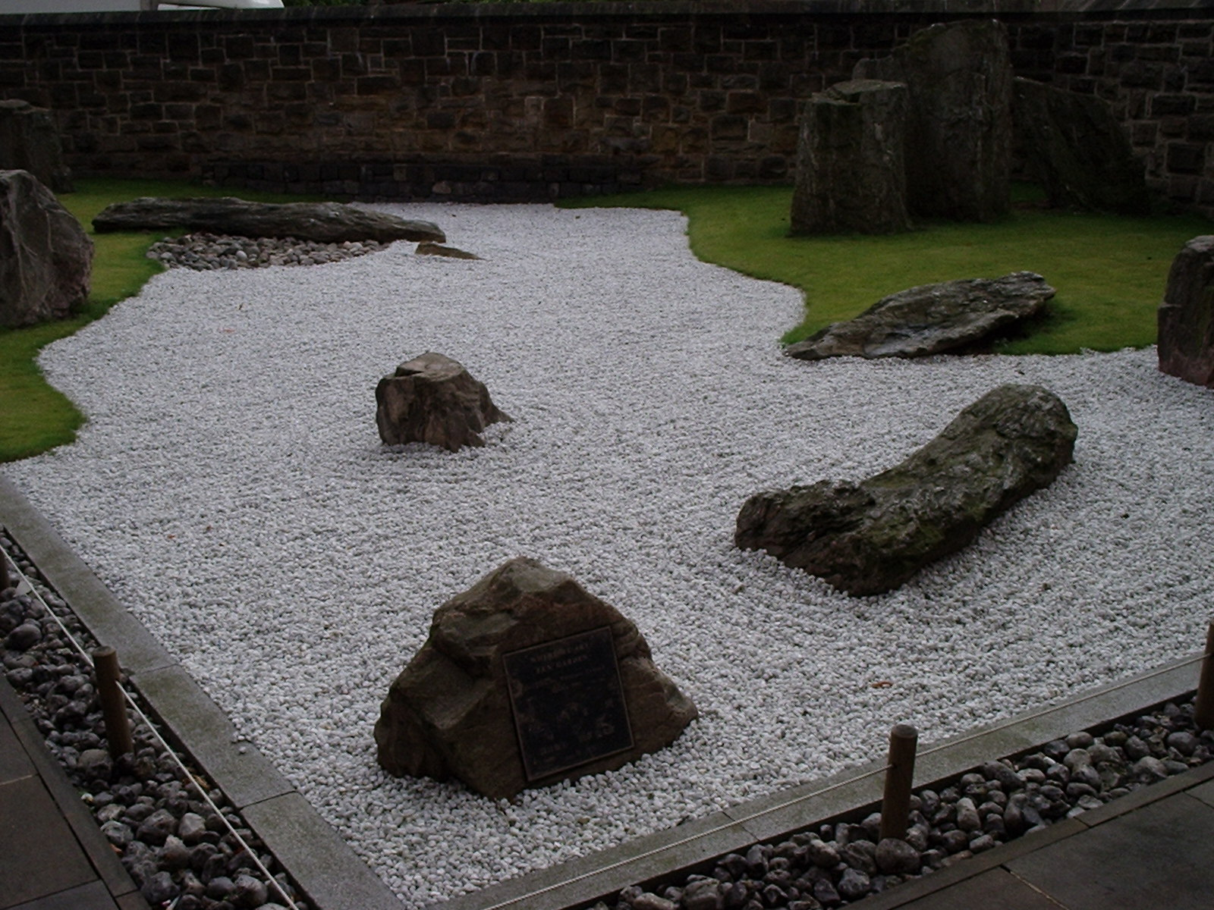

Movement/physical exploration
In the workshops children will develop awareness to their body, and relationship to the space around them and between each other. We will find inspiration in forms around us and in flow of movement, learning to distinguish between form and movement, to observe and translate ideas and our observations into the body, create forms, relate to forms and find movement.
Children will work on their own and in small groups. Children will have the chance to respond to the experience of dance by discussing their thoughts and feelings, as well as giving and accepting constructive comment on my own and others’ work.

Practical Information

Set up time/Strike time for performance or lecture demonstration:
Set up time:
2-3 hours before show: this could be the night before performance or morning time (again this could be decided with the schools according to other schedules and availability).
Striking down time:
1 hour

Space required
Schools will need to provide with the large gym hall and some benches or chairs organised around the space. Our technician will need few hours to build the installation (mainly hanging fabric and spreading paper on floor) and the sound system. Dancers will need a place to change to costume and a place to warm up and prepare to perform. Workshops can be led during same day.

Summery:
The Enso performance and workshops offer a variety of stimulating experiences and contexts explored through active engagement and multi disciplinary activities. It is suitable for Level 1-3 learners. The project will allow children to be physically active, increase their knowledge and understanding, be inspired and explore:
- physical activity, dance and expression through movement
- creativity
- self awareness and expression
- working alone and in groups
- developing ideas collaboratively
- learning about another culture – its art and philosophy
- relating to the environment – natural and man made
- respecting themselves, others and the environment
- learning about and participating in different art forms – dance, poetry, landscaping, calligraphy, minimalism
- cultural history
- experiencial fun learning
- making connections between cultures, people, different art forms, their own experience and others, the workshop and the performance experience
- making choices through creative expression
- learning through a multi sensory experience
- being stimulated physically, aesthetically, spiritually, cognitively and emotionally
- developing skills
- sharing their creativity and learning

For booking the company, please contact
Susan Hay
M: 07872 006836
E: lanua.info@gmail.com or susan.hay@blueyonder.co.uk

