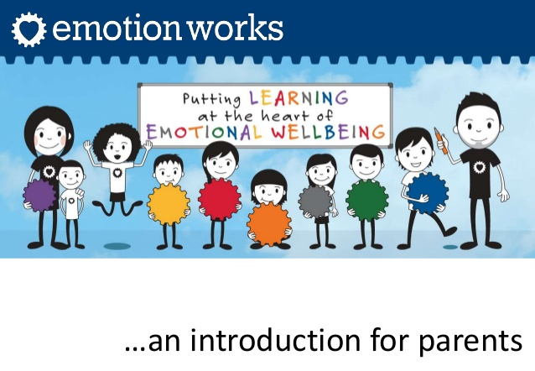
About Emotion Works
Emotion Works is based on the ‘Cog Model’. It breaks the topic of emotions down into 7 parts, but also shows how each links together to help children and young people understand their emotions and how to express and manage them in a healthy way.

Emotion Works is a colourful education
programme designed to help children learn emotional language, develop emotional understanding and manage feelings and emotional behaviours.

This programme is used throughout our school, from Primary 1 to Primary 7, to
ensure our children are happy, settled and confident and ready to learn.

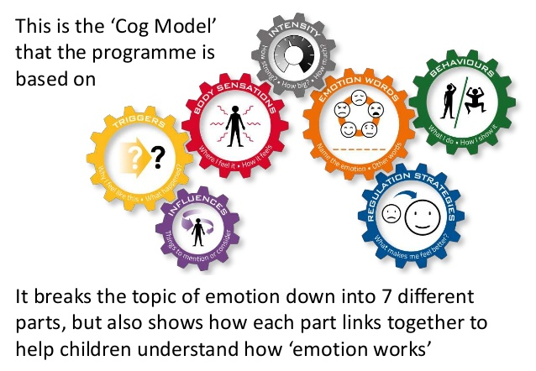

Early Level

With our youngest children we
focus on building and developing emotional language. We encourage children to think about other emotions; moving on from just ‘happy’ or ‘sad’.
First Level
Our next step is to explore the yellow cog; looking at various triggers/causes for different emotions. We use
stories, films, music, art and daily situations to discuss these. The red cog encourages us to think about how the emotion makes us feel inside i.e. butterflies in our tummy, feeling hot, shaky or sweaty etc.
The green cog is the behaviour cog.
This looks at what do we do to show how we are feeling? What actions, facial
expressions movements? Is this behaviour okay, and if not what could we do instead? This cog is important as we need to ensure our children are expressing their emotions in healthy and safe ways.
The blue cog is our regulation strategy. Here we explore what strategies we could use to cheer up or calm down if the emotion we are experiencing is a negative one. Different children will have
different strategies. This may take some time to find what works for our children.
Second Level
The grey cog focuses on the
intensity of the emotion i.e. on a scale of 0-10 how happy are you? A little or a lot.
The purple cog is the influences cog where we look at the wider context, thinking about if there is anything significant about the situation or the person involved. Both of these cogs can be trickier for some of our children to
understand which is why we look at these last, usually around Primary 7.

If you’d like to use Emotion Works strategies at home please refer to the additional handout.
As always, please contact us at school if we can support you with the use of Emotion Works at home.

