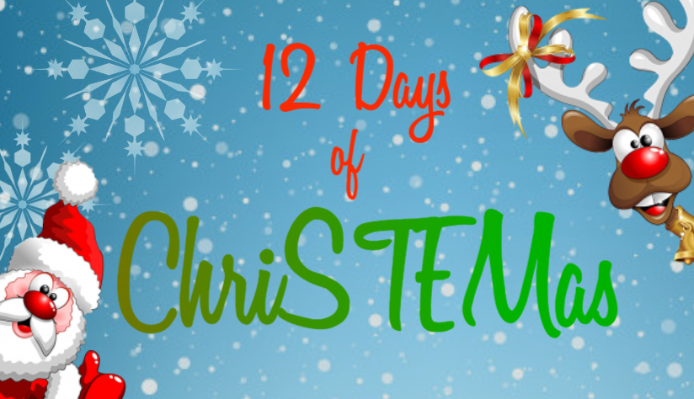
Resource Guide & Curriculum Alignment
How to use the Resource page 2
Activity 1: Jingle Bell Maze page 3
Activity 2: Code a Christmas Ornament page 4-5
Activity 3: Snowball Catapult page 6
Activity 4: Dissolve a Candy Cane page 7-8
Activity 5: Help the Grinch page 9-10
Activity 6: Decoding Elf Messages page 11
Activity 7: The Tallest, Jolliest Snowman page 12
Activity 8: Paper Chain Decoration page 13
Activity 9: Green Glow Three in a Row page 14
Activity 10: Santa’s Parachute page 15-16
Activity 11: A Hidden Message page 17-18
Activity 12: Santa’s Sleigh page 19

How to use the Resource
Resources
All resources, such as worksheets, games and the PDF version of advent calendar, can be found within this One Drive location.
Interactive Advent Calendar
There are two interactive versions of the resources, which can be used as an advent calendar: the PDF which can be found in the above One Drive location; and a version created using Google Slides.
If the advent calendar is too much, simply pick and choose your activities.
Navigation
Click on the presents to be taken to the activity screen.
Click on the gingerbread house to be taken back to the main presents screen.
Activity Instructions
There are further instructions on each activity within this guide, links to the Curriculum.
The activities should be low-cost; with resources you may have in school or are easy to find in stores like Home Bargains, Pound Store etc. I have also tried to include adaptations to keep costs down, allow you to use fewer resources and/or extend the task.

Activity 1: Jingle Bell Maze
You will need… | Adaptations
1 x Jingle bell  1 x Paper plate  Assortment of paper/card  Straws  Glue/tape | Replace jingle bell with marble or pom-pom  Use construction toys such as Lego or even recyclable materials

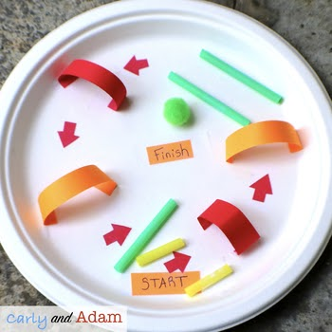
Activity Instructions
Can you use the materials to create a maze?
You’ll need to make sure:
- The jingle bell can fit through any paths
- You have a starting point and an end
Extension: Build a maze from different materials
Curriculum Alignment
Early | First | Second
Art and Design  Working on my own and with others, I use my curiosity and imagination to solve design problems.  EXA 0-06a | Computer Science  I can demonstrate a range of basic problem solving skills by building simple programs to carry out a given task, using an appropriate language.  TCH 1-15a  Art and Design  I can use exploration and imagination to solve design problems related to real-life situations.  EXA 1-06a | Craft, Design, Engineering and Graphics  I can extend and enhance my design skills to solve problems and can construct models.  TCH 2-09a  Art and Design  I can develop and communicate my ideas, demonstrating imagination and presenting at least one possible solution to a design problem.  EXA 2-06a

Activity 2: Code a Christmas Ornament
You will need… | Adaptations
- Pipe cleaners  - Beads (3 colours)  - Binary alphabet  (2. Code a Christmas Ornament BINARY ALPHABET)  - Twinkl Binary Name worksheet  (2. Code a Christmas Ornament TWINKL SHEET) | Candy Cane worksheet instead of using pipe cleaners and beads. (2. Code a Christmas Ornament CANDY CANE TEMPLATE 1 & 2. Code a Christmas Ornament CANDY CANE TEMPLATE 2)

What is Binary?
The binary numeral system is a way to write numbers using only two digits: 0 and 1.
These are used in computers and electronics as a series of "off" and "on" switches
0 = off and 1 = on
Similarly the computer doesn’t read the letter A like we read the letter A. It reads it in a series of 1s and 0s. Each letter has its own code made up of 1s and 0s.
Activity Instructions
- Spend some time familiarising yourselves with the binary alphabet. You could do some whole class work on identifying letters by their codes e.g. asking the children to write down the code for letter F etc. and building to 2 and 3 letter words.
- Now you need to assign colours to 1s, 0s and spaces – therefore you will need beads of 3 different colours. Get children to make a note of this on their Twinkl worksheet. Note that the worksheet states 0s are red, 1s are blue and spaces are yellow, but you may wish to use more ‘Christmassy’ colours.
- Have children complete the worksheet, either spelling out their name in binary or Christmas words such as GIFT, SNOW, LOVE – these 4 letter words should use one pipe cleaner, longer words may require pipe cleaners joined together.
- Once children have their word marked out on their sheet, they can begin building their candy cane decoration with the beads.
ADAPTATION: If you are not using pipe cleaners and beads, you can use the candy cane template and children can colour the ‘beads’ on that.
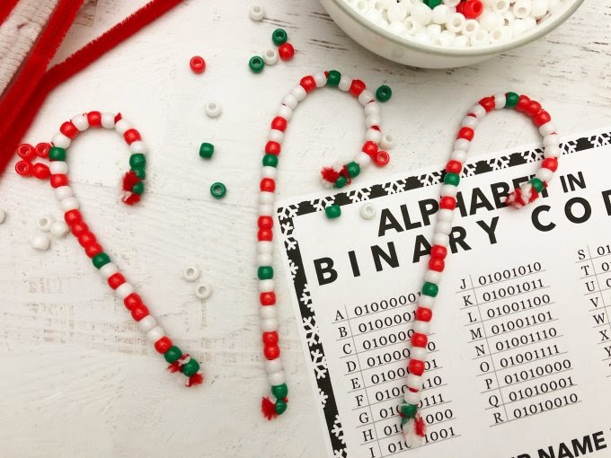

Activity 2: Code a Christmas Ornament
Curriculum Alignment
Early | First | Second
May be too advance for Early  Computing Science  I can explore computational thinking processes involved in a variety of everyday tasks and can identify patterns in objects or information  TCH 0-13a  Patterns and Relationships  I have spotted and explored patterns in my own and the wider environment and can copy and continue these and create my own patterns.  MTH 0-13a | Computer Science  I can demonstrate a range of basic problem solving skills by building simple programs to carry out a given task, using an appropriate language.  TCH 1-15a  Patterns and Relationships  I can continue and devise more involved repeating patterns or designs, using a variety of media.  MTH 1-13a | Computer Science  I understand the operation of a process and its outcome. I can structure related items of information.  TCH 2-13a  Patterns and Relationships  Having explored more complex number sequences, including well-known named number patterns, I can explain the rule used to generate the sequence, and apply it to extend the pattern.  MTH 2-13a

Activity 3: Snowball Catapult
You will need… | Adaptations
- Lollipop sticks  - Elastic bands  - Plastic spoon/fork  - Marshmallows (aka snowballs) | Target (3. Snowball Catapult TARGET)  How many points can they score from 5 shots?  Measuring  Measure how far the snowballs go.  Which catapult has the longest reach?  Does this depend on the height of the catapult? E.g. the number of lollipop sticks between the levered two?

Activity Instructions
- Take 3 lollipop sticks, bundle them, and wrap rubber bands around each end to hold them together.
- Take 2 more lollipop sticks and put them together with a rubber band around one end.
- Then put the first bundle between those two sticks.
- Take one another rubber band and wrap it around the point where the sticks all meet to hold them in place.
- Then place the spoon along the top stick and rubber band or glue that into place.
- Try making the catapults with different amounts of lollipop sticks for step 1 and/or 2 and test to see which one can launch the ‘snowball’ the furthest.

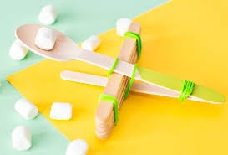

Curriculum Alignment

Early | First | Second
Craft, Design, Engineering and Graphics  I explore everyday materials in the creation of pictures/models/concepts  TCH 0-10a  Measurement  I have experimented with everyday items as units of measure to investigate and compare sizes and amounts in my environment, sharing my findings with others.  MNU 0-11a | Craft, Design, Engineering and Graphics  I can extend and enhance my design skills to solve problems and can construct models.  TCH 2-09a  I can recognise basic properties and uses for a variety of materials and can discuss which ones are most suitable for a given task.  TCH 2-10a | Measurement  I can use my knowledge of the sizes of familiar objects or places to assist me when making an estimate of measure.  MNU 2-11a  I can use the common units of measure, convert between related units of the metric system and carry out calculations when solving problems.  MNU 2-11b
Activity 4: Dissolve a Candy Cane
You will need… | Adaptations
- Candy canes  - 3 x glass beakers (per group)  - Assortment of liquids e.g.  - cold water  - warm water (keep in a flask)  - lemon juice  - fizzy juice  - vinegar  - Recording sheets (4. Dissolve a Candy Cane)  - Measuring jug (optional if the beakers aren’t marked)  - Timing device | The activity can be done as a whole class or by breaking into smaller groups.  If working in smaller groups you can use mini candy canes rather than full-sized ones.  You can use plastic cups rather than glass beakers, but ensure the water is not too warm.

Activity Instructions
- Discuss the liquids you have selected for the experiment as a whole class. Can the learners describe them?
- Explain that the aim of the experiment is to find out which liquid will dissolve the candy cane the quickest.
- If working in groups, children will select 3 different liquids to test (or you might want them all to use the same liquids to make things easier). Get them to write down which liquids they will test on their recording sheets, as well as their predictions.
- Children will need to measure equal amounts of each liquid into each of the beakers/cups and then place the candy cane in. One member of the group will press the start button on their timer.
- Keep track of the changes to each candy cane throughout the process as well as how long each liquid takes to dissolve the candy cane. You may wish to take photos every 2-5 minutes to track the changes or have learners draw the candy cane.
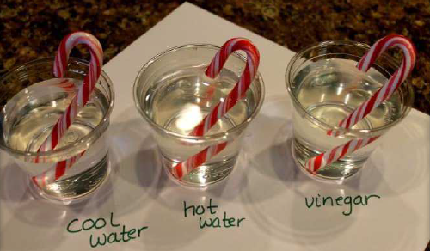
Activity 4: Dissolve a Candy Cane
Curriculum Alignment
Early | First | Second
 | Materials  Through exploring properties and sources of materials, I can choose appropriate materials to solve practical challenges.  SCN 1-15a  I can make and test predictions about solids dissolving in water and can relate my findings to the world around me.  SCN 1-16a | Materials  By contributing to investigations into familiar changes in substances to produce other substances, I can describe how their characteristics have changed.  SCN 2-15a  By investigating common conditions that increase the amount of substance that will dissolve or the speed of dissolving, I can relate my findings to the world around me.  SCN 2-16b  Craft, Design, Engineering and Graphics  I can recognise basic properties and uses for a variety of materials and can discuss which ones are most suitable for a given task.  TCH 2-10a

Activity 5: Help the Grinch
You will need… | Adaptations
- Green balloon
- Red Sharpie
- Empty water bottle
- White vinegar
- Funnel
- Baking Soda
Have you watched How the Grinch Stole Christmas yet this year? When you do, add a little extra fun when you do this grow the Grinch’s heart science experiment.
Read aloud version: https://www.youtube.com/watch?v=YOpKuQO1FkA
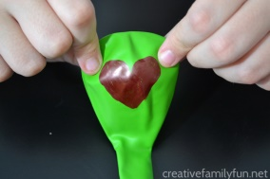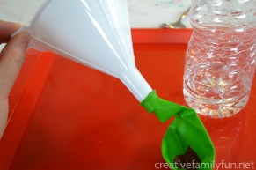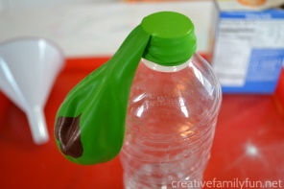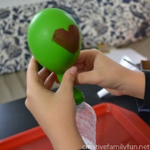
Instructions
- Before you begin, you’ll want to make the Grinch’s small heart.
Take a green balloon and use your red Sharpie to draw a simple heart on the balloon.
Give it a minute to dry before you begin your grow the Grinch’s heart science experiment.
- For the first step in your experiment, add some vinegar to your empty water bottle. I filled it up to about the second groove from the bottom. Eyeball it. You don’t need to be exact.
- Attach your balloon to the bottom of your funnel (like the picture above). Fill the balloon with about two to three spoonfuls of baking soda. You may need to shake it a bit to get all the baking soda into the balloon.
- Remove your balloon from the funnel.
- Carefully, without dumping any baking soda into your bottle, attach the balloon to the top of the water bottle, like you see illustrated in the photo above.
- You’re all set up! Get ready to grow the Grinch’s heart. Lift the balloon up and shake the baking soda into the bottle. Your balloon will start inflating immediately.
- You can let go once the balloon starts filling up and watch the Grinch’s heart grow three sizes (or more).
Extension: You could use a measuring tape to find out which balloon grew the biggest (measure around the widest part).

Why did the Grinch’s heart grow?
The science behind the experiment
The combination of baking soda and vinegar formed a gas called carbon dioxide, which filled your balloon. This is a chemical reaction. This is the same gas that forms the bubbles in your favourite carbonated drink.

Activity 5: Help the Grinch
Curriculum Alignment
Early | First | Second
Chemical Changes
I have collaborated in activities which safely demonstrate simple chemical reactions using everyday chemicals. I can show an appreciation of a chemical reaction as being a change in which different materials are made.
SCN 2-19a

Activity 6: Decoding Elf Messages
You will need… | Adaptations
- Elf Cipher (printed on card to make it sturdier)  - Split pin  - Elf Messages | Can children create their own messages using the cipher? Use squared paper to keep it neat.  Can children create their own cipher?

Activity Instructions
- Children build the cipher using a split pin to attach both pieces.
- Use the cipher to decode the messages from the elves (some letters in each message have been identified)
Extension: See adaptations
Curriculum Alignment
Early | First | Second
Patterns and Relationships  I have spotted and explored patterns in my own and the wider environment and can copy and continue these and create my own patterns.  MTH 0-13a | Computer Science  I can demonstrate a range of basic problem solving skills by building simple programs to carry out a given task, using an appropriate language.  TCH 1-15a  Patterns and Relationships  I can continue and devise more involved repeating patterns or designs, using a variety of media.  MTH 1-13a

Activity 7: The Tallest, Jolliest Snowman
You will need… | Adaptations
- Marshmallows
- Toothpicks

Activity Instructions
Children are to work in a team or individually to build the tallest, free-standing snowman. They are allowed to use the toothpicks to attach the marshmallows; however they can’t use the toothpicks to prop up their snowman.
You can set a time limit of 10 minutes (e.g. 3 minutes to plan, 7 to build) to make it more challenging.
Curriculum Alignment
Early | First | Second
Measurement  I have experimented with everyday items as units of measure to investigate and compare sizes and amounts in my environment, sharing my findings with others.  MNU 0-11a  Art and Design  Working on my own and with others, I use my curiosity and imagination to solve design problems.  EXA 0-06a | Measurement  I can estimate how long or heavy an object is, or what amount it holds, using everyday things as a guide, then measure or weigh it using appropriate instruments and units.  MNU 1-11a  Art and Design  I can use exploration and imagination to solve design problems related to real-life situations.  EXA 1-06a | Art and Design  I can develop and communicate my ideas, demonstrating imagination and presenting at least one possible solution to a design problem.  EXA 2-06a

Activity 8: Paper Chain Decoration
You will need… | Adaptations
- 1 x A4 paper/card per child  - Scissors  - Glue/tape | Measuring tapes/metre sticks/trundle wheels if you wish to measure the lengths of the chains

Activity Instructions
Can you work out a way to build the longest paper chain using only 1 sheet of paper?
Remember to measure your paper chain afterwards!
You may wish to show children how to attach the rings together.

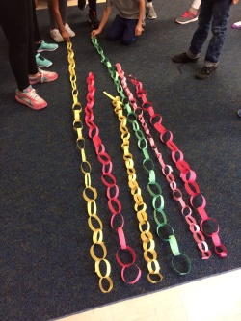

Challenge: Can all of the paper chains go the whole way around your classroom or gym hall?

Curriculum Alignment
Early | First | Second
Measurement  I have experimented with everyday items as units of measure to investigate and compare sizes and amounts in my environment, sharing my findings with others.  MNU 0-11a | Measurement  I can estimate how long or heavy an object is, or what amount it holds, using everyday things as a guide, then measure or weigh it using appropriate instruments and units.  MNU 1-11a

Activity 9: Green Glow Three in a Row
You will need… | Adaptations
- Game board  - 2 x players  - 6 x coloured counters (3 x one colour, 3 x another colour) | ‘Shannon Switching’ games

Activity Instructions
- Each player gets 3 game pieces of the same colour.
- Take turns putting the pieces on a dot on the game board.
- When all 6 pieces are used, take turns moving pieces along the lines until one player gets three in a row across, up and down, or diagonally. That player is the winner!

Rules
- No jumping is allowed.
- Plan your strategy
- Clear the board and play again!

Shannon Switching Game

A similar problem solving and logic game, in which one player tries to plot a route whilst the other tries to block their path. Full instructions and games boards can be found at: https://www.maths.ed.ac.uk/school-of-mathematics/outreach/mathsweekscotland/have-fun-with-maths
Curriculum Alignment
Early | First | Second
Problem solving and logic | Problem solving and logic | Problem solving and logic

Activity 10: Santa’s Parachute
You will need… | Adaptations
- 1 x Lego figure/block (Santa)
- 4 x pieces of string per parachute
- Ruler
- Assorted material (e.g. newspaper, tissue paper, plastic bag, coffee filter, paper plate…)
- Paper/plastic cup for basket
- Hole punch

Activity Instructions
Santa needs a parachute with a basket which will allow him to land safely.
For this challenge you will work in teams of 4. You either must:
- Change the size of your parachutes but all use the same material OR
- Change the material of your parachutes but keep them the same size.

- Give children the opportunity to explore the different materials. Which ones do they think would work the best for a parachute and why?
- Groups will need to choose which option they will do (changing the size or changing the material)
- Get the children to collect the materials they need.
- Children need to draw out a square on their selected material – if not changing the size, opt for a parachute no smaller than 8cm x 8cm
- Cut out the material and use the hole punch to make a hole in each corner, and 4 holes in the cup
- Tie a piece of string to each corner and then attach it to the cup
- To test the parachutes, drop them from a height of 1m with the Lego figure/block inside.

Activity 10: Santa’s Parachute
Curriculum Alignment
Early | First | Second
Art and Design  Working on my own and with others, I use my curiosity and imagination to solve design problems.  EXA 0-06a | Materials  Through exploring properties and sources of materials, I can choose appropriate materials to solve practical challenges.  SCN 1-15a  Food and Textile  I am developing and using problem solving strategies to meet challenges with a food or textile focus  TCH 1-04c  Craft, Design, Engineering and Graphics  I can recognise a variety of materials and suggest an appropriate material for a specific use  TCH 1-10a  Art and Design  I can use exploration and imagination to solve design problems related to real-life situations.  EXA 1-06a | Food and Textile  I can extend and explore problem solving strategies to meet increasingly difficult challenges with a food or textile focus  TCH 2-04c  I can discuss, debate and improve my ideas with increasing confidence and clear explanations  TCH 2-04d  Craft, Design, Engineering and Graphics  I can recognise basic properties and uses for a variety of materials and can discuss which ones are most suitable for a given task.  TCH 2-10a  Art and Design  I can develop and communicate my ideas, demonstrating imagination and presenting at least one possible solution to a design problem.  EXA 2-06a

Activity 11: A Hidden Message
You will need… | Adaptations
- Different coloured cellophane or overlays, but ensure you have red  - Christmas card template with grid  - Coloured pencils – red, yellow, pink, orange & light blue | You can try with different colours for the message and use a filter which is opposite it on the colour wheel.

Activity Instructions
Sunlight is made of many colours – all the colours of a rainbow – that blend to form “white light”. Clear glass allows all colours of light pass through. Coloured plastic acts as a filter, letting some colours through and blocking others. A red filter will let red light through, and block all the other colours, for example. So if you look through a red filter, everything looks a little bit red. Other colours look dark. You can use this knowledge to send some super-secret words.

- Use the light blue pencil to write out a message on the grid
- Colour over some sections of the message as well as other spaces on the grid using the other colours
- You can then use the red cellophane over the top to reveal the message below

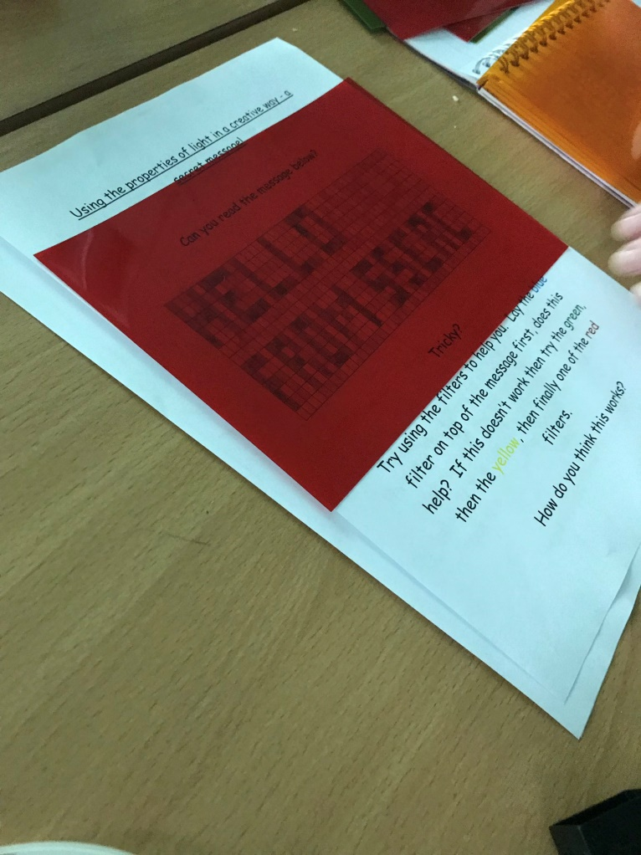
Activity 11: A Hidden Message
Curriculum Alignment
Early | First | Second
Forces, Electricity and Waves
By exploring reflections, the formation of shadows and the mixing of coloured lights, I can use my knowledge of the properties of light to show how it can be used in a creative way.
SCN 2-11b

This activity is taken from SSERC’s Light and Shadow’s workshop aimed at 2nd Level

Activity 12: Santa’s Sleigh
You will need… | Adaptations
- Plain paper (or activity planning sheet – 12. Santas Sleigh PLANNING SHEET)
- Pencils (writing and colouring)
- Materials to build a prototype e.g. recyclable material, construction toys…
- An imagination

Activity Instructions
Santa needs a new sleigh.
He has some requirements:
- It must be able to hold presents (Lego bricks)
- It must be able to float on water – in case of emergency landings!
- It must have a steering device
- It must have an emergency power system to help the reindeer return to the North Pole at the end of the night

- Give the children the criteria and allow them to plan out their designs, ensuring that they label their designs clearly and have all the features Santa requires.
- Once they’ve completed their plans, they can then use materials to construct a prototype which must be able to hold Lego bricks and float!

Curriculum Alignment
Early | First | Second
Art and Design  Working on my own and with others, I use my curiosity and imagination to solve design problems.  EXA 0-06a | Craft, Design, Engineering and Graphics  I can design and construct models and explain my solutions.  TCH 1-09a  Art and Design  I can use exploration and imagination to solve design problems related to real-life situations.  EXA 1-06a | Craft, Design, Engineering and Graphics  I can use a range of graphic techniques, manually and digitally, to communicate ideas, concepts or products, experimenting with the use of shape, colour and texture to enhance my work.  TCH 2-11a  Art and Design  I can develop and communicate my ideas, demonstrating imagination and presenting at least one possible solution to a design problem.  EXA 2-06a

