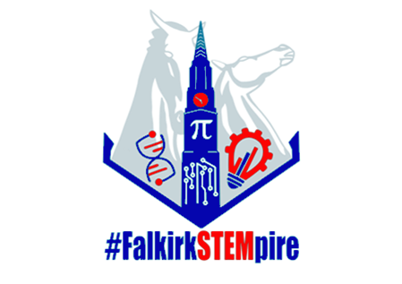

Sunday | Monday | Tuesday | Wednesday | Thursday | Friday | Saturday
1 | 2  Subsea  Invitations sent via email | 3  STEM Sharing Session  Falkirk CPD Manager  STEM Grants  Education Scotland | 4 | 5  Wonderful Woodwork  Falkirk CPD Manager  Introduction to Scratch  Barefoot Computing | 6 | 7
8 | 9  STEM Grants  Education Scotland  Introduction to Scratch  Barefoot Computing | 10  Young STEM Leaders Information Session  Falkirk CPD Manager | 11  STEM Outdoor Learning  Falkirk CPD Manager | 12  Maths in Action  Falkirk CPD Manager  Computational Thinking  Barefoot Computing | 13 | 14
5 | 16  Lego Spike  Falkirk CPD Manager  Teaching Money  Education Scotland | 17 | 18 | 19 | 20 | 21
22 | 23 | 24  Wonderful Woodwork  Falkirk CPD Manager  Computational Thinking  Barefoot Computing | 25  STEM Makerspaces  Falkirk CPD Manager  Introduction to Scratch  Barefoot Computing | 26  Young STEM Leaders Non-Formal Training  Falkirk CPD Manager  Bar Modelling  Falkirk CPD Manager | 27 | 28
29 | 30  Lego Spike  Falkirk CPD Manager | 31 | 1 | 2 | 3 | 4

