Task Brief

Pupils need to save the chicks from the ice.

Use a variety of liquids to investigate which works best to save the chicks.

Es & Os

Early

* SCN 0-05a

First

* SCN 1-05a

Skills

* Focusing
* Initiative
* Curiosity
* Critical Thinking

Resources

* Mini chicks frozen into ice cubes
* Bottles of different liquids – cold water, hot water, salt water, lemon juice
* Pipettes

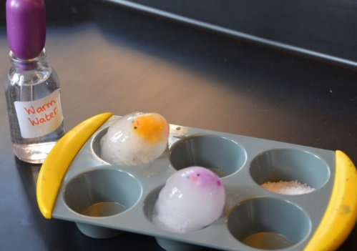

**Save the Chicks – Ice Excavation**