Task Brief

Use a variety of junk materials to create a marble run for easter eggs.

*Challenge – give pupils a start and end point. This could be the length of a table, the classroom or even the corridor.*

Es & Os

First

* TCH 1-09a
* SCN 1-07a

Second

* TCH 2-09a
* SCN 2-07a

Skills

* Focusing
* Adapting
* Initiative
* Communicating
* Collaborating
* Curiosity
* Creativity
* Critical Thinking

Resources

* Junk Materials e.g. carboard tubes, guttering, cardboard boxes etc.
* Tape
* Easter Eggs

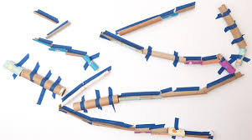

**Easter Egg Marble Run**