BRAES HIGH
SCHOOL

BHS LEARNING OPPORTUNITIES

EXCURSIONS
2019 – 2020
(Revised September 2018)

EXCURSIONS 2019—2020

Braes High School is committed to providing as full an education as possible. In the past years we have offered a variety of educational excursions to our young people from New York, Washington, Disneyland Paris, London to Barcelona, canoeing in the Ardeche to working alongside pupils in Gambia, Tanzania and China.

We understand that these types of experiences can be costly and require planning in advance.

We have asked our staff to do this planning in order that we can notify you of all excursions which will be on offer. This should allow you to discuss with your son/daughter which, if any, suits them best. Where possible, excursions have been planned to coincide with our activities day in school, i.e. the last week of the summer term.

Please note pupils must be members of the school at the time of departure.

Please find information about the trips planned for 2019-2020 below.

PARENT/CARER INFORMATION FOR RESIDENTIAL TRIPS

It is important that the following information is read before you make a final decision about them taking part and/or start paying for the trip.

Risk/Benefit
Residential visits, whether in the UK or abroad, provide rich learning experiences for young people and are a valuable part of the curriculum we provide. However it is important for you to be aware of, and accept, that every trip will have specific risks associated with them. Examples of this would include travel to and from the venue, the activities that the young people will be taking part in or health/security risks. However parents/carers should be reassured that every residential visit is assessed on an individual basis to ensure that the risks are minimised and acceptable.

It is the responsibility of trip leaders to give parents/carers detailed information about a trip, and highlight any particular risks that might not be obvious, so that you can make an informed decision about your child taking part. However you also have a responsibility to ask about anything you’re unsure about.

Finance
Once parents/carers have signed their child up for a trip, and paid the deposit, this commits them to paying the full cost of the trip in line with the payment plan. The following points are important to consider:

- If you or your child changes their mind about taking part you would be liable for the full costs unless their place can be filled
- Trips will only be cancelled if the Foreign and Commonwealth Office is advising against travel to that area – in which case all monies paid would be reimbursed or an alternative opportunity provided
- In some circumstances (e.g. medical reasons or a bereavement) a claim would be made through Falkirk Council’s insurance to recover monies paid
Terrorist/Health risks
Situations that we have no control over may well occur in the lead up to trip that would cause concern for you or your child. The most recent examples of this include terrorist attacks and the Ebola and Zika outbreaks.

As a local authority we keep close checks on, and follow, the advice being given by the Foreign and Commonwealth Office and travel companies. We also have access to valuable information from other schools and local authorities. The safety of our young people is our main concern and parents should be reassured that each individual trip is assessed in the initial planning stage, and regularly in the run up to the trip, to ensure that we are not putting pupils or staff at unacceptable risk.

However parents making a commitment to a residential visit may still find themselves in the situation where they no longer feel comfortable with their child taking part. As outlined above you would be liable for the full cost of the trip if you choose to withdraw your child and it is important to ensure that you are comfortable with this risk and accept that responsibility.

Please consider the above information carefully and if appropriate complete the tear-off slip at the back of the booklet, along with a £20 deposit (if this has not already been paid online) to the front office BY RETURN. You will receive in due course payment plans for the trip of your choice once you have secured a place.

Deposits and Instalments for all trips can be made online by visiting our website at www.braes.falkirk.sch.uk and choosing online payments on the left-hand side.

CANCELLATION POLICY

We understand that circumstances may arise which could result in you removing your child from the trip. However, the Council incurs costs from the time your child’s booking is confirmed with the travel company. All aspects of this trip, including the price, are based on all confirmed pupils attending; therefore we cannot reimburse you for any monies paid unless the place on our trip can be filled by another pupil. If we cannot fill the place, you will also be liable to pay the outstanding balance of the trip if the school incurs costs as a result of your child’s withdrawal.

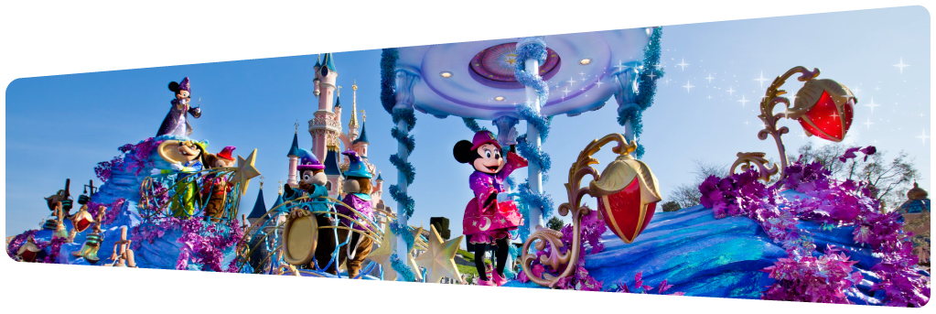
Paris/Disneyland Paris

Trip Leader: Mrs Reid
Dates: 17 – 20 November 2019
Age Group: S2
No. of Pupils: 45
Estimated Cost: £500
Details: Disneyland Paris is offering a four day study experience incorporating two seminars directly related to Design and Technology.

Included will be two interactive workshops examining rollercoaster design and graphic products to discover how Disney imaginers communicate their ideas.

Learning will then turn to fun as everything learned in the workshops will be experienced exploring the parks with the two day passes and accommodation in one of the onsite Disney hotels.

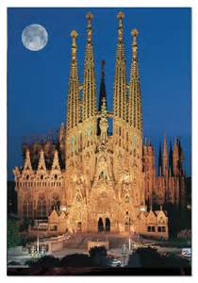
BARCELONA

Trip Leader: Mr Deane/Miss Binnie
Dates: June 2020
Age Group: S1 – S5
No. of Pupils: 90
Estimated Cost: £700
Sagrada Familialia

Details:
Itinerary - Day 1 - In the morning we will visit the “Camp Nou” the famous home of Barcelona FC for a tour of the stadium before going to the Parc de Citudella where pupils will go on the boating lake then onto the Sagrada Familia Antonio Gaudi’s most famous work. In the evening we will have diner at the Hardrock café before pupils and staff will have a fun team quiz.

Day 2 – Pupils will spend the day at Puertaventura Theme Park where the pupils will go around in friendship groups enjoying the rides. In the evening we will go to Glories shopping centre for diner and shopping.

Day 3 – Pupils will spend the day at the beach where the pupils will get the opportunity to take part in water sports. In the evening we will enjoy a Flamenco experience which is new for 2020. The pupils will then visit the world famous Gothic Quarter with a visit to Barcelona Cathedral.

Day 4 – Pupils will spend the full day at Tibadabo Theme Park before going to Barcelona Olympic Port and the Maremagnum Shopping Centre where the pupils will visit take part in a boat trip around the Port before enjoying a games night at the hotel.

Day 5 – Pupils will start their final day with a visit to Costa Caribe Waterpark before taking part in Glitz and Glam night where we will enjoy a special meal at a local Spanish restaurant before our final prize giving and awards night.

This is the fourth time Braes High has travelled to Barcelona and the pupils always have a fantastic time. Extra surprises will be added to the already packed schedule to make the trip even more exciting this time. Their will something for every taste including cultural visits, sporting activities, team building and lots of fun activities.

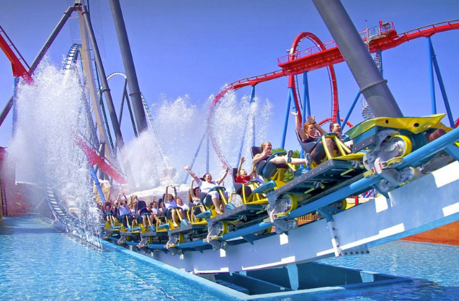
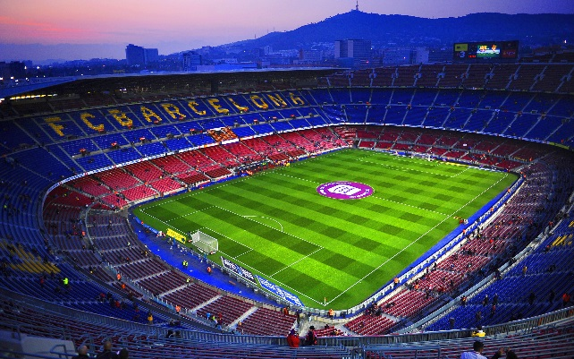
Camp Nou
Port Aventura

NICE, FRANCE
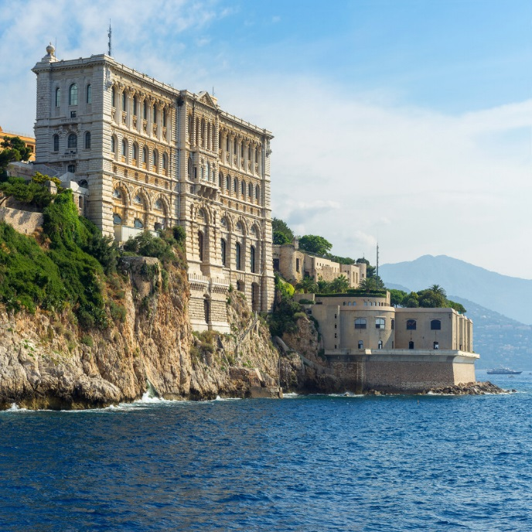
Oceanographic Museum, Monaco

Trip Leader: Miss Liesse
Dates: June 2020
Age Group: S2-S4
No. of Pupils: 30/40 max
Estimated Cost: Approx £800/850

Details:
Guided Visit to Confiserie Florian

Guided Visit to Galimard Perfumery

Visit to Chateau de Berne

Visit of Villa Kerylos

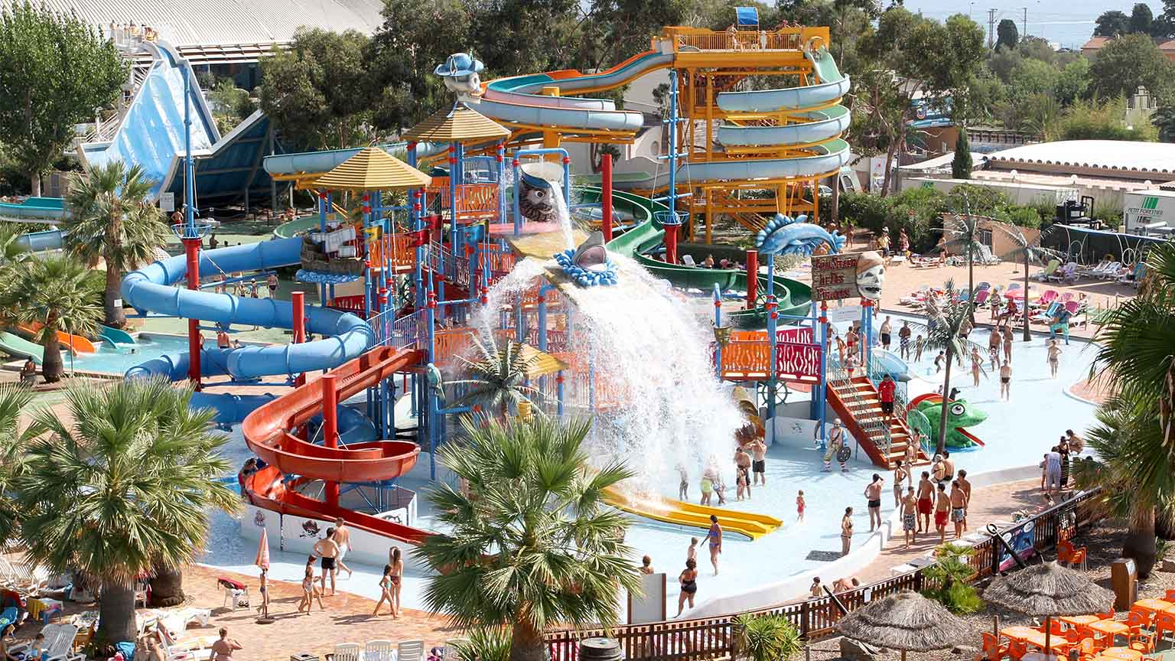
Visit to Oceanographic Museum in Monaco
Aquasplash Antibes

Entrance to Aquasplash Antibes

Visit to Cannes, Antibes and St Tropez

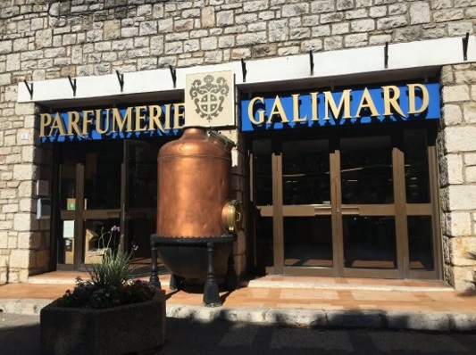
Galimard Perfumery
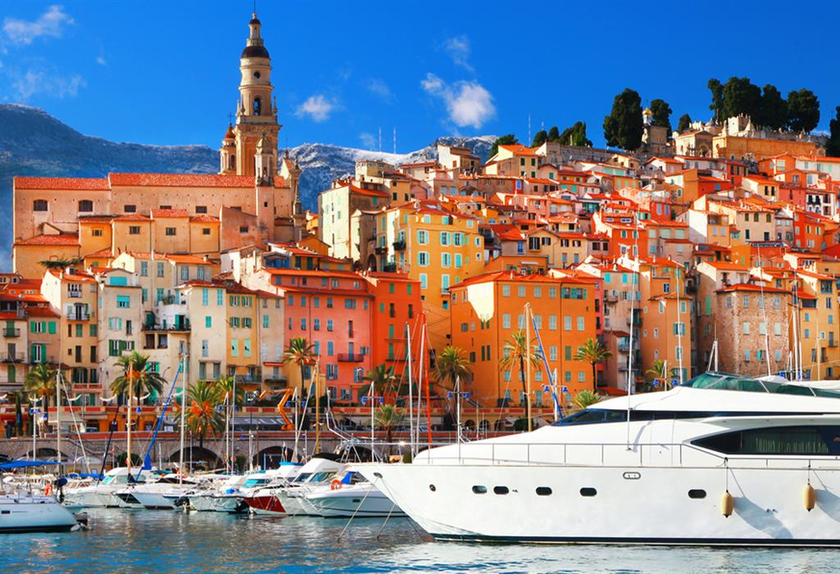
Cannes

WW1 Battlefields experience Belgium

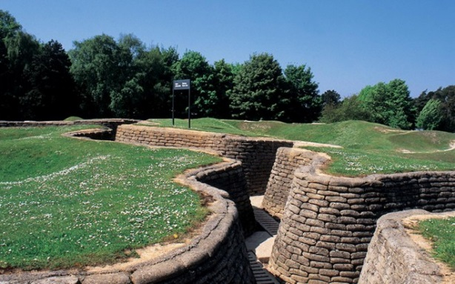

Trip Leader: Miss Newman
Dates: Oct 2019
Age Group: S2 – S6
No. of Pupils: 20
Estimated Cost: £470

Details: The 2nd Battalion Braes Pals will be heading off to the Western Front in October 2019. After a successful campaign last year (all pals made it back safely). 20 pupils are going to mark the Centenary of the start of the First World War. If any family have relatives who died in Belgium or France during WW1, then there may be an opportunity to mark our respects at their grave. Our pupils will be taking part in an educational experience guided by an expert historian round the battlefields and monuments of Belgium and Northern France, including an evening visit to witness the ceremony at the Menin Gate. There will also be time in Burges and Ypres for shopping and sightseeing.

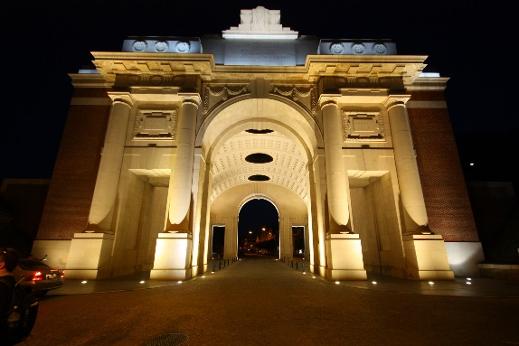
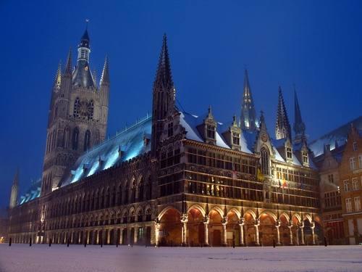
Menin Gate at Night
Ypres - Belgium

LONDON
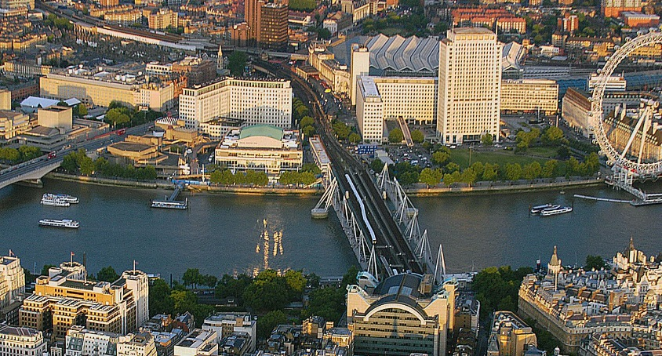

Trip Leader: Mr Morris
Dates: June 2019
Age Group: All Years
No. of Pupils: 40
Estimated Cost: £410

Details: Itinerary
London South Bank

Creative Arts Trip

A fabulous opportunity to experience the cultural life of London from many angles, our trip leaves early on Monday morning and returns late on Wednesday night. All travel is done by coach, which will be with us for the duration of the trip, and a huge amount is included for a bargain price (if you know the prices in London!)

Day 1 - Travel to London by coach, to arrive early afternoon. Check into our hotel, likely the excellent Ramada Hotel (North London). Evening Meal at the Hard Rock Café (included), with a visit to the shop
Catch a theatre show (included) (last time we saw Wicked). Return to the hotel (coach) for a well- deserved sleep!

Day 2 - Breakfast at the hotel (included). Travel to the South Bank (coach). A flight on the London Eye (included). A slap up meal at McDonalds (NOT included). A walk along the South Bank to visit a gallery, probably the excellent Tate Modern. Travel to Planet Hollywood (coach) for evening meal (included)
Catch a second theatre show (included) (last time we saw School of Rock). Return to the hotel (coach) tired, but excited!

Day 3 - Breakfast at the hotel (included). Later checkout to allow some extra sleep. Travel to the Warner Bros. Studios for the Harry Potter Experience Tour (included). Visit the Harry Potter shop. Travel home by coach, late afternoon. Arrive home around midnight
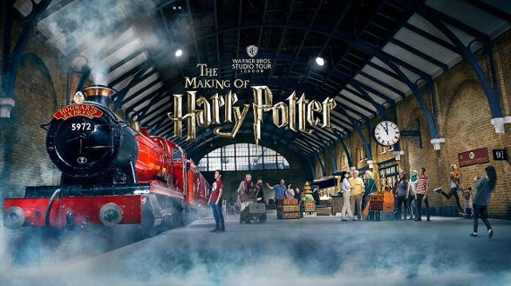
Warner Bros Studios Harry Potter Experience
CAIRNGORMS

Trip Leader: Miss Parmar
Dates: February 2020
Age Group: S2 – S6
No. of Pupils: 16
Estimated Cost: £500

Details: An opportunity to experience skiing at Cairngorms. Our trip will leave on the Friday morning and return Monday morning. All travel will be done by the schools minibus. (Cost covers all food, ski hire, travel, accommodation etc)

Day 1: Friday
Travel to Cairngorms by minibus and arrive early afternoon. Check into Youth Hostel (pupils will be in dorms). Pupils will be put into 3 teams: Cooking, Table Setting, Dish washing (these will alternate each day). Have packed lunch brought from home. Hiking options: Around the Loch/ or alternative trail Go to Aviemore ski school to pick up gear and go back to hostel. Cook dinner and Free time.

Day 2:
Breakfast at the hostel (made/prepared by the teams). Drive up the mountain to meet our instructors. Ski all day. Packed lunch will be taken up the mountain with us. Return to the hostel (minibus). Cook dinner and Free time

Day 3:
Breakfast at the hostel (made/prepared by the teams). Drive up the mountain to meet our instructors. Ski all day. Packed lunch will be taken up the mountain with us. Return to the hostel (minibus). Return all gear to the Ski School. Cook dinner and Free time

Day 4:
Pack and head home

MADRID
For information only FULLY SUBSCRIBED in previous years booklet

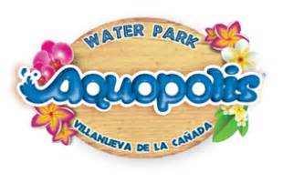
Trip Leader: Mr Deane
Dates: June 2019
Age Group: S1 – S5
No. of Pupils: 80
Estimated Cost: £725
Details: The pupils will enjoy 5 nights in Madrid where they will take in all of the famous sites including a visit to the Santiago Bernabeu Stadium, the home of Real Madrid, a tour of the Royal Palace, the Plaza Mayor and the world famous Prado museum. The pupils will also spend a day at the Warner Brothers Theme Park and another day at the Aquopolis Villanueva de la Canada Water Park. Pupils will spend a morning at Madrid Zoo before shopping at Zanadu Shopping Centre. In the evenings pupils will visit the Hard Rock café, attend a bowling evening and staff will provide quizzes and games throughout the week. On our final day we will visit the Parque de Atracciones with its legendary Abyss rollercoaster.

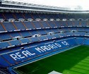
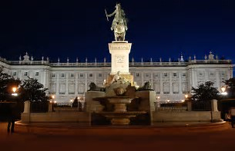

Royal Palace Madrid
Santiago Bernadeu Stadium

Paris/Disneyland Paris

For information only FULLY SUBSCRIBED in previous years booklet

Trip Leader: Mr Fergus
Dates: June 2019
Age Group: S1 – S5
No. of Pupils: 35+
Estimated Cost: £690
Details: We will be staying at the Thomas Cook Explorer’s Hotel situated outside the Disneyland Paris resort. This excursion includes sightseeing and shopping in Paris, one day in Parc Asterix and a two day Hopper Pass to Disneyland Paris/Disney Studios.
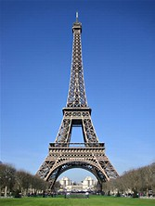
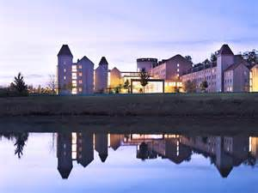
Eiffel Tower
Val d'Europe Shopping Centre

“Early Notification”

PARIS 2024 – Olympic Games Excursion

“Watch This Space”

Please hand the slip below into the school office
BY RETURN

Name: Form Class:

I would like to register my initial interest interest in the following trip and *enclose deposit of £20/have paid £20 deposit online (* delete as applicable). (On-line payment ref. no. )

Madrid ☐
Barcelona ☐
Paris ☐
San Francisco ☐
Battlefields ☐

NOTE: Pay for all activities quickly and easily on-line by visiting our website (www.braes.falkirk.sch.uk) and follow the instrucitons under “Online Payments”. Choose Braes High School then Events.

- Cash Payments can only be made at reception on a Wednesday, Thursday, Friday during interval and lunchtime. Please enure pupil’s name and form class is noted on envelope.

- Places are allocated on a first come first served basis. However, Senior Management reserve the right to refuse pupils if required.

- Should your child be unsuccessful in securing a place, a letter will be issued with a cheque for the returned deposit. However, those pupils will be put on a reserved list.

Parent/Guardian Signature: Date:

By siging this form you are agreeing to the terms and conditions in the Excursion Policy.
Booklet is available in colour on website

