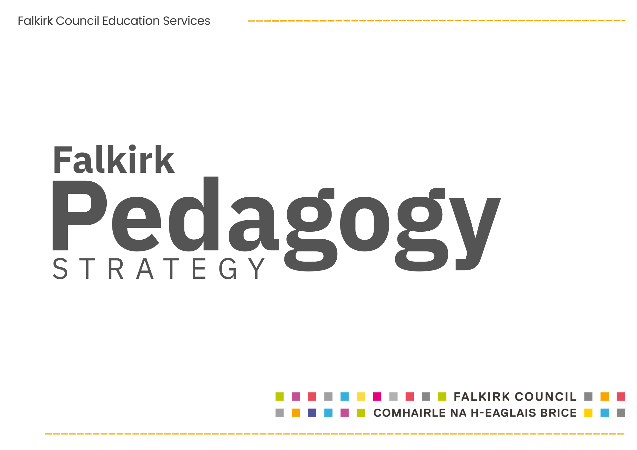
Director’s Foreword

At the heart of everything we do in Falkirk are our children and young people. Learning to Achieve remains our core policy, setting out the entitlements we expect every learner to experience and provides the scaffolding for high-quality education across our establishments.
This pedagogy strategy builds on that foundation. It is about how we bring Learning to Achieve to life, every day, in every classroom.
Our practitioners are, and will always be, our most important resource. The quality of what happens in our learning environments is the single most important factor in improving outcomes for children and young people. That is why our focus on pedagogy, on how we design learning, how learners engage with it, and how we continuously improve our practice is so important.
When we get this right, we see the impact immediately. Learners are engaged, challenged and supported. Curiosity is sparked, confidence grows and children begin to see themselves as capable and successful. Over time, this translates into stronger outcomes, but more importantly, it shapes the life chances and trajectories of our young people.
We know that across Falkirk we already have strong practice. Our ambition now is to move further, to take what is good and make it very good, and what is very good and make it excellent. This strategy sets out how we will do that together, through a shared understanding of high-quality pedagogy and a strong professional learning culture.
As Director of Education, I am clear that this matters, it is our core business, and we will continue to do everything that we can to support our practitioners to deliver the highest quality learning experiences that enable children and young people to thrive and achieve.
Jon Reid Director of Education









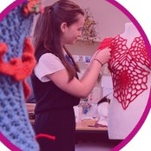

In Falkirk, I matter.

Purpose and Entitlements

Learning to Achieve defines the core entitlements for all learners in Falkirk; what every child and young person should consistently experience. These entitlements represent a shared commitment to quality, equity and purpose in learning.
Our success will be measured by the lived experience of learners when they can confidently say:
“I was seen. I was challenged. And I achieved.”

This Pedagogy Strategy builds on and supersedes the previous 2.3 Learning and Teaching Strategy. It sets out how we will deliver these entitlements through a shared, evidence-informed pedagogical approach across all establishments.
It provides clarity and consistency so that practitioners are supported to deliver high-quality learning experiences for every learner, every day.
Learner Entitlements:

How the Strategy Should Be Used
This strategy supports continuous improvement at all levels, providing a shared framework for planning, teaching, assessment and leadership.
Through a consistent approach, pedagogy becomes the driver through which learner entitlements are realised in practice.
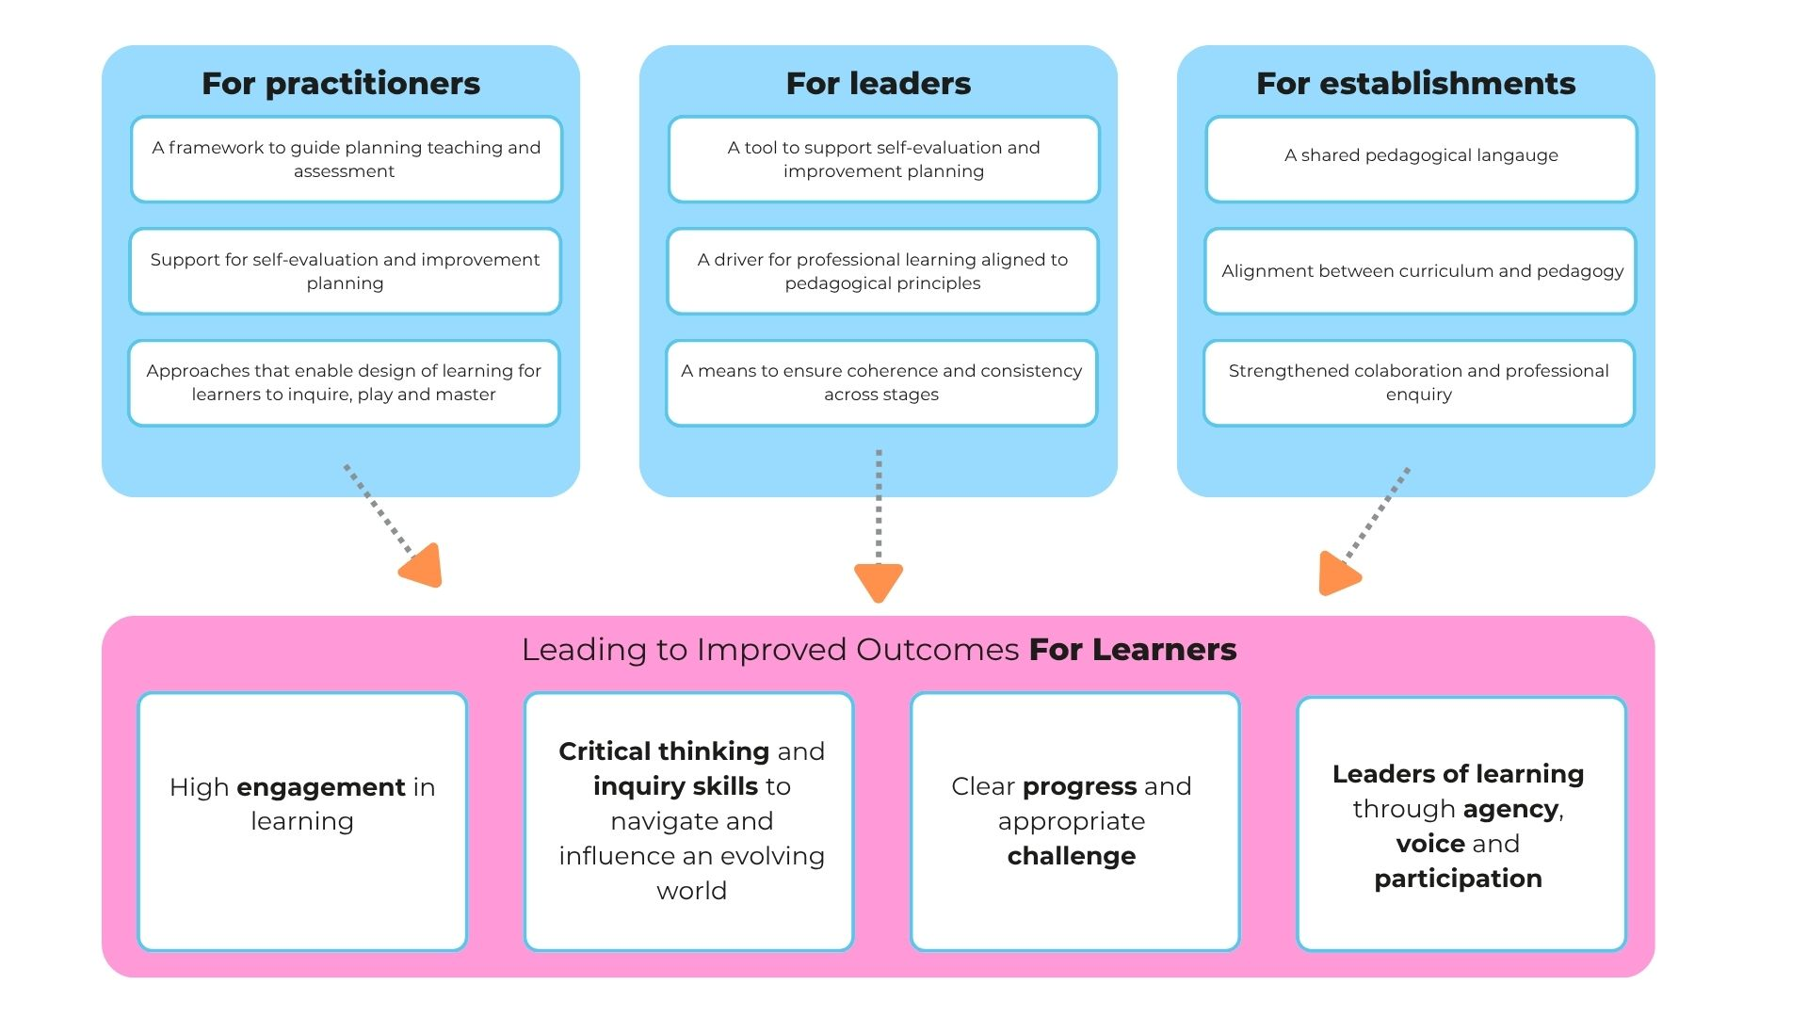

Our Pedagogical Vision
We are committed to a pedagogy that ensures all learners:
Inquire • Play • Master
At all stages, children and young people will experience learning that:
- builds confidence, agency and a passion for learning
- promotes deep thinking and problem solving
- values curiosity and creativity

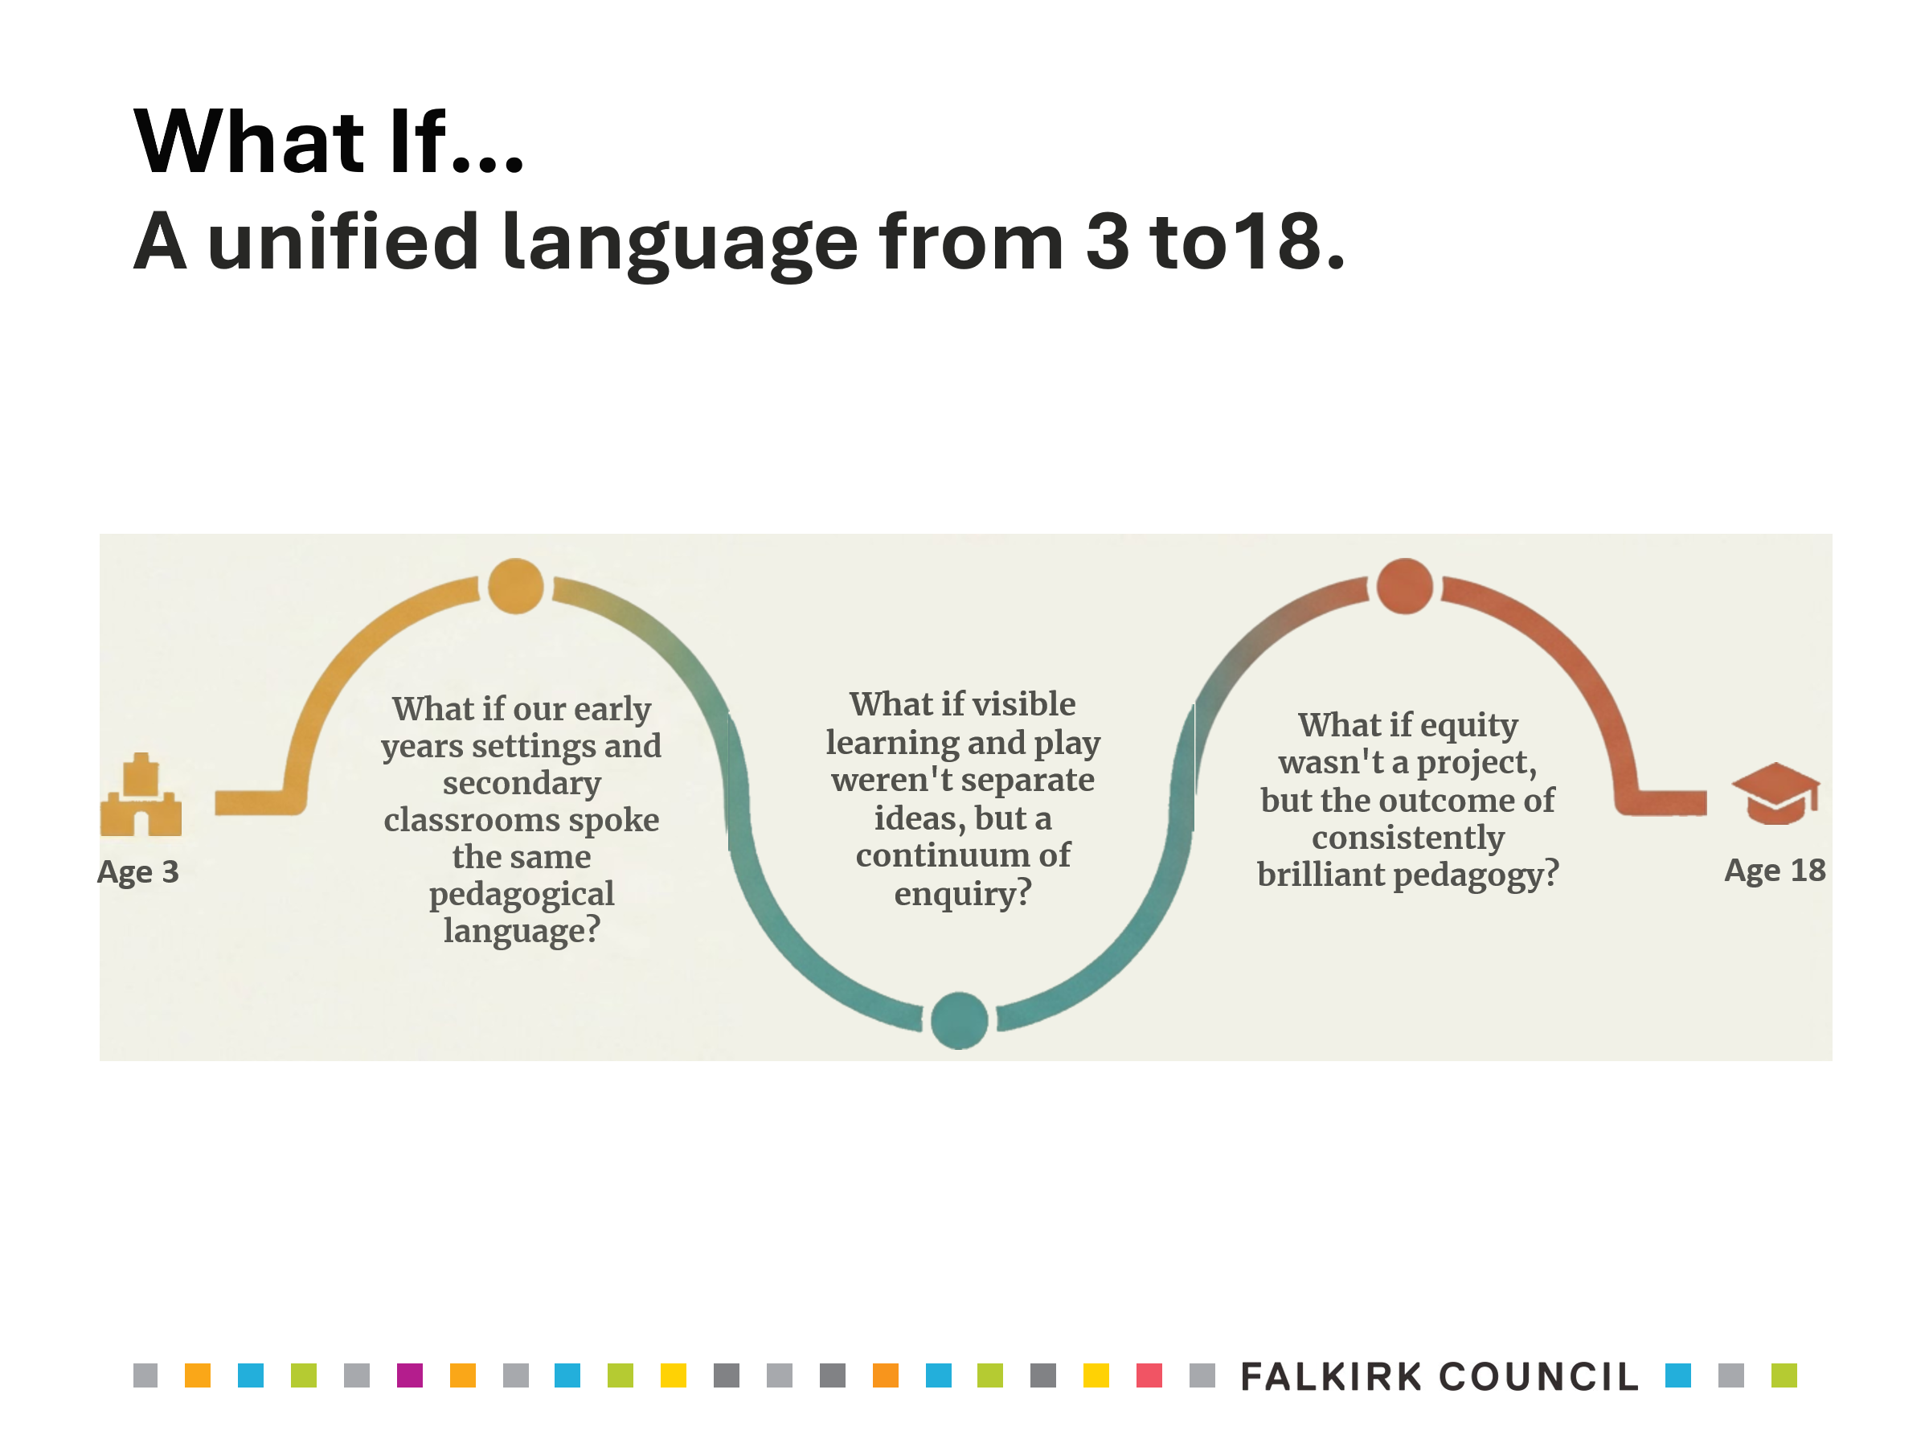

This reflects The National Definition of Pedagogy which states:
“Pedagogy is curriculum enacted and manifested in and through the interactions, experiences and spaces and times of learning, teaching and assessment.”
Education Scotland

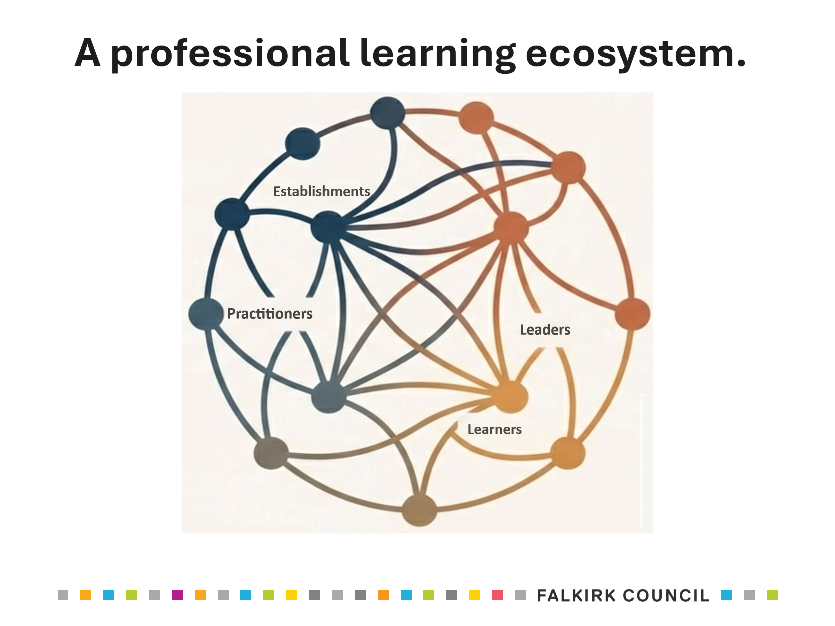
Implementation Approach

We will enact this strategy through:
- Collaborative professional learning
- Enquiry and evidence-informed practice
- Leadership at all levels
- A commitment to continuous reflection and improvement
This is not a short-term initiative, but a sustained, system-wide approach.
We will nurture a culture where we:
- learn together
- enquire together
- challenge and support one another
- grow collectively as a system

Bringing the Strategy to Life: Falkirk’s Five Key Principles of Pedagogy

At the heart of this approach is a shared understanding of what strong pedagogy looks like in practice.
Falkirk’s Five Key Principles of Pedagogy provide clarity and consistency, translating our vision and entitlements into everyday learning experiences across Falkirk.
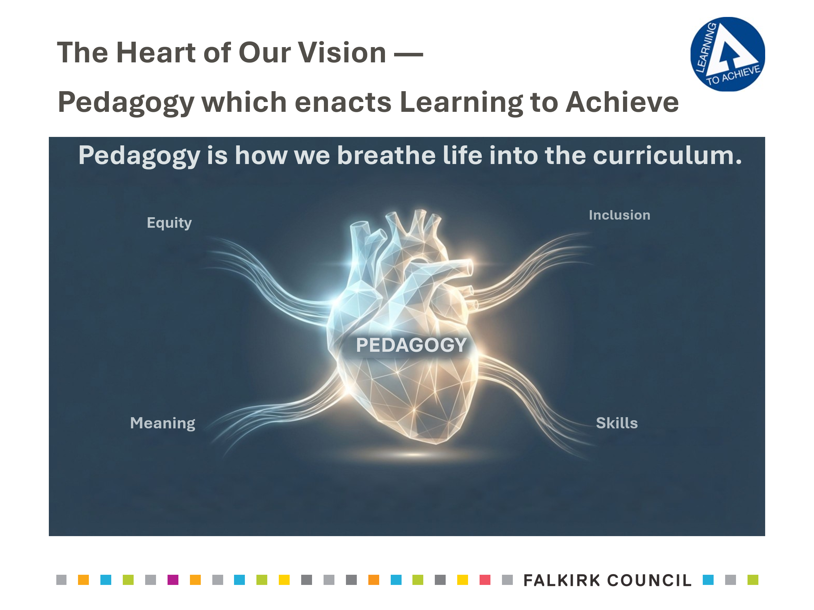

The five principles underpin all learning, teaching and assessment. They define what high-quality pedagogy looks like in action.

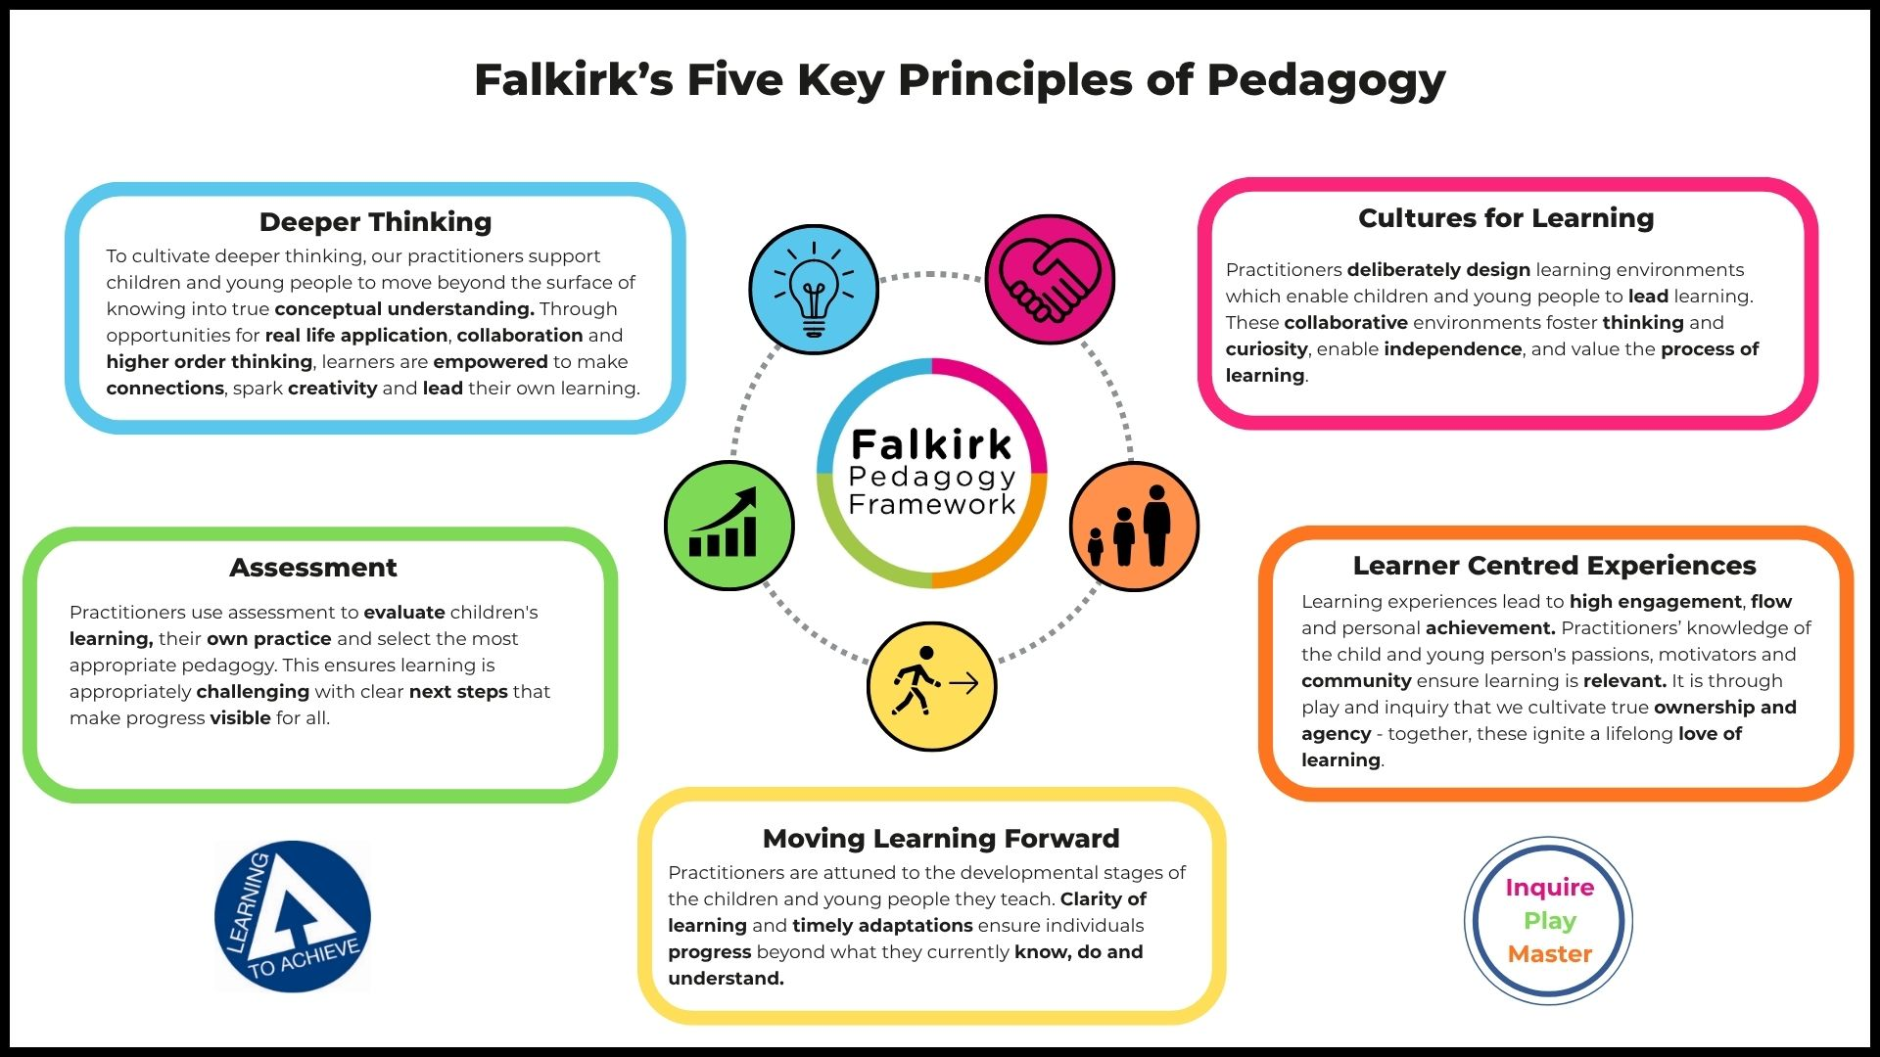
Conclusion
Ultimately, this Pedagogy Strategy is about transforming the lived experience of every learner in Falkirk. It provides a shared language, a common direction and a clear commitment to what excellent learning looks like in practice.
Through sustained collaboration, professional enquiry and a relentless focus on equity and quality, pedagogy will not simply be something we do, but something we live every day.
In doing so, we realise our ambition of learners who confidently inquire, explore through play, and grow towards mastery, developing curiosity, creativity and deep thinking so that every child and young person in Falkirk can truly say:
“I was seen. I was challenged. And I achieved.”






Cultures for learning: Practitioners deliberately design learning environments which enable children and young people to lead learning. These collaborative environments foster thinking and curiosity, enable independence, and value the process of learning.
Learning to Achieve Entitlements: Equity and Inclusion, Agency, Voice and Participation, Development of skills, knowledge and understanding.
Learner Centred Experiences: Learner experiences lead to high engagement, flow and personal achievement. Practitioners’ knowledge of the child and young person’s passions, motivators and community ensure learning is relevant. It is through play and inquiry that we cultivate true ownership and agency – together these ignite a lifelong love of learning.
Learning to Achieve Entitlements: High quality engaging learning experiences, Agency, Voice and Participation, Learning for Life, Work and Future

Moving Learning Forward: Practitioners are attuned to the developmental stages of the children and young people they teach. Clarity of learning and timely adaptations ensure individuals progress beyond what they currently know, do and understand.
Learning to Achieve Entitlements: Progression, Challenge and Achievement, Development of Skills, Knowledge and Understanding, Agency, Voice and Participation
Assessment: Practitioners use entitlements to evaluate children’s learning, their own practice and select the most appropriate pedagogy. This ensures learning is appropriately challenging with clear next steps that make progress visible to all.
Learning to Achieve Entitlements: Progression, Challenge and Achievement; Development of Skills, Knowledge and Understanding; Equity and inclusion

Deeper Thinking: To cultivate deeper thinking, our practitioners support children and young people to move beyond the surface of knowing into true conceptual understanding. Through opportunities for real life application, collaboration and higher order thinking, learners are empowered to make connections, spark creativity and lead their own learning.
Learning to Achieve Entitlements: Development of Skills, Knowledge and Understanding, Learning for Life, Work and the Future, High quality engaging learning experiences

Appendix: Falkirk’s Five Key Principles of Pedagogy

