THIRD LEVEL  Secondary 1 and 2 |  |  | LEARNING FOR SUSTAINABILITY  BUNDLE 5 – POSITIVE ACTIVISM
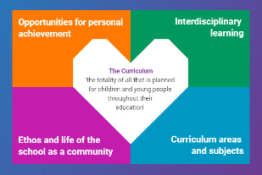  Indicates which of the contexts this plan addresses |  |  |   Depending on your focus, this plan could link to some or all of these SDGs |  |  |  |  |  |  | 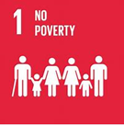 | 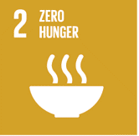
 |  |  | 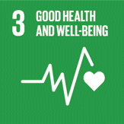 |  | 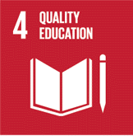 |  | 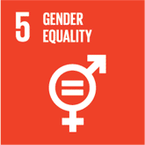 | 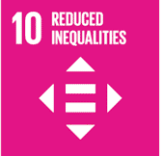 | 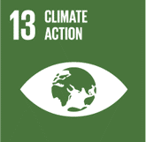 | 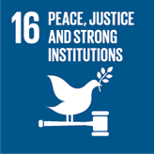 | 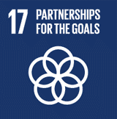
This plan is designed to develop pupil understanding of the following elements of Learning for Sustainability: developing political literacy, engaging with democracy, eradicating poverty & inequality, human rights, social justice, equality & fairness, children’s rights.
THIS PLAN BUNDLES THE FOLLOWING EXPERIENCES AND OUTCOMES, SUBJECT AREAS & ORGANISERS
Social Studies – People, society, economy & business  SOC 3-16a - I can explain why a group I have identified might experience inequality & can suggest ways in which this inequality might be addressed.  SOC 3-17a I have compared the rights & responsibilities of citizens in Scotland with a contrasting society & can describe & begin to understand reasons for differences.  SOC 3-17b I can discuss the extent to which my choices & decisions are influence by the ways in which I am informed  SOC 3-18a I understand the arrangements for political decision making at different levels & the factors which shape these arrangements. |  |  | 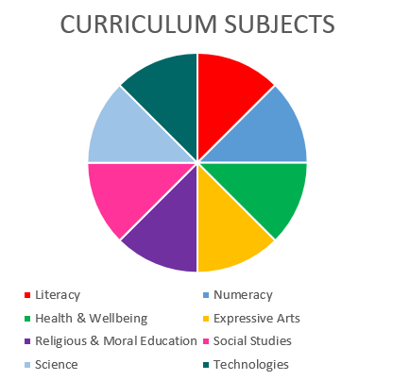  Social Studies  RMPS  Literacy |  |  |  |  |  |  | Literacy and English – Listening and Talking  Tools for listening & talking  LIT 3-02a – When I engage with others, I can make a relevant contribution, encourage others to contribute & acknowledge that they have the right to hold a different opinion.  I can respond in ways appropriate to my role & use contributions to reflect on, clarify or adapt thinking  ENG 3-03a – Having explored & analysed the features of spoken language, I can use these, adopting an appropriate register to suit my purpose & audience.  Creating Texts  LIT 3-09a – When listening & talking with others for different purposes, I can:  - Communicate information, ideas or opinions  - Explain processes, concepts or ideas  - Identify issues raised, summarise findings or draw conclusions  LIT 3-10a I am developing confidence when engaging with others within & beyond my place of learning, I can communicate in a clear, expressive way & I am learning to select & organise resources independently
Religious & Moral Education – Development of beliefs & values
RME 3-07a - I am developing respect for others & my understanding of their beliefs & values.
RME 3-09a – Through reflection & discussion, I can explain a range of beliefs which people hold & can participate in debates about “ultimate questions”.
RME 3-09b - I am developing my own understanding of values such as honesty, respect & compassion & am able to identify how these values might be applied in relation to moral issues.
RME 3-09c - I can explain how the different beliefs that people have, including beliefs which are independent of religion, relate to their moral viewpoints & how this leads them to respond to moral issues.
RME 3-09d - I am developing my understanding of the nature of belief & morality.
 | 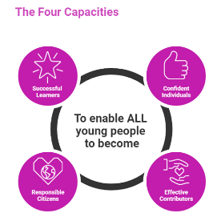 | The over-arching learning purposes of this plan are broad and you will want to focus your teaching to make it more coherent for your learners. Here are examples of possible, interdisciplinary learning intentions for this plan. You may choose alternatives which derive from your pupils’ progress, needs and interests.
We are developing our understanding of inequality.
We are learning about the impact of inequality on people in society (societies).
We are developing our ability to communicate our beliefs and values appropriately.
 |  | The key questions below are examples of how you could meet the above learning intentions and structure your teaching of the knowledge, skills and attitudes in selected E s & O s from this bundle. As above, you may choose alternatives which derive from your pupils’ progress, needs and interests. Our suite of Falkirk Council Progression Pathways will help you differentiate your teaching to ensure appropriate pace and challenge.
 | Which area of inequality have we observed & why do we think we can make a difference to this? |  |  |  |  | What can I say or do to reduce or eradicate these inequalities?
 | Can we find examples of similar inequalities elsewhere? Do these help us to understand why these inequalities occur? |  |  |  |  | How can I use my listening and talking skills to communicate my beliefs and moral position in ways which are respectful and/or improve the inequalities I have observed?
 | In what ways are our inequality focus helped or hindered by Scottish laws and/or traditions or culture? |  |  |  |  | In what ways can my choice of vocabulary, listening and talking skills support my argument when speaking to/with a particular audience?
 | How do I feel about these inequalities as an individual? |  |  |  |  | How should I prepare for occasions where my communication skills might improve the inequalities I/we have observed?
 | Where does my information about these issues come from and what do I know about these sources? |  |  |  |  | In what ways can I improve my ability to communicate facts and meaning with expression?
 | In what ways do people’s beliefs, values & attitudes affect these inequalities? |  |  |  |  | In what ways can I become more confident in my ability to communicate with others about these issues?
 | How do my own values shape my ideas about morality in this situation?
 | Focus Skills/Benchmarks Assessed through this plan of work – tick or highlight
Social Studies Benchmarks:
- Reviews basic sources of evidence such as newspapers or surveys used in arguments about current affairs to form a valid opinion.
- Presents using appropriate methods an informed view of a current affairs issue.
- Provides at least two simple explanations as to why a selected group might experience inequality, for example gender, race/ethnicity, age, disability.
- Makes two or more reasoned suggestions of ways in which this inequality might be addressed.
- Identifies their own rights and responsibilities as a Scottish citizen and makes a comparison with a contrasting society.
- Gives at least two simple explanations for the differences between their own rights and responsibilities and those in a contrasting society.
- Identifies at least three sources of information that influence the ways in which he/she is informed.
- Provides at least two valid opinions about the ways in which choices and decisions might be influenced by bias or exaggeration.
- Describes the role of elected representatives and/or groups which influence the political decision-making process at local, national or international level.
Religious & Moral Education Benchmarks:
- Analyses how values, for example, honesty, respect and compassion might be applied in relation to at least one moral issue, illustrating a possible impact on society.
- Expresses an opinion with supporting reasons on the relationship between own values and actions.
Literacy and English Benchmarks:
- Contributes regularly in group discussions or when working collaboratively, offering relevant ideas, knowledge or opinions with supporting evidence.
- Responds appropriately to the views of others developing or adapting own thinking.
- Builds on the contributions of others, for example, by asking or answering questions, clarifying or summarising points, supporting or challenging opinions or ideas.
- Applies verbal and non-verbal techniques appropriately to enhance communication, for example, eye contact, body language, emphasis, pace, tone, and/or some rhetorical devices.
- Uses appropriate register for purpose and audience, for the most part.
- Identifies features of spoken language, for example, body language, gesture, emphasis, pace, tone and/or rhetorical devices.
- Communicates in a clear expressive way in a variety of contexts.
- Presents ideas, information or points of view including appropriate detail or evidence.
- Organises thinking and structures talks to present ideas in a logical order.
- Introduces and concludes talks with some attempt to engage the audience.
- Uses signposts throughout talks to provide a basic structure or argument, for example, topic sentences and/or linking phrases.
- Uses appropriate tone and vocabulary for purpose and audience.
- Applies verbal and non-verbal techniques in an attempt to enhance communication and engagement with audience, for example, eye contact, body language, emphasis, pace, tone and/or some rhetorical devices.
- Selects and uses resources to enhance communication and engagement with audience.
 | Use the boxes below to capture Literacy, Numeracy and Health and Wellbeing E s & O s which fit well with the purpose of this plan. Consider whether this learning context offers opportunities for your pupils to develop and/or apply skills and knowledge within these E s & O s.
 | 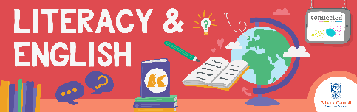
 | 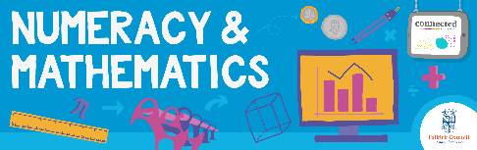
 | 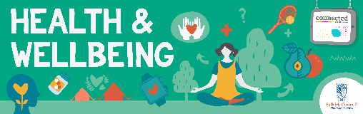
 | Other subject area?

Quality Learning Experiences | Use this space to record the learning experiences you plan with and for your pupils. These should include opportunities for pedagogy which is playful, active and inquiry-based. You may also want to create a learning plan, wall or floor book with you pupils.  These experiences should take account of whether the indoor or outdoor environment is best suited for this learning.
Assessment Approaches used  & evidence generated | This will be a blend of formative and summative, formal and more informal assessment & feedback. This may include checking achievement of a level through a task which results in formal evidence of application of learning within an unfamiliar context.
Evaluation | Recording your reflections on this learning will guide subsequent teaching and learning for you and the next teacher of this class/group. It may help you identify evidence for a practitioner enquiry, or small test of change to help you manage your own ongoing improvement. You may also want to capture pupil feedback on this block of learning

