SECOND LEVEL  Primaries 5, 6 & 7 | LEARNING FOR SUSTAINABILITY  BUNDLE 5 – POSITIVE ACTIVISM
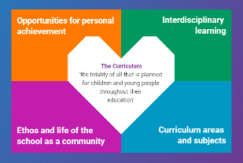  Indicates which of the contexts this plan addresses |   Depending on your focus, this plan could link to some or all of these SDGs |  |  |  |  | 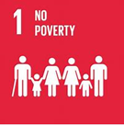 | 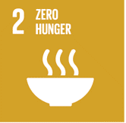
 | 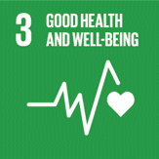 | 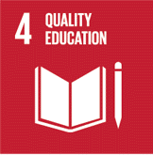 | 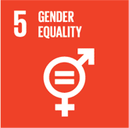 | 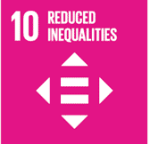 | 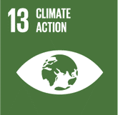 | 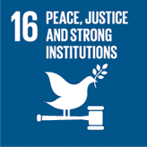 | 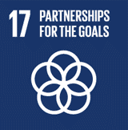
This plan is designed to develop pupil understanding of the following elements of Learning for Sustainability: developing political literacy, engaging with democracy, eradicating poverty & inequality, human rights, social justice, equality & fairness, children’s rights.
USE THE SPACES BELOW TO NOTE THE SUBJECT AREAS, ORGANISERS & EXPERIENCES & OUTCOMES WHICH ARE RELEVANT TO THIS BUNDLE PLAN IN YOUR CLASSROOM/DEPARTMENT/SCHOOL
Social Studies – People, society, economy & business  SOC 2-16a I can explain how the needs of a group in my local community are supported  SOC 2-17a I can describe the main features of a democracy and discuss the rights and responsibilities of citizens in Scotland.  SOC 2-18a I can investigate the features of an election and the work of representatives at a local, national or European level to begin to develop my understanding of how democracy works | 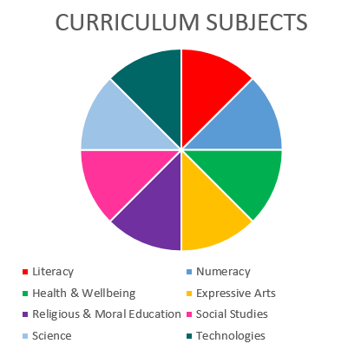  Social Studies  RMPS  Literacy |  |  |  |  | Literacy and English – Listening and Talking  Tools for listening & talking  LIT 2-02a When I engage with others I can respond in ways appropriate to my role, show that I value others’ contributions and use these to build my thinking  ENG 2-03a I can recognise how the features of spoken language can help in communication, and I can use what I learn. I can recognise different features of my own and others’ spoken language  Creating Texts  LIT 2-09a When listening and talking with others for different purposes I can: share information, experiences and opinions; explain processes and ideas; identify issues raised and summarise main points or findings; clarify points by asking questions or by asking others to say more.  LIT 2-10a I am developing confidence when engaging with others within and beyond my place of learning. I can communicate in a clear, expressive way and I am learning to select and organise resources independently
Religious & Moral Education – Development of beliefs & values
RME 2-07a - I am developing respect for others & my understanding of their beliefs & values.
RME 2-09a – I am increasing my understanding of how people come to have their beliefs, and further developing my awareness that there is a diversity of belief in Scotland
RME 2-09b - I am developing my understanding that people have beliefs and values based upon religious or other positions.

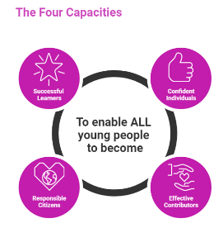 | The over-arching learning purposes of this plan are broad and you will want to focus your teaching to make it more coherent for your learners. Here are examples of possible, interdisciplinary learning intentions for this plan. You may choose alternatives which derive from your pupils’ progress, needs and interests.
We are learning what a society is.
We are developing our understanding of how societies work.
We are learning about democracy.
 | The key questions below are examples of how you could meet the above learning intentions and structure your teaching of the knowledge, skills and attitudes in selected E s & O s from this bundle. As above, you may choose alternatives which derive from your pupils’ progress, needs and interests. Our suite of Falkirk Council Progression Pathways will help you differentiate your teaching to ensure appropriate pace and challenge.
What kind of groups and organisations do we have in our community? |  | What kinds of societies can we find out about?
Who/what takes responsibility for things which happen in our community? |  | How are societies different? What is different about the rules and responsibilities they use/have?
What is a society? |  | What problems do we notice in our society? Or in other societies?
How do communities fit within a society? |  | How do we feel about these problems?
How do societies use or make rules? |  | In what ways would we like to fix or help with problems we notice in our world?
How do decisions get made by societies? |  | What communication skills can we/I use to help with these problems?
What is a democracy? |  | What does it mean to be an active (or activist) member of society?
Focus Skills/Benchmarks you want to assess through this plan of work
Social Studies Benchmarks:
- Selects appropriate evidence and uses it to research a social, political or economic issue
- Provides a basic explanation as to how the needs of a particular group within the local community can be supported, using relevant examples
- Uses evidence to form a valid opinion of the impact of discrimination or prejudice on people’s lives, for example, racism or the effect of immigration
- Discusses in any form at least three issues related to cultures, values and customs in our society, for example, the role of family, traditions and gender stereotyping.
- Describes the main features of a democracy.
- Identifies links between rights and responsibilities.
- Presents information (in any preferred form) about the features of local, national or European elections and discusses the work of the appropriate representative.
- Compares and contrasts the lifestyle and culture of the citizens of Scotland as compared to the citizens of another country.
- Describes the basic needs of human beings.
- Draws valid conclusions as to why some countries can meet these needs better than others.
- Identifies which goods and services would be essential in society.
Religious & Moral Education Benchmarks:
- Discusses ways in which own values can affect actions.
- Discusses ways in which own beliefs can affect actions.
- Discusses and expresses views about the importance of values such as honesty, respect and compassion.
Literacy and English Benchmarks:
- Contributes a number of relevant ideas, information and opinions when engaging with others.
- Shows respect for the views of others and offers own viewpoint.
- Builds on the contributions of others, for example, by asking or answering questions, clarifying points or supporting others’ opinions or ideas.
- Applies verbal and non-verbal techniques in oral presentations and interactions, for example, vocabulary, eye contact, body language, emphasis, pace and/or tone.
- Recognises some techniques used to engage or influence the listener, for example, vocabulary, emphasis, tone and/or rhetorical questions.
- Communicates clearly, audibly and with expression in different contexts.
- Plans and delivers an organised presentation/talk with relevant content and appropriate structure.
- Uses suitable vocabulary for purpose and audience.
- Selects and uses resources to support communication

Use the boxes below to capture Literacy, Numeracy and Health and Wellbeing E s & O s which fit well with the purpose of this plan. Consider whether this learning context offers opportunities for your pupils to develop and/or apply skills and knowledge within these E s & O s.
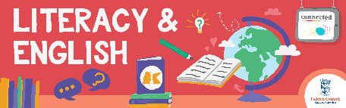

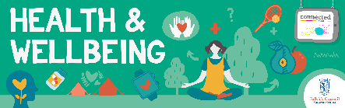
Other subject area?

Quality Learning Experiences | Use this space to record the learning experiences you plan with and for your pupils. These should include opportunities for pedagogy which is playful, active and inquiry-based. You may also want to create a learning plan, wall or floor book with you pupils.  These experiences should take account of whether the indoor or outdoor environment is best suited for this learning.
Assessment Approaches used  & evidence generated | This will be a blend of formative and summative, formal and more informal assessment & feedback. This may include checking achievement of a level through a task which results in formal evidence of application of learning within an unfamiliar context.
Evaluation | Recording your reflections on this learning will guide subsequent teaching and learning for you and the next teacher of this class/group. It may help you identify evidence for a practitioner enquiry, or small test of change to help you manage your own ongoing improvement. You may also want to capture pupil feedback on this block of learning

