FIRST LEVEL  P 2, 3 & 4 | LEARNING FOR SUSTAINABILITY  BUNDLE 5 – POSITIVE ACTIVISM
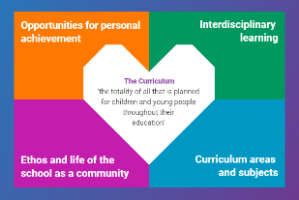  Indicates which of the contexts this plan addresses |   Depending on your focus, this plan could link to some or all of these SDGs |  |  |  |  | 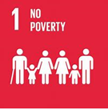 | 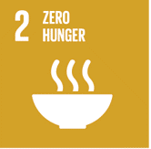
 | 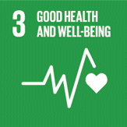 | 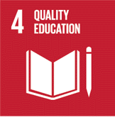 | 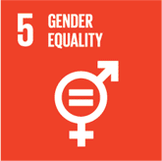 | 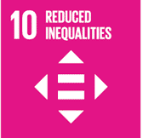 | 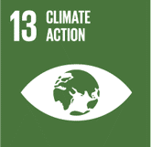 | 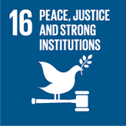 | 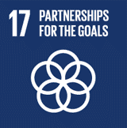
This plan is designed to develop pupil understanding of the following elements of Learning for Sustainability: developing political literacy, engaging with democracy, eradicating poverty & inequality, human rights, social justice, equality & fairness, children’s rights.
USE THE SPACES BELOW TO NOTE THE SUBJECT AREAS, ORGANISERS & EXPERIENCES & OUTCOMES WHICH ARE RELEVANT TO THIS BUNDLE PLAN IN YOUR CLASSROOM/DEPARTMENT/SCHOOL
Social Studies – People, society, economy & business  SOC 1-16a I can contribute to a discussion of the difference between my needs and wants and those of others around me  SOC 1-17a By exploring the ways we use and need rules, I can consider the meaning of rights and responsibilities and discuss those relevant to me  SOC 1-18a I have participated in decision making and have considered the different options available in order to make decisions | 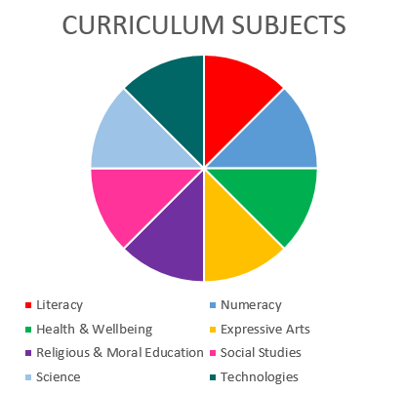  Social Studies  RMPS  Literacy |  |  |  |  | Literacy and English – Listening and Talking  Tools for listening & talking  LIT 1-02a When I engage with others, I know when to listen, when to talk, how much to say, when to ask questions and how to respond with respect  ENG 1-03a I am exploring how pace, gesture, expression, emphasis and choice of words are used to engage others, and I can use what I learn  Creating Texts  LIT 1-09a When listening and talking with others for different purposes, I can exchange information, experiences, explanations, ideas and opinions, and clarify points by asking questions or by asking others to say more  LIT 1-10a I can communicate clearly when engaging with others within and beyond my place of learning, using selected resources as required.
Religious & Moral Education – Development of beliefs & values
RME 1-07a I am developing respect for others & my understanding of their beliefs & values.
RME 1-09a I am developing an awareness that some people have beliefs and values which are independent of religion

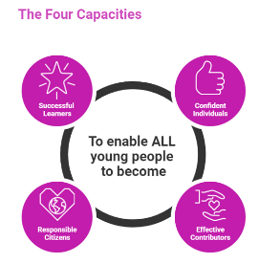 | The over-arching learning purposes of this plan are broad and you will want to focus your teaching to make it more coherent for your learners. Here are examples of possible, interdisciplinary learning intentions for this plan. You may choose alternatives which derive from your pupils’ progress, needs and interests.
We are learning about the difference between needs and wants
We are learning how to contribute to a social group
We are developing our understanding of rules, rights and responsibilities
 | The key questions below are examples of how you could meet the above learning intentions and structure your teaching of the knowledge, skills and attitudes in selected E s & O s from this bundle. As above, you may choose alternatives which derive from your pupils’ progress, needs and interests. Our suite of Falkirk Council Progression Pathways will help you differentiate your teaching to ensure appropriate pace and challenge.
What do we/people need to stay alive/healthy/happy? |  | What kind of rules do we follow when we speak, play and work with others?
What kinds of things do we/people want in their lives? |  | How do those rules make working with others easier/better?
What are the differences between the things we need and the things we want? |  | What other rules have we come across in our daily lives? What do we think of these rules?
Are people’s needs and wants the same all over the world? |  | Are all rules good/valuable/important?
Does everyone in our local area have everything they need and want? |  | What happens when rules are not followed?
Who helps people when they don’t have everything they need? |  | What does it mean to be responsible for something?
Is there anything we could do to help others? |  | What is the same and what is different about rules, rights and responsibilities?
Focus Skills/Benchmarks you want to assess through this plan of work
Social Studies Benchmarks:
- Identifies needs and wants using examples from their own experience.
- Presents an informed opinion on rights and responsibilities using their own experience.
- Makes informed decisions on an issue having listened to others.
- Names two local organisations who provide for needs in the local community and describe what they do.
Religious & Moral Education Benchmarks:
- Describes and discusses at least one personal belief and at least one example of how own beliefs might affect actions.
Literacy and English Benchmarks:
- Takes turns and contributes at the appropriate time when engaging with others in a variety of contexts.
- Listens and responds appropriately to others in a respectful way, for example, by nodding or agreeing, asking and answering questions.
- Applies a few techniques (verbal and non-verbal) when engaging with others, for example, vocabulary, eye contact, expression and/or body language.
- Communicates clearly and audibly.
- Contributes to group/class discussions, engaging with others for a range of purposes.
- Selects and shares ideas/information using appropriate vocabulary in a logical order.
- Selects and uses, with support, appropriate resources to engage with others, for example, objects, pictures and/or photographs.

Use the boxes below to capture Literacy, Numeracy and Health and Wellbeing E s & O s which fit well with the purpose of this plan. Consider whether this learning context offers opportunities for your pupils to develop and/or apply skills and knowledge within these E s & O s.
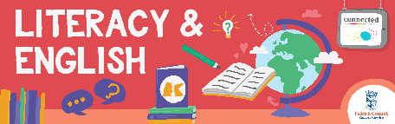
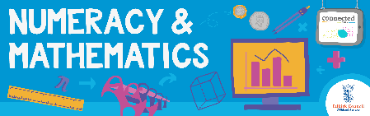
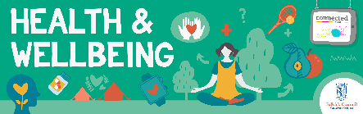
Other subject area?

Quality Learning Experiences | Use this space to record the learning experiences you plan with and for your pupils. These should include opportunities for pedagogy which is playful, active and inquiry-based. You may also want to create a learning plan, wall or floor book with you pupils.  These experiences should take account of whether the indoor or outdoor environment is best suited for this learning.
Assessment Approaches used  & evidence generated | This will be a blend of formative and summative, formal and more informal assessment & feedback. This may include checking achievement of a level through a task which results in formal evidence of application of learning within an unfamiliar context.
Evaluation | Recording your reflections on this learning will guide subsequent teaching and learning for you and the next teacher of this class/group. It may help you identify evidence for a practitioner enquiry, or small test of change to help you manage your own ongoing improvement. You may also want to capture pupil feedback on this block of learning

