EARLY LEVEL  Ante-pre, pre-school & Primary 1 | LEARNING FOR SUSTAINABILITY  BUNDLE 5 – POSITIVE ACTIVISM
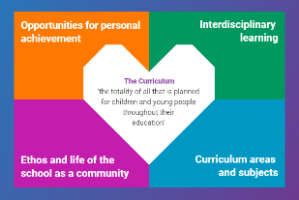  Indicates which of the contexts this plan addresses |   Depending on your focus, this plan could link to some or all of these SDGs |  |  |  |  | 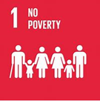 | 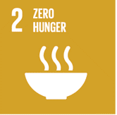
 | 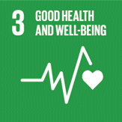 | 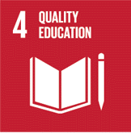 | 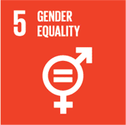 | 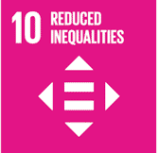 | 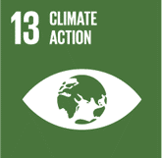 | 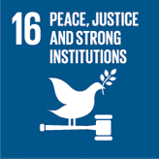 | 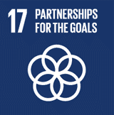
This plan is designed to develop pupil understanding of the following elements of Learning for Sustainability: developing political literacy, engaging with democracy, eradicating poverty & inequality, human rights, social justice, equality & fairness, children’s rights.
USE THE SPACES BELOW TO NOTE THE SUBJECT AREAS, ORGANISERS & EXPERIENCES & OUTCOMES WHICH ARE RELEVANT TO THIS BUNDLE PLAN IN YOUR CLASSROOM/DEPARTMENT/SCHOOL
Social Studies – People, society, economy & business  SOC 0-16a By exploring my local community, I have discovered the different roles people play and how they can help  SOC 0-17a I can make decisions and take responsibility in my everyday experiences and play, showing consideration for others  SOC 0-18a Within my everyday experiences and play, I make choices about where I work, how I work and who I work with | 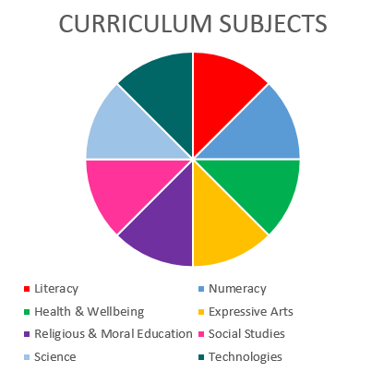  Social Studies  RMPS  Literacy |  |  |  |  | Literacy and English – Listening and Talking  Tools for listening & talking  LIT 0-02a/ENG 0-03a As I listen and talk in different situations, I am learning to take turns and am developing my awareness of when to talk and when to listen  Creating Texts  LIT 0-09a Within real and imaginary situations I share experiences and feelings, ideas and information in a way that communicates my message  LIT 0-10a As I listen and take part in conversations and discussions, I discover new words and phrases which I use to help me express my ideas, thoughts and feelings.
Religious & Moral Education – Development of beliefs & values
RME 0-07a - I am developing respect for others & my understanding of their beliefs & values.
RME 0-09a – As I play and learn, I am developing my understanding of what is fair and unfair and why caring and sharing are important

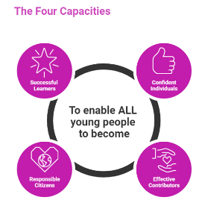 | The over-arching learning purposes of this plan are broad and you will want to focus your teaching to make it more coherent for your learners. Here are examples of possible, interdisciplinary learning intentions for this plan. You may choose alternatives which derive from your pupils’ progress, needs and interests.
We are developing our understanding of fairness.
We are developing our understanding of human rights.
We are developing our social skills.
 | The key questions below are examples of how you could meet the above learning intentions and structure your teaching of the knowledge, skills and attitudes in selected E s & O s from this bundle. As above, you may choose alternatives which derive from your pupils’ progress, needs and interests. Our suite of Falkirk Council Progression Pathways will help you differentiate your teaching to ensure appropriate pace and challenge.
What does local mean? |  | What are choices and decisions?
What is a community? |  | What kind of choices and decisions do we make when we are playing or working with other people?
Who helps make our community a good place to live? |  | What does caring look like?
How do they do help our community? |  | How do we show that we care about people/places/things?
How do we make our play and learning spaces into communities? |  | What examples of unfairness can we think of?
What does fair mean? What does unfair mean? |  | What are social skills? Why do we need them?
What kind of things do we say and do to help us get along with each other |  | How can I get better at sharing and explaining my thoughts and feelings?
Focus Skills/Benchmarks you want to assess through this plan of work
Social Studies Benchmarks:
- Identifies at least two sources of evidence which provide information about the world, for example, newspapers and television.
- Identifies at least two people who provide help in the community.
- Talks about ways that each of those people help.
- Takes on appropriate roles during imaginative play.
Religious & Moral Education Benchmarks:
- Relates information and ideas about at least two beliefs to personal experiences.
Literacy and English Benchmarks:
- Makes an attempt to take turns when listening and talking in a variety of contexts.
- Shares ideas with a wider audience, for example, group or class.
- Talks clearly to others in different contexts, sharing feelings, ideas and thoughts.
- Relates information and ideas from a text to personal experiences.

Use the boxes below to capture Literacy, Numeracy and Health and Wellbeing E s & O s which fit well with the purpose of this plan. Consider whether this learning context offers opportunities for your pupils to develop and/or apply skills and knowledge within these E s & O s.
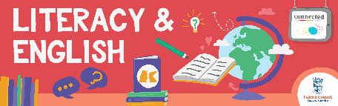
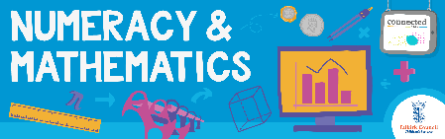
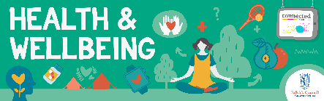
Other subject area?

Quality Learning Experiences | Use this space to record the learning experiences you plan with and for your pupils. These should include opportunities for pedagogy which is playful, active and inquiry-based. You may also want to create a learning plan, wall or floor book with you pupils.  These experiences should take account of whether the indoor or outdoor environment is best suited for this learning.
Assessment Approaches used  & evidence generated | This will be a blend of formative and summative, formal and more informal assessment & feedback. This may include checking achievement of a level through a task which results in formal evidence of application of learning within an unfamiliar context.
Evaluation | Recording your reflections on this learning will guide subsequent teaching and learning for you and the next teacher of this class/group. It may help you identify evidence for a practitioner enquiry, or small test of change to help you manage your own ongoing improvement. You may also want to capture pupil feedback on this block of learning

