SECOND LEVEL  Primary 5, 6 & 7 |  | LEARNING FOR SUSTAINABILITY  BUNDLE 4 – EXPLORING VALUES & ATTITUDES
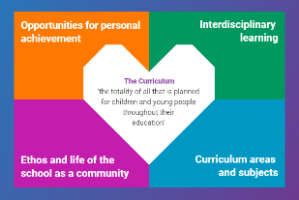  Indicates which of the contexts this plan addresses |  |   Depending on your focus, this plan could link to some or all of these SDGs |  |  |  |  |  |  | 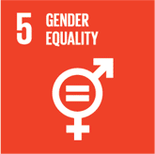 | 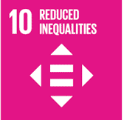
 |  |  |  |  |  |  |  |  | 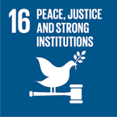
This plan is designed to develop pupil understanding of the following elements of Learning for Sustainability: discussing controversial issues, addressing discrimination and prejudice, peace and conflict
THIS PLAN BUNDLES THE FOLLOWING EXPERIENCES AND OUTCOMES, SUBJECT AREAS & ORGANISERS
Religious & Moral Education  Christianity - Beliefs  I can show understanding of Christian beliefs & explore the similarities and differences between these & my developing beliefs RME 2-01c  Christianity - Values & Issues  I can share my developing views about values such as fairness & equality & love, caring, sharing & human rights. RME 2-02b  World Religions – Beliefs  I can show understanding of the beliefs of world religions & explore the similarities & differences between these & my developing beliefs. RME 2-04c  World Religions - Values & Issues  I can share my developing views about values such as fairness & equality & love, caring, sharing & human rights RME 2-05b  World Religions - Practices & traditions  Through investigating & reflecting upon the ways in which followers of world religions mark major life events & times of year, I can explain key features of such festivals & celebrations RME 2-06b  Religious and Moral Education – Development of beliefs & values  I am developing respect for others & my understanding of their beliefs & values RME 2-07a  I am increasing my understanding of how people come to have their beliefs, & further developing my awareness that there is a diversity of belief in modern Scotland RME 2-09a |  | 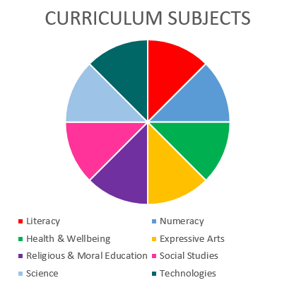  Social Studies  Literacy & English  Health & wellbeing  Religious & Moral Education  Social Studies – People in society, economy & business  I can use evidence selectively to research current social, political or economic issues SOC 2-15a |  |  |  |  |  |  | Health & wellbeing – Mental & emotional wellbeing  I know that we all experience a variety of thoughts & emotions that affect how we feel & behave & I am learning ways of managing them HWB 2-02a  I understand that my feelings & reactions can change depending on what is happening within & around me. This helps me to understand my own behaviour & the way others behave HWB 2-04a  I know that friendship, caring, sharing, fairness, equality & love are important in building positive relationships. As I develop & value relationships I care & show respect for myself & others. HWB 2-05a  I understand that people can feel alone & can be misunderstood & left out by others. I am learning how to give appropriate support. HWB 2-08a  Health & wellbeing – Social wellbeing  I recognise that each individual has a unique blend of abilities & needs. I contribute to making my school community one which values individuals equally & is a welcoming place for all HWB 2-10a
Religious & Moral Education in Roman Catholic Schools
I know that I have been called by God to grow in love, justice & peace in my relationships with others. RERC 2-20a
I can recognise how my relationship with God & others can be shaped by the values of Jesus’ Kingdom. RERC 2-21a
I recognise the contribution of other Christian Churches to Jesus’ Kingdom. I have explored ecumenical action & reflected upon its impact in the world. RERC 2-21b
I have explored the call to forgiveness & reconciliation & have reflected on how this can restore my relationship with God & others. I can put this understanding into practice in my relationship with God & others. RERC 2-22a
I know that God has given me the freedom to make choices about the way I live my life. I have reflected on how the decisions of my conscience affect my relationship with God & others RERC 2-23a
I have considered ways in which the Catholic Christian community works together to show care for the world & for the needs of all people. I have reflected on the implications of this for my life & that of others. RERC 2-24a
Literacy & English – Listening & Talking – Understanding, analysing & evaluating
To help me develop an informed view, I can distinguish fact from opinion, & I am learning to recognise when my sources try to influence me & how useful these are LIT 2-08a
Literacy and English – Reading – Understanding, analysing & evaluating
To help me develop an informed view, I can identify & explain the difference between fact & opinion, recognise when I am being influenced, & have assessed how useful & believable my sources are LIT 2-18a
Literacy and English – Writing – Organising & using information
By considering the type of text that I am creating, I can select ideas & relevant information, organise these in an appropriate way for my purpose & use suitable vocabulary for my audience LIT 2-26a
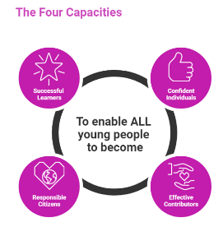 | The over-arching learning purposes of this plan are broad and you will want to focus your teaching to make it more coherent for your learners. Here are examples of possible, interdisciplinary learning intentions for this plan. You may choose alternatives which derive from your pupils’ progress, needs and interests.
We are developing our understanding of the role of values in our society
We are developing our understanding of peace and conflict in society
We are developing our ability to evaluate evidence
We are developing our ability to prepare for and present to an audience
 | The key questions below are examples of how you could meet the above learning intentions and structure your teaching of the knowledge, skills and attitudes in selected E s & O s from this bundle. As above, you may choose alternatives which derive from your pupils’ progress, needs and interests. Our suite of Falkirk Council Progression Pathways will help you differentiate your teaching to ensure appropriate pace and challenge.
What is the role of values such as caring, sharing, equality, justice in our lives? |  |  |  |  | What sources of information can we find to help us understand how beliefs and values bring peace or conflict?
In what ways do people’s values affect our community and our world? |  |  |  |  | What skills do we need to develop to help us evaluate and analyse the evidence we find in these sources?
What other values do we think are important in our society and our world? |  |  |  |  | When we listen to, read or watch for information, how can we recognise when we are being influenced or persuaded?
In what ways do religious and other beliefs inform the values and behaviour of people? |  |  |  |  | How can we use these skills to become informed about a controversial issue which we are interested in?
How do our beliefs and values develop – where do they come from? |  |  |  |  | Which current social, political or economic issues do we want to become informed about?
What can we discover about the ways in which beliefs and values have affected our world? |  |  |  |  | What kind of writing, presentation or event would we like to organise to share our findings about our chosen issue?
How have beliefs and values caused peace or conflict in our world? |  |  |  |  | In what ways will we present/share our factual information and/or our opinions?
Focus Skills/Benchmarks you want to assess through this plan of work
Religious & Moral Education
- Investigates, describes, explains and expresses an opinion on at least one belief from Christianity, at least one World Religion, and at least one belief group independent of religion.
- Discusses ways in which own beliefs can affect actions.
- Discusses and expresses views about the importance of values such as honesty, respect and compassion.
- Investigates, describes, explains and expresses an opinion with supporting reasons on the importance of at least two from a tradition, a practice, a ceremony, a custom, a way of marking a major life event in Christianity, at least one World Religion, and at least one belief group independent of religion.
Religious & Moral Education in Roman Catholic Schools
- Participates in discussion and reflection upon the gift of life.
- Demonstrates, through their words and actions, Church teaching on care for the world and others.
- Demonstrates through words and actions how Jesus influences people’s lives and values.
- Acts in a loving, just and peaceful way, using their gifts and talents for the good of all; and has identified ways to develop these.
- Reflects and acts upon how good choices, forgiveness and reconciliation are important in their relationship with God and others.
Health & wellbeing – Mental & emotional wellbeing – there are no benchmarks for the experiences and outcomes in this plan
Social Studies – People in society, economy & business
- Selects appropriate evidence and uses it to research a social, political or economic issue.
- Uses evidence to form a valid opinion of the impact of discrimination or prejudice on people’s lives, for example, racism or the effect of immigration.
Literacy & English
- Asks and responds to a range of questions, including literal, inferential and evaluative questions, to demonstrate understanding of spoken texts.
- Identifies the difference between fact and opinion with suitable explanation.
- Distinguishes between fact and opinion with appropriate explanation.
- Recognises techniques used to influence the reader, for example, word choice, emotive language, rhetorical questions and/or repetition.
- Identifies which sources are most useful/reliable.
- Organises information in a logical way.
- Selects relevant ideas and information.
- Uses appropriate vocabulary, including subject-specific vocabulary, to suit purpose and audience.
Use the boxes below to capture Literacy, Numeracy and Health and Wellbeing E s & O s which fit well with the purpose of this plan. Consider whether this learning context offers opportunities for your pupils to develop and/or apply skills and knowledge within these E s & O s.
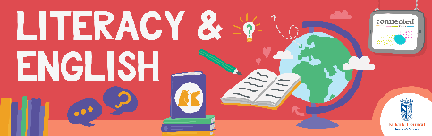
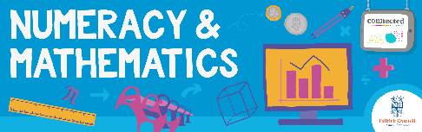
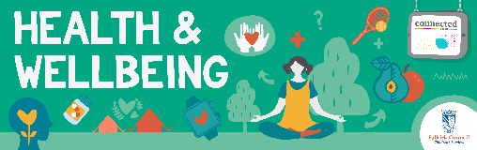
Other subject area?

Quality Learning Experiences | Use this space to record the learning experiences you plan with and for your pupils. These should include opportunities for pedagogy which is playful, active and inquiry-based. You may also want to create a learning plan, wall or floor book with you pupils.  These experiences should take account of whether the indoor or outdoor environment is best suited for this learning.
Assessment Approaches used  & evidence generated | This will be a blend of formative and summative, formal & informal assessment & feedback. This may include checking achievement of a level through a task which results in formal evidence of application of learning within an unfamiliar context.
Evaluation | Recording your reflections on this learning will guide subsequent teaching and learning for you and the next teacher of this class/group. It may help you identify evidence for a practitioner enquiry, or small test of change to help you manage your own ongoing improvement. You may also want to capture pupil feedback on this block of learning

