FOURTH LEVEL  Secondary 2 & 3 | LEARNING FOR SUSTAINABILITY  BUNDLE 4 – EXPLORING VALUES & ATTITUDES
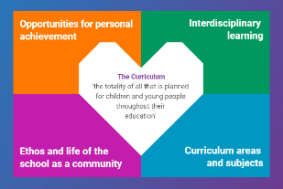  Indicates which of the contexts this plan addresses |   Depending on your focus, this plan could link to some or all of these SDGs |  |  |  |  | 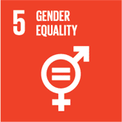 | 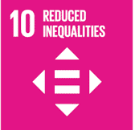
 |  |  |  |  |  | 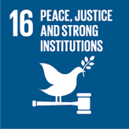
This plan is designed to develop pupil understanding of the following elements of Learning for Sustainability: discussing controversial issues, addressing discrimination and prejudice, peace and conflict
THIS PLAN BUNDLES THE FOLLOWING EXPERIENCES AND OUTCOMES, SUBJECT AREAS & ORGANISERS
Religious & Moral Education  Christianity - Beliefs  Having considered key Christian beliefs, I can express reasoned views on these and discuss how putting them into practice might affect individuals and society. I can confidently support my own responses to these issues of belief. RME 4-01a  Christianity - Values & Issues  I can apply my developing understanding of morality to consider a range of moral dilemmas in order to find ways which could promote a more just and compassionate society. RME 4-02b  World Religions – Beliefs  Having considered the key beliefs of world religions, I can express reasoned views on these and discuss how putting them into practice might affect individuals and society. I can confidently support my own responses to these issues of belief. RME 4-04a  World Religions - Values & Issues  I can apply my developing understanding of morality to consider a range of moral dilemmas in order to find ways which could promote a more just and compassionate society. RME 4-05b  World Religions - Practices & traditions  I am able to reflect upon my own responses to the challenges and opportunities presented by Scotland’s religious and cultural diversity and extend this reflection to the global context. RME 4-06b  Religious and Moral Education – Development of beliefs & values  I am developing respect for others & my understanding of their beliefs & values RME 4-07a  I am able to apply my understanding of a range of moral viewpoints, including those which are independent of religions, to specific moral issues and am aware of the diversity of moral viewpoints held in modern Scotland and the wider world. RME 4-09b | 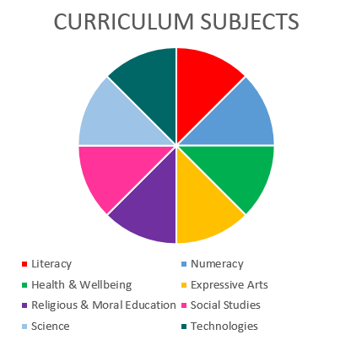  Social Studies  Literacy & English  Health & wellbeing  Religious & Moral Education  Social Studies – People in society, economy & business  I can evaluate conflicting sources of evidence to sustain a line of argument. SOC 4-15a |  |  |  |  | Health & wellbeing – Mental & emotional wellbeing  I know that we all experience a variety of thoughts & emotions that affect how we feel & behave & I am learning ways of managing them HWB 4-02a  I understand that my feelings & reactions can change depending on what is happening within & around me. This helps me to understand my own behaviour & the way others behave HWB 4-04a  I know that friendship, caring, sharing, fairness, equality & love are important in building positive relationships. As I develop & value relationships I care & show respect for myself & others. HWB 4-05a  I understand that people can feel alone & can be misunderstood & left out by others. I am learning how to give appropriate support. HWB 4-08a  Health & wellbeing – Social wellbeing  I recognise that each individual has a unique blend of abilities & needs. I contribute to making my school community one which values individuals equally & is a welcoming place for all HWB 4-10a
Religious & Moral Education in Roman Catholic Schools
I have reflected on the Ten Commandments and the teachings of Christ. I have acted on Christ’s personal challenge to contribute to the creation of a transformed world of Justice, Love and Peace, through the power of the Holy Spirit. RERC 4-20a
I can recognise how my relationship with God & others can be shaped by the values of Jesus’ Kingdom. RERC 4-21a
I have considered the need for reconciliation in situations in society. RERC 4-22a
I have developed awareness of the elements essential for making informed decisions and I have examined situations which pose a moral challenge in life. I can describe and explain my response and the responses of others to these situations. RERC 4-23a
I have experienced opportunities to engage with issues of social injustice. I can describe how Church teaching in this area has affected my response and the responses of others to these issues. RERC 4-24a
Literacy & English – Listening & Talking – Understanding, analysing & evaluating
To help me develop an informed view, I can identify some of the techniques used to influence or persuade and can assess the value of my sources. LIT 4-08a
Literacy and English – Reading – Understanding, analysing & evaluating
To help me develop an informed view, I can recognise persuasion and bias, identify some of the techniques used to influence my opinion, and assess the reliability of information and credibility and value of my sources. LIT 4-18a
Literacy and English – Writing – Organising & using information
By considering the type of text that I am creating, I can independently select ideas & relevant information for different purposes, and organise essential information or ideas and any supporting detail in a logical order. I can use suitable vocabulary to communicate effectively with my audience. LIT 4-26a

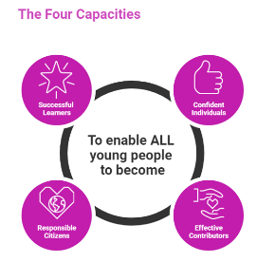 | The over-arching learning purposes of this plan are broad and you will want to focus your teaching to make it more coherent for your learners. Here are examples of possible, interdisciplinary learning intentions for this plan. You may choose alternatives which derive from your pupils’ progress, needs and interests.
We are developing and/or applying our understanding of beliefs and their impact on our society
We are developing our understanding of morality
We are developing our skills of argument and persuasion
We are developing our self-awareness and ability to build effective relationships
 | The key questions below are examples of how you could meet the above learning intentions and structure your teaching of the knowledge, skills and attitudes in selected E s & O s from this bundle. As above, you may choose alternatives which derive from your pupils’ progress, needs and interests. Our suite of Falkirk Council Progression Pathways will help you differentiate your teaching to ensure appropriate pace and challenge.
Which beliefs do we hold and how do they affect our relationships? Our community? Our society? |  | What can we learn about the morals and morality we see in the world around us?
What can we learn about beliefs from the texts we find around us? |  | What is a moral dilemma?
How do the texts around us attempt to influence our beliefs? |  | What can we learn from our responses to different moral dilemmas?
How might we argue for our own beliefs? |  | How can we explore, capture, and share our learning about moral dilemmas?
What are morals and morality? |  | What have I learned about myself and my ability to build relationships with others?
What can we learn about our own morals and morality? |  | How can I demonstrate my growing self-awareness and ability to understand and negotiate increasingly complex relationship issues?
Focus Skills/Benchmarks you want to assess through this plan of work
Religious & Moral Education
- Investigates, and evaluates at least one issue of belief drawing upon a range of sources to explain and compare responses from Christianity, at least one World Religion, and at least one belief group independent of religion.
- Evaluates the relationship between own beliefs and actions.
- Investigates, and evaluates at least one moral issue drawing upon a range of sources to explain and compare responses from Christianity, at least one World Religion, and at least one belief group independent of religion.
- Evaluates how at least one moral viewpoint might be applied in relation to at least one moral issue.
- Expresses a developed opinion with supporting reasons on the relationship between own values and actions.
- Investigates, compares and evaluates the importance of at least two from a tradition, a practice, a ceremony, a custom, a way of marking a major life event in Christianity, at least one World Religion, and at least one belief group independent of religion.
Religious & Moral Education in Roman Catholic Schools
- Develops and expresses own reasons as to why prayer is important.
- Knows traditional prayers and independently participates in different forms of prayer.
- Independently researches key beliefs and core values from one other world religion and confidently expresses own beliefs on these issues.
- Compares learning from research to other world religions and discusses the impact of these for the good of society.
- Demonstrates respect and understanding for people of different religions.
- Describes the place of religious practice in Scotland and wider world.
Health & wellbeing – Mental & emotional wellbeing – there are no benchmarks for the experiences and outcomes in this plan
Social Studies – People in society, economy & business
- Suggests the impact of a social issue, for example, poverty and demonstrates the attitudes of those affected.
- Compares and contrasts two world ideologies and how it affects the lives of people.
Literacy & English
- Identifies persuasive language, for example, word choice, emotive language, repetition, rhetorical questions, use of statistics and/or hyperbole.
- Comments appropriately on the relevance, reliability and credibility of sources, justifying opinion with reference to the text.
- Identifies the use of bias and persuasion and comments appropriately on some of the techniques used, for example, word choice, emotive language, repetition, rhetorical questions, use of statistics and/or hyperbole.
- Makes evaluative comments about the relevance, reliability and credibility of sources, with appropriate justification.
- Selects relevant ideas and information including essential detail or evidence/
- Organises essential ideas and information to convey a structured line of thought.
- Uses varied and appropriate vocabulary to communicate effectively and/or to enhance writing.

Use the boxes below to capture Literacy, Numeracy and Health and Wellbeing E s & O s which fit well with the purpose of this plan. Consider whether this learning context offers opportunities for your pupils to develop and/or apply skills and knowledge within these E s & O s.
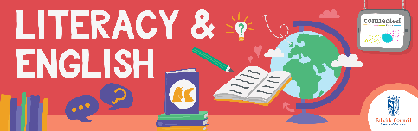
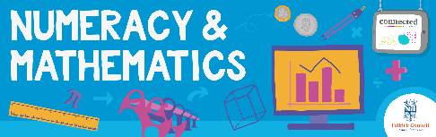
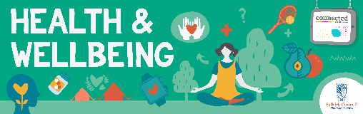
Other subject area?

Quality Learning Experiences | Use this space to record the learning experiences you plan with and for your pupils. These should include opportunities for pedagogy which is playful, active and inquiry-based. You may also want to create a learning plan, wall or floor book with you pupils.  These experiences should take account of whether the indoor or outdoor environment is best suited for this learning.
Assessment Approaches used  & evidence generated | This will be a blend of formative and summative, formal & informal assessment & feedback. This may include checking achievement of a level through a task which results in formal evidence of application of learning within an unfamiliar context.
Evaluation | Recording your reflections on this learning will guide subsequent teaching and learning for you and the next teacher of this class/group. It may help you identify evidence for a practitioner enquiry, or small test of change to help you manage your own ongoing improvement. You may also want to capture pupil feedback on this block of learning

