EARLY LEVEL  Ante-Pre-school, Pre-school & Primary 1 |  | LEARNING FOR SUSTAINABILITY  BUNDLE 4 – EXPLORING VALUES & ATTITUDES
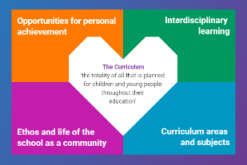  Indicates which of the contexts this plan addresses |  |   Depending on your focus, this plan could link to some or all of these SDGs |  |  |  |  |  | 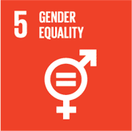 | 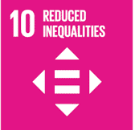
 |  |  |  |  |  |  |  | 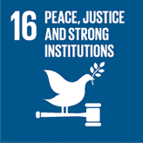
This plan is designed to develop pupil understanding of the following elements of Learning for Sustainability: discussing controversial issues, addressing discrimination and prejudice, peace and conflict
THIS PLAN BUNDLES THE FOLLOWING EXPERIENCES AND OUTCOMES, SUBJECT AREAS & ORGANISERS
Religious & Moral Education  Christianity – Beliefs  As I explore Christian stories, images, music & poems, I am becoming familiar with some beliefs Christian people have about God & Jesus RME 0-01a  Christianity - Values & Issues  As I play & learn, I am developing my understanding of what is fair & unfair & the importance of caring for, sharing & cooperating with others. RME 0-02a  World Religions – Beliefs  As I explore stories, images, music & poems, I am becoming familiar with the beliefs of the world religions I am learning about. RME 0-04a  World Religions - Values & Issues  As I play & learn, I am developing my understanding of what is fair & unfair & the importance of caring for, sharing & cooperating with others RME 0-05a  World Religions - Practices & traditions  I am becoming aware of the importance of celebrations, festivals & customs in religious people’s lives. RME 0-06a  Religious & Moral Education – Development of beliefs & values  I am developing respect for others & my understanding of their beliefs & values RME 0-07a  As I play & learn, I am developing my understanding of what is fair & unfair & why caring & sharing are important RME 0-09a |  | 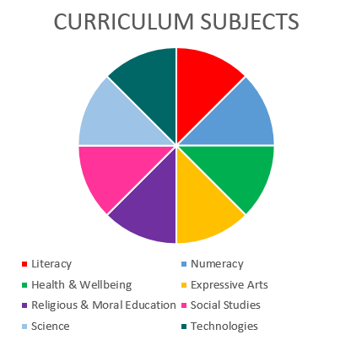  Social Studies  Religious & Moral Education  Health & wellbeing  Literacy & English  Religious and Moral Education in Roman Catholic Schools - Reign of God  I know that God invites us to show love to others RERC 0-20a  I can respond to stories that reflect Christian values. RERC 0-21a  Social Studies – People in society, economy & business  I am aware that different types of evidence can help me to find out about the world around me SOC 0-15a |  |  |  |  |  | Health & wellbeing – Mental & emotional wellbeing  I know that we all experience a variety of thoughts & emotions that affect how we feel & behave & I am learning ways of managing them HWB 0-02a  I understand that my feelings & reactions can change depending on what is happening within & around me. This helps me to understand my own behaviour & the way others behave HWB 0-04a  I know that friendship, caring, sharing, fairness, equality & love are important in building positive relationships. As I develop & value relationships I care & show respect for myself & others. HWB 0-05a  I understand that people can feel alone & can be misunderstood & left out by others. I am learning how to give appropriate support. HWB 0-08a  Health & wellbeing – Social wellbeing  I recognise that each individual has a unique blend of abilities & needs. I contribute to making my school community one which values individuals equally & is a welcoming place for all HWB 0-10a
Literacy & English – Listening & Talking – Understanding, analysing & evaluating
To help me understand stories, & other texts, I ask questions & link what I am learning with what I already know. LIT 0-07a/LIT 0-16a & ENG 0-17a
Literacy & English – Reading – Understanding, analysing & evaluating (will link at first level to LIT 1-18a)
Literacy & English – Writing – Organising & using information
Within real & imaginary situations I share experiences & feelings, ideas & information in a way that communicates my message LIT 0-26a
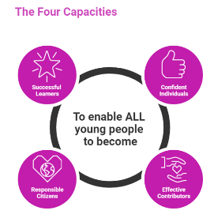 | The over-arching learning purposes of this plan are broad and you will want to focus your teaching to make it more coherent for your learners. Here are examples of possible, interdisciplinary learning intentions for this plan. You may choose alternatives which derive from your pupils’ progress, needs and interests.
We are developing our understanding of beliefs
We are developing our understanding of values
We are developing our understanding of the role of relationships in society
 | The key questions below are examples of how you could meet the above learning intentions and structure your teaching of the knowledge, skills and attitudes in selected E s & O s from this bundle. As above, you may choose alternatives which derive from your pupils’ progress, needs and interests. Our suite of Falkirk Council Progression Pathways will help you differentiate your teaching to ensure appropriate pace and challenge.
What sorts of things do people believe in? |  |  |  | What can we do to help us understand what fair and unfair means in our lives and our world?
What kinds of festivals, celebrations and ceremonies do people hold because of their beliefs? |  |  |  | What examples of fair and unfair behaviour can we find in stories or real-life events?
What do we know about religion? |  |  |  | What does it mean to be respectful?
What kinds of religious beliefs do we know about? |  |  |  | What does respectful behaviour look, sound and feel like? Can we find examples of this in stories and the world around us?
What messages do the stories from different religious beliefs give us? |  |  |  | In what ways should we behave to help others stay happy and well?
How do religious and other beliefs help people? |  |  |  | What kinds of relationships are there and how many different relationships do we all have?
In what ways can people harm each other because of their religious and other beliefs? |  |  |  | How can we learn to build relationships with others around us?
Focus Skills/Benchmarks you want to assess through this plan of work
Religious & Moral Education
- Relates information and ideas about at least two beliefs to personal experiences
- Shares thoughts about what is fair, unfair, caring and sharing
Religious and Moral Education in Roman Catholic Schools
- Talks about where they can see God’s creation. Recognises and identifies signs of God’s love.
- Shows love for others.
- Shares what gifts they have and talks about how they are different from other people’s.
- Asks and answers questions about their community and gives an example of how they are part of a Catholic community.
- Talks about a story with Christian values
Health & wellbeing – Mental & emotional wellbeing – there are no benchmarks for the experiences and outcomes in this plan
Social Studies – People in society, economy & business
- Identifies at least two sources of evidence which provide information about the world, for example, newspapers and television.
Literacy & English
- Engages with texts read to them.
- Asks and answers questions about events and ideas in a text.
- Answers questions to help predict what will happen next.
- Contributes to discussions about events, characters and ideas relevant to the text
- Writes to convey ideas, messages and information in different ways in play, imaginative and real contexts.
- Writes to reflect own experiences and feelings using appropriate vocabulary to convey meaning.

Use the boxes below to capture Literacy, Numeracy and Health and Wellbeing E s & O s which fit well with the purpose of this plan. Consider whether this learning context offers opportunities for your pupils to develop and/or apply skills and knowledge within these E s & O s.
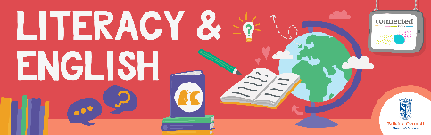
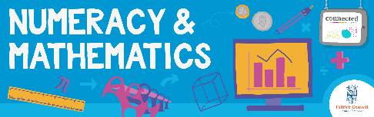
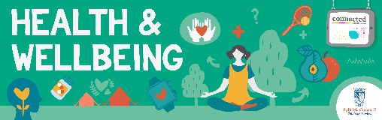
Other subject area?

Quality Learning Experiences | Use this space to record the learning experiences you plan with and for your pupils. These should include opportunities for pedagogy which is playful, active and inquiry-based. You may also want to create a learning plan, wall or floor book with you pupils.  These experiences should take account of whether the indoor or outdoor environment is best suited for this learning.
Assessment Approaches used  & evidence generated | This will be a blend of formative and summative, formal & informal assessment & feedback. This may include checking achievement of a level through a task which results in formal evidence of application of learning within an unfamiliar context.
Evaluation | Recording your reflections on this learning will guide subsequent teaching and learning for you and the next teacher of this class/group. It may help you identify evidence for a practitioner enquiry, or small test of change to help you manage your own ongoing improvement. You may also want to capture pupil feedback on this block of learning.

