FIRST LEVEL  Primary 2, Primary 3 and  Primary 4 | LEARNING FOR SUSTAINABILITY  BUNDLE 3 – CONNECT WITH CULTURE AND HERITAGE (LOCAL TO GLOBAL)
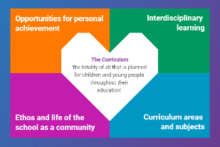  Indicates which of the contexts this plan addresses |   Depending on your focus, this plan could link to some or all of these SDGs |  |  | 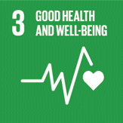 | 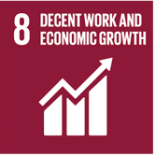
 | 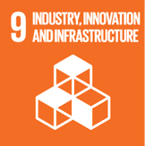 | 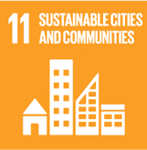 | 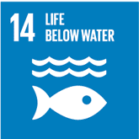 | 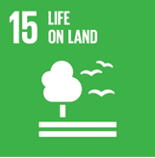 | 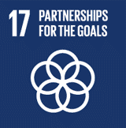
This plan is designed to develop pupil understanding of the following elements of Learning for Sustainability: social and cultural diversity, identity and heritage, links between environment and economy, community partnerships
POTENTIAL INTERDISCIPLINARY BUNDLE OF SUBJECT AREAS, ORGANISERS & EXPERIENCES & OUTCOMES FOR THIS BUNDLE
Social Studies - People, past events and society  SOC 1-02a – By exploring places, investigating artefacts and locating them in time, I have developed an awareness of the ways we remember and preserve Scotland’s history.  SOC 1-04a - I compare aspects of people’s daily lives in the past with my own by using historical evidence or the experience of recreating an historical setting.  People, place and environment  SOC 1-07a - I can describe and recreate the characteristics of my local environment by exploring the features of the landscape.  SOC 1-08a - I can ways of looking after my school or community and can encourage others to care for their environment.  People, society, economy and business  SOC 1-16a – I can contribute to a discussion of the difference between my needs and wants and those of others around me.  SOC 1-20a – I have developed an understanding of the importance of local organisations in providing for the needs of my local community. | 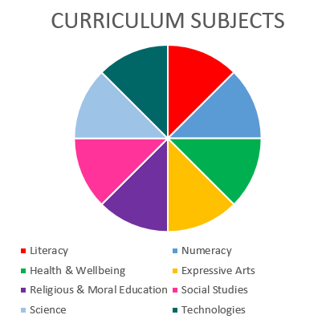  Technologies - Technological Developments in Society and Business – Impact, contribution and relationship of technologies on business, the economy, politics, and the environment  TCH 1-07a - I understand how technologies help provide for our needs and wants and how they can affect the environment in which we live.  TECHNOLOGIES  SOCIAL STUDIES  EXPRESSIVE ARTS  HEALTH & WELLBEING |  |  | Expressive Arts – Participation in performances and presentations – EXA 1-01a - I have experienced the energy and excitement of presenting/performing for audiences and being part of an audience for other people’s presentations/performances.  Expressive Arts – Art and Design  EXA 1-05a - Inspired by a range of stimuli, I can express and communicate my ideas, thoughts and feelings through activities within art and design.  EXA 1-07a - I can respond to the work of artists and designers by discussing my thoughts and feelings. I can give and accept constructive comment on my own and others’ work.  Expressive Arts – Dance  EXA 1-10a - I am becoming aware of the different features of dance and can practise and perform steps, formations and short dance.  EXA 1-11a - I can respond to the experience of dance by discussing my thoughts and feelings. I can give and accept constructive comment on my own and others’ work.  Expressive Arts – Drama  EXA 1-14a - I have developed confidence and skills in creating and presenting drama which explores real and imaginary situations, using improvisation and script.  Expressive Arts – Music  EXA 1-16a - I can sing and play from other styles and cultures, showing growing confidence and skill while learning about musical notation and performance directions.
Health and Wellbeing – Mental, emotional, social and physical wellbeing - Social Wellbeing
HWB 1-10a - I recognise that each individual has a unique blend of abilities and needs. I contribute to making my school community one which values individuals equally and is a welcoming place for all
HWB 1-12a - Representing my class, school and/or wider community encourages my self-worth and confidence and allows me to contribute to and participate in society.
HWB 1-13a -Through contributing my views, time and talents, I play a part in bringing about positive change in my school and wider community

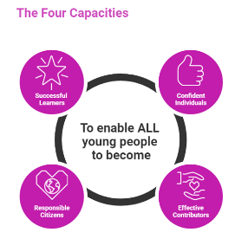 | The over-arching learning purposes of this plan are broad and you will want to focus your teaching to make it more coherent for your learners. Here are examples of possible, interdisciplinary learning intentions for this plan. You may choose alternatives which derive from your pupils’ progress, needs and interests.
We are developing our knowledge of Scotland’s heritage
We are developing our knowledge of our local landscape and environment
We are developing our understanding of how local organisations meet the needs and wants of our community
We are developing our ability to respond creatively to information and experiences
 | The key questions below are examples of how you could meet the above learning intentions and structure your teaching of the knowledge, skills and attitudes in selected E s & O s from this bundle. As above, you may choose alternatives which derive from your pupils’ progress, needs and interests. Our suite of Falkirk Council Progression Pathways will help you differentiate your teaching to ensure appropriate pace and challenge.
What do we know about the history of Scotland? |  | How do these groups meet the needs and wants of local people?
How can we compare the way people lived in the past with our own lives in the present? What can we find out and how can we share this? |  | What do we think of the ways in which technologies affect our people and our landscape? Are there any issues we would like to explore?
What can we learn about the landscape of our local area within Scotland? |  | How can we express our feelings and ideas through art, drama, music and dance?
How do we feel about the geography of our local area and Scotland? |  | What does creativity mean? What creative skills will help me live my life well?
Which local groups of people help to look after our local area and its people?? |  | How can we communicate our thoughts and feelings about Scotland and our local area through art, dance, drama and music?
Focus Skills/Benchmarks you want to assess through this plan of work
Social studies Benchmarks
- Draws a short timeline and can locate two or more events on the line in the correct order.
- Uses information learned from sources to relate the story of a local place or individual of historic interest though media such as drawings models or writing.
- Draws comparisons between modern life and life from a time in the past
- Draws or makes a model of features in their local landscape, for example, hill, river, building.
- Identifies a way in which the school looks after its environment.
- Identifies needs and wants using examples from their own experience.
- Names two local organisations who provide for needs in the local community and describe what they do.
Expressive Arts Benchmarks
Art and Design
- Shares thoughts and feelings by expressing personal views in response to the work of at least one artist and one designer.
- Shares views and listens appropriately to views of others, suggesting what works well and what could be improved in their own and others’ work, using some art and design vocabulary
When creating images and objects to express ideas, thoughts and feelings:
- chooses and uses technology and a range of media;
- shows understanding of basic colour theory, for example, which secondary colours are made from mixing primary colours;
- shows some understanding of the qualities and limitations of selected media, for example, uses pencil instead of a large brush to make fine marks, uses chalks instead of pencil to fill larger spaces;
- shows understanding of the concept of scale, for example, represents mountains as bigger than people.
Dance
- Creates, rehearses and performs short dance sequences, working on their own and with others
- Demonstrates understanding of simple formations, such as circles or squares, through taking in part in group dance.
- Demonstrates safe practice in dance, for example, being aware of personal space, planned landings.
- Shares thoughts and feelings by expressing personal views in response to experiencing live or recorded dance performance.
- Shares views and listens appropriately to views of others, suggesting what works well and what could be improved in their own and others’ work, using some dance vocabulary
Drama
- Creates, chooses and takes on a role within a drama such as a real or imagined situation, re-enactment of a story, a traditional tale.
- Creates a short drama using improvisation, from a given stimulus, and working collaboratively.
- Shows understanding of how to work from a script by acting or speaking at the appropriate time, for example, in a nativity play, a sound story or a poem.
Music
- Performs songs with enthusiasm, from a range of styles and cultures, demonstrating a variety of basic singing techniques such as accurate pitch, good diction and appropriate dynamics, for example, loud or quiet.
- Shares thoughts and feelings by expressing personal views in response to musical experiences such as performances, school shows and music from different styles and cultures.
There are no benchmarks for the Health and Wellbeing experiences and outcome in this plan
Technologies Benchmarks
- Gives examples of how people (for example police, fire, healthcare) who help us use technologies in their everyday work.

Use the boxes below to capture Literacy, Numeracy and Health and Wellbeing E s & O s which fit well with the purpose of this plan. Consider whether this learning context offers opportunities for your pupils to develop and/or apply skills and knowledge within these E s & O s.


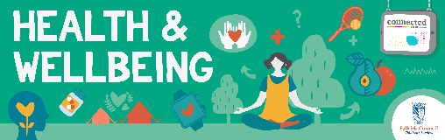
Other subject area?

Quality Learning Experiences | Use this space to record the learning experiences you plan with and for your pupils. These should include opportunities for pedagogy which is playful, active and inquiry-based. You may also want to create a learning plan, wall or floor book with you pupils.  These experiences should take account of whether the indoor or outdoor environment is best suited for this learning.
Assessment Approaches used  & evidence generated | This will be a blend of formative and summative, formal & informal assessment & feedback. This may include checking achievement of a level through a task which results in formal evidence of application of learning within an unfamiliar context.
Evaluation | Recording your reflections on this learning will guide subsequent teaching and learning for you and the next teacher of this class/group. It may help you identify evidence for a practitioner enquiry, or small test of change to help you manage your own ongoing improvement. You may also want to capture pupil feedback on this block of learning.

