EARLY LEVEL  Ante- Pre-School, Pre-school and Primary 1 | LEARNING FOR SUSTAINABILITY  BUNDLE 3 – CONNECT WITH CULTURE AND HERITAGE (LOCAL TO GLOBAL)
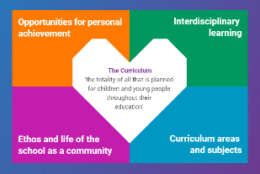  Indicates which of the contexts this plan addresses |   Depending on your focus, this plan could link to some or all of these SDGs |  |  | 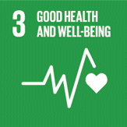 | 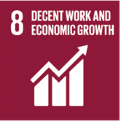
 | 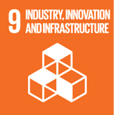 | 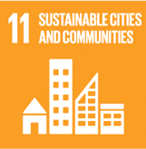 | 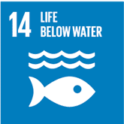 | 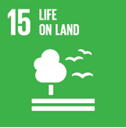 | 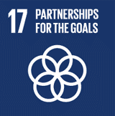
This plan is designed to develop pupil understanding of the following elements of Learning for Sustainability: social and cultural diversity, identity and heritage, links between environment and economy, community partnerships
POTENTIAL INTERDISCIPLINARY BUNDLE OF SUBJECT AREAS, ORGANISERS & EXPERIENCES & OUTCOMES FOR THIS BUNDLE
Social Studies - People, past events and society  SOC 0-02a - I can make a personal link to the past by exploring items or images connected with important individuals or special events in my life  SOC 0-04a - I have explored how people lived in the past and have used imaginative play to show how their lives were different from my own and the people around me  People, place and environment  SOC 0-07a - I explore and discover the interesting features of my local environment to develop an awareness of the world around me  SOC 0-08a - I explore and appreciate the wonder of nature within different environments and have played a part in caring for the environment  People, society, economy and business  SOC 0-16a - By exploring my local community, I have discovered the different roles people play and how they can help  SOC 0-20a - In real-life settings and imaginary play, I explore how local shops and services provide us with what we need in our daily lives | 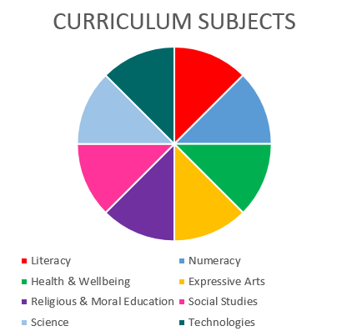  Technologies - Technological Developments in Society and Business – Impact, contribution, and relationship of technologies on business, the economy, politics, and the environment  TCH 0-07a - I understand how local shops and services use technologies to provide us with what we need and want in our daily lives.  TECHNOLOGIES  SOCIAL STUDIES  EXPRESSIVE ARTS  HEALTH & WELLBEING |  |  | Expressive Arts – Participation in performances and presentations – EXA 0-01a - I have experienced the energy and excitement of presenting/performing for audiences and being part of an audience for other people’s presentations/performances  Expressive Arts – Art and Design  EXA 0-05a - Inspired by a range of stimuli, I can express and communicate my ideas, thoughts and feelings through activities within art and design  EXA 0-07a - I can respond to the work of artists and designers by discussing my thoughts and feelings. I can give and accept constructive comment on my own and others’ work  Expressive Arts – Dance  EXA 0-10a - I have opportunities to enjoy taking part in dance experiences  EXA 0-11a - I can respond to the experience of dance by discussing my thoughts and feelings. I can give and accept constructive comment on my own and others’ work  Expressive Arts – Drama  EXA 0-14a - I use drama to explore real and imaginary situations, helping me to understand my world  Expressive Arts – Music  EXA 0-16a - I enjoy singing and playing along to music of different styles and cultures
Health and Wellbeing – Mental, emotional, social and physical wellbeing - Social Wellbeing
HWB 0-10a - I recognise that each individual has a unique blend of abilities and needs. I contribute to making my school community one which values individuals equally and is a welcoming place for all
HWB 0-12a - Representing my class, school and/or wider community encourages my self-worth and confidence and allows me to contribute to and participate in society.
HWB 0-13a -Through contributing my views, time and talents, I play a part in bringing about positive change in my school and wider community

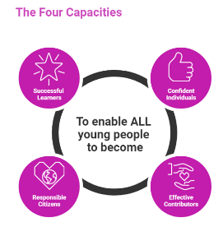 | The over-arching learning purposes of this plan are broad and you will want to focus your teaching to make it more coherent for your learners. Here are examples of possible, interdisciplinary learning intentions for this plan. You may choose alternatives which derive from your pupils’ progress, needs and interests.
We are developing our knowledge of our local area and its heritage
We are developing our ability to appreciate and look after our local environment
We are developing our understanding of how people help make our local community better
We are learning about our local shops and services
We are developing our ability to understand and emphasise with others
 | The key questions below are examples of how you could meet the above learning intentions and structure your teaching of the knowledge, skills and attitudes in selected E s & O s from this bundle. As above, you may choose alternatives which derive from your pupils’ progress, needs and interests. Our suite of Falkirk Council Progression Pathways will help you differentiate your teaching to ensure appropriate pace and challenge.
What do we know about our local community? |  | How do people help make our local community and environment better?
What happened in our local community in the past? |  | How do people harm our local community or environment?
What can we learn from exploring images and information about our local heritage? |  | How can we share our thoughts feelings about our local area/environment?
What connections can I make between my own family and friends and our local heritage? |  | What role do/did music and dance play in our local community?
In what ways has the history of our community helped or harmed our local environment? |  | How can we communicate our thoughts and feelings about our local area through art, dance, drama and music?
Focus Skills/Benchmarks you want to assess through this plan of work
Social studies Benchmarks
- Recalls past events from their own life or that of their family, for example learning to ride a bike, a special party.
- Recognises that people in the past lived differently.
- Uses knowledge of the past to demonstrate a difference between their life today and life in the past. For example, diet, lifestyle, clothing.
- Identifies simple features of the local environment, for example, hill, river, road, railway.
- Talks about something they have done to care for the environment.
- Identifies at least two people who provide help in the community.
- Talks about ways that each of those people help.
- Takes on appropriate roles during imaginative play.
- Identifies at least two different types of shops or services families might use, for example, supermarket or health centre
Expressive Arts Benchmarks
Art and Design
- When creating images and objects to express ideas, thoughts and feelings:
- uses a variety of available materials and technology;
- shows understanding that line can have different qualities, for example, thick, thin, broken, wavy.
Dance
- Shares thoughts and feelings in response to dance experiences, either as a performer or as part of an audience, giving reasons for likes and dislikes.
- Shares views and listens appropriately to the views of others on their own or others’ work.
Drama
- Conveys through drama what characters in real or imaginary situations might say, do or feel, for example, being upset about losing a toy, what a character in a well-known fairy tale might say or how they might feel.
- Communicates their ideas through improvised drama i.e. making it up as they go along.
Music
- Participates actively and uses his/her voice in singing activities from a range of styles and cultures, for example, nursery rhymes and songs with actions.
- Uses instruments such as drum, claves, chime bar to play along to a range of music styles
There are no benchmarks for the Health and Wellbeing experiences and outcome in this plan
Technologies Benchmarks
- Gives examples of how people (for example police, fire, healthcare) who help us use technologies in their everyday work.

Use the boxes below to capture Literacy, Numeracy and Health and Wellbeing E s & O s which fit well with the purpose of this plan. Consider whether this learning context offers opportunities for your pupils to develop and/or apply skills and knowledge within these E s & O s.

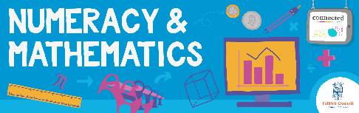
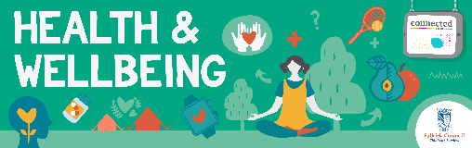
Other subject area?

Quality Learning Experiences | Use this space to record the learning experiences you plan with and for your pupils. These should include opportunities for pedagogy which is playful, active and inquiry-based. You may also want to create a learning plan, wall or floor book with you pupils.  These experiences should take account of whether the indoor or outdoor environment is best suited for this learning.
Assessment Approaches used  & evidence generated | This will be a blend of formative and summative, formal & informal assessment & feedback. This may include checking achievement of a level through a task which results in formal evidence of application of learning within an unfamiliar context.
Evaluation | Recording your reflections on this learning will guide subsequent teaching and learning for you and the next teacher of this class/group. It may help you identify evidence for a practitioner enquiry, or small test of change to help you manage your own ongoing improvement. You may also want to capture pupil feedback on this block of learning.

