THIRD LEVEL  Secondary 1 & 2 | LEARNING FOR SUSTAINABILITY  BUNDLE 2 – GLOBAL CITIZENSHIP & INTERNATIONAL EDUCATION
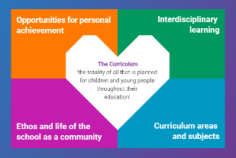  Indicates which of the contexts this plan addresses |   Depending on your focus, this plan could link to some or all of these SDGs |  |  |  |  | 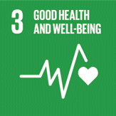  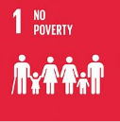 | 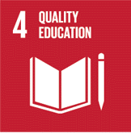  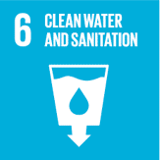
 | 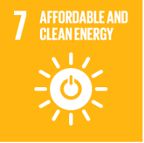 | 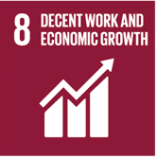 | 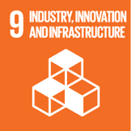 | 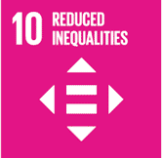 | 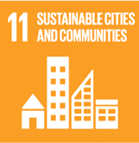 | 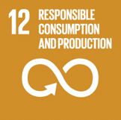 | 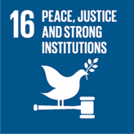  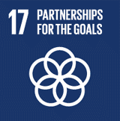
This plan is designed to develop pupil understanding of the following elements of Learning for Sustainability: fair trade, learning for a better world, ethical issues, human rights, children’s rights, school linking, links between environment and economy
USE THE SPACES BELOW TO NOTE THE SUBJECT AREAS, ORGANISERS & EXPERIENCES & OUTCOMES WHICH ARE RELEVANT TO THIS BUNDLE PLAN IN YOUR CLASSROOM/DEPARTMENT/SCHOOL
Social Studies - People, society, economy and business  SOC 3-15a - I can use my knowledge of current social, political or economic issues to interpret evidence & present  an informed view  SOC 3-16a - I can explain why a group I have identified might experience inequality & can suggest ways in which this inequality might be addressed.  SOC 3-20a - When participating in an enterprise activity, I can explore ethical issues relating to business practice & gain an understanding of how businesses help to satisfy needs.  SOC 3-20b - I can present conclusions about the impact of the globalisation of trade on patterns of work & conditions  of employment in Scotland, the UK or beyond | 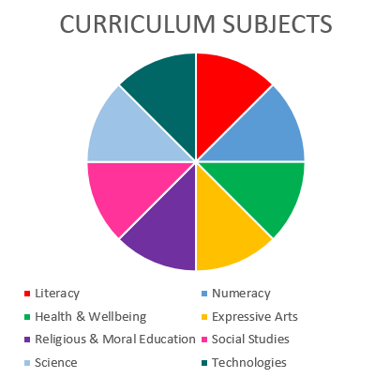  RELIGIOUS & MORAL EDUCATION  HEALTH & WELLBEING  SOCIAL STUDIES |  |  |  |  | Health and Wellbeing – Mental, emotional, social and physical wellbeing - Social Wellbeing  HWB 3-09a - As I explore the rights to which I and others are entitled, I am able to exercise these rights appropriately and accept the responsibilities that go with them. I show respect for the rights of others.  HWB 3-12a - Representing my class, school and/or wider community encourages my self-worth and confidence and allows me to contribute to and participate in society.  HWB 3-13a - Through contributing my views, time and talents, I play a part in bringing about positive change in my school and wider community
Religious and Moral Education – Development of beliefs and values
RME 3-07a - I am developing respect for others and my understanding of their beliefs and values
RME 3-09a - Through reflection & discussion, I can explain a range of beliefs which people hold & can participate in debates about ‘ultimate questions’
RME 3-09b - I am developing my own understanding of values such as honesty, respect & compassion & am able to identify how these values might be applied in relation to moral issues

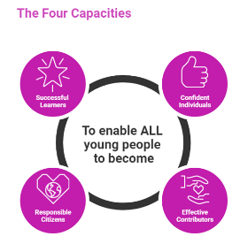 | The over-arching learning purposes of this plan are broad and you will want to focus your teaching to make it more coherent for your learners. Here are examples of possible, interdisciplinary learning intentions for this plan. You may choose alternatives which derive from your pupils’ progress, needs and interests.
We are developing our understanding of current social, political and economic issues
We are learning about inequality, the exercise of rights and ethical practices in our country and beyond
We are developing our understanding of how values and ethics influence trade and enterprise
We are developing our understanding of global citizenship and our role as global citizens
 | The key questions below are examples of how you could meet the above learning intentions and structure your teaching of the knowledge, skills and attitudes in selected E s & O s from this bundle. As above, you may choose alternatives which derive from your pupils’ progress, needs and interests. Our suite of Falkirk Council Progression Pathways will help you differentiate your teaching to ensure appropriate pace and challenge.
Which current social, political or economic issues would we like to investigate? |  | Which trading relationships can we explore in our school/community/country and beyond?
In what ways do these issues affect the rights of others in our community and beyond? |  | Are the trading relationships we explored fair and equal? What evidence can we gather about the effects and consequences of these trading relationships on people’s socio-economic position?
What is inequality and where have we observed it in our community/society? |  | How ethical are these trading relationships?
In what ways do the inequalities we observe relate to the Convention of Human Rights articles (UK Gov 1998)? |  | In what ways do the trading relationships we know about affect the United Nations Sustainable Development Goals and the health of our planet?
What is the impact of these inequalities on those affected? |  | Which ethical issues can we identify in local, national or international business practices?
How might we address these inequalities and their impact? |  | In what ways do different businesses and “not for profit” organisations fulfil the needs and wants of people?
What is a trading relationship? |  | What can we learn about international trade and its impact on people?
Focus Skills/Benchmarks you want to assess through this plan of work
Social studies Benchmarks (you may wish to add further benchmarks where relevant to your chosen learning experiences)

- Reviews basic sources of evidence such as newspapers or surveys used in arguments about current affairs to form a valid opinion.
- Presents using appropriate methods an informed view of a current affairs issue.
- Provides at least two simple explanations as to why a selected group might experience inequality, for example gender, race/ethnicity, age, disability.
- Makes two or more reasoned suggestions of ways in which this inequality might be addressed
- Describes the unequal nature of trading relationships and the consequences on people’s socio-economic position, for example, Fairtrade, Arms Trade.
- Draws valid conclusions about the effectiveness of the response, for example, NGOs, NATO, UN.
- Identifies at least two ethical issues related to business practices, for example, Fairtrade, Credit Unions, food banks, zero hours contracts, recycling and packaging.
- Describes how different businesses and not for profit organisations help to satisfy needs and wants.
- Identifies the advantages and disadvantages of international trade, and issues around free trade agreements.
There are no benchmarks for the Religious and Moral Education experiences and outcomes in this plan

There are no benchmarks for the Health and Wellbeing experiences and outcome in this plan

Use the boxes below to capture Literacy, Numeracy and Health and Wellbeing E s & O s which fit well with the purpose of this plan. Consider whether this learning context offers opportunities for your pupils to develop and/or apply skills and knowledge within these E s & O s.
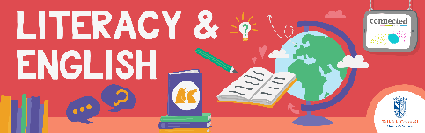
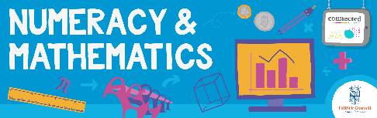
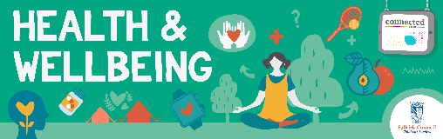
Other subject area?

Quality Learning Experiences | Use this space to record the learning experiences you plan with and for your pupils. These should include opportunities for pedagogy which is playful, active and inquiry-based. You may also want to create a learning plan, wall or floor book with you pupils.  These experiences should take account of whether the indoor or outdoor environment is best suited for this learning.
Assessment Approaches used  & evidence generated | This will be a blend of formative and summative, formal & informal assessment & feedback. This may include checking achievement of a level through a task which results in formal evidence of application of learning within an unfamiliar context.
Evaluation | Recording your reflections on this learning will guide subsequent teaching and learning for you and the next teacher of this class/group. It may help you identify evidence for a practitioner enquiry, or small test of change to help you manage your own ongoing improvement. You may also want to capture pupil feedback on this block of learning.

