SECOND LEVEL  Primary 5, 6 & 7 | LEARNING FOR SUSTAINABILITY  BUNDLE 2 – GLOBAL CITIZENSHIP & INTERNATIONAL EDUCATION
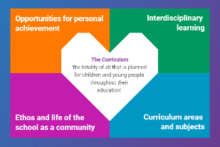  Indicates which of the contexts this plan addresses |   Depending on your focus, this plan could link to some or all of these SDGs |  |  |  |  | 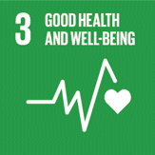  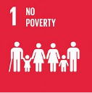 | 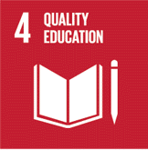  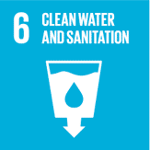
 | 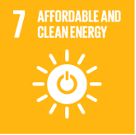 | 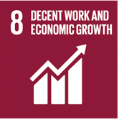 | 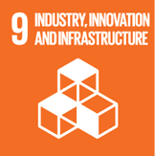 | 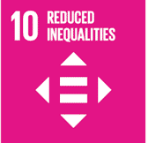 | 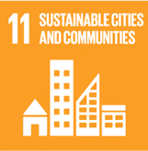 | 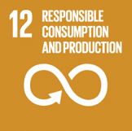 | 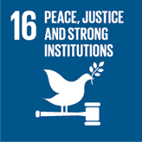  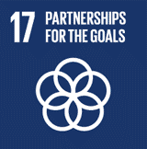
This plan is designed to develop pupil understanding of the following elements of Learning for Sustainability: fair trade, learning for a better world, ethical issues, human rights, children’s rights, school linking, links between environment and economy
USE THE SPACES BELOW TO NOTE THE SUBJECT AREAS, ORGANISERS & EXPERIENCES & OUTCOMES WHICH ARE RELEVANT TO THIS BUNDLE PLAN IN YOUR CLASSROOM/DEPARTMENT/SCHOOL
Social Studies - People, society, economy and business  SOC 2-15a - I can use evidence selectively to research current social, political or economic issues.  SOC 2-16a - I can explain how the needs of a group in my local community are supported.  SOC 2-16b - I can gather and use information about forms of discrimination against people in societies and consider the impact this has on people’s lives  SOC 16c - I can discuss issues of the diversity of cultures, values and customs in our society  SOC 2-20a - Through exploring ethical trading, I can understand how people’s basic needs are the same around the world, discussing why some societies are more able to meet these needs than others. | 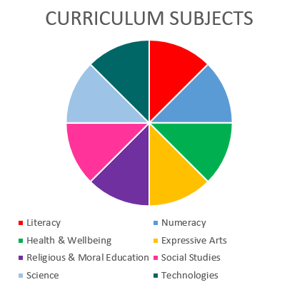  RELIGIOUS & MORAL EDUCATION  SOCIAL STUDIES  HEALTH & WELLBEING |  |  |  |  | Health and Wellbeing – Mental, emotional, social and physical wellbeing - Social Wellbeing  HWB 2-09a - As I explore the rights to which I and others are entitled, I am able to exercise these rights appropriately and accept the responsibilities that go with them. I show respect for the rights of others.  HWB 2-12a - Representing my class, school and/or wider community encourages my self-worth and confidence and allows me to contribute to and participate in society.  HWB 2-13a - Through contributing my views, time and talents, I play a part in bringing about positive change in my school and wider community
Religious and Moral Education – Development of beliefs and values
RME 2-07a - I am developing respect for others and my understanding of their beliefs and values
RME 2-09a - I am increasing my understanding of how people come to have their beliefs, and further developing my awareness that there is a diversity of belief in modern Scotland
RME 2-09b - I am developing my understanding that people have beliefs and values based upon religious or other positions.

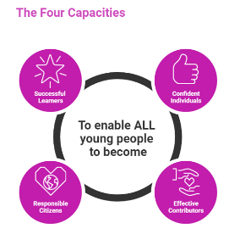 | The over-arching learning purposes of this plan are broad and you will want to focus your teaching to make it more coherent for your learners. Here are examples of possible, interdisciplinary learning intentions for this plan. You may choose alternatives which derive from your pupils’ progress, needs and interests.
We are developing our research skills
We are learning about how our needs and wants are met in our country and beyond
We are developing values such as tolerance and respect
We are developing our understanding of what a community is and how it works
We are learning how to be effective contributors to our community
 | The key questions below are examples of how you could meet the above learning intentions and structure your teaching of the knowledge, skills and attitudes in selected E s & O s from this bundle. As above, you may choose alternatives which derive from your pupils’ progress, needs and interests. Our suite of Falkirk Council Progression Pathways will help you differentiate your teaching to ensure appropriate pace and challenge.
What are current social, political or economic issues? |  | How diverse are other countries and how do they meet the needs of their citizens?
Are there local community groups who need our support? |  | What is ethical trading?
What is discrimination? |  | How does international trade and business affect the lives of citizens of the world?
What impact does discrimination have in our society? |  | Which current social, political or economic issues do we care about?
How does discrimination affect people’s lives? |  | How should we research these issues to ensure we find reliable evidence?
What are the cultures, values and customs of Scotland? How diverse is our Scottish culture? |  | How can we make our community/country/other country even better?
Focus Skills/Benchmarks you want to assess through this plan of work
Social studies Benchmarks
- Selects appropriate evidence and uses it to research a social, political or economic issue.
- Provides a basic explanation as to how the needs of a particular group within the local community can be supported, using relevant examples.
- Uses evidence to form a valid opinion of the impact of discrimination or prejudice on people’s lives, for example, racism or the effect of immigration.
- Discusses in any form at least three issues related to cultures, values and customs in our society, for example, the role of family, traditions and gender stereotyping.
- Describes the basic needs of human beings.
- Draws valid conclusions as to why some countries can meet these needs better than others.
- Identifies which goods and services would be essential in society
- Describes and pros and cons of using Fairtrade products and community service providers such as credit unions.
There are no benchmarks for the Religious and Moral Education experiences and outcomes in this plan

There are no benchmarks for the Health and Wellbeing experiences and outcome in this plan

Use the boxes below to capture Literacy, Numeracy and Health and Wellbeing E s & O s which fit well with the purpose of this plan. Consider whether this learning context offers opportunities for your pupils to develop and/or apply skills and knowledge within these E s & O s.
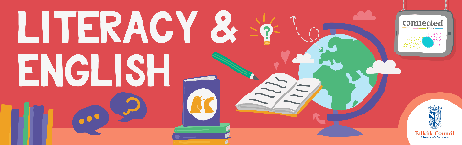
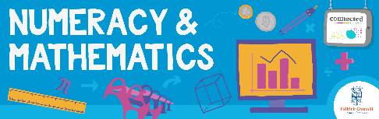
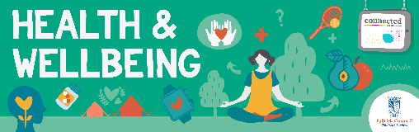
Other subject area?

Quality Learning Experiences | Use this space to record the learning experiences you plan with and for your pupils. These should include opportunities for pedagogy which is playful, active and inquiry-based. You may also want to create a learning plan, wall or floor book with you pupils.  These experiences should take account of whether the indoor or outdoor environment is best suited for this learning.
Assessment Approaches used  & evidence generated | This will be a blend of formative and summative, formal & informal assessment & feedback. This may include checking achievement of a level through a task which results in formal evidence of application of learning within an unfamiliar context.
Evaluation | Recording your reflections on this learning will guide subsequent teaching and learning for you and the next teacher of this class/group. It may help you identify evidence for a practitioner enquiry, or small test of change to help you manage your own ongoing improvement. You may also want to capture pupil feedback on this block of learning

