FOURTH LEVEL  Secondary 2 & 3 | LEARNING FOR SUSTAINABILITY  BUNDLE 2 – GLOBAL CITIZENSHIP & INTERNATIONAL EDUCATION
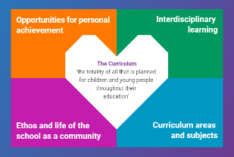  Indicates which of the contexts this plan addresses |   Depending on your focus, this plan could link to some or all of these SDGs |  |  |  |  | 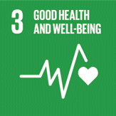  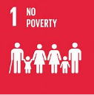 | 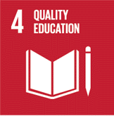  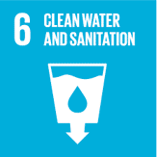
 | 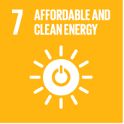 | 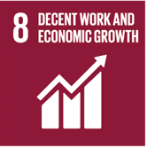 | 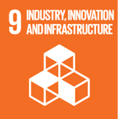 | 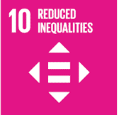 | 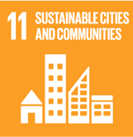 | 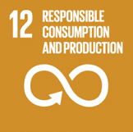 | 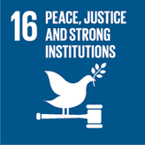  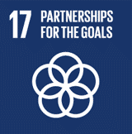
This plan is designed to develop pupil understanding of the following elements of Learning for Sustainability: fair trade, learning for a better world, ethical issues, human rights, children’s rights, school linking, links between environment and economy
USE THE SPACES BELOW TO NOTE THE SUBJECT AREAS, ORGANISERS & EXPERIENCES & OUTCOMES WHICH ARE RELEVANT TO THIS BUNDLE PLAN IN YOUR CLASSROOM/DEPARTMENT/SCHOOL
Social Studies - People, society, economy and business  SOC 4-15a - I can evaluate conflicting sources of evidence  to sustain a line of argument  SOC 4-16a - I can contribute to a discussion on the extent to which people’s needs should be met by the state or the individual  SOC 4-16b - Through discussion, I have identified aspects of a social issue to investigate & by gathering information I can assess its impact & the attitudes of the people affected  SOC 4-16b - I can analyse the factors contributing to the development of a multicultural society & can express an informed view on issues associated with this  SOC 4-20a - I can critically examine how some economic factors can influence individuals, businesses or communities  SOC 4-20b - I can research the purposes & features of private,  public & voluntary sector organisations to contribute  to a discussion on their relationships with stakeholders.  SOC 4-20c - I can evaluate working practices available to employees within different types of business organisations. | 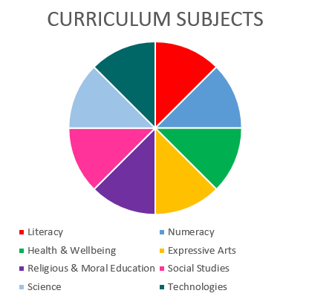  RELIGIOUS & MORAL EDUCATION  HEALTH & WELLBEING  SOCIAL STUDIES |  |  |  |  | Health and Wellbeing – Mental, emotional, social and physical wellbeing - Social Wellbeing  HWB 4-09a - As I explore the rights to which I and others are entitled, I am able to exercise these rights appropriately and accept the responsibilities that go with them. I show respect for the rights of others.  HWB 4-12a - Representing my class, school and/or wider community encourages my self-worth and confidence and allows me to contribute to and participate in society.  HWB 4-13a - Through contributing my views, time and talents, I play a part in bringing about positive change in my school and wider community
Religious and Moral Education – Development of beliefs and values
RME 4-07a - I am developing respect for others and my understanding of their beliefs and values
RME 4-09a - Having reflected upon & considered a range of beliefs, belief systems &
moral viewpoints, I can express reasoned views on how putting these beliefs &
values into action might lead to changes in society
RME 4-09b - I am able to apply my understanding of a range of moral viewpoints, including those which are independent of religion, to specific moral issues & am aware of the diversity of moral viewpoints held in modern Scotland & the wider world.

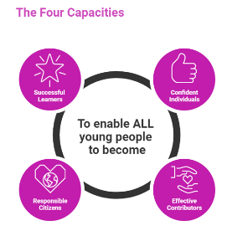 | The over-arching learning purposes of this plan are broad and you will want to focus your teaching to make it more coherent for your learners. Here are examples of possible, interdisciplinary learning intentions for this plan. You may choose alternatives which derive from your pupils’ progress, needs and interests.
We are developing our skills of analysis and evaluation
We are developing our understanding of multiculturalism in society
We are learning about inequality, the exercise of rights and ethical practices in our country and beyond
We are developing our understanding of the relationship between society and our local/national/global economy
We are developing our understanding of the private, public and third sector and their employment practices
 | The key questions below are examples of how you could meet the above learning intentions and structure your teaching of the knowledge, skills and attitudes in selected E s & O s from this bundle. As above, you may choose alternatives which derive from your pupils’ progress, needs and interests. Our suite of Falkirk Council Progression Pathways will help you differentiate your teaching to ensure appropriate pace and challenge.
What is a multicultural society? Which key elements or factors are required in a multicultural society? |  | How can we identify and capture the relationships between societal and economic issues:  - Locally  - Nationally  - Internationally
Which issues affect the development of a multicultural society? |  | How can we capture and define the ways in which infringements of human rights and unethical practices affect the development of a multicultural society?
In what ways do these issues relate to inequality, the exercise of rights and ethical practices in our country and beyond? |  | What are employment practices, and how do these look in jobs which we know about?
Which particular issues do we observe, or are we most interested in within our local, national or global society? |  | What can we learn about the public, private and third sectors in our society? Is there more to learn from looking at these sectors in another country?
How might we investigate these issues? |  | How can we explain the roles of each of these sectors in our society and beyond?
How might we analyse and evaluate the impact of these issues on multiculturalism? |  | What kind of jobs exist in the public, private and third sector?
What is a trading relationship? |  | What can we learn from a comparison of employment practices in public sector, private sector and third sector businesses?
Focus Skills/Benchmarks you want to assess through this plan of work
Social studies Benchmarks (you may wish to add further benchmarks where relevant to your chosen learning experiences)
- Discusses the extent to which individuals, organisations or the state should meet the needs of people, or stimulate the demand for goods and services.
- Suggests the impact of a social issue, for example, poverty and demonstrates the attitudes of those affected.
- Explains the development of a multicultural society and expresses a reasoned opinion on the issues associated with it, for example, the impact of immigration
- Presents an informed view as to how the expansion of power and influence of countries or organisations may impact on cultures, attitudes and experiences of those involved.
- Evaluates the effectiveness of any chosen international organisations, for example the UN, NATO or the EU in meeting their aims.
- Critically examines how at least three economic factors can influence the decisions and behaviours of individuals, businesses or communities.
- Exemplifies the purposes and features of different sector organisations: private, public and third sector.
- Contributes to a discussion on the relationship between these organisations and their stakeholders, recognising the contribution of entrepreneurial and enterprising behaviours
- Evaluates at least two working practices available to employees working within different types of business organisations
There are no benchmarks for the Religious and Moral Education experiences and outcomes in this plan
There are no benchmarks for the Health and Wellbeing experiences and outcome in this plan

Use the boxes below to capture Literacy, Numeracy and Health and Wellbeing E s & O s which fit well with the purpose of this plan. Consider whether this learning context offers opportunities for your pupils to develop and/or apply skills and knowledge within these E s & O s.
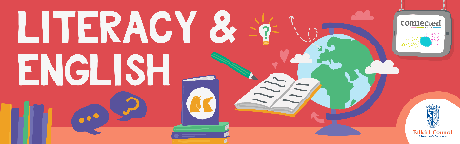

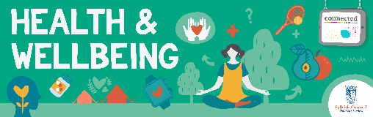
Other subject area?

Quality Learning Experiences | Use this space to record the learning experiences you plan with and for your pupils. These should include opportunities for pedagogy which is playful, active and inquiry-based. You may also want to create a learning plan, wall or floor book with you pupils.  These experiences should take account of whether the indoor or outdoor environment is best suited for this learning.
Assessment Approaches used  & evidence generated | This will be a blend of formative and summative, formal & informal assessment & feedback. This may include checking achievement of a level through a task which results in formal evidence of application of learning within an unfamiliar context.
Evaluation | Recording your reflections on this learning will guide subsequent teaching and learning for you and the next teacher of this class/group. It may help you identify evidence for a practitioner enquiry, or small test of change to help you manage your own ongoing improvement. You may also want to capture pupil feedback on this block of learning

