FIRST LEVEL  Primary 2, 3 & 4 | LEARNING FOR SUSTAINABILITY  BUNDLE 2 – GLOBAL CITIZENSHIP & INTERNATIONAL EDUCATION
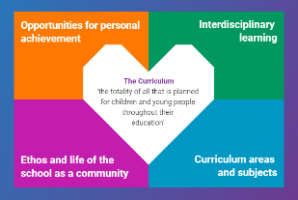  Indicates which of the contexts this plan addresses |   Depending on your focus, this plan could link to some or all of these SDGs |  |  |  |  | 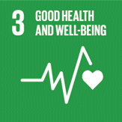  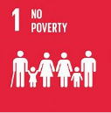 | 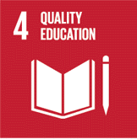  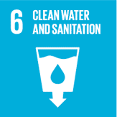
 | 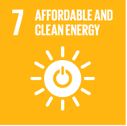 | 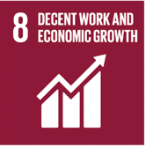 | 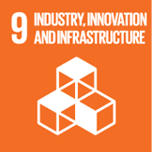 | 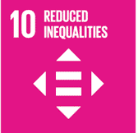 | 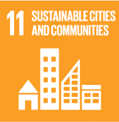 | 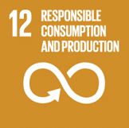 | 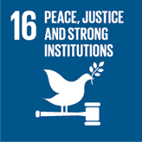  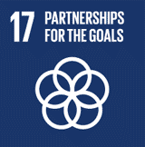
This plan is designed to develop pupil understanding of the following elements of Learning for Sustainability: fair trade, learning for a better world, ethical issues, human rights, children’s rights, school linking, links between environment and economy
USE THE SPACES BELOW TO NOTE THE SUBJECT AREAS, ORGANISERS & EXPERIENCES & OUTCOMES WHICH ARE RELEVANT TO THIS BUNDLE PLAN IN YOUR CLASSROOM/DEPARTMENT/SCHOOL
Social Studies - People, society, economy and business  SOC 1-15a - I understand that evidence varies in the extent to which it can be trusted and can use this in learning about current issues in society.  SOC 1-16a - I can contribute to a discussion of the difference between my needs and wants and those of others around me.  SOC 1-20a - I have developed an understanding of the importance of local organisations in providing for the needs of my local community. | 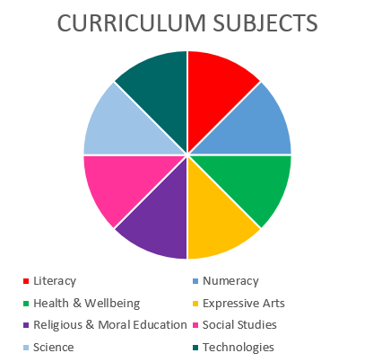  RELIGIOUS & MORAL EDUCATION  HEALTH & WELLBEING  SOCIAL STUDIES |  |  |  |  | Health and Wellbeing – Mental, emotional, social and physical wellbeing - Social Wellbeing  HWB 1-09a - As I explore the rights to which I and others are entitled, I am able to exercise these rights appropriately and accept the responsibilities that go with them. I show respect for the rights of others.  HWB 1-12a - Representing my class, school and/or wider community encourages my self-worth and confidence and allows me to contribute to and participate in society.  HWB 1-13a - Through contributing my views, time and talents, I play a part in bringing about positive change in my school and wider community
Religious and Moral Education – Development of beliefs and values

RME 1-07a - I am developing respect for others and my understanding of their beliefs and values
RME 1-09a - I am developing an awareness that some people have beliefs and values which are independent of religion.

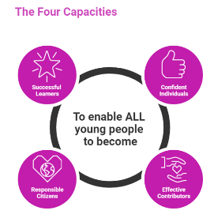 | The over-arching learning purposes of this plan are broad and you will want to focus your teaching to make it more coherent for your learners. Here are examples of possible, interdisciplinary learning intentions for this plan. You may choose alternatives which derive from your pupils’ progress, needs and interests.
We are developing our research skills
We are learning about how our needs and wants are met in our local community and beyond
We are developing values such as tolerance and respect
We are developing our understanding of what a community is and how it works
We are learning how to be effective contributors to our community and beyond
 | The key questions below are examples of how you could meet the above learning intentions and structure your teaching of the knowledge, skills and attitudes in selected E s & O s from this bundle. As above, you may choose alternatives which derive from your pupils’ progress, needs and interests. Our suite of Falkirk Council Progression Pathways will help you differentiate your teaching to ensure appropriate pace and challenge.
What is evidence? |  | Which local organisations provide for the needs of our community?
Where can we find evidence about current issues in our community or society? |  | What do we think of the way the needs of our community are met?
How can we decide whether evidence is reliable or unreliable? |  | Are the Human Rights of everyone in our community being met?
What is the difference between things we need and things we want? What examples can we find from our lives? |  | What do we do to make our classroom/school/community a fair and respectful place to live?
What/How can we find out about the way people’s needs and wants are met in other countries? |  | How can we make our class/school/community even better?
Focus Skills/Benchmarks you want to assess through this plan of work
Social studies Benchmarks
- Identifies a reliable and an unreliable source of evidence.
- Identifies needs and wants using examples from their own experience.
- Presents an informed opinion on rights and responsibilities using their own experience.
- Makes informed decisions on an issue having listened to others.
- Names two local organisations who provide for needs in the local community and describe what they do.

There are no benchmarks for the Religious and Moral Education experiences and outcomes in this plan

There are no benchmarks for the Health and Wellbeing experiences and outcome in this plan

Use the boxes below to capture Literacy, Numeracy and Health and Wellbeing E s & O s which fit well with the purpose of this plan. Consider whether this learning context offers opportunities for your pupils to develop and/or apply skills and knowledge within these E s & O s.
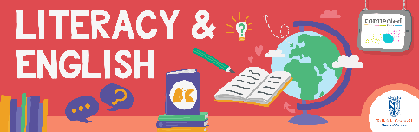
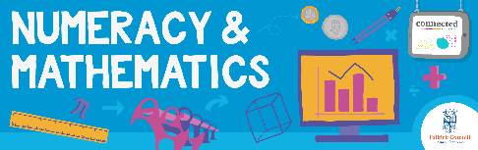
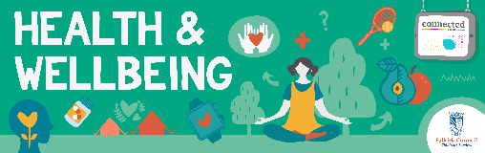
Other subject area?

Quality Learning Experiences | Use this space to record the learning experiences you plan with and for your pupils. These should include opportunities for pedagogy which is playful, active and inquiry-based. You may also want to create a learning plan, wall or floor book with you pupils.  These experiences should take account of whether the indoor or outdoor environment is best suited for this learning.
Assessment Approaches used  & evidence generated | This will be a blend of formative and summative, formal & informal assessment & feedback. This may include checking achievement of a level through a task which results in formal evidence of application of learning within an unfamiliar context.
Evaluation | Recording your reflections on this learning will guide subsequent teaching and learning for you and the next teacher of this class/group. It may help you identify evidence for a practitioner enquiry, or small test of change to help you manage your own ongoing improvement. You may also want to capture pupil feedback on this block of learning

