EARLY LEVEL  Ante- Pre School, Pre-school & Primary 1 | LEARNING FOR SUSTAINABILITY  BUNDLE 1 – EXPLORING SUSTAINABLE PRACTICES
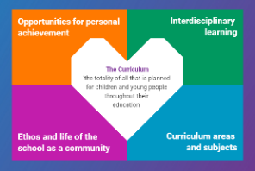  Indicates which of the contexts this plan addresses |   Depending on your focus, this plan could  link to some or all of these SDGs |  |  |  | 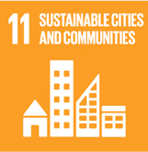 | 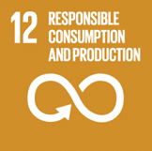
 | 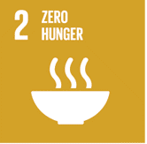 | 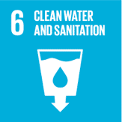 | 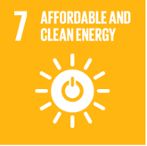 | 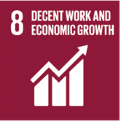 | 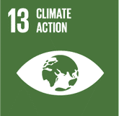 | 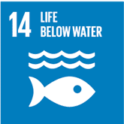
This plan is designed to develop pupil understanding of the following elements of Learning for Sustainability: waste reduction, recycling, sustainable energy and water use, protecting biodiversity, responsible use of the planet’s resources, growing food and tackling climate change.
THIS PLAN BUNDLES THE FOLLOWING EXPERIENCES AND OUTCOMES, SUBJECT AREAS & ORGANISERS
Science – Biodiversity and interdependence  SCN 0-01a - I have observed living things in the environment over time and am becoming aware of how they depend on each other | 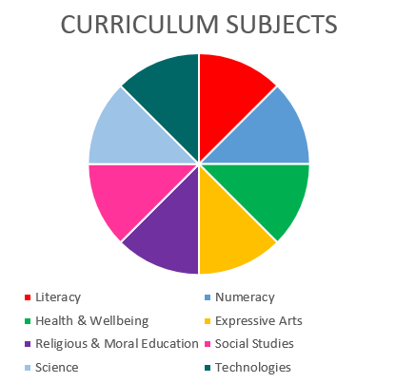  SCIENCE  TECHNOLOGIES |  |  |  | Technologies – Impact, contribution, and relationship of technologies on business, the economy, politics, and the environment  TCH 0-06a - To help care for the environment, I reduce, re-use and recycle the resources I use  TCH 0-07a – I understand how local shops & services use technologies to provide us with what we need & want in our daily lives.
Science – Planet Earth – Energy sources & sustainability
SCN 0-04a - I have experienced, used and described a wide range of toys and common appliances. I can say “what makes it go” and say what they do when they work.
Science – Planet Earth – Processes of the planet  SCN 0-05a - By investigating how water can change from one form to another, I can relate my findings to everyday experiences |  |  |  |  | Representing ideas, concepts and products through a variety of graphic media  TCH 0-11a - I explore & discover different ways of representing ideas in imaginative ways.

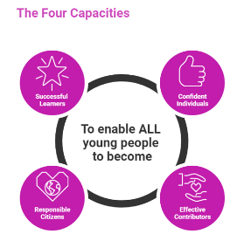 | The over-arching learning purposes of this plan are broad and you will want to focus your teaching to make it more coherent for your learners. Here are examples of possible, interdisciplinary learning intentions for this plan. You may choose alternatives which derive from your pupils’ progress, needs and interests.
We are learning about diversity
We are developing our ability to understand & build on concepts & ideas
We are learning about interdependence and consequences
 | The key questions below are examples of how you could meet the above learning intentions and structure your teaching of the knowledge, skills and attitudes in selected E s & O s from this bundle. As above, you may choose alternatives which derive from your pupils’ progress, needs and interests. Our suite of Falkirk Council Progression Pathways will help you differentiate your teaching to ensure appropriate pace and challenge.
What is observing? What does alive mean? |  | Are the living things in our area healthy? What might be harming living things?
What does it mean to “depend” on someone or something? What plants & animals can we find which depend on one and other? |  | Can we improve the diversity of living things in our local area? Should we?
What plants and animals do we/you depend on? What do we need plants & animals for? |  | How do the things I do affect my local area, living things and planet Earth?
Are there places in our local area which we could visit to learn more about the living things around us? Where else can we learn about living things? |  | What can I do to make sure I don’t harm other living things or my local area or Planet Earth?
What is diversity? Do we think we live in a place which has a diverse range of living things? |  | How can we share what we have discovered? What is the best way to capture this information?
Focus Skills/Benchmarks Assessed through this plan of work – tick or highlight
Science Skills
- Explores and observes through play.
- Asks questions arising from play activities.
- Makes simple predictions of what might happen.
- Makes suggestions about what to do to answer the selected question
- Uses their senses to acquire information.
- Presents and sorts data/information, for example, using displays, photographs, simple charts and drawings
- Provides oral descriptions of what was done and what happened
- Recognises similarities, patterns and differences in the findings and links these to the original question
- Discusses, with support, how the experiment might be improved
- Relates findings to everyday experiences. –
- Identifies and discusses new knowledge and understanding.
- Communicates findings to others verbally and through drawings, photographs, displays and simple charts. –
- Responds to questions about their investigation
Science Benchmarks
- Explores and sorts objects as living, non-living or once living.
- Describes characteristics of livings things and how they depend on each other, for example, animals which depend on plants for food.

Technologies Skills
- Higher order thinking – observing and interpreting information, analysing and evaluating, making decisions
- Exploring ideas with creativity
- Maintaining focus on the purpose & constraints of a task/project
- Creating solutions to problems in 2 or 3 dimensions
- Using materials in sustainable ways – reducing waste, thinking of ways to re-use or upcycle materials/objects
Technologies Benchmarks
- Understands what can be reduced, re-used and recycled
- Gives examples of how people (for example police, fire, healthcare) who help us use technologies in their everyday work.
Use the boxes below to capture Literacy, Numeracy and Health and Wellbeing E s & O s which fit well with the purpose of this plan. Consider whether this learning context offers opportunities for your pupils to develop and/or apply skills and knowledge within these E s & O s.
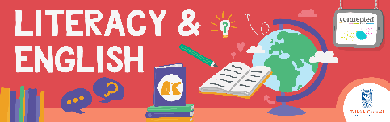
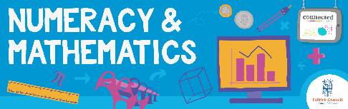
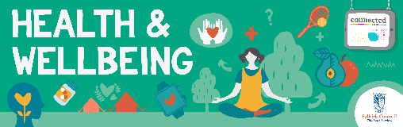
Other subject?

Quality Learning Experiences | Use this space to record the learning experiences you plan with and for your pupils. These should include opportunities for pedagogy which is playful, active and inquiry-based. You may also want to create a learning plan, wall or floor book with you pupils.  These experiences should take account of whether the indoor or outdoor environment is best suited for this learning.
Assessment Approaches used  and evidence generated | This will be a blend of formative and summative, formal and more informal assessment & feedback. This may include checking achievement of a level through a task which results in formal evidence of application of learning within an unfamiliar context.
Evaluation | Recording your reflections on this learning will guide subsequent teaching and learning for you and the next teacher of this class/group. It may help you identify evidence for a practitioner enquiry, or small test of change to help you manage your own ongoing improvement. You may also want to capture pupil feedback on this block of learning

