FOURTH LEVEL  Secondary 2 & 3 | LEARNING FOR SUSTAINABILITY  BUNDLE 1 – EXPLORING SUSTAINABLE PRACTICES
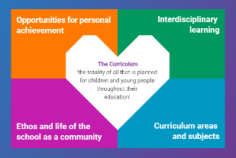  Indicates which of the contexts this plan addresses |   Depending on your focus, this plan could  link to some or all of these SDGs |  |  |  | 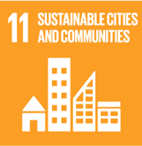 | 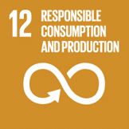
 | 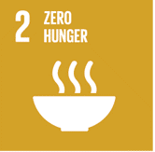 | 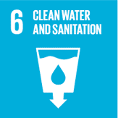 | 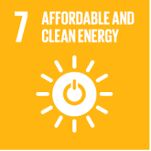 | 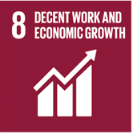 | 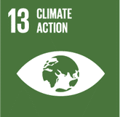 | 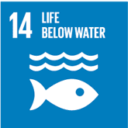
This plan is designed to develop pupil understanding of the following elements of Learning for Sustainability: waste reduction, recycling, sustainable energy and water use, protecting biodiversity, responsible use of the planet’s resources, growing food and tackling climate change
THIS PLAN BUNDLES THE FOLLOWING EXPERIENCES AND OUTCOMES, SUBJECT AREAS & ORGANISERS
Science – Planet Earth -  Biodiversity and interdependence  SCN 4-01a - I understand how animal and plant species depend on each other and how living things are adapted for survival. I can predict the impact of population growth and natural hazards on biodiversity.  SCN 4-02a - I have propagated and grown plants using a variety of different methods. I can compare these methods and develop my understanding of their commercial use | 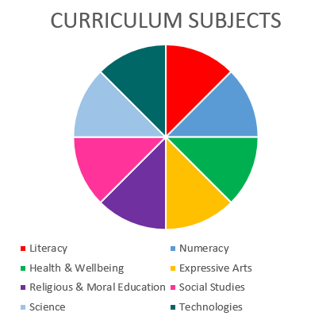  SCIENCE  TECHNOLOGIES |  |  |  | Technologies – Impact, contribution, and relationship of technologies on business, the economy, politics and the environment  TCH 4-06a – I can examine a range of materials, processes or designs in my local community to consider their environmental, social and economic impact.  TCH 4-07a – I can present conclusions about the impact of technologies on the economy, politics and the environment.  TCH 4-08a - I can select and use appropriate hardware and software which supports evolving business activities.
Science – Planet Earth – Energy sources & sustainability  SCN 4-04a - By contributing to an investigation on different ways of meeting society’s energy needs, I can express an informed view on the risks and benefits of different energy sources, including those produced from plants.  SCN 4-04b - Through investigation, I can explain the formation and use of fossil fuels and contribute to discussions on the responsible use and conservation of finite resources. | Science – Planet Earth – Processes of the planet  SCN 4-05a – I have developed my understanding of the kinetic model of a gas. I can describe the qualitative relationships between pressure, volume and temperature of gases.  SCN 4-05b - Through exploring the carbon cycle, I can describe the processes involved in maintaining the balance of gases in the air, considering causes and implications of changes in the balance.

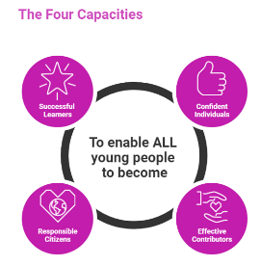 | The over-arching learning purposes of this plan are broad and you will want to focus your teaching to make it more coherent for your learners. Here are examples of possible, interdisciplinary learning intentions for this plan. You may choose alternatives which derive from your pupils’ progress, needs and interests.
We are learning about diversity.
We are developing our ability to understand & build on concepts & ideas
We are learning about interdependence and consequences
 | The key questions below are examples of how you could meet the above learning intentions and structure your teaching of the knowledge, skills and attitudes in selected E s & O s from this bundle. As above, you may choose alternatives which derive from your pupils’ progress, needs and interests. Our suite of Falkirk Council Progression Pathways will help you differentiate your teaching to ensure appropriate pace and challenge.
What is interdependence? |  | What can we discover about society’s use of energy and how energy needs are met?
How do living things adapt to their habitats? |  | What are fossil fuels and how were these created?
How does population growth affect biodiversity? |  | How do the properties and behaviour of gases behave contribute to the energy needs of society?
How might we predict the impact of natural hazards on biodiversity? |  | What is the carbon cycle and how does it relate to sustainable energy sources and the processes of our planet?
How can we propagate and grow different plants? |  | What energy sources, gases and materials are present in my local area and how are these affecting local biodiversity?
What can we discover by comparing methods of propagation and growth? How are these methods used commercially? |  | What conclusions about technology can I draw from studying the impact of energy and technologies on my local environment?
What can we learn from commercial propagation and growth of plants? |  | How can we compare and express our thoughts about the risks and benefits of different energy sources/methods?
Focus Skills/Benchmarks Assessed through this plan of work – tick or highlight
Science Skills
- Plans and designs scientific investigations and enquiries.
- Carries out practical activities within a variety of learning environments.
- Analyses, interprets and evaluates scientific findings.
- Presents scientific findings.
- Applies scientific thinking skills while working with unfamiliar and complex contexts.
- Applies and combines knowledge and understanding from different areas of science to solve problems.
- Demonstrates understanding of the impact of science on society and debates and discusses the moral and ethical implications of some scientific developments, demonstrating respect for the views of others.
- Expresses informed views about topical scientific issues, including those featured in the media, based on evidence and demonstrating understanding of underlying scientific concepts.
- Demonstrates increased awareness of creativity and inventiveness in science and the use of technologies in the development of sciences.
Science Benchmarks
- Describes how plants and animals depend on each other for food, shelter and pollination, using scientific vocabulary such as ‘population’, ‘community’ and ‘species’.
- Explains the possible effects of removal or addition of species on food webs and biodiversity.
- Summarises research findings to provide examples of structural, physiological and behavioural adaptations which lead to species survival.
- Compares natural and artificial techniques to propagate plants, for example, seeds, bulbs and cuttings, and suggests commercial uses such as food production and food security.
- Applies knowledge and understanding from different areas of the curriculum to express an informed view of the risks and benefits of different energy sources, including at least one energy source derived from plants.
- Discusses, following research, the formation and use of fossil fuels and the need to use remaining fossil fuel resources responsibly, for example, to preserve finite supplies, limit pollution and reduce emissions of greenhouse gases
- Calculates the pressure exerted by a force over an area using the relationship P = F / A.
- Describes, from experimental observation, the relationships between pressure, volume and temperature for a fixed mass of gas.
- Describes the steps in the carbon cycle and explains how processes such as respiration, photosynthesis and burning carbon-based fuels affect the balance of gases in the air.
- Researches the effects of changes in the balance of gases in the air and shares their scientific findings in an appropriate manner.
Technologies Skills
- Higher order thinking – observing and interpreting information, analysing and evaluating, making decisions.
- Exploring ideas with creativity.
- Maintaining focus on the purpose & constraints of a task/project.
- Creating solutions to problems in 2 or 3 dimensions.
- Using materials in sustainable ways – reducing waste, thinking of ways to re-use or upcycle materials/objects.
Technologies Benchmarks
- Demonstrates an understanding of the impact of materials and processes on design.
- Explains the impact of technologies on globalisation, patterns of work and conditions of employment.
- Updates and presents information using appropriate hardware and software

Use the boxes below to capture Literacy, Numeracy and Health and Wellbeing E s & O s which fit well with the purpose of this plan. Consider whether this learning context offers opportunities for your pupils to develop and/or apply skills and knowledge within these E s & O s.
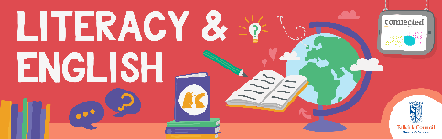

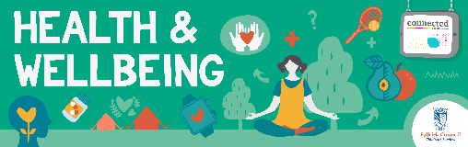
Other subject area?

Quality Learning Experiences | Use this space to record the learning experiences you plan with and for your pupils. These should include opportunities for pedagogy which is playful, active and inquiry-based. You may also want to create a learning plan, wall or floor book with you pupils.  These experiences should take account of whether the indoor or outdoor environment is best suited for this learning.
Assessment Approaches used  & evidence generated | This will be a blend of formative and summative, formal and more informal assessment & feedback. This may include checking achievement of a level through a task which results in formal evidence of application of learning within an unfamiliar context.
Evaluation | Recording your reflections on this learning will guide subsequent teaching and learning for you and the next teacher of this class/group. It may help you identify evidence for a practitioner enquiry, or small test of change to help you manage your own ongoing improvement. You may also want to capture pupil feedback on this block of learning

