THIRD LEVEL  Secondary 1 & 2 | LEARNING FOR SUSTAINABILITY  BUNDLE 1 – EXPLORING SUSTAINABLE PRACTICES
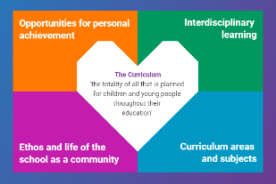  Indicates which of the contexts this plan addresses |   Depending on your focus, this plan could  link to some or all of these SDGs |  |  |  | 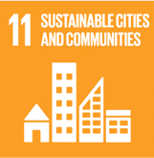 | 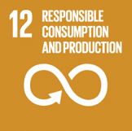
 | 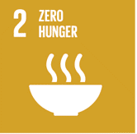 | 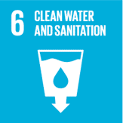 | 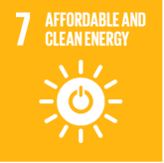 | 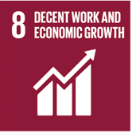 | 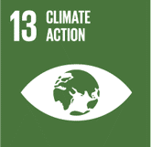 | 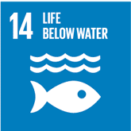
This plan is designed to develop pupil understanding of the following elements of Learning for Sustainability: waste reduction, recycling, sustainable energy and water use, protecting biodiversity, responsible use of the planet’s resources, growing food and tackling climate change
THIS PLAN BUNDLES THE FOLLOWING EXPERIENCES AND OUTCOMES, SUBJECT AREAS & ORGANISERS
Science – Planet Earth -  Biodiversity and interdependence  SCN 3-01a - I can sample & identify living from different habitats to compare their biodiversity & can suggest reasons for their distribution.  SCN 3-02a I have collaborated on investigations into the process of photosynthesis & I can demonstrate my understanding of why plants are vital to sustaining life on Earth. | 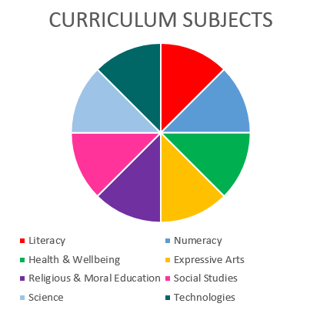  TECHNOLOGIES  SCIENCE |  |  |  | Technologies – Impact, contribution, and relationship of technologies on business, the economy, politics and the environment  TCH 3-06a – I can evaluate the implications for individuals & societies of the ethical issues arising from technological developments  TCH 3-07a – I can identify the costs & benefits of using technologies to reduce the impact of our activities on the environment & business.  TCH 3-08a - I can explore the impact, contribution & use of various software applications & emerging hardware in business.
Science – Planet Earth – Energy sources & sustainability  SCN 3-04a - I can use my knowledge of the different ways in which heat is transferred between hot & cold objects & the thermal conductivity of materials to improve energy efficiency in building or other systems.  SCN 3-04b By investigating renewable energy sources & taking part in practical activities to harness them, I can discuss their benefits & potential problems. | Science – Planet Earth – Processes of the planet  SCN 3-05a - By contributing to experiments & investigations, I can develop my understanding of models of matter & can apply this to changes of state & the energy involved as they occur in nature.  SCN 3-05b - I can explain some of the processes which contribute to climate change & discuss the possible impact of atmospheric change on the survival of living things.

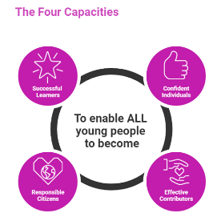 | The over-arching learning purposes of this plan are broad and you will want to focus your teaching to make it more coherent for your learners. Here are examples of possible, interdisciplinary learning intentions for this plan. You may choose alternatives which derive from your pupils’ progress, needs and interests.
We are learning about diversity.
We are developing our ability to understand & build on concepts & ideas
We are learning about interdependence and consequences
 | The key questions below are examples of how you could meet the above learning intentions and structure your teaching of the knowledge, skills and attitudes in selected E s & O s from this bundle. As above, you may choose alternatives which derive from your pupils’ progress, needs and interests. Our suite of Falkirk Council Progression Pathways will help you differentiate your teaching to ensure appropriate pace and challenge.
What is biodiversity? |  | What can we discover about heating & cooling our homes & workplaces?
How can we check or measure biodiversity? |  | Which materials retain heat? How is heat lost?
What does sampling involve? |  | How is this knowledge useful in the design of homes & workplaces?
What is a habitat? |  | What is renewable energy? How could it contribute to heating our homes & work places?
How can we check and describe distribution? |  | How can we use the processes of our planet to give us useful energy?
How do plants grow? Where does their energy come from? |  | How does our use of energy harm planet Earth?
How important are plants in our world? |  | How do our actions affect the diversity of living things on Planet Earth?
Focus Skills/Benchmarks Assessed through this plan of work – tick or highlight
Science Skills
- Plans and designs scientific investigations and enquiries
- Carries out practical activities within a variety of learning environments
- Analyses, interprets and evaluates scientific findings
- Presents scientific findings
- Applies scientific analytical thinking skills, with increasing independence, working with less familiar and more complex contexts.
- Applies understanding of an increasing range of science concepts to solve problems and provide solutions. –
- Demonstrates further development of creative thinking including through the engineering processes of design, construction, testing and modification
- Demonstrates understanding of the impact of science on society and debates and discusses the moral and ethical implications of some scientific developments, demonstrating respect for the views of others. –
- Expresses informed views about topical scientific issues, including those featured in the media, based on evidence and demonstrating understanding of underlying scientific concepts
Science Benchmarks
- Identifies living things using biological keys.
- Collects and analyses increasingly complex data and information, for example, temperature and light intensity, to suggest reasons for the distribution of organisms within different habitats.
- Describes the process of photosynthesis (using the word equation) in terms of reactants (raw materials) and products.
- Applies knowledge gained from practical investigations to explain how green plants make their own food in the form of sugars and store this as starch.
- Investigates and presents information on how plants help to sustain life, for example, by providing oxygen, food, habitat, raw materials and medicines
- Applies knowledge from practical investigations to explain how heat is transferred by conduction, convection and radiation.
- Establishes a link between heat loss in buildings and the temperature difference between the inside and outside of the building.
- Applies understanding of thermal energy efficiency, conductors and insulators to explain how materials can be used in building design to reduce heat loss, for example, in double and triple glazing
- Presents research findings on the advantages and disadvantages associated with the use of renewable energy sources and their impact on society, demonstrating an informed view based on evidence.
- Describes, using particle models and diagrams, the properties of solids, liquids and gases and applies this knowledge to identify and classify unknown substances.
- Applies understanding of models of matter to explain changes of state in terms of energy being gained or lost by a substance
- Explains how the levels of carbon dioxide in the atmosphere have increased over time, for example, through respiration of organisms, deforestation and increased combustion of fuels.
- Draws on supporting evidence, quotes and sources to demonstrate an association between carbon dioxide in the atmosphere and increasing global temperatures as a result of the greenhouse effect.

Technologies Skills
- Higher order thinking – observing and interpreting information, analysing and evaluating, making decisions
- Exploring ideas with creativity
- Maintaining focus on the purpose & constraints of a task/project
- Creating solutions to problems in 2 or 3 dimensions
- Using materials in sustainable ways – reducing waste, thinking of ways to re-use or upcycle materials/objects
Technologies Benchmarks
- Demonstrate an awareness of ethical issues around product development
- Demonstrates an understanding of the impact of technologies on the environment and business
- Searches, edits and manipulates text and numbers using appropriate hardware and software

Use the boxes below to capture Literacy, Numeracy and Health and Wellbeing E s & O s which fit well with the purpose of this plan. Consider whether this learning context offers opportunities for your pupils to develop and/or apply skills and knowledge within these E s & O s.


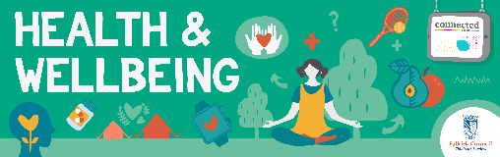
Other subject area?

Quality Learning Experiences | Use this space to record the learning experiences you plan with and for your pupils. These should include opportunities for pedagogy which is playful, active and inquiry-based. You may also want to create a learning plan, wall or floor book with you pupils.  These experiences should take account of whether the indoor or outdoor environment is best suited for this learning.
Assessment Approaches used  & evidence generated | This will be a blend of formative and summative, formal and more informal assessment & feedback. This may include checking achievement of a level through a task which results in formal evidence of application of learning within an unfamiliar context.
Evaluation | Recording your reflections on this learning will guide subsequent teaching and learning for you and the next teacher of this class/group. It may help you identify evidence for a practitioner enquiry, or small test of change to help you manage your own ongoing improvement. You may also want to capture pupil feedback on this block of learning

