FIRST LEVEL  Primary 2, 3 & 4 | LEARNING FOR SUSTAINABILITY  BUNDLE 1 – EXPLORING SUSTAINABLE PRACTICES
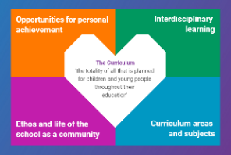  Indicates which of the contexts this plan addresses |   Depending on your focus, this plan could  link to some or all of these SDGs |  |  |  | 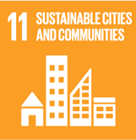 | 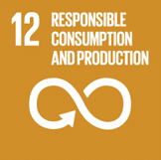
 | 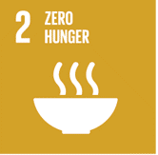 | 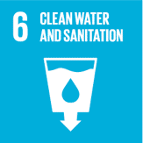 | 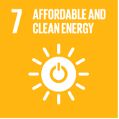 | 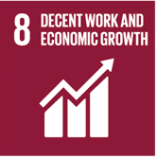 | 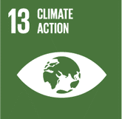 | 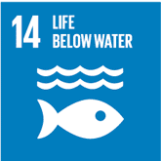
This plan is designed to develop pupil understanding of the following elements of Learning for Sustainability: waste reduction, recycling, sustainable energy and water use, protecting biodiversity, responsible use of the planet’s resources, growing food and tackling climate change.
THIS PLAN BUNDLES THE FOLLOWING EXPERIENCES AND OUTCOMES, SUBJECT AREAS & ORGANISERS
Science – Biodiversity and interdependence  SCN 1-01a - I can distinguish between living and non-living things. I can sort living things into groups and explain my decisions. | 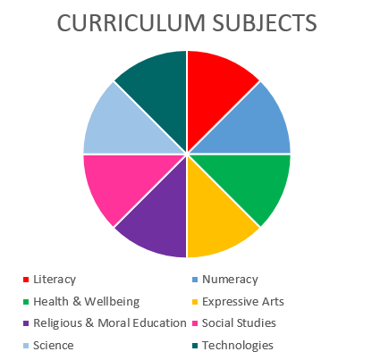  SCIENCE  TECHNOLOGIES |  |  |  | Technologies – Impact, contribution, and relationship of technologies on business, the economy, politics and the environment  TCH 1-06a - I can take appropriate action to ensure conservation of materials and resources, considering the impact of my actions on the environment  TCH 1-07a I understand how technologies help provide for our needs and wants, and how they can affect the environment in which we live.
Science – Planet Earth – Energy sources & sustainability
SCN 1-04a - I am aware of different types of energy around me and can show their importance to everyday life and my survival.
Science – Planet Earth – Processes of the planet  SCN 1-05a - By investigating how water can change from one form to another, I can relate my findings to everyday experiences |  |  |  |  | Representing ideas, concepts and products through a variety of graphic media  TCH 1-11a - I can explore and experiment with sketching, manually or digitally, to represent ideas in different learning contexts.

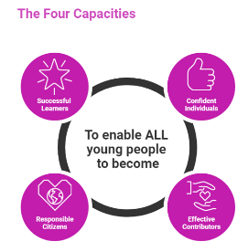 | The over-arching learning purposes of this plan are broad and you will want to focus your teaching to make it more coherent for your learners. Here are examples of possible, interdisciplinary learning intentions for this plan. You may choose alternatives which derive from your pupils’ progress, needs and interests.
We are learning about diversity
We are developing our ability to understand & build on concepts & ideas
We are learning about interdependence and consequences
 | The key questions below are examples of how you could meet the above learning intentions and structure your teaching of the knowledge, skills and attitudes in selected E s & O s from this bundle. As above, you may choose alternatives which derive from your pupils’ progress, needs and interests. Our suite of Falkirk Council Progression Pathways will help you differentiate your teaching to ensure appropriate pace and challenge.
What are the differences between living and non-living things? |  | How important is water to me and my life, and to living and non-living things/our planet?
How can living things be sorted and categorised according to their characteristics and features? |  | How can we look after our supplies of water and other important materials around us?
What is energy and how does it look and work in my life? |  | Which technologies do I need and want, and how do these affect my local area, other living things and planet Earth?
How important is energy to me and to the world around me? |  | How can I use my drawing, writing and graphic design skills to share my ideas about living things, energy and looking after the resources of our planet?
What do I know about water and the ways it can change? |  | Which manual and digital skills can I use to capture and share my ideas and findings?
Focus Skills/Benchmarks Assessed through this plan of work – tick or highlight
Science Skills
- Plans and designs scientific investigations and enquiries.
- Carries out practical activities in a variety of learning environments.
- Analyses, interprets and evaluates scientific findings.
- Presents scientific findings.
- Applies learning in the sciences.
- Provides creative solutions to scientific issues and problems.
- Contributes to the design processes and uses components to make models.
- Demonstrates reasoning skills and draws on understanding of science concepts to make and test predictions.
- Provides explanations which are supported by evidence.
- Expresses informed views of scientific issues, both orally and in writing, and respects the views of others.
- Makes connections between science and their own health and wellbeing.
- Demonstrates awareness of their own impact on the world
- Demonstrates awareness of how people use science in their everyday lives and in a variety of jobs and careers.
- Discusses science topics in real-life contexts including those appearing in the media
Science Benchmarks
- Explains the difference between living and non-living things, taking into consideration movement, reproduction, sensitivity, growth, excretion and feeding.
- Creates criteria for sorting living things and justifies decisions.
- Sorts living things into plant, animal and other groups using a variety of features.
- Demonstrates awareness of how energy from the sun can be taken in by plants to provide the major source of food for all living things.
- Interprets and constructs a simple food chain, using vocabulary such as ‘producer’, ‘consumer’, ‘predator’ and ‘prey’
- Identifies and talks about types of energy that we get from different energy sources, for example, light, sound, heat and electrical.
- Uses knowledge of different energy sources, for example, sun, food, fuel, wind and waves, to discuss the importance of different types of energy for everyday life and survival.
- Uses more complex vocabulary to describe changes of states of water, for example, ‘condensation’ and ‘evaporation’.
- Contributes to the design of an experiment to determine the temperature at which water boils, freezes and melts, ensuring appropriate use of units.
- Knows that pure water boils at 100°, melts at 0° and freezes at 0°

Technologies Skills
- Higher order thinking – observing and interpreting information, analysing and evaluating, making decisions.
- Exploring ideas with creativity
- Maintaining focus on the purpose & constraints of a task/project
- Creating solutions to problems in 2 or 3 dimensions
- Using materials in sustainable ways – reducing waste, thinking of ways to re-use or upcycle materials/objects
Technologies Benchmarks
- Identifies ways in which energy can be saved.
- Understands how and where we waste materials and resources.
- Demonstrates an understanding of how technologies, by meeting our needs and wants, affect the environment in which we live.
- Creates manual and/or digital sketches to represent ideas.

Use the boxes below to capture Literacy, Numeracy and Health and Wellbeing E s & O s which fit well with the purpose of this plan. Consider whether this learning context offers opportunities for your pupils to develop and/or apply skills and knowledge within these E s & O s.
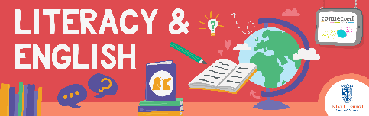
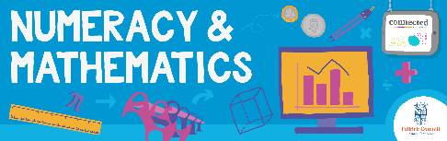
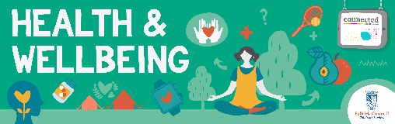
Other subject?

Quality Learning Experiences | Use this space to record the learning experiences you plan with and for your pupils. These should include opportunities for pedagogy which is playful, active and inquiry-based. You may also want to create a learning plan, wall or floor book with you pupils.  These experiences should take account of whether the indoor or outdoor environment is best suited for this learning.
Assessment Approaches used  and evidence generated | This will be a blend of formative and summative, formal and more informal assessment & feedback. This may include checking achievement of a level through a task which results in formal evidence of application of learning within an unfamiliar context.
Evaluation | Recording your reflections on this learning will guide subsequent teaching and learning for you and the next teacher of this class/group. It may help you identify evidence for a practitioner enquiry, or small test of change to help you manage your own ongoing improvement. You may also want to capture pupil feedback on this block of learning

