SECOND LEVEL  Primary 5, 6 & 7 | LEARNING FOR SUSTAINABILITY  BUNDLE 1 – EXPLORING SUSTAINABLE PRACTICES
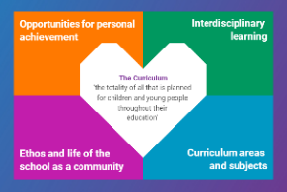  Indicates which of the contexts this plan addresses |   Depending on your focus, this plan could  link to some or all of these SDGs |  |  |  | 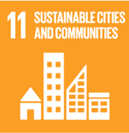 | 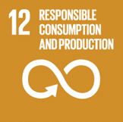
 | 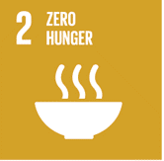 | 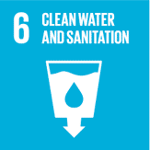 | 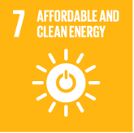 | 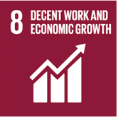 | 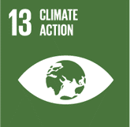 | 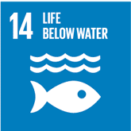
This plan is designed to develop pupil understanding of the following elements of Learning for Sustainability: waste reduction, recycling, sustainable energy and water use, protecting biodiversity, responsible use of the planet’s resources, growing food and tackling climate change.
THIS PLAN BUNDLES THE FOLLOWING EXPERIENCES AND OUTCOMES, SUBJECT AREAS & ORGANISERS
Science – Biodiversity and interdependence  SCN 2-01a - I can identify and classify examples of living things, past and present, to help me appreciate their diversity. I can relate physical and behavioural characteristics to their survival or extinction. | 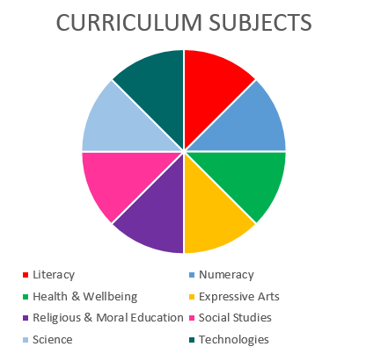  SCIENCE  TECHNOLOGIES |  |  |  | Technologies – Impact, contribution, and relationship of technologies on business, the economy, politics and the environment  TCH 2-06a – I can analyse how lifestyles can impact on the environment and Earth’s resources and can make suggestions about how to live in a more sustainable way.  TCH 2-07a I can make suggestions as to how individuals and organisations may use technologies to support sustainability and reduce the impact on our environment.
Science – Planet Earth – Energy sources & sustainability
SCN 2-04a - By considering examples where energy is conserved, I can identify the energy source, how it is transferred and ways of reducing wasted energy
Science – Planet Earth – Processes of the planet  SCN 2-05a - I can apply my knowledge of how water changes state to help me understand the processes involved in the water cycle in nature over time. | Technologies – Representing ideas, concepts and products through a variety of graphic media  TCH 2-11a - I can use a range of graphic techniques, manually and digitally, to communicate ideas, concepts or products, experimenting with the use of shape, colour and texture to enhance my work.

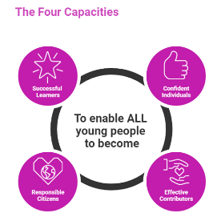 | The over-arching learning purposes of this plan are broad and you will want to focus your teaching to make it more coherent for your learners. Here are examples of possible, interdisciplinary learning intentions for this plan. You may choose alternatives which derive from your pupils’ progress, needs and interests.
We are learning about diversity.
We are developing our ability to understand & build on concepts & ideas
We are learning about interdependence and consequences
 | The key questions below are examples of how you could meet the above learning intentions and structure your teaching of the knowledge, skills and attitudes in selected E s & O s from this bundle. As above, you may choose alternatives which derive from your pupils’ progress, needs and interests. Our suite of Falkirk Council Progression Pathways will help you differentiate your teaching to ensure appropriate pace and challenge.
What can we discover about the classification of living things? |  | How can we use science and technology to reduce wasted energy in the world around us?
What can we find out about how the characteristics of species and their environment have contributed to their survival or extinction? |  | What does making sustainable use of resources, energy and water mean?
What is adaptation and where can we see successful adaptations? Can we look at the past as well as the present to find successful and failed adaptations? |  | In what ways do science and technology bring advantages and disadvantages to the way we use resources. energy and water?
What is the law of conservation of energy? |  | How can we share our views and evidence our thinking about scientific and environmental issues?
How, where and when is energy transferred or transformed into ‘useful’ or ‘wasted’ energy? |  | By considering a particular audience, what kind of graphic text can we create to share and evidence our views?
Focus Skills/Benchmarks Assessed through this plan of work – tick or highlight
Science Skills
- Plans and designs scientific investigations and enquiries.
- Carries out practical activities within a variety of learning environments.
- Analyses, interprets and evaluates scientific findings.
- Presents scientific findings.
- Applies scientific analytical thinking skills, with assistance, working with less familiar (or familiar but more complex) contexts.
- Applies understanding, and a combination of more than one science concept, to solve problems and provide solutions.
- Demonstrates further development of creative thinking including through the engineering processes of design, construction, testing and modification.
At Second Level, it is anticipated that learners will be able to demonstrate the skills below with assistance.
- Presents a reasoned argument based on evidence, demonstrating understanding of underlying scientific concepts, and engages with the views of others.
- Demonstrates understanding of the relevance of science to their future lives and the role of science in an increasing range of careers and occupations.
- Demonstrates increased awareness of creativity and inventiveness in science, the use of technologies in the development of sciences and the impact of science on society.
- Expresses informed views about scientific and environmental issues based on evidence.
Science Benchmarks
- Classifies living things into plants (flowering and non-flowering), animals (vertebrates and invertebrates) and other groups through knowledge of their characteristics.
- Begins to construct and use simple branched keys which can be used to identify particular plants or animals.
- Identifies characteristics of living things and their environment which have contributed to the survival or extinction of a species.
- Describes how some plants and animals have adapted to their environment, for example, for drought or by using flight.
- Demonstrates understanding of the law of conservation of energy (energy can be converted from one form to another but cannot be created or destroyed).
- Identifies the common types of energy (kinetic, potential, electrical, chemical, light, sound and heat) used in energy transfers and transformations that occur in everyday appliances.
- Explains that when energy transfers and transformations take place, energy is converted into ‘useful’ and ‘wasted’ energy, for example a mechanical braking system transforms kinetic energy into heat energy which is dissipated to the atmosphere as ‘waste’ heat.
- Researches non-renewable sources of energy, such as fossil fuels and nuclear, and discusses how these are used in Scotland.
- Draws on increasing knowledge and understanding to suggest ways in which they can reduce their own energy use and live more sustainably.
- Discusses the necessity of water for life, for example, for the growth of crops, for drinking and in river formation/flow.
- Demonstrates understanding of the processes involved in the water cycle
Technologies Skills
- Higher order thinking – observing and interpreting information, analysing and evaluating, making decisions
- Exploring ideas with creativity
- Maintaining focus on the purpose & constraints of a task/project
- Creating solutions to problems in 2 or 3 dimensions
- Using materials in sustainable ways – reducing waste, thinking of ways to re-use or upcycle materials/objects
Technologies Benchmarks
- Explains how and why it is important to conserve energy.
- Discusses the advantages and disadvantages of how technologies impact on the environment for example, renewable energy technologies
- Demonstrates planning for a targeted audience when creating a of graphic display

Use the boxes below to capture Literacy, Numeracy and Health and Wellbeing E s & O s which fit well with the purpose of this plan. Consider whether this learning context offers opportunities for your pupils to develop and/or apply skills and knowledge within these E s & O s.
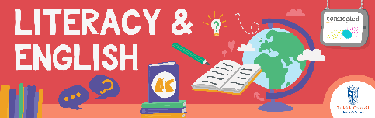
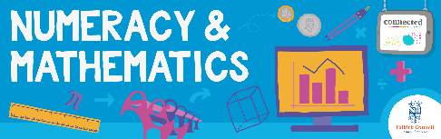
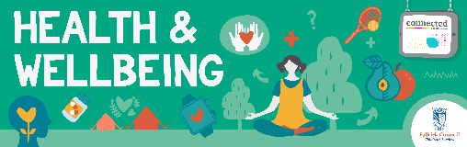
Other subject area?

Quality Learning Experiences | Use this space to record the learning experiences you plan with and for your pupils. These should include opportunities for pedagogy which is playful, active and inquiry-based. You may also want to create a learning plan, wall or floor book with you pupils.  These experiences should take account of whether the indoor or outdoor environment is best suited for this learning.
Assessment Approaches used  and evidence generated | This will be a blend of formative and summative, formal and more informal assessment & feedback. This may include checking achievement of a level through a task which results in formal evidence of application of learning within an unfamiliar context.
Evaluation | Recording your reflections on this learning will guide subsequent teaching and learning for you and the next teacher of this class/group. It may help you identify evidence for a practitioner enquiry, or small test of change to help you manage your own ongoing improvement. You may also want to capture pupil feedback on this block of learning.

