THIRD LEVEL but also suitable for FOURTH LEVEL & SENIOR GROUPS | LEARNING FOR SUSTAINABILITY  BUNDLE 1 – EXPLORING & IMPROVING ENERGY USE IN OUR SCHOOL
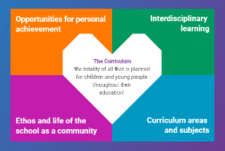  Indicates which of the contexts this plan addresses |   Depending on your focus, this plan could  link to some or all of these SDGs |  |  |  | 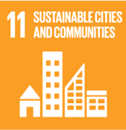 | 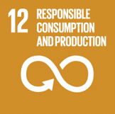
 | 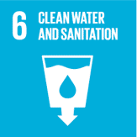 | 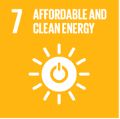 | 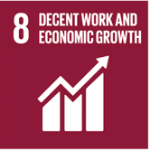 | 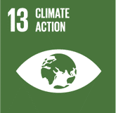 | 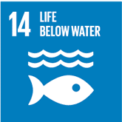
This is a starter plan designed to support teachers and pupils as they engage with the use of energy within their schools. It promotes pupil understanding of the following elements of Learning for Sustainability: sustainable energy, responsible use of the planet’s resources, and tackling climate change
THIS PLAN BUNDLES THE FOLLOWING EXPERIENCES AND OUTCOMES, SUBJECT AREAS & ORGANISERS
Numeracy & Maths – Information Handling – Data Analysis  MNU 3-20a I can work collaboratively, making apppropriate use of technology, to source information presented in a range of ways, interpret what it conveys & discuss whether I believe the information to be robust, vague or misleading.  MTH 3-20b When analysing information or collecting data of my own, I can use my understanding of how bias may arise & how sample size can affect precision, to ensure that the data allows for a fair conclusion to be drawn.  MTH 3-20a I can display data in a clear way using a suitable scale, by choosing appropriately from an extended range of tables, charts, diagrams & graphs, making effective use of technology. | 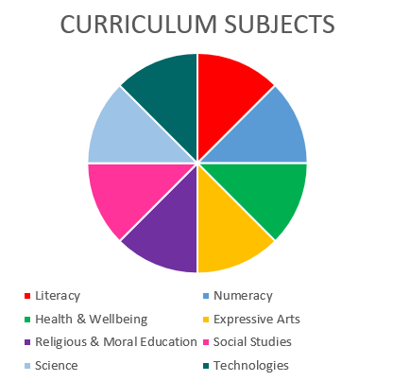 |  |  |  | Literacy & English – Reading – Understanding, Analysing & Evaluating  LIT 3-16a To show my understanding across different areas of learning, I can:  - Identify & consider the purpose, main concerns or concepts & use supporting details  - Make inferences from key statements  - Identify & discuss similarities & differences between different types of text.  ENG 3-17a To show my understanding, I can comment, with evidence, on the content & form of short & extended texts, and respond to literal, inferential and evaluative questions and other close reading tasks and can create different types of close reading tasks.  Writing – Creating Texts  LIT 3-29a I can persuade, argue, evaluate, explore issues or express an opinion using a clear line of thought, relevant supporting detail and / or evidence.
Technologies – Impact, contribution, and relationship of technologies on business, the economy, politics and the environment
TCH 3-06a – I can evaluate the implications for individuals & societies of the ethical issues arising from technological developments
TCH 3-07a – I can identify the costs & benefits of using technologies to reduce the impact of our activities on the environment & business.
TCH 3-08a - I can explore the impact, contribution & use of various software applications & emerging hardware in business.

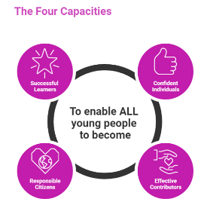 | The over-arching learning purposes of this plan are broad and you will want to focus your teaching to make it more coherent for your learners. Here are examples of possible, interdisciplinary learning intentions for this plan. Feel free to adapt these to your learners’ progress, needs and interests.
We are learning how energy is used in our school.
We are developing our ability to interrogate numerical data.
We are learning how to influence the actions of others
 | You may want to use the key questions below to use as starting points for the learning experiences which will structure your teaching of the knowledge, skills and attitudes in the selected E s & O s for this bundle. Feel free to choose alternatives which better suit your learners’ progress, needs and interests.
How is energy use measured in Scotland? |  | How do we feel about the amount of money our energy costs? Where does this money come from ultimately?
How can we find out how much energy our school uses? |  | What technologies in our school are influencing the amount of energy we use?
How should we read and interpret the numerical information in the graphs and charts? |  | What human behaviours are influencing the amount of energy we use?
What literal information about our school’s energy use can we gain from the graphs and charts? |  | In what ways could we work with others in our school to reduce the unit and financial cost of energy?
What can we infer about energy use in our school from these charts and graphs? |  | In what ways would these reductions affect our school’s carbon footprint/impact on climate change?
How robust do we feel this data is? |  | In what ways could we use our communication skills to campaign for energy use reduction within our school?
In what ways could we check and use this data? |  | In what ways could we measure the impact of our campaign?
How do we feel about the amount of energy units which are used in our school? |  | What have we learned from this experience? What difference have we made to our school and the people in it?

Use the boxes below to capture linked learning in other curriculum areas. Consider whether this learning context offers opportunities for your pupils to develop and/or apply skills and knowledge within these E s & O s.
 | Science – Planet Earth -  Energy sources and sustainability  SCN 3-04a - I can use my knowledge of the different ways in which heat is transferred between hot & cold objects & the thermal conductivity of materials to improve energy efficiency in buildings or other systems.  SCN 3-04b By investigating renewable energy sources & taking part in practical activities to harness them, I can discuss their benefits & potential problems.
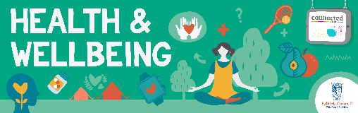 | HWB 3-13a Through contributing my views, time and talents, I play a part in bringing about positive change in my school and wider community.
 | Using digital products & services in a variety of contexts to achieve a purposeful outcome  TCH 3-01a – I can explore and use the features of a range of digital technologies, integrated software and online resources to determine the most appropriate to solve problems  Representing ideas, concepts & products through a variety of graphic media  TCH 3-01a – I can apply a range of graphic techniques and standards when producing images using sketching, drawing and software. TCH 3-11a

Quality Learning Experiences | A suggested outline and sequence of activities is provided below as a starter – you might want to adjust this in practice.
- Launch lesson – Ask learners to guess how much the average Scottish home spends on energy each year. Use appropriate sources to explore this in terms of units and pound and pence. Practise interpreting different kinds of charts and graphs. Explore how this data could enable us to estimate how much energy is used by our school.
- Climate Change team input – share energy use platform and data available about school consumption. Introduce the charts and graphs available in the platform. Share information about climate change and the links with energy use. Introduce the competition to reduce school’s energy use.
- Investigation – consider the order of the following suggestions for your timetable/learners. Skills links are provided for guidance:
- Numeracy skills – use the platform to investigate our school’s energy use charts in both units and pounds/pence. It may be relevant to find out how many people, rooms, floors, windows, etc may be affecting these figures. Consider comparing our school’s data with another school which has similar conditions/numbers. Identify trends, similarities, differences and key information which might inform how we could reduce energy use in school.
- Technologies skills – where/how is energy being used in our school and are there opportunities to reduce this. Group investigation of: fabric of building, facilities, heating system/fuel, window and door specifications, etc. Collate and interrogate data gathered to hypothesise on any technological causes for energy consumption. Identify ideas and technological solutions to reducing energy use in school.
- Literacy skills – research which adults in our school can provide information about how energy being used in school. Initiate and prepare for interview appointment or information exchange with these people. Prepare questions, conduct interview, draw conclusions and key points from these regarding possible next steps. Check whether others use our school and its energy after school hours.
- Science skills – investigate how the heating & lighting systems in school works. What is the science behind each and does this learning suggest any ways in which consumption could be reduced?
- Planning our changes – consider the order of the following suggestions for your timetable/learners:
- Numeracy skills – use the combined information from the investigation phase to prepare estimations and predictions for how much energy it is realistic to save in our school.
- Technologies skills – combine the information from the investigation phase to propose a plan for reducing the energy use in our school. Communicate and collaborate with adults in school who can support any maintenance/running procedures relating to heating, lighting & energy use. Adjust your plan with these adults and discuss how to present this plan to the wider school
- Literacy skills – Look at the proposed maths and technologies plans for reducing school energy usage. Identify key points and actions and plan how to present these to the wider school. Study examples of persuasive texts. Study climate change texts and campaign materials. Identify the techniques and strategies being used in visual, written and digital/moving image texts to persuade people (to reduce their impact on climate change). Work in groups to propose a campaign plan and texts. Groups present plans to rest of class/group, identify which campaign has the best chance of reducing energy use (ensure that learners consider combining/mixing & matching these if valuable).
- All – pupil planning should include consideration and agreement of how the campaign will be managed and run between available timetabled time. This should include the gathering of evidence during the campaign AND the analysis and evaluation of the impact at the end of March 2025.
- Campaign –
- Monitor energy use in units and pound/pence via platform
- Liaise with adults in school to monitor any maintenance/running procedural changes or issues
- Gather evidence of the engagement with the campaign of people in our school
- Analysing and evaluating the impact of our campaign to reduce energy and water use in our school
- Numeracy skills – describe trends in our data. Consider how best to interpret and display data for others.
- Technologies skills – examine evidence regarding the use of heating, lighting and other technologies throughout the campaign. Identify which technological changes had the greatest impact on the energy use of our school as an environment and as a business who is accountable to the local authority. Interpret and create a visual representation of the impact of the campaign for a whole school audience.
- Literacy skills - examine the outcomes of the campaign in terms of people’s responses to the texts and communications strategies employed. Identify which texts/communication strategies had the most/least impact and hypothesise/justify this thinking.

*Optional at any point during the process/period. Consider whether learners would benefit from meeting with peers from another similar school to compare information, ideas, campaign strategies or outcomes. Y McBlain can facilitate an online meeting between all secondary groups involved if desired within our Falkirk Children and Young People’s Team.

Focus Skills/Benchmarks Assessed through this plan of work – tick or highlight
Numeracy and Maths Benchmarks
- Sources information or collects data making use of digital technology where appropriate.
- Interprets data sourced or given.
- Describes trends in data using appropriate language, for example, increasing trend.
- Determines if information is robust, vague or misleading by considering, for example, the validity of the source, scale used, sample size, method of presentation and appropriateness of how the sample was selected.
- Collects data by choosing a representative sample to avoid bias.
- Organises and displays data appropriately in a variety of forms, for example, compound bar and line graphs and pie charts, making effective use of technology as appropriate.
Literacy and English Benchmarks
- Identifies purpose and audience of a range of texts with appropriate justification.
- Gives an accurate account of the main ideas of texts.
- Makes inferences and deductions with appropriate justification.
- Identifies similarities and differences between texts and makes appropriate comments about content, style and/or language
- Responds to a range of close reading questions, including literal, inferential and evaluative questions, to show understanding of texts and knowledge of language.
- Identifies features of language and gives an appropriate explanation of the effect they have on the reader, for example, word choice, sentence structure, punctuation, grammar- and/or imagery
When writing to persuade, argue, evaluate, explore issues or express an opinion:
- Presents ideas or conveys a point of view with relevant supporting detail or evidence.
- Organises and structures ideas or information in a logical order.
- Uses signposts to make structure and/or argument clear, for example, topic sentences and/or linking phrases.
- Includes an introduction that makes the purpose of the text clear and makes some attempt to engage the audience.
- Ends with a conclusion that sums up the line of thought.
- Uses language to influence or persuade the reader, for example, word choice, repetition, rhetorical questions and/or emotive language
Technologies Skills
- Higher order thinking – observing and interpreting information, analysing and evaluating, making decisions
- Exploring ideas with creativity
- Maintaining focus on the purpose & constraints of a task/project
- Using materials in sustainable ways – reducing waste, thinking of ways to re-use or upcycle materials/objects
Technologies Benchmarks
- Demonstrates an understanding of the impact of technologies on the environment and business
- Searches, edits and manipulates text and numbers using appropriate hardware and software

Assessment Approaches used  & evidence generated | This will be a blend of formative and summative, formal and more informal assessment & feedback.  Below there is a suggestion of the range of holistic evidence of learner progress which could be gathered during this interdisciplinary unit of work. This is not exhaustive and provides a few examples which you will want to supplement in each subject area or as an overall unit assessment.
Formative/informal – teacher observation and comment linked to the success criteria for relevant activities in all subject areas.
Formative/informal – pupil self and peer assessment of selected tasks. Most relevant when a specific task within the whole process is completed but is also useful for review of progress to inform improvements in planned next steps – or editing of ideas and texts.
Formative/semi-formal – teacher comment on specific tasks during the process. Always relating to success criteria set e.g. lesson 3.b) learner gathering of observation of heating, lighting and water-related technology/provision across school.
Summative/semi-formal - teacher marking and comment on specific tasks during the process. Always relating to success criteria set e.g. lesson 3.a) identification of key trends, interpretation of graphs and charts in maths.
Summative/formal – Pupil self and teacher assessment of lessons 6a, b & c – could be via pupil written or visual assessment of the impact of the unit on school energy and water use OR a conversation between learner(s) and teachers. A rating scale could be defined in advance by the group for each of the selected over-arching success criteria.

Evaluation | Recording your reflections on this learning will guide subsequent teaching and learning for you and the next teacher of this class/group. It may help you identify evidence for a practitioner enquiry, or small test of change to help you manage your own ongoing improvement. You may also want to capture pupil feedback on this block of learning

