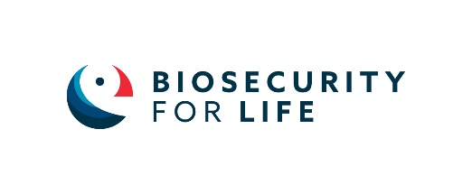
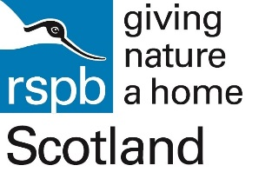

Media release
For immediate release

Pupil power takes saving our seabirds to another level
Online education resources designed by school children launched by conservation project
RSPB Scotland is encouraging primary schoolteachers to inspire Scotland’s young nature conservationists to save our seabirds by signing up to a free education resource.
Designed by pupils for pupils, with the support of RSPB Scotland’s Education, Youth & Families team, the resources are all available in English, Gaelic and Welsh. They have been produced as part of the Biosecurity for LIFE project which is working to raise awareness of the threat of invasive predators to seabirds and put in place systems to prevent their accidental introduction to islands.
Seven island and coastal schools and youth groups around Scotland were involved in the process. Due to covid restrictions they all took part in online workshop sessions with RSPB Scotland to learn about biosecurity, its importance in their communities, and then encouraged to design ways for other children to find out about how to help island and coastal nature.
The education resource pack is made up of online modules including: an online snakes and ladders style game created by pupils from Small Isles and Raasay Primary with the aim of collecting as many eggs as possibly whilst avoiding predators, a campaigning module where pupils launch a campaign to share this important conservation story and a free physical board game designed by pupils from Small Isles Primary with the aim of eradicating rats from islands.
Laura Copley, RSPB Scotland Education, Youth & Families Manager said: “Scotland is such an important place for many of the world’s incredible seabirds but unfortunately they are facing an increasingly difficult future. It is our collective responsibility to protect them and who better to advocate for this than young nature enthusiasts!
“It’s been a joy collaborating with so many passionate young people from our island and coastal schools to bring this conservation project to life in such an imaginative and empowering the children by helping the nature that lives alongside them in their communities. Watching the resources develop through the concept, design and production stage has been a fantastic learning experience for us all!”
Pupils from the Small Isles Primary in Jura invented the board game Save our seabirds, where players work together to eradicate rats from their islands and prevent their spread to other islands by answering questions and collecting ‘Conservation Points’ to buy biosecurity measures. The design concept was brought to life by Glasgow based company Focus Games. The physical game is now available for free to school signing up to the project.
Jonathan Pye, a teacher from Small Isles Primary, Jura said: “The children seeing their resources brought to life was such a refreshing change and the buzz around this was wonderful to see. So often, engaging with outside organisations means that ideas the children generate aren’t brought to fruition so seeing the looks on their faces when they were able to see (and play) their board games and online resources meant that children had a real sense of worth.”
The resources are simple for teachers to use and form a great project that can easily be included in planning curriculums across the UK.
Ingrid Smith, a teacher in Shetland said: “This inclusive interdisciplinary project fully encapsulates the four cornerstones of Curriculum for Excellence – to enable each child or young person to be a successful learner, confident individual, responsible citizen and an effective contributor.
“Prior to this project, the word biosecurity was not a word most pupils were familiar with, now they are experts and are thrilled to share their knowledge and understanding on this topic, and do so with great enthusiasm, which is definitely contagious! Through developing knowledge, skills and attributes in this innovative way, students were encouraged to appreciate their place in the world and, indeed, how they can make a positive difference.”
When asked what their favourite part of the programme had been the pupils’ responses included: ‘Making our ideas reality’, ‘We worked together’ and ‘I can’t decide, I loved everything.’
Teachers can register an interest in signing up here: educationscotland@rspb.org.uk

You can find out more about Biosecurity for Life here:www.biosecurityforlife.org.uk/education

Biosecurity for LIFE is a partnership between RSPB, National Trust and National Trust for Scotland, it is funded by EU LIFE Environmental Governance and Information [LIFE17 GIE/UK/000572], Scottish Natural Heritage, Natural England, Natural Resources Wales and the Northern Ireland Department for Agriculture, Environment and Rural Affairs

ends
For further information, please contact:
Yvonne McMahon, RSPB Scotland Communications Officer on 07740555262 or email yvonne.mcmahon@rspb.org.uk
Editor’s notes:
The activities were invented and designed by pupils from:
Achaleven Primary School, Argyll & Bute
Aith Junior High School, Shetland
Elgol Primary School, Isle of Skye
North Berwick Youth Group, East Lothian
Raasay Primary School, Ross-shire
Sgoil Bhaile a’ Mhanaich, Na h-Eileanan an Iar
Small Isles Primary School, Argyll & Bute
Photos:

RSPB Scotland is part of the RSPB, the UK’s largest nature conservation charity, inspiring everyone to give nature a home. Together with our partners, we protect threatened birds and wildlife so our towns, coast and countryside will teem with life once again. We play a leading role in BirdLife International, a worldwide partnership of nature conservation organisations.

RSPB Scotland
2 Lochside View
Edinburgh Park
Edinburgh
EH12 9DH
rspb.org.uk

If you’d like to change how you hear from us, it’s easy to do. Email yvonne.mcmahon@rspb.org.uk or write to Media Relations, RSPB, The Lodge, Sandy, Bedfordshire, SG19 2DL.

The Royal Society for the Protection of Birds (RSPB) is a registered charity.
In England and Wales, no: 207076.
In Scotland, no: SC037654.

