Sustainable living: food, phones and fashion
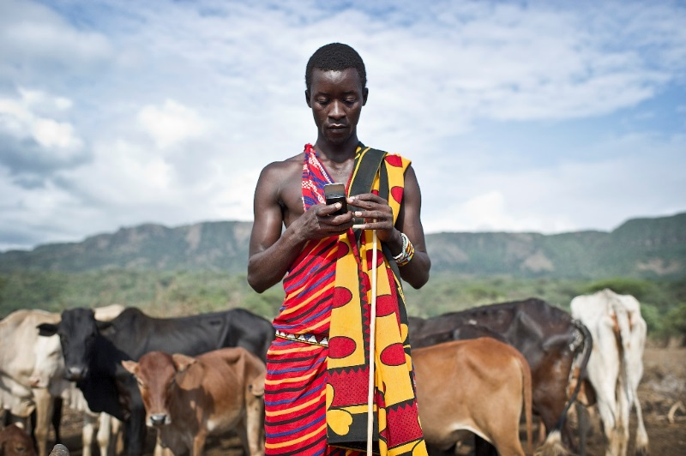
What do you know about how your mobile phone, your food and your clothes were produced? Who made them? What kind of life do they have? What impact did its production have on the environment?
Explore issues of sustainable development, rights and our global connections as we consider how everyday products link us to people and issues around the world and ask: how can we use our consumer power to make a difference?
This session will provide ideas, resources and activities for exploring these ideas in the classroom. Our starting point will be our everyday global connections and the unexpected impacts this can have on the lives of others.
Aims:
- Make links between our understanding of Global Citizenship and our attitudes and behaviours as consumers
- Consider the issues of trade, the environment, workers’ rights, through clothes, mobile phones and food
- Reflect on the impact of everyday consumer goods from an environmental, social and economic perspective and reflect on how we can explore this issue with young people
- Consider the possibilities we have as consumers to make choices and how we can support young people to take action
Venue: Camelon Education Centre
Date: 14th January 2016
To register for a place on this contact isabel@scotdec.org.uk
This session is one in a series of professional learning workshops being offered under the Global Learning Programme Scotland.

