Global learning, sustainable learning: how is it going with you?

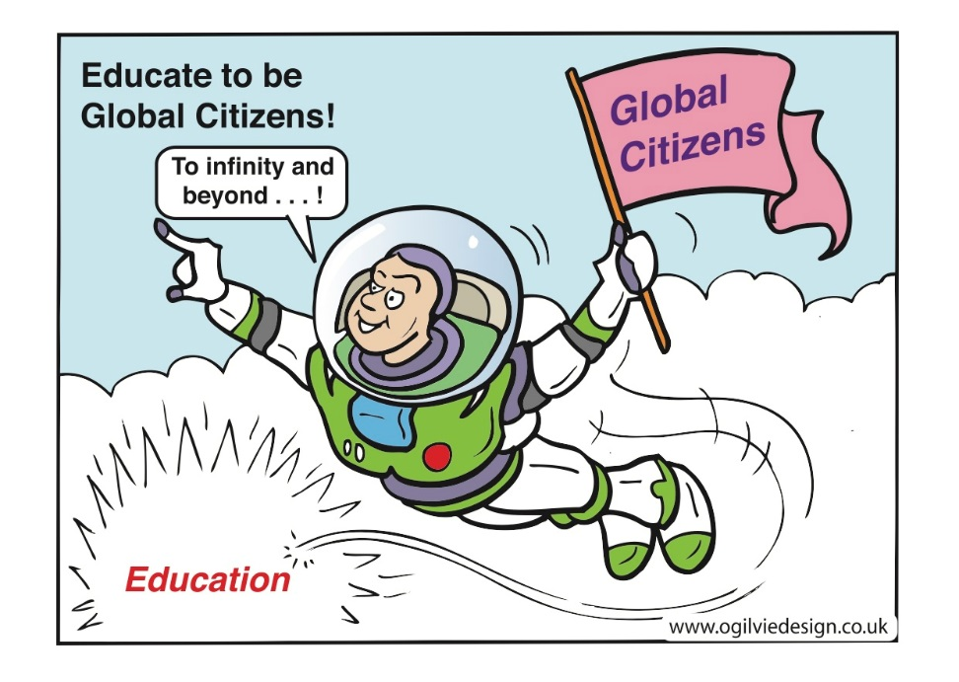

Done Fairtrade? Tried out an issues tree? Like pupil participation? Keen to make local to global connections?

This GLOW meet is all about sharing good practice in Global Citizenship, thinking about how it supports Learning for Sustainability and finding out what further resources and support are available to you and your schools.

Hosted by Scotdec Global Learning centre and Falkirk Council we will provide a space to reflect on your professional learning in this field with like-minded colleagues. We will consider how global learning is connected to Learning for Sustainability and highlight further resources and professional development opportunities available to you.

To register for this event on 26 November please visit Falkirk CPD Manager and use the course code LfS14. Or contact Isabel@scotdec.org.uk for more details.

The link to the Glow meet is https://meet.glowscotland.org.uk/scotdecfalkirk/

Help guides in Adobe Connect itself and here:
https://glowhelp.wikis.glowscotland.org.uk/Glow+Meet

.

