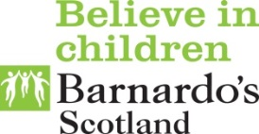
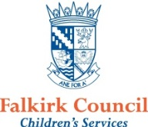

Positive Mental Health & Wellbeing Service
Confidential Self - Referral Form

Date: | Click or tap to enter a date.

Part 1a: About you

Your full name:
Your address:

Your postcode (if you know it):

Your telephone number (if you have one)
What is your date of birth? | Click or tap to enter a date. | Gender: | Choose an item.
Do you have a disability? | Choose an item. | Ethnicity: | Choose an item.

What is the best way for us to contact you?

1b: If you are under 16, who looks after you most of the time?

Name/s

What is their relationship to you?

Telephone number
Do they know that you have asked for our help? |  |  | Yes☐  No ☐
Are you happy for us to speak with them? |  |  | Yes☐  No ☐

1c: Do you help/look after anyone else at home?
Name | Relationship to you | Age

1d: Do you go to school, college, or work?
School ☐ Name of school:
College ☐
Work ☐
None ☐

If yes, is there a time / day you would prefer us to contact you?
Part 2: What would you like us to help you with? (select all that apply)
Developing healthy & positive relationships ☐  Staying safe online ☐  Being confident about body image / building self-esteem ☐  Parenting support ☐  Building resilience / coping strategies ☐ | Please tell us about anything else you are having difficulty with:
Part 3: Are you working with any other services just now?
If yes, please tell us which service and who your key worker is:

Part 4: Is there anything else you think would be helpful for us to know about?

Thank you for completing this form.

Please email the completed form to forthvalleyservices@barnardos.org.uk

A member of the team will be in touch within 48 hours

