SUMMER FAIR
Our parents and pupils worked their socks off to prepare for the school’s summer fair which took place on the 19th June 2019.

All manner of crafts had been created from small wooden benches to toad stools.
The weather was fantastic with bunting, cakes and tea giving the event a lovely summer feel.
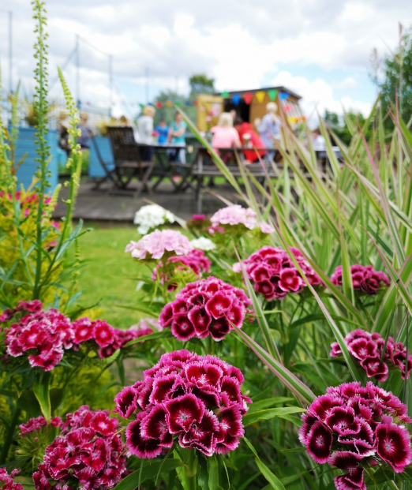

The fair had a great turnout and over £400 pounds have been raised for the school. A great effort from parents, pupils and the family support team. Congratulations to all those involved!

SELAMAT TINGGAL
It’s the end of an era here at the Inclusion & Wellbeing Service as Gillian MacAdam leaves not only the school, but Scotland for a new life in Malaysia.
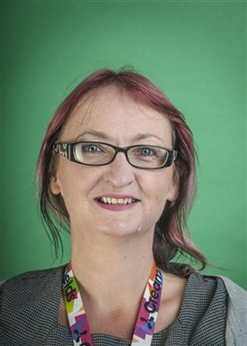
Gillian has worked within the Inclusion & Wellbeing Service for some 9 years, taking on positions such as Depute Head Teacher and acting Head Teacher.

Gillian has accepted a new position in a school in Penang. All pupils and staff wish Gillian and her husband a fond farewell and good luck for the future. Incidentally, Selamat Tinggal means ‘Goodbye’ in Malay.
DofE AWARD
Pupils continue to work towards their Duke of Edinburgh’s Bronze Award with some very close to completion. Over the past few months, pupils have focused on the volunteering component by helping at Bandeath Dogs Shelter. Pupils walk the dogs and look after their welfare.
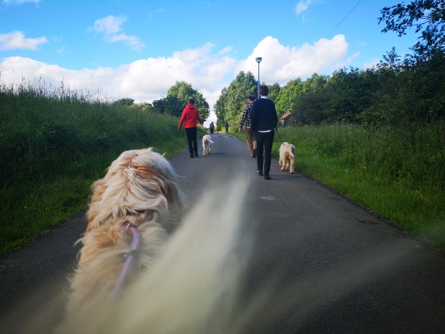

All pupils have been a credit to both themselves and the school. Elsewhere, one pupil took the opportunity to join Kelpies Rugby as part of his physical section and has really enjoyed the experience.

For the skills section, a group of pupils have begun to learn how to tie flies for fly fishing. This skill requires great patience and like the sport itself, a lot of resilience. All pupils showed this in abundance and did really well tying a Black Pennell and Red Tag.
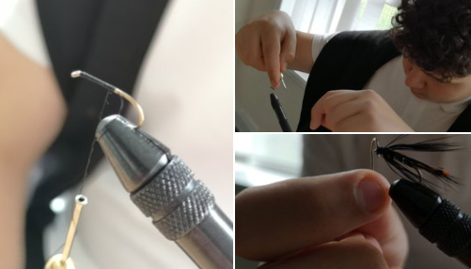
RDA VOLUNTEERING
The school has been given the opportunity for pupils to volunteer with the Forth Valley Driving Group.

This group is based at Carronshore and provides carriage driving for clients with various disabilities. We hope to continue working with the group and involving other pupils in this tremendous activity.
MEET THE STAFF
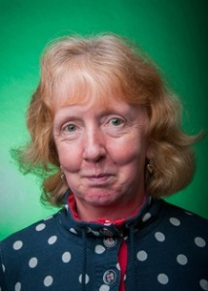
Maggie Castle is one of our longest serving members of staff but one the youngest at heart.

She is revered by pupils and staff for the care and attention she showers on each and every person she meets; Maggie is a ray of sunshine even on the darkest day!
Maggie, a keen walker and horsewoman, is often seen dashing off at the end of the school day to go and care for her animals.
CATERPILLARS
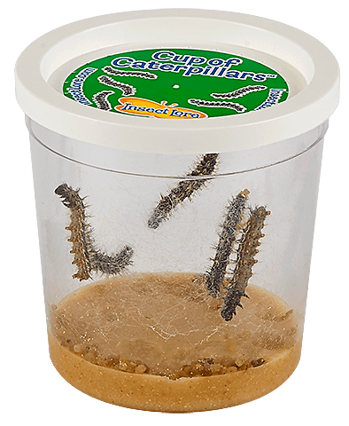
We recently took receipt of ten caterpillars in order to watch, close up and personal, the miracle of metamorphosis.

When the caterpillars arrived, they were only 1cm long, however they are quickly growing!
Some of the pupils have been recruited as monitors so that we can keep a record of this wonderful event.
SAUSAGE SIZZLE
The traditional Friday breakfast has returned with a small group of pupils developing their independent living skills by cooking and serving breakfast to their fellow pupils.
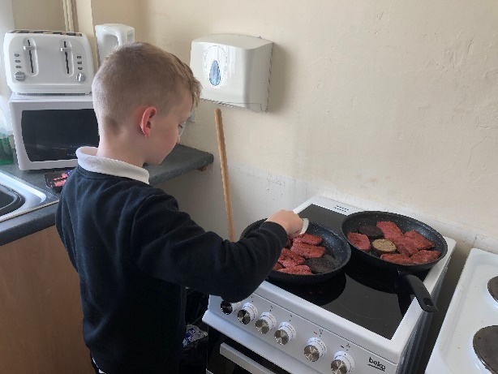

The Friday menu consists of rolls with either scrambled egg, black pudding or square sausage. A big thank you to all our budding chefs and John Ross for organising the breakfast.
DYNAMIC YOUTH
Pupils have been continuing to work towards their Bronze Dynamic Youth Award.
Having set themselves a personal challenge, the pupils have been travelling near and far to undertake project work and bank hours for their award. They have chosen a set of goals and assess each other’s work at the end of the project.
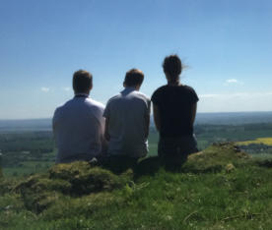
In May this year, one group visited Dumyat. Walking a little way up the hill, they could see the different stages of the River Forth below them.
Another group visited Alva Glen, walking along the path to view the fast-flowing water, gorges and waterfalls.
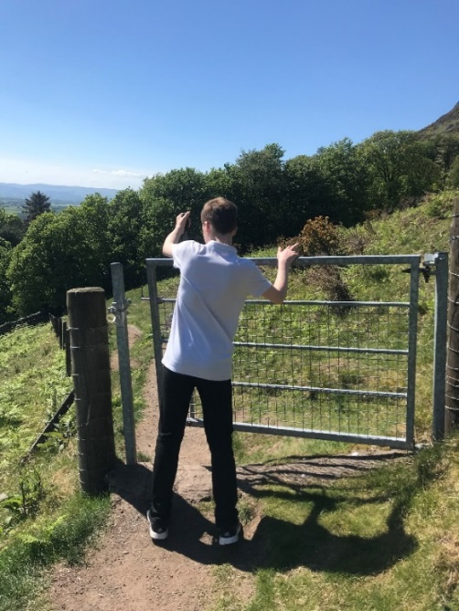

LITTLE KERSE
Our resident football guru, Darren has been coaching a group of pupils every Friday at Little Kerse.

After a series of warm up drills, the pupils focus on the basics of passing, dribbling and shooting. Towards the end of the session they put their skills to good use with a quick match.
ACTIVITY DAY
Earlier in the term, pupils from across the school participated in an activity day. Pupils took part in several activities including navigation training in Devilla Forrest, a visit to the beach and the Science Museum. The weather for the day was very kind with glorious sunshine all day.
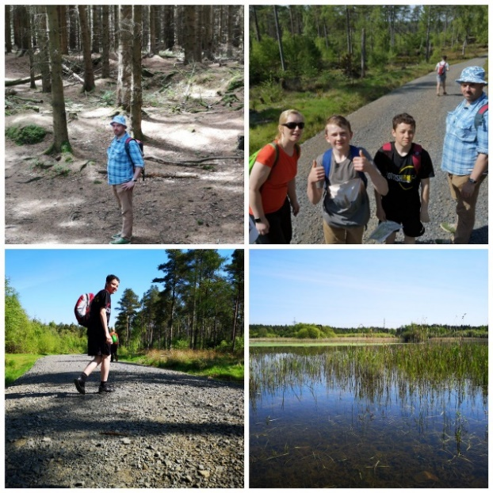

JUMPING BEANS
The second half of the year has seen all pupils within the school, don the now familiar grey and red socks to burn off some energy at Jump N Joy in Clackmannanshire.
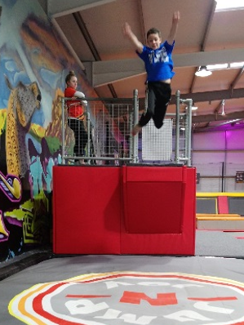

The pupils have been jumping, falling and climbing during these sessions. Pupils have also been able to test out their reaction skills and take a leap of faith from the platform…all in the name of fun.
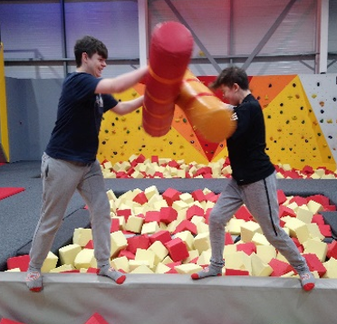

MEET THE STAFF
Meet Darren our teacher of all things religious and philosophical with a bit of morality thrown in.
Darren is our star manager of the school football team, taking the pupils training every Friday.

Darren says “I’ve been a teacher for too many years I care to remember but spent most of my teaching career in Aberdeen before moving down to the central belt a couple of years ago”.
Outside of school, Darren is a passionate Liverpool FC fan and was delirious with the team’s success in the Champions League this season and completely gutted that Liverpool did not win the League.
He’s a massive Ulster and Ireland rugby supporter and will be cheering Ireland on to World Cup glory in this year’s World Cup in September in Japan.

BLOOMING SUCCESS
The school’s Parents Group with help from the Family Support team scored an amazing double this month at Gardening Scotland. Scotland’s annual gardening show plays host to one of the most popular attractions at the Show – the Pallet Garden Competition.
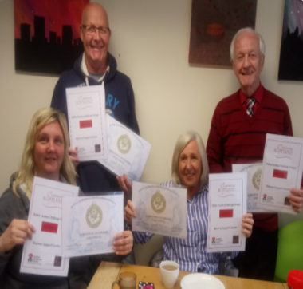

The Family Group won two awards this year, winning a gold award and coming second in their group. This is a fantastic achievement for our both the group and the school.
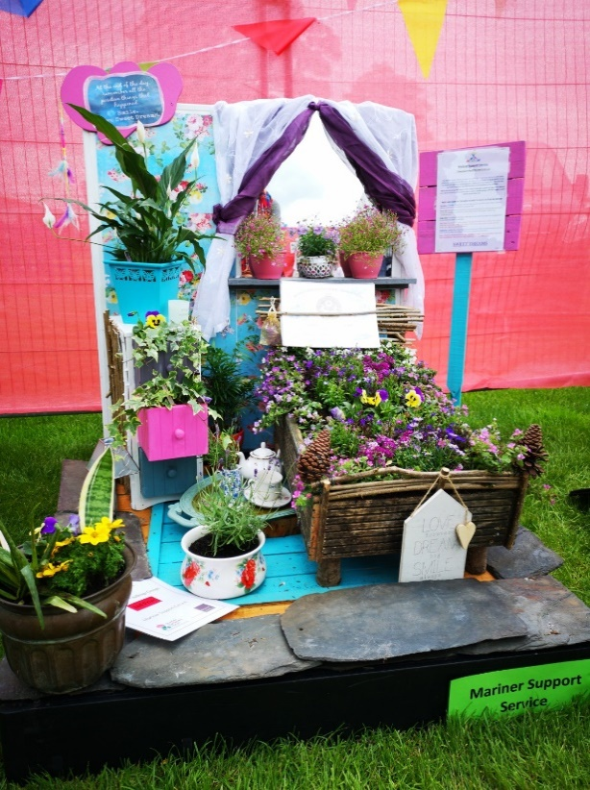

THE DARK SIDE
The month of May saw teaching staff adopt a Star Wars theme for their notice boards.
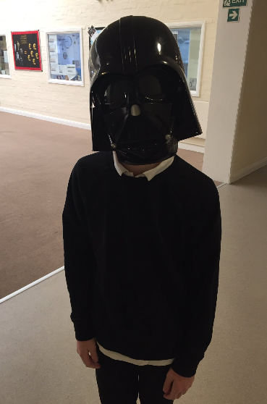

All subjects and even the Head Teacher got their thinking caps on to find a way to incorporate the topic of Star Wars into their subject area. The overall winner of the competition was Maths! Well done to Bev!
This month sees subject areas display their courses for the next academic year.
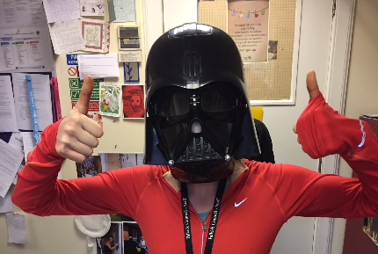

AND FINALLY…
The Pupil Council agreed to purchase seating for the outside activity area to the rear of the school.
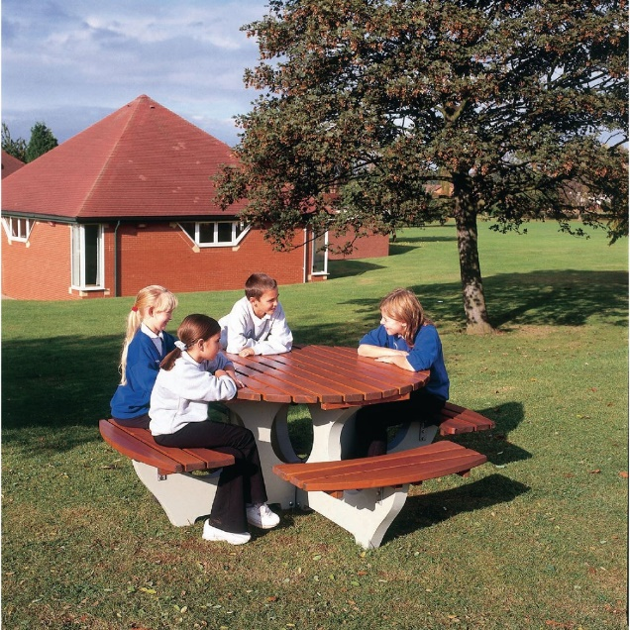
They have also purchased 5-a-side goals for the area. With the better weather, pupils have been enjoying their breaks playing football or sitting in the garden.
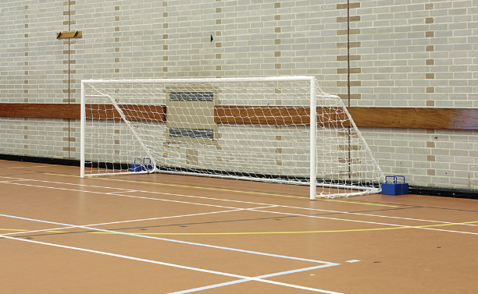
The fitness suite has also benefited from some new equipment including a punching bag, gloves and weights – while the Duke of Edinburgh’s Award group have been busy buying expedition equipment for the new academic year.

Have a wonderful summer holiday!

