|  |
| --- |
| **Service Guidelines for Partners and Schools**  **Inclusion and Wellbeing Service 3-18**  **2018-2019** |
| **Children's Services crest** |
|  |
| |  |  |  |  | | --- | --- | --- | --- | | Inclusion and Wellbeing Service-  Grangemouth Campus  (mid primary)  c/o Moray Primary School  Moray Place  Grangemouth  FK3 9DL  01324 501311 | Inclusion and Wellbeing Service-  Slammanan Campus  (early primary)  Bog Road  Falkirk  FK2 9PB  01324 851082 | Inclusion and Wellbeing Service-  Laurieston Campus  (upper primary and secondary)  Bog Road  Falkirk  FK2 9PB  01324 501090 | Children’s Services  Sealock House  2 Inchyra Road.  Grangemouth.  FK3 9XB.  01324 506600 | |
|  |
|  |

|  |
| --- |
| **Contents** |

|  |  |
| --- | --- |
|  |  |
| Vision Statement | Page 3 |
| Introduction | Page 4 |
| Continuum of Support | Page 5 |
| What to Expect | Page 6 |
| Specialist Provision Placements | Page 8 |
| Requesting Support | Page 10 |
| Ongoing Support Agreements | Page 10 |
| Ending of Support | Page 10 |
| Guidelines for Effective Support and Partnership Working | Page 11 |

|  |
| --- |
| **Vision Statement** |

Vision:

The service is committed to being reflective and responsive to meet the changing needs of the children and young people in Falkirk Council. Our aim is to become a centre of excellence, working with all our partners to plan for and achieve positive outcomes for all of our children, young people and their families.

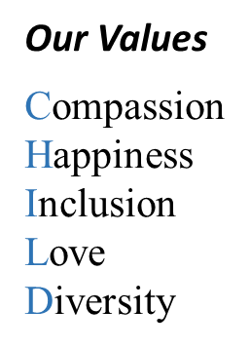

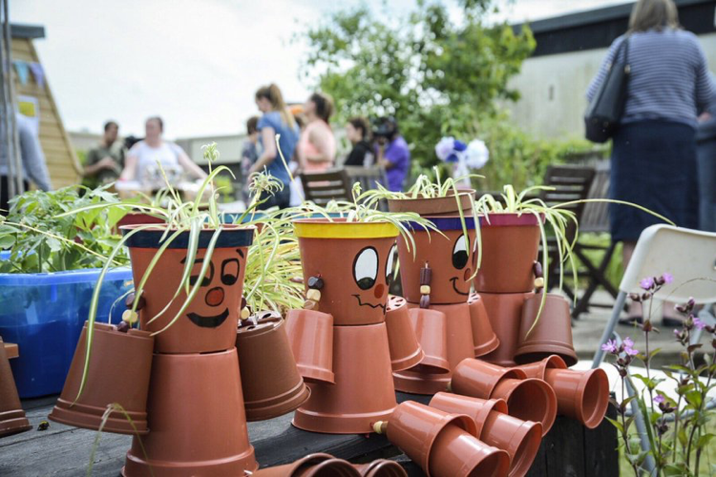

|  |
| --- |
| **INTRODUCTION** |

The Inclusion and Wellbeing Service 3-18 is one of Falkirk Council’s Additional Support Need provisions. The service provides a range of specialist support to children, young people, families, schools and wider agencies. The service has a primary service, located in Grangemouth, and a secondary service located in Laurieston.

We provide an outreach service that can be accessed for children or establishments who required additional support beyond what is available within school resources. The team promotes inclusion and sustainable practice through developing and enhancing the skills of children, families and staff. The aim is to build skills and capacity for the children to remain and succeed within the mainstream setting.

There are a limited number of placements available within the primary and secondary services. The provisions can accommodate part time or full time placements for children aged 5 to 16 years old. Here the children and young people experience environments which are grounded in nurturing approaches and time to begin to reengage positively with learning. The aim is always to build skills and capacity for the children to successfully return to full time mainstream education and raise attainment and achievement.

The multi-disciplinary team working across the Inclusion and Wellbeing Service 3-18 consists of:

* Headteacher
* Depute Headteachers
* Principal Teachers
* Primary and Secondary Teachers
* Support for Learning Assistants
* Inclusion Workers
* Early Years Officers
* Specialist Family Support Workers
* Community Education Worker
* Clerical

“Good relationships and positive behaviour across whole school communities are fundamental to the successful delivery of a Curriculum for Excellence. Underpinning the delivery of these outcomes are the creation of a positive ethos, peaceful learning environments, improved relationships, and positive behaviour in our schools; and making sure our children and young people are included, engaged and involved throughout their school careers.”

Improving relationships and promoting positive behaviour in Scotland’s schools

Scottish Government 2008

|  |
| --- |
| **CONTINUUM OF SUPPORT (Outreach)** |

The Inclusion and Wellbeing Service 3-18 provides a continuum of support for children, young people, families and educational establishments. There is an understanding that educational establishments are continually working towards building their capacity to enhance support available to children, young people and their families. The support offered from the service is designed to avoid duplication of resource and offer additionality to the current provision located within educational establishments. There is an expectation that all partner establishments continue to use existing resource to target and meet the needs of the children.

|  |
| --- |
| **What to Expect** |

**CONSULTATIONS**

Consultation is provided by the service to inform planning the most appropriate way to provide support for children. The aims are:

* To support the development of whole school policies and approaches to promoting positive relationships and behaviour
* To support individual class or subject teachers to ensure purposeful learning environments
* To support school staff to enhance positive behaviour skills
* To support the development of planning for positive behaviours
* To Support consideration of assessment leading to interventions

**CLPL**

The service offers a range of staff development opportunities. The service continues to work in partnership with Psychological Services and wider ASN teams to design and plan training based upon establishment needs and authority priorities.

Staff development can be accessed through:

* Authority CPD Manager
* Direct request for whole school or department staff development
* Direct request for a cluster approach to staff development

SEBN Support Service delivers staff development on topics such as:

* Antecedent Planning
* Health and Wellbeing intervention planning
* Promoting positive behaviour
* Emotion Works (limited availability)
* Responding to challenging behaviour
* De-escalation strategies
* Coaching and Reflecting
* Nurturing Principles
* Trauma Informed Practice
* Child Sexual Exploitation awareness training

The service can design bespoke staff development based upon the needs of the department, school, or learning community.

**DIRECT SUPPORTS**

**Developing group work within a school setting on e.g.**

* Developing self-regulation
* Life skills, personal safety, rights and responsibilities
* Managing feelings, understanding emotions, resolving conflict, problem solving, assertiveness, anxiety, worry and stress, managing low mood, dealing with change
* Self-esteem, self-assurance, self-confidence, self-identity, self-efficacy
* Social communication, friendships, social skills, relationships, working with others, team building
* Supporting transitions programmes

**These interventions would not replace or duplicate what pupil support teams will be able to offer within existing mainstream resources.**

**Direct individualised support**

* Working with parents and carers to identify barriers to participation in school based support or education
* Home school liaison to facilitate effective communication
* Time limited interventions to identify and implement strategies, within the home and/or school, to enhance attendance or engagement
* Contributing to multi-agency assessments
* Contributing to Risk Assessments
* Promoting and supporting social inclusion and participation in school/community based activities
* Contributing to, developing and facilitating personal development programmes for groups and individuals
* Working in partnership with teachers to develop individualised programmes of work aimed at promoting good work habits, social skills and appropriate patterns of behaviour
* Developing and supporting management strategies in classrooms and learning environments
* Working directly with children on developing good habits of behaviour to enhance their ability to access learning
* Working in partnership with parents, carers and other agencies
* Providing intensive support for times of change or transition
* Contributing to multi-agency assessments
* Contributing intervention planning
* Co-operative teaching
* Whole class teaching in order to allow a class teacher to develop a relationship with a child
* Support for embedding restorative ethos

The service has a range of staff available to support outreach. These include Promoted Staff, Teachers, Inclusion Workers, Family Support Workers, Community Learning and Early Years Officers. The service works hard to avoid duplication therefore, termly planning is prerequisite in order to continue any agreed supports. Many of the direct interventions available already exist within secondary school existing resources.

|  |
| --- |
| **Specialist Provision Placements** |

Following full multi-agency assessment, a limited number of placements are available across the service. The placements range from shared placements between the mainstream settings and the specialist provisions to full time specialist placements.

**Placements Primary 1 to Primary 3:**

* Considered once mainstream supports have been exhausted
* Available through request to Placement Change Panel
* Most vulnerable children identified through robust assessment
* Offer up to 50% of the school week:
  + - 1x group of up to 6 children in the morning
    - 1x group of up to 6 children in the afternoon
* Morning groups will support children who have assessed SEBN and will have focus upon relationships, regulation, resilience, literacy and numeracy
* Afternoon groups will support children who have assessed SEBN and will focus upon relationships, resilience and regulation
* The time in mainstream must be effectively resourced and supported within the mainstream setting’s resources.
* Schools must commit their class teacher to a minimum of 1 hour per month to undertake joint planning with provision staff
* Access to the provision is time limited and will not normally be offered for more than 2 years
* Remain on the mainstream school roll
* Mainstream schools will be expected to continue to plan and host termly TAC meetings

**Placements for Primary 4 to S4:**

* Up to 12 children in their final 4 years of primary education (P4-P7). Where assessed as meeting needs this group may include S1 pupils who are not yet ready for secondary experiences
* Up to 24 children between S1 and S4 of their secondary education
* Considered ‘full time’ specialist provision pupils
* Full educational entitlements met for all children
* Most vulnerable children identified through robust assessment
* Additional support available for families of children accessing placements
* Expectation that all children accessing specialist provision will retain a mainstream element in their individualised programmes
* Mainstream schools will commit to attending and contributing to termly TAC meetings
* Continued joint planning to increase mainstream experiences where possible
* Ensuring that children build the skills required to meet their potential for accessing mainstream settings
* Presumption that all children begin S1 within mainstream secondary setting

**Criteria for Primary 1 to Secondary 4:**

* Have previous outreach involvement from Inclusion and Wellbeing Service or has relocated to Falkirk and has been assessed by Falkirk as requiring specialist provision
* Will have been assessed as having/experiencing significant social, emotional or behavioural needs arising from multiple and complex social, emotional and behavioural development factors and/or family circumstances, impacting across the curriculum
* Will have robust assessment of any additional learning needs
* Will be Stage 4 on Falkirk Council’s Staged Intervention
* Require significant support to interact appropriately with adults/peers
* Require support with family relationships
* Require a coordinated approach with partner agencies including family support
* Require a differentiated and adapted learning environment likely to meet the additional support needs
* Presumption that all children begin S1 within mainstream secondary setting

**There is an expectation that all children accessing full time specialist provision will retain a mainstream element in their individualised programmes. Full time alternative educational provision will be only be considered for the last 18 months of statutory education.**

**The Named Person role will move to the Headteacher or Depute Headteacher of the Inclusion and Wellbeing Service 3-18 for children in Primary 4 to S4 who have an agreed placement at a specialist provision. The coordinator from the mainstream school must continue to attend TAC meetings for those children accessing specialist provision.**

|  |
| --- |
| **Requesting Support** |

Support from the Inclusion and Wellbeing Service 3-18 can be requested in line with Local Authority procedures for requesting all ASN supports. Please refer to the Individual and Additional Support Needs page located at <https://blogs.glowscotland.org.uk/fa/asnfalkirk/forms/>

A group will meet monthly to consider all requests and allocated support where appropriate. There may be occasions where the service is running at or near capacity and short waiting lists are required. Therefore, the group may need to make decisions around competing demands based upon clearly assessed needs. Where priorities create the need to change programmes of support, there will be clear planning undertaken with the TAC.

|  |
| --- |
| **Ongoing Support Agreements** |

Once support has been allocated, there should be a TAC meeting put in place within an ongoing 10-12 week cycle to support planning. During the initial meeting it is important to establish the purpose of the intervention, timescales, and frequency of interventions and where the interventions should take place. It is essential that key people are involved in the detailed planning. Normally this would involve the class teacher and support coordinator. Regular check-ins are expected between the teacher and the member(s) of staff offering additional support.

|  |
| --- |
| **Ending of Support** |

Once interventions have ended and the establishment are able to support the additional support needs from within their existing resource, a TAC meeting should be held to formalise the change in support.

The service will then monitor progress for up to 6 months. Where support is required once more and is within the 6 month period then an invitation to the next TAC meeting is required. After 6 months the TAC will be required to resubmit a request for support using the process located on the Additional Support Needs page located at <https://blogs.glowscotland.org.uk/fa/asnfalkirk/forms/>

|  |
| --- |
| **GUIDELINES FOR EFFECTIVE SUPPORT AND PARTNERSHIP WORKING** |

To ensure positive outcomes to services offered partner schools are asked to:

* Allocate time for regular consultation between service staff and establishment staff in order to plan and evaluate support programmes.
* Allocate suitable space and resources to facilitate individual or group work undertaken by the service staff as agreed during planning meetings.
* Retain the responsibility for maintaining a sense of belonging at all times of individual children supported by the service and remain responsible for communicating relevant information to all staff involved with the child.
* Set meetings dates within agreed time limits.
* Support close partnership working with all staff, agencies, parents or carers concerned with meeting the needs of an individual child.
* Consider support offered by the service as intended to enhance supports already provided by staff within the individual school.
* Cooperate in the processes of evaluating and measuring the impact of the services offered by the service