Inclusion and Wellbeing Service 3-18

Inclusion and Wellbeing Service 3-18
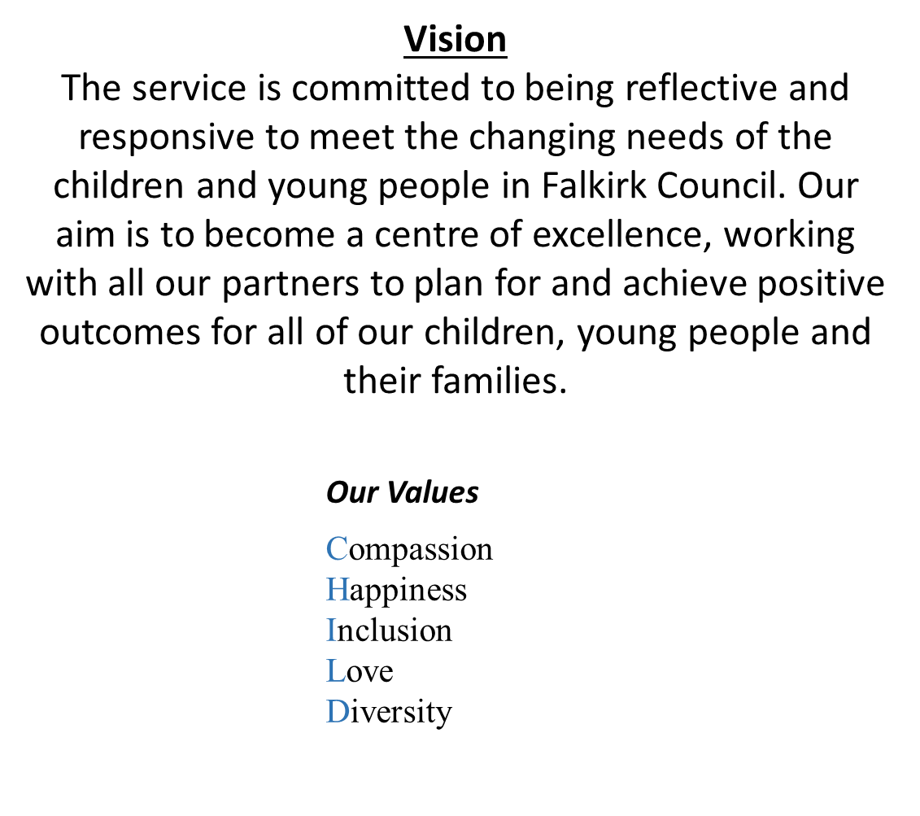
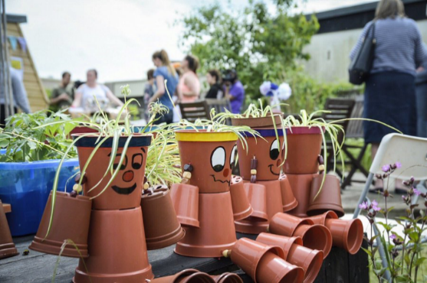
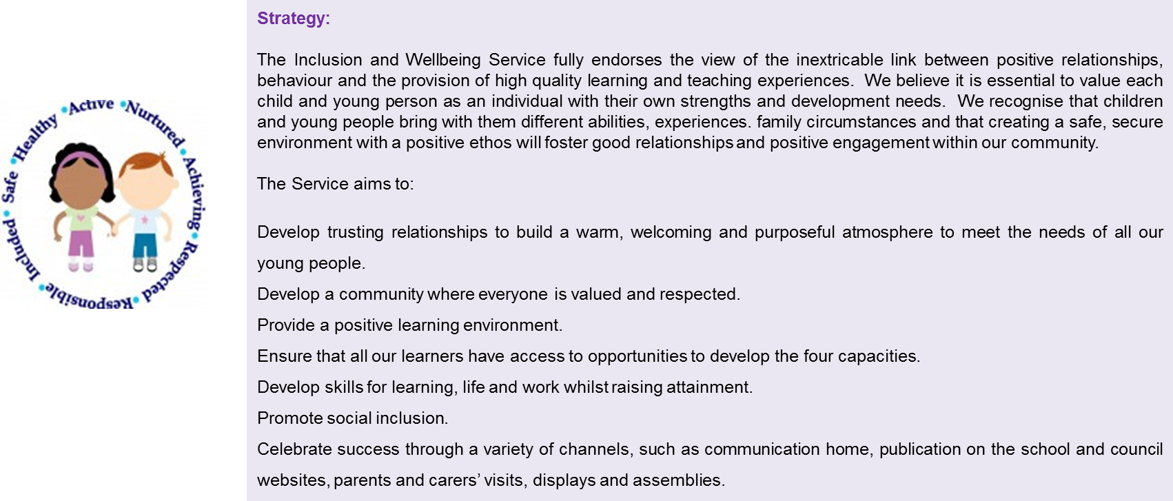
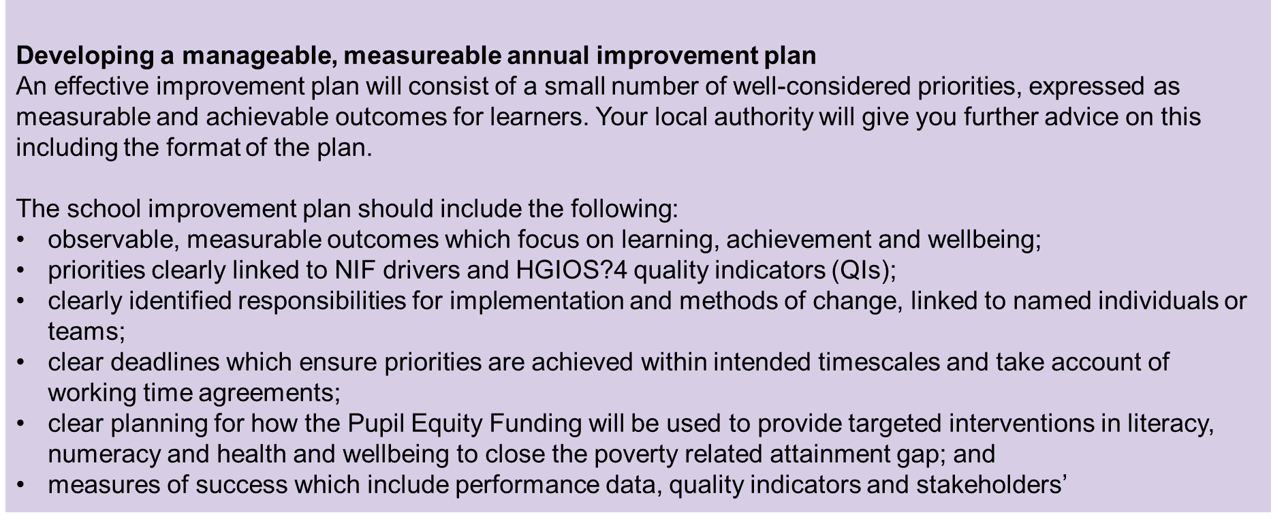
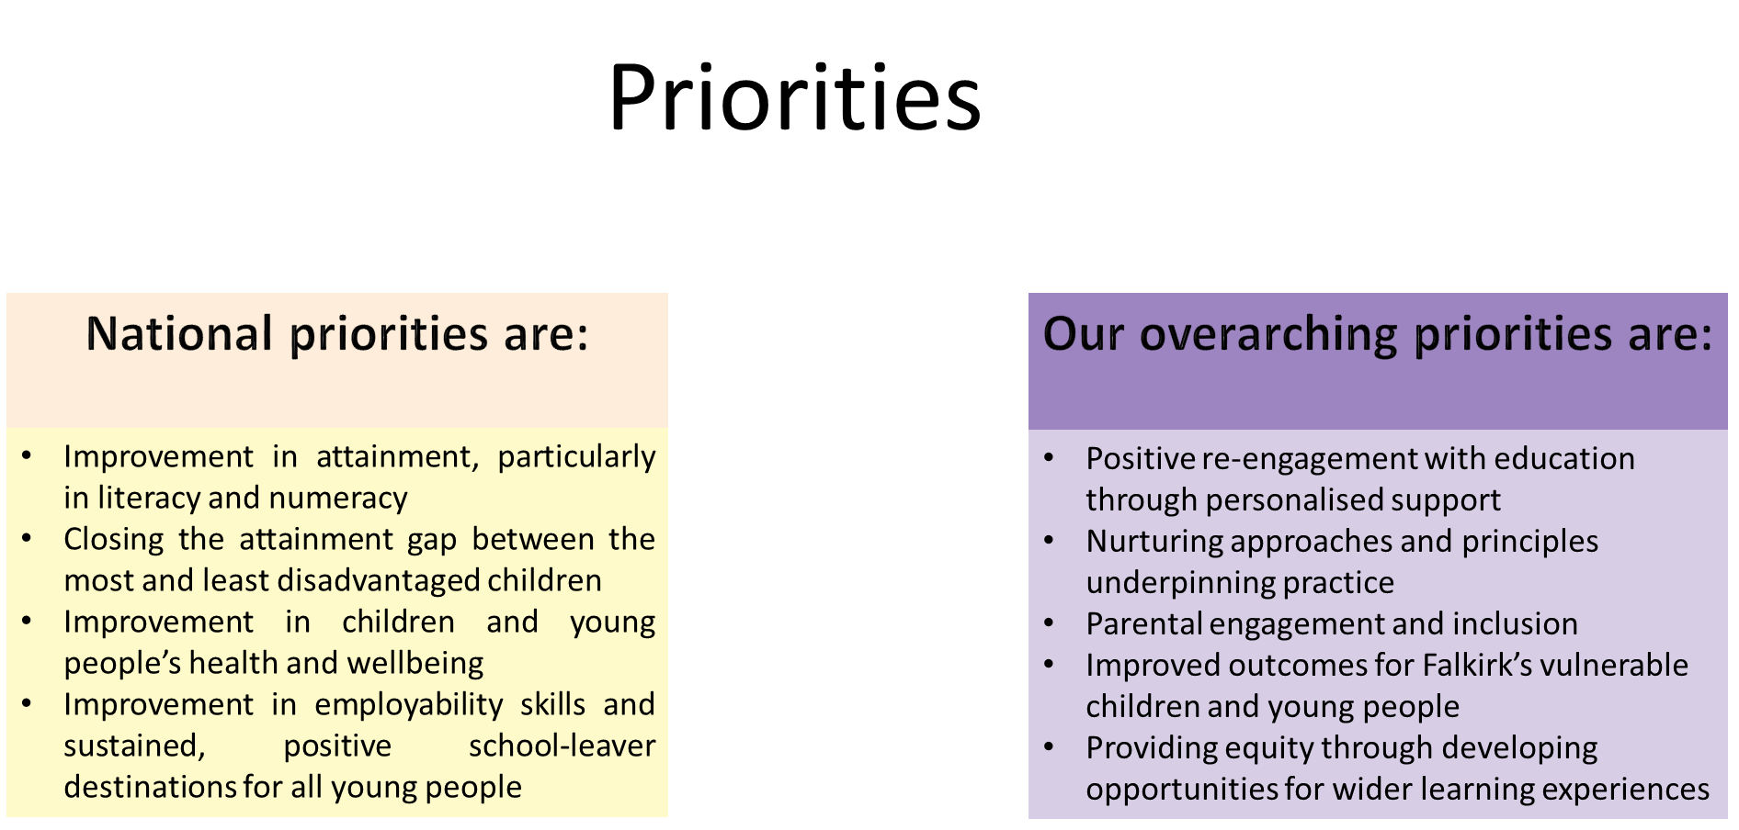

Primary Overview 2019-2022
Link to NIF

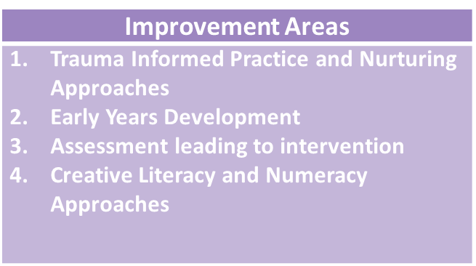
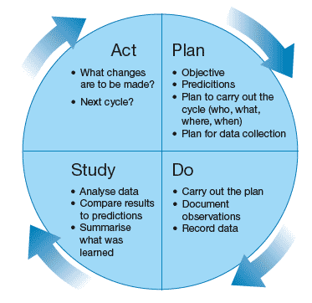

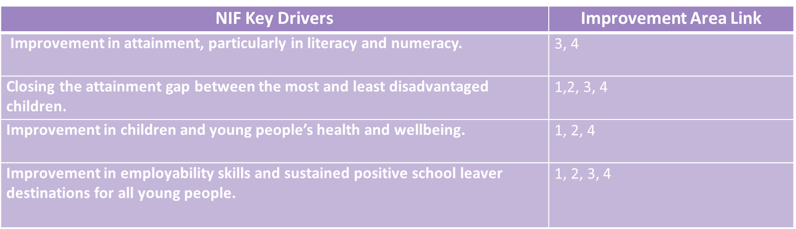

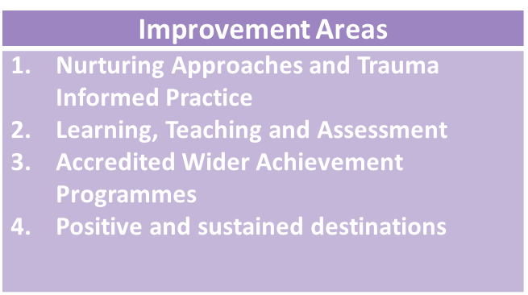
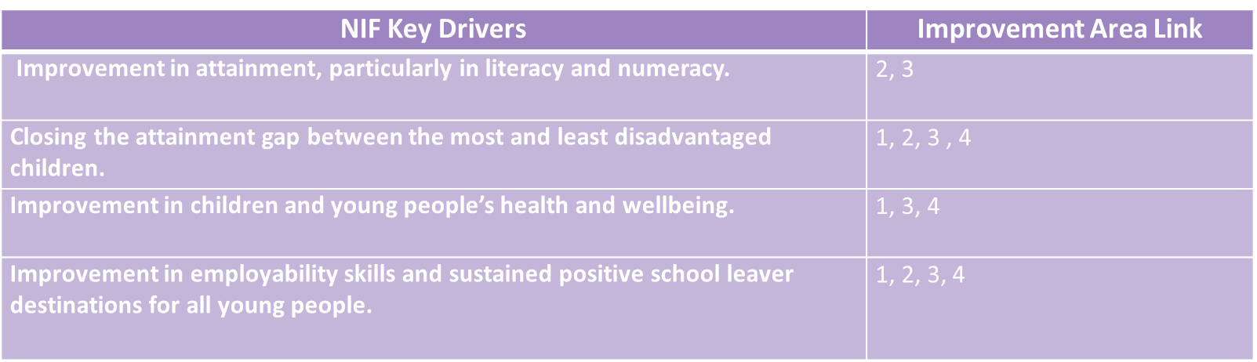
Secondary Overview 2019-2022
Link to NIF

Improvement Priority :
What data / evidence informs this priority? | Outcomes (Detail targets % etc. | Interventions  (Interventions supported by PEF should be in Bold) |  | Expected Impact | Measures  (What on-going information will demonstrate progress? (Qualitative, Quantitative - short / medium / long term data) | Actual Impact
Primary
Specific use of wellbeing assessments is beginning to support direct interventions and measurement. Through using a smaller number of selected wellbeing assessments planning for skills based interventions allows direct interventions to be designed to focus on specific skills based approaches. | To improve the quality and consistency of HWb assessments to inform planning and improve outcomes for young people. | - Support staff in using and analysing the Leuven Scale of Active Engagement in Learning to support change for improvement re adaptations to environment and curriculum  - PT to continue to share knowledge and skills in implementation and utilise online assessment profile and Leuven Scale of Active Engagement in Learning.  - Continued use of the Boxall Profile and Boxall online system as a tool used to design targeted skills based interventions for all children accessing the service’s specialist primary provision  - 6-10 week Boxall assessments being undertaken and data analysed and annotated. |  | - Consistent use of Leuven Scale of Active Engagement in Learning to inform adaptation to environment and curriculum.  - Pupils will participate in daily Boxall (Me Time) sessions.  - Staff are clear about the skills which are being developed through planned HWb experiences.  - Pupils are given valuable daily experiences to support their cognitive, social and emotional developmental skills.  - Pupils able to identify successes and next steps in learning. | - Continuation of Boxall Profile scores improving over time.  - Improved resilience and regulation demonstrated through educational engagement and reduces incidents.  - Progress made in relation to benchmarks.  - Leuven Scale of Active Engagement in Learning showing increasing for all children.
Children attending specialist provision have been assessed as having learning gaps within their early years experiences. The children have poor interaction, resilience and regulation skills. | To improve the quality of children’s play experiences to facilitate play inclusive of learner voice | - All children will receive quality play experiences.  - Both indoor and outdoor play areas are stimulating well-resourced environments with continuous provisions for play available  - Focus on Outdoor play and introducing more loose parts / sensory play  - Staff are clear about the skills which are being developed through planned play experiences. There is a clear progression of skills development  - Extend outdoor educational opportunities for children to explore and learn within contextualised settings  - Further develop children’s voice in their play experiences – through planning.  - Children’s personalisation and choice evident in planning. |  | - Children are engaged in purposeful play experiences.  - Children’s playground experiences are more active and positive.  - Children will be involved in planning their play experiences.  - Children will be more resilient.  - Children will be more ready to apply themselves to work in class.  - All provisions set up with appropriate play spaces and parent/carer involvement continuing to evolve. | - Children show increased self-confidence & self-esteem through increased social interaction.  - Children report more positive playtimes- fewer playground difficulties.  - Children show increased ability to participate in purposeful play experiences.  - Children’s voice evident in their play experiences.
Children accessing specialist provision have had poor experiences of schools limiting their capacity to engage with academic learning. To reduce the barriers and anxiety about learning creative approaches to engagement and accessing literacy and numeracy are required. This will support potential to return to mainstream. | To develop creative ways in Literacy and Numeracy to engage children in their learning. | - Staff planning creative and engaging activities linking to learning within literacy and numeracy  - Use of support staff to support delivery of creative approaches  - Engagement of parents to help with resources  - Use of digital technologies to support improving literacy and numeracy  - Use of outdoor spaces to promote contextualised use of literacy and numeracy skills |  | - Staff/pupil feedback  - Establish pupil voice in the assessment  - Each child will have a literacy and numeracy pack that they engage with on a daily basis  - Pupils will comment on their work and suggest ways to improve or identify what they have done well.  - Staff will feel confident choosing activities related to the learning  - Planning evidencing creative approaches to literacy and numeracy | - Increased engagement with learning  - Samples of work demonstrating re-engagement with literacy and numeracy  - Progress made in relation to benchmarks in literacy and numeracy
There are no additional languages taught within the specialist provision. To reduce disadvantage for those returning to mainstream this is an area that will become increasingly important. | To deliver a 1+2 approach within a small primary provision. | - Launch of French within the primary provision.  - Creation of service languages policy.  - Consultation with staff and parents.  - Completion of bespoke training for all teaching staff  - Principal Teachers delivering French lessons  - Class based staff to embed and reinforce learning that has been undertaken |  | - To develop links with mainstream schools to ensure consistency for children returning to mainstream  - Curriculum provided for learning of pupils  - Gather creative ideas to engage learners in 1+2  - Provide structure and guidance to the provisions to ensure quality learning and teaching | - Increased engagement with learning  - Samples of work demonstrating re-engagement with 1+2  - Progress made in relation to benchmarks
Secondary
Positive destinations are sought for all of the young people leaving specialist provision, however, sustaining these destinations have been challenging for the children once they have left. The service commitment is to support the young people beyond their leaving date. Generational unemployment exists within the family setting and in order to support raising aspirations and opportunity the parents will also be supported by the service to increase their opportunities. | Increasing and promoting sustained and positive destinations for young people, parents and carers | - Careers advice and information office to be established beside library space  - ‘It’s Not Rocket Science’ test of change data to be analysed to develop the group  - Links with Forth Valley College Access and Progression Department for parents and carers and Education Training Unit to be strengthened  - Develop methods of re-engaging families of previous school leavers with no sustained positive destinations  - Enhance creative options for senior phase students to access as career pathways  - Introduce ‘Transition in Action and Essential Skills for Employment’ (Playback ICE) for all senior phase pupils |  | - Annual increase to sustained positive destinations for young people and their parents | - Destination data for pupils and parents  - Uptake data around parental engagement with SDS  - Feedback from parents and pupils on personal impact of program  - Tracking across multiple sessions to measure sustainability of the intervention  - ‘It’s Not Rocket Science’ test of change data showing improvements in key areas
A focus upon learning, teaching and assessment was identified by HMIe in January 2018. This will be a key focus to ensure consistent good practice is evident across each learning opportunity. | Implementation of self-evaluation within the classroom to improve learning, teaching, tracking and assessment | - Increased adaptability, by teachers, to lesson plans when assessing presenting pupils’ mental and physical wellbeing.  - Starters and plenaries to be embedded in each lesson and have direct link to the previous learning.  - Tracking and Monitoring Across BGE to ensure all learners have timely, planned and evidenced based interventions  - All teaching staff to use and examine Leuven Scale of Active Engagement in Learning to support change for improvement re adaptations to curriculum  - Re-launch BGE tracking & monitoring spreadsheet to include newly recruited staff  - Development of a ‘Pupil Skills & Development Record’ encompassing all subjects across BGE level  - Teaching staff to begin identifying skills specific to their subject |  | - Better link between prior learning and current learning.  - Improved continuity of learning and progression.  - Increased engagement in learning. | - Pupil questionnaire.  - SQA results.  - Formative assessment.  - Improvements measures for young people in relation to Leuven Scale of Active Engagement
The service continues to strive to ensure that all children leave with suitable qualifications that build the options and pathways for adult life. Children accessing Mariner Support Service have poor experiences within other settings and often have lower aspirations. | Broadening staff capacity to deliver wider achievement, leading to purposeful learning while broadening opportunities to increase attainment | - Regular staff meetings to evaluate individual pupils and match them to the most suitable and relevant wider achievement activities  - Outdoor Education across 32 weeks with 26 weeks of those delivered by accredited secondary based staff  - Sourcing additional wider achievement opportunities and resource for children and young people relevant to their needs, interests and skills  - Staff ensuring pupils complete the relevant paperwork and evidence  - Use of Amazing Things document to enhance linking curriculum with additional providers to ensure a broader range of qualifications and accreditation  - PT to Support staff in filling in relevant paperwork and logging this in the spreadsheet when registered as completed. |  | - Pupils will develop and enhance resilience and regulation skills  - The pupils will begin to gain experiences away from the confines of the school environment  - Pupils will be able to learn and use social skills and practical transferable skills during their wider achievement experiences.  - Pupils will transfer skills they have developed to enable them to Access College, work experience or paid employment.  - Increased attainment and achievement  - Designated staff will widen their skills and be offered further training opportunities (for example hill and mooreland Leader, mountain bike leader and possible paddle sports) | - Tracking through SCQF Framework and wider achievement providers (Amazing Things)  - Tracking of attainment and achievement via pupil evidence folders  - Attendance tracking to ensure improvement in accessing wider achievement opportunities
Whole Service
An integral part of the service is staff capacity to build nurturing relationships and experiences across the context of the school community. This has a direct correlation to how we support children who have experienced trauma, loss and those who have had other poor life experiences. | Adoption of nurturing approaches across the whole service as a solution and response to past or current trauma | - Principal Teachers accessing additional training and cascade back to whole team over years 2019-2021  - Outreach staff and selected provision staff will be part of the authority Connected and Compassionate Community Pilot  - Nurture and GIRFEC CLPL for staff not on the pilot.  - Staff to familiarise themselves with Scottish Governments The Compassionate and Connected Classroom resource  - Introduction of relaxation therapy for secondary aged pupils  - Relaxation and mindfulness time for primary aged pupils  - Continue to develop and enhance parental supports and parents groups  - Continued development and enhancement of therapeutic space |  | - Improved emotional and mental health and Increased enjoyment and engagement within learning contexts  - Increased capacity to access literacy and numeracy programmes  - Improved attendance  - Lower exclusion rates  - Reduction in recorded incidents  - Improved attainment and accreditation | - Clerical support for SEEMIS data gathering and sharing  - Secondary Boxall profiles  - Nurture Audit Tool  - Key teachers in secondary leading Boxall Profiling and outcome/target setting  - Improvements in engagement using Leuven Scale as a tool to measure
Improvement Planning 2019 -2020 - Inclusion and Wellbeing Service 3-18

