**Falkirk Child and Young Person’s**

**Integrated Assessment and Plan**

**Lead Professional Assessment**

|  |
| --- |
|  |

Assessment Completed by:

|  |
| --- |
|  |

Role of person completing assessment:

|  |
| --- |
| Click or tap to enter a date. |

|  |
| --- |
| Click or tap to enter a date. |

Date assessment started:

Date assessment completed**:**

# My Core Information

*Fields marked with an asterisk (*) are mandatory.*

### My Core Information

|  |  |  |  |
| --- | --- | --- | --- |
| Forename* | | Surname/Alias* | |
|  | |  | |
| Middle Name(s) | | Known as | |
|  | |  | |
| Gender | Date of Birth/  Estimated date of delivery* | Place of Birth | Child’s I.D Number |
| Choose an item. | Click or tap to enter a date. |  |  |

|  |  |  |
| --- | --- | --- |
| Home Address* | Contact telephone number(s)* | |
|  | Home: |  |
| Mobile: |  |
| Work: |  |
| Is the [child]’s current address subject to a ’non-disclosure measure’? |  | |
| Current Address (if different from above) | | |
|  | | |

|  |  |
| --- | --- |
| Main Language* | Choose an item. |
| If ‘Other’, please specify |  |
| Interpreter Needed/Translation requirements |  |
| Religion* | Choose an item. |
| Ethnicity* | Choose an item. |
| Disability* | Choose an item. |
| Is the [child] a Young Carer?* |  |
| If ‘Yes’, details of person cared for: |  |
| Legal Status* | Choose an item. |
| Please specify any conditions |  |
| Immigration status |  |
| [Child] of a person with no recourse to public funds |  |
| Unaccompanied asylum-seeking [child] |  |
|  |  |

### Education

|  |  |
| --- | --- |
| School / Early Learning Centre / Child Care |  |
| Name and contact details |
| Pupil candidate number |  |
| Additional support plan |  |

### Health

|  |  |
| --- | --- |
| Health visitor/school nurse |  |
| Name and contact details |
| GP’s name and contact details |  |

### Family Details*

|  |  |  |
| --- | --- | --- |
|  | Mother | Father |
| Forename |  |  |
| Surname |  |  |
| Birth Surname (if different) |  |  |
| Other names (if any) |  |  |
| Date of Birth | Click or tap to enter a date. | Click or tap to enter a date. |
| I.D No (if applicable) |  |  |
| Parental Responsibility | Choose an item. | Choose an item. |
| If ‘some’ above, please add details |  |  |
| Address (if different to child’s address) |  |  |
| Telephone |  |  |
| Main Language | Choose an item. | Choose an item. |
| If ‘Other’, please specify |  |  |
| Interpreter needed? |  |  |

### Other Significant Children*

|  |  |  |  |
| --- | --- | --- | --- |
| Also Referred | Relationship | Forename | Surname |
| Choose an item. |  |  |  |
| Gender | Ethnicity | Language | Date of Birth |
| Choose an item. | Choose an item. | Choose an item. | Click or tap to enter a date. |
| Address (if different) |  | | |
| I.D Number |  | | |

### Other Significant Adults (including Kinship Carer, Foster Carer) *

|  |  |  |  |
| --- | --- | --- | --- |
| Relationship to [child] | | Forename | Surname |
|  | |  |  |
| Gender | Ethnicity | Language | Date of Birth |
| Choose an item. | Choose an item. | Choose an item. | Click or tap to enter a date. |
| Address (if different) |  | | |
| Tel No. |  | | |

### Child Protection Registration

|  |  |
| --- | --- |
| Current [Child] Protection Registration* |  |
| Previous [Child] Protection Registration* |  |

|  |  |  |  |
| --- | --- | --- | --- |
| Dates of CP Registration, if ‘Yes’ to either above | Start Date | End Date |  |
| Click or tap to enter a date. | Click or tap to enter a date. |  |

**Looked After Episodes**

|  |  |  |  |
| --- | --- | --- | --- |
| Is the [child] currently looked after? | Looked after type | Start Date | End Date |
|  | Choose an item. | Click or tap to enter a date. | Click or tap to enter a date. |

|  |  |  |  |
| --- | --- | --- | --- |
| Has the [child] previously been looked after? | Looked after type | Start Date | End Date |
|  | Choose an item. | Click or tap to enter a date. | Click or tap to enter a date. |

# The Team Around Me

|  |  |
| --- | --- |
| Has a referral been made to FGDM as part of this assessment? |  |
| If no, please state the reason. | |
|  | |

### The team around me, including my family

|  |  |  |  |
| --- | --- | --- | --- |
| Name | Role/Agency/Relationship | Contact details | Contributed to Assessment? |
|  |  |  | Choose an item. |

**Current circumstances**

|  |
| --- |
| Please provide a short description of the current circumstances of the family. |
|  |

### Relevant Family Background

|  |
| --- |
| My family’s background.  Please provide a short overview of signficant background information here. |
|  |

# My Chronology

### Personal details

|  |  |  |  |
| --- | --- | --- | --- |
| Forename* | Surname* | Date of Birth/  Estimated Delivery Date | ID Number |
|  |  | Click or tap to enter a date. |  |

|  |  |  |  |  |  |  |
| --- | --- | --- | --- | --- | --- | --- |
| Event Date | Entry Date | Source | Significant Event | Age | Impact | Action |
| Click or tap to enter a date. | Click or tap to enter a date. |  |  |  |  |  |

# My Assessment

|  |
| --- |
| How long has the assessment been going on & what has it involved e.g. individual sessions with me/my parents, family work or family time (supervised contact). Please give a concise overview including focus of sessions and how many sessions took place? (This section should summarise the process of your assessment including child and parent’s attendance/participation) |
|  |

# My Development and Wellbeing

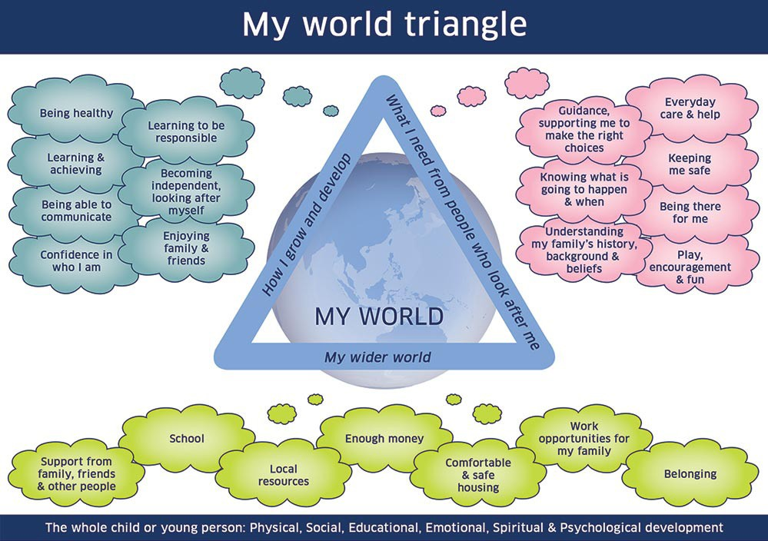

**Question 3**

**Question 2**

**Question 1**

|  |
| --- |
| 1. How well am I growing and developing? What is working well, what are other people worried about, what worries me? |
|  |

|  |
| --- |
| 1. Are my needs being met by the people looking after me?  What is working well, what are other people worried about, what worries me? |
|  |

|  |
| --- |
| 3. Are my needs being met from my wider world?  What is working well, what are other people worried about, what worries me? |
|  |

|  |
| --- |
| My Protection and Resilience |

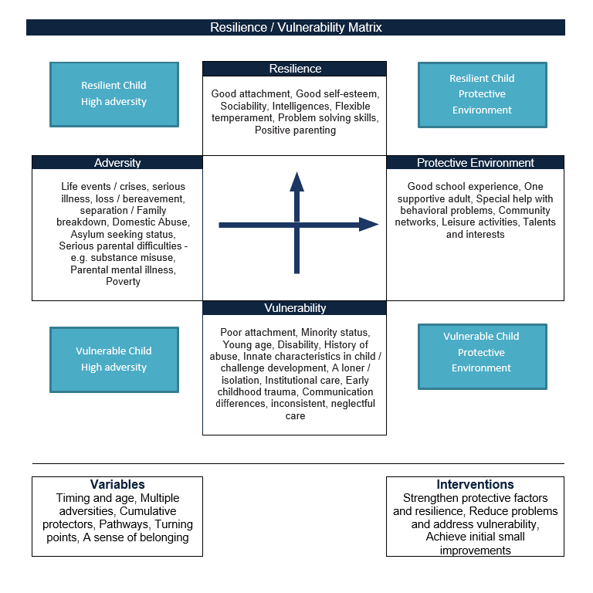

### Risk Analysis

|  |
| --- |
| What are the risks to me? What are other people worried about and what worries me about my safety? Have specialist risk assessment tools been used, e.g. Neglect Toolkit, Child Sexual Exploitation (CSE) Tool, Safe & Together Model, Impact of Parental Substance Use (IPSU) as part of this assessment?  WHAT IS THE CHRONOLOGY TELLING YOU? ARE THERE ANY PATTERNS? |
|  |

|  |
| --- |
| Are there any risks from me, based on the things I have been doing? |
|  |

|  |
| --- |
| Are there things that make me particularly vulnerable to risk? |
|  |

|  |
| --- |
| What would help me?  What protective factors and strengths would increase my resilience and reduce adversity. |
|  |

# My Needs and My Parent/Carer’s Capacity to Meet These (Parenting Capacity Assessment) Osectisection

|  |
| --- |
| Do changes need to be made to help my wellbeing and keep me safe? If so, what is my family’s capacity to change - do my parents/carers have the motivation and ability to change?  What needs to change in order for my needs to be met?  Does my family understand that changes need to be made?  What are my parents/carers motivation to change, and has there been any resistance to change?  Will my parents/carers be able to make the changes needed quickly enough for my timescale?  What does patterns in my family’s history mean for me?  Are there any difficulties my family have which mean change is difficult, such as learning difficulties or disabilities?  What are the strengths of my parents/carers?  What support did my family receive, and what difference did this make to my safety and wellbeing?  If permanence away from home is recommended in this assessment, please ensure the assessment evidences the serious detriment of the child being returned to their parents’ care/clear analysis in relation to the need for permanence away from home.. |
|  |

# My Participation, Rights and Views

### Child

|  |  |
| --- | --- |
| What are my thoughts on what’s going on for me right now and what do I want for the future?  How have I been able to share my views?  Do I know about my rights?  How can I find out about them? | |
|  | |
| What would help me take part in any meetings about me and my family? | |
|  | |
| If this assessment is for a Children’s Hearing, should I attend or should the social worker ask for me to be excused? |  |
| If yes, why is it best for me to be excused from going to my Children’s Hearing? |  |
| Pre-hearing panel details (if ‘Yes’ above) |  |

### Parents/Carers

|  |
| --- |
| What are my parents/carers views about the current circumstances and their wishes for the future? Include any disagreements with aspects of the assessment and/or plan. Include the views of each parent separately.  Do my parents/carers need any support to take part in meetings such as a support person/advocacy worker? |
|  |

**Siblings**

|  |
| --- |
| Do I have brothers and sisters or sibling-type relationships? If so, who are they, how often do I see them and how do I feel about the time with them? |
|  |

|  |
| --- |
| Recommendations of AssessmentPlease provide a short summary of your conclusions. A Child’s Plan should be completed to identify outcomes and actions to be achieved. If this assessment has been completed for a Children’s Hearing or Children Protection Case Conference, please ensure recommendations and rationale are clear in terms of the need for statutory measures and/or a Child Protection Plan. (Please also reference any measures required such as family time contact with parents and other family members including brothers and sisters. |
|  |

# Child/Young Person’s Plan

|  |  |  |
| --- | --- | --- |
| Legal Status | Education Establishment (if applicable) | Does the child/young person require a Co‑ordinated Support Plan? |
| Choose an item. |  |  |

|  |  |  |  |  |  |
| --- | --- | --- | --- | --- | --- |
| Desired Outcomes | How will we know this has been achieved | Actions required | By whom | Frequency/ Timescale | [Progress](#Progress" \o "Do not complete this column if this is an initial or proposed plan.  Please include score, if relevant,  if outcome framework is being used to measure progress.) |
|  |  |  |  |  |  |
|  |  |  |  |  |  |

|  |
| --- |
| What action will be taken if outcomes or agreements are not reached within specified timescales or if there are increased concerns for safety, care or wellbeing of me? ( please be as specific and detailed as possible about the arrangements in place if plans change, risks increase, needs cannot be met) |
|  |

**Contingency**

### Child’s Views

|  |
| --- |
| What are my views of the plan? |
|  |

### Parent/Carer Views

|  |
| --- |
| What are my parents/carers views of the plan? |
|  |

|  |  |
| --- | --- |
| Is there agreement or disagreement regarding the plan and recommendations? How has this been resolved? | |
|  | |
| Has the Assessment and plan been shared with me and my parent/carers? |  |
| If not, why not? |  |