Inclusion & Wellbeing Service
Falkirk Council

Wellbeing Booklet
20-21
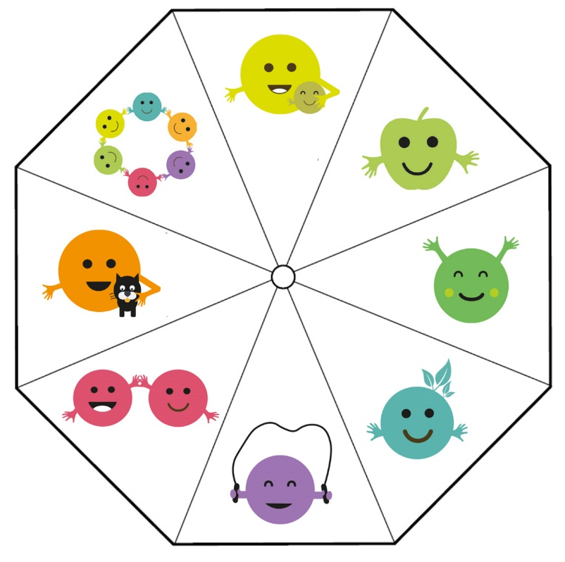

Name:________________

Term 1 Assessment

Date:_______________

Wellbeing Web
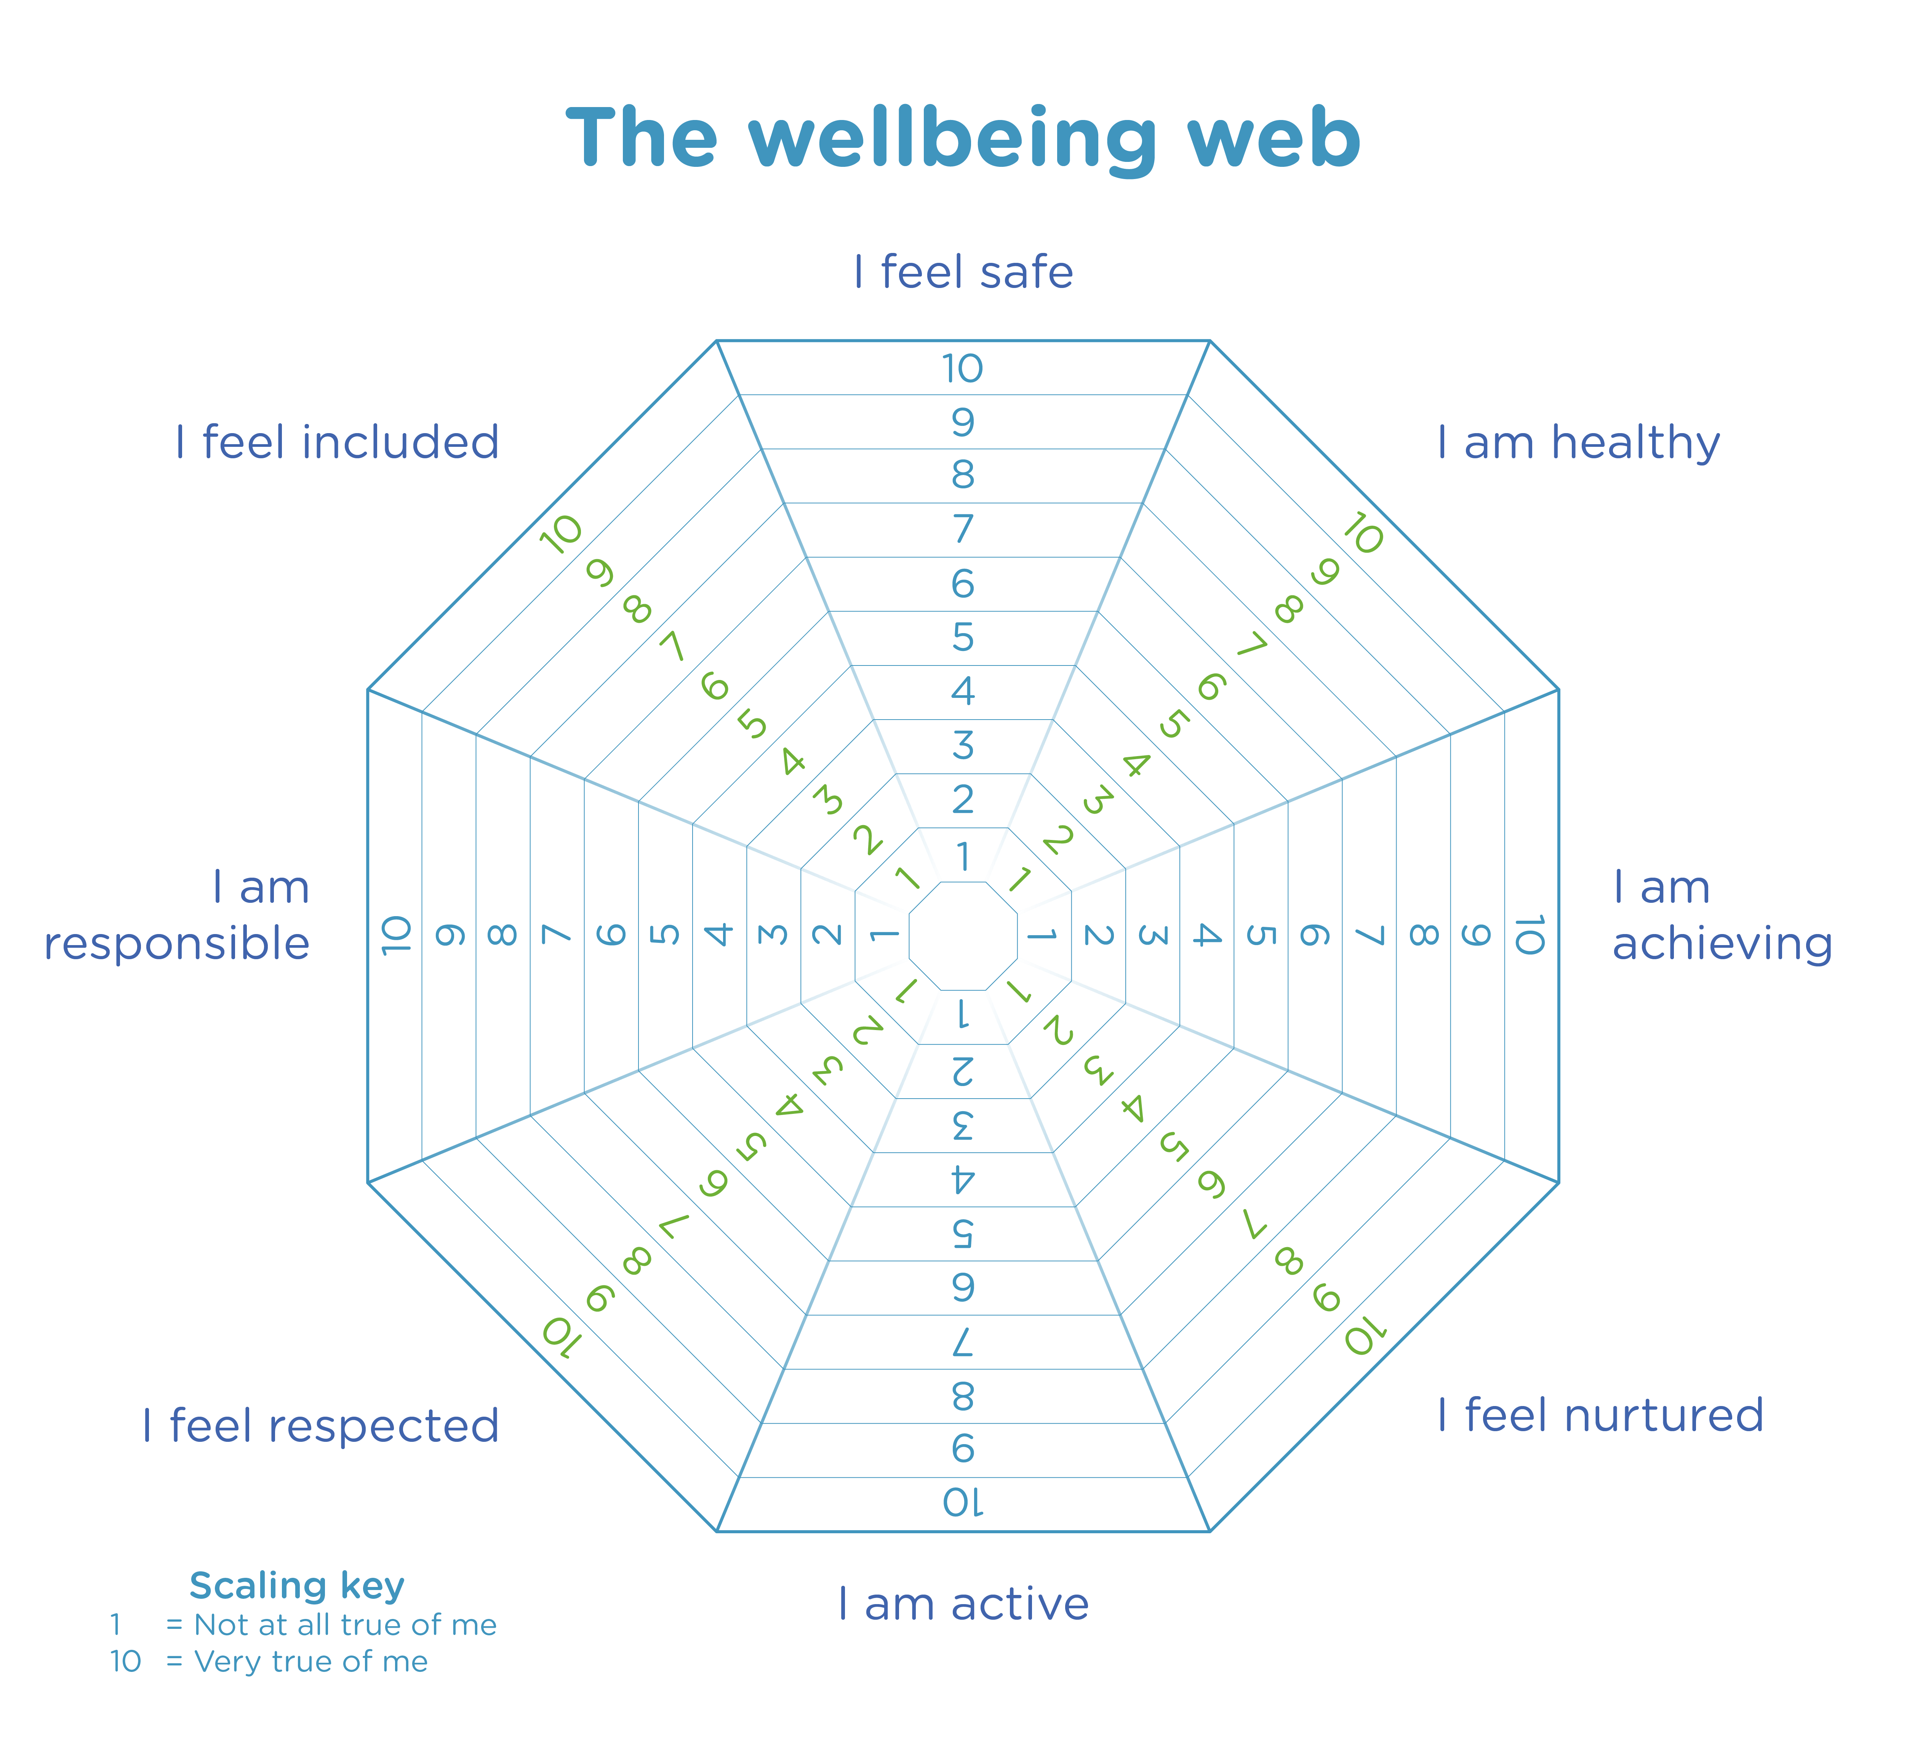

We would like you to colour in the web and rate yourself 1-10 on each section. 1 is the lowest and 10 is the highest. You may want to rate yourself high on some on low on others, that is ok.
Reflection tool
Use the tables below to help you decide how to rate yourself on the web. Tick either red, amber or green for each statement.

Safe
I like to have a safe space for me when I get worried or upset.
I know what to do if I need to ask for help in school.
I know what to do if I am bullied at school.
I know what to do if I do not like what other pupils are doing at school.
Comments

Healthy
I feel ok about using the school toilets.
I am able to eat food that I like at school.
I get the right amount of sleep for me.
I can enjoy PE at school.
I know which adults I can talk to at school if:
- I do not like something.
- I am feeling unwell.
- I am feeling anxious, worried of afraid.
Comments

Achieving
I have an individualised plan.
I know what my targets are.
I know what to do if I don’t understand when an adults tells me to do something.
I know what to do if I am worried about work at school.
I can start work on my own in class.
Comments

Nurtured
I have been able to tell the adults at school about:
- What is important to me.
- The things I find difficult
- Things that I really don’t like.
I have one or more friends in school.
Comments

Active
I can go to clubs.
I take regular exercise.
I like to do individual sports and exercise
I have a safe space to get changed for PE.
Comments

Respected
I am included in making decisions about me.
People listen to my views.
I can sometimes do things that I am really interested in at school.
Comments

Responsible
I understand the rules at school.
I understand the rules at home.
I am able to do some of my work on my own.
I am learning how to look after myself at school.
I can look after my belongings.
Comments.

Included
I enjoy break times and lunch times at school.
I have some friends at school.
I know where I can go if I feel upset, worried or unhappy at school.
I can join in any special events at school.
Comments.

Rate you skills
Below are the 4 capacities. Rate yourself 1-5 for each skill.
Effective Contributor | 1 | 2 | 3 | 4 | 5
Flexible/Adaptive
- I can cope when plans change
- I can work with different people in different situations
Creativity
- I have imaginative ideas
- I can make decisions
- I can solve problems
Empathy
- I can understand how others are feeling
- I am respectful to others
Enthusiasm
- I am keen to take part
- I have a positive attitude
Successful Learner | 1 | 2 | 3 | 4 | 5
Team player
- I can get on well with others
- I can value others ideas and opinions
Cope with pressure
- I can stay calm when things get tricky
- I can tell if something is a big deal or a little deal
Good Communicator
- I can talk to others clearly and appropriately
- I can listen to others well
Responsible Citizen | 1 | 2 | 3 | 4 | 5
Self-control/ Patience
- I can manage my feelings
- I can wait and take turns
Accept responsibility
- I can talk honestly about the choices I have made
Resolve Conflict
- I can talk about disagreements and put things right
Leadership
- I can set a good example for others
- I can give advice and support others
Confident individual | 1 | 2 | 3 | 4 | 5
Negotiation
- I can suggest ways of dealing with tricky times
Hardworking
- I try my best in all tasks
Resilient
- I keep trying when things are hard
- I can move on from tricky things
Confident
- I believe in myself

Professional Dialogue with Pupils
Name something that works well in your classroom or school that you want to continue.
Name something that you would like to start happening in your classroom or school
Name something that happens that you think does not work well and you would like to change.
Tell me something you have learned this session.

Tell me the best thing about the Inclusion and Wellbeing Service ( learning, activities, house events, school events, playground, lunches)

Tell me something we could do to make the Inclusion and Wellbeing Service even better.

Last time you said... | What we did... | How is this now? | What else can we do?

Term 2 Assessment

Date:_______________

Wellbeing Web

We would like you to colour in the web and rate yourself 1-10 on each section. 1 is the lowest and 10 is the highest. You may want to rate yourself high on some on low on others, that is ok.
Reflection tool
Use the tables below to help you decide how to rate yourself on the web. Tick either red, amber or green for each statement.

Safe
I like to have a safe space for me when I get worried or upset.
I know what to do if I need to ask for help in school.
I know what to do if I am bullied at school.
I know what to do if I do not like what other pupils are doing at school.
Comments

Healthy
I feel ok about using the school toilets.
I am able to eat food that I like at school.
I get the right amount of sleep for me.
I can enjoy PE at school.
I know which adults I can talk to at school if:
- I do not like something.
- I am feeling unwell.
- I am feeling anxious, worried of afraid.
Comments

Achieving
I have an individualised plan.
I know what my targets are.
I know what to do if I don’t understand when an adults tells me to do something.
I know what to do if I am worried about work at school.
I can start work on my own in class.
Comments

Nurtured
I have been able to tell the adults at school about:
- What is important to me.
- The things I find difficult
- Things that I really don’t like.
I have one or more friends in school.
Comments

Active
I can go to clubs.
I take regular exercise.
I like to do individual sports and exercise
I have a safe space to get changed for PE.
Comments

Respected
I am included in making decisions about me.
People listen to my views.
I can sometimes do things that I am really interested in at school.
Comments

Responsible
I understand the rules at school.
I understand the rules at home.
I am able to do some of my work on my own.
I am learning how to look after myself at school.
I can look after my belongings.
Comments.

Included
I enjoy break times and lunch times at school.
I have some friends at school.
I know where I can go if I feel upset, worried or unhappy at school.
I can join in any special events at school.
Comments.

Rate you skills
Below are the 4 capacities. Rate yourself 1-5 for each skill.
Effective Contributor | 1 | 2 | 3 | 4 | 5
Flexible/Adaptive
- I can cope when plans change
- I can work with different people in different situations
Creativity
- I have imaginative ideas
- I can make decisions
- I can solve problems
Empathy
- I can understand how others are feeling
- I am respectful to others
Enthusiasm
- I am keen to take part
- I have a positive attitude
Successful Learner | 1 | 2 | 3 | 4 | 5
Team player
- I can get on well with others
- I can value others ideas and opinions
Cope with pressure
- I can stay calm when things get tricky
- I can tell if something is a big deal or a little deal
Good Communicator
- I can talk to others clearly and appropriately
- I can listen to others well
Responsible Citizen | 1 | 2 | 3 | 4 | 5
Self-control/ Patience
- I can manage my feelings
- I can wait and take turns
Accept responsibility
- I can talk honestly about the choices I have made
Resolve Conflict
- I can talk about disagreements and put things right
Leadership
- I can set a good example for others
- I can give advice and support others
Confident individual | 1 | 2 | 3 | 4 | 5
Negotiation
- I can suggest ways of dealing with tricky times
Hardworking
- I try my best in all tasks
Resilient
- I keep trying when things are hard
- I can move on from tricky things
Confident
- I believe in myself

Professional Dialogue with Pupils
Name something that works well in your classroom or school that you want to continue.
Name something that you would like to start happening in your classroom or school
Name something that happens that you think does not work well and you would like to change.
Tell me something you have learned this session.

Tell me the best thing about the Inclusion and Wellbeing Service ( learning, activities, house events, school events, playground, lunches)

Tell me something we could do to make the Inclusion and Wellbeing Service even better.

Last time you said... | What we did... | How is this now? | What else can we do?

Term 3 Assessment

Date:_______________

Wellbeing Web

We would like you to colour in the web and rate yourself 1-10 on each section. 1 is the lowest and 10 is the highest. You may want to rate yourself high on some on low on others, that is ok.
Reflection tool
Use the tables below to help you decide how to rate yourself on the web. Tick either red, amber or green for each statement.

Safe
I like to have a safe space for me when I get worried or upset.
I know what to do if I need to ask for help in school.
I know what to do if I am bullied at school.
I know what to do if I do not like what other pupils are doing at school.
Comments

Healthy
I feel ok about using the school toilets.
I am able to eat food that I like at school.
I get the right amount of sleep for me.
I can enjoy PE at school.
I know which adults I can talk to at school if:
- I do not like something.
- I am feeling unwell.
- I am feeling anxious, worried of afraid.
Comments

Achieving
I have an individualised plan.
I know what my targets are.
I know what to do if I don’t understand when an adults tells me to do something.
I know what to do if I am worried about work at school.
I can start work on my own in class.
Comments

Nurtured
I have been able to tell the adults at school about:
- What is important to me.
- The things I find difficult
- Things that I really don’t like.
I have one or more friends in school.
Comments

Active
I can go to clubs.
I take regular exercise.
I like to do individual sports and exercise
I have a safe space to get changed for PE.
Comments

Respected
I am included in making decisions about me.
People listen to my views.
I can sometimes do things that I am really interested in at school.
Comments

Responsible
I understand the rules at school.
I understand the rules at home.
I am able to do some of my work on my own.
I am learning how to look after myself at school.
I can look after my belongings.
Comments.

Included
I enjoy break times and lunch times at school.
I have some friends at school.
I know where I can go if I feel upset, worried or unhappy at school.
I can join in any special events at school.
Comments.

Rate you skills
Below are the 4 capacities. Rate yourself 1-5 for each skill.
Effective Contributor | 1 | 2 | 3 | 4 | 5
Flexible/Adaptive
- I can cope when plans change
- I can work with different people in different situations
Creativity
- I have imaginative ideas
- I can make decisions
- I can solve problems
Empathy
- I can understand how others are feeling
- I am respectful to others
Enthusiasm
- I am keen to take part
- I have a positive attitude
Successful Learner | 1 | 2 | 3 | 4 | 5
Team player
- I can get on well with others
- I can value others ideas and opinions
Cope with pressure
- I can stay calm when things get tricky
- I can tell if something is a big deal or a little deal
Good Communicator
- I can talk to others clearly and appropriately
- I can listen to others well
Responsible Citizen | 1 | 2 | 3 | 4 | 5
Self-control/ Patience
- I can manage my feelings
- I can wait and take turns
Accept responsibility
- I can talk honestly about the choices I have made
Resolve Conflict
- I can talk about disagreements and put things right
Leadership
- I can set a good example for others
- I can give advice and support others
Confident individual | 1 | 2 | 3 | 4 | 5
Negotiation
- I can suggest ways of dealing with tricky times
Hardworking
- I try my best in all tasks
Resilient
- I keep trying when things are hard
- I can move on from tricky things
Confident
- I believe in myself

Professional Dialogue with Pupils
Name something that works well in your classroom or school that you want to continue.
Name something that you would like to start happening in your classroom or school
Name something that happens that you think does not work well and you would like to change.
Tell me something you have learned this session.

Tell me the best thing about the Inclusion and Wellbeing Service ( learning, activities, house events, school events, playground, lunches)

Tell me something we could do to make the Inclusion and Wellbeing Service even better.

Last time you said... | What we did... | How is this now? | What else can we do?

Term 4 Assessment

Date:_______________

Wellbeing Web

We would like you to colour in the web and rate yourself 1-10 on each section. 1 is the lowest and 10 is the highest. You may want to rate yourself high on some on low on others, that is ok.
Reflection tool
Use the tables below to help you decide how to rate yourself on the web. Tick either red, amber or green for each statement.

Safe
I like to have a safe space for me when I get worried or upset.
I know what to do if I need to ask for help in school.
I know what to do if I am bullied at school.
I know what to do if I do not like what other pupils are doing at school.
Comments

Healthy
I feel ok about using the school toilets.
I am able to eat food that I like at school.
I get the right amount of sleep for me.
I can enjoy PE at school.
I know which adults I can talk to at school if:
- I do not like something.
- I am feeling unwell.
- I am feeling anxious, worried of afraid.
Comments

Achieving
I have an individualised plan.
I know what my targets are.
I know what to do if I don’t understand when an adults tells me to do something.
I know what to do if I am worried about work at school.
I can start work on my own in class.
Comments

Nurtured
I have been able to tell the adults at school about:
- What is important to me.
- The things I find difficult
- Things that I really don’t like.
I have one or more friends in school.
Comments

Active
I can go to clubs.
I take regular exercise.
I like to do individual sports and exercise
I have a safe space to get changed for PE.
Comments

Respected
I am included in making decisions about me.
People listen to my views.
I can sometimes do things that I am really interested in at school.
Comments

Responsible
I understand the rules at school.
I understand the rules at home.
I am able to do some of my work on my own.
I am learning how to look after myself at school.
I can look after my belongings.
Comments.

Included
I enjoy break times and lunch times at school.
I have some friends at school.
I know where I can go if I feel upset, worried or unhappy at school.
I can join in any special events at school.
Comments.

Rate you skills
Below are the 4 capacities. Rate yourself 1-5 for each skill.
Effective Contributor | 1 | 2 | 3 | 4 | 5
Flexible/Adaptive
- I can cope when plans change
- I can work with different people in different situations
Creativity
- I have imaginative ideas
- I can make decisions
- I can solve problems
Empathy
- I can understand how others are feeling
- I am respectful to others
Enthusiasm
- I am keen to take part
- I have a positive attitude
Successful Learner | 1 | 2 | 3 | 4 | 5
Team player
- I can get on well with others
- I can value others ideas and opinions
Cope with pressure
- I can stay calm when things get tricky
- I can tell if something is a big deal or a little deal
Good Communicator
- I can talk to others clearly and appropriately
- I can listen to others well
Responsible Citizen | 1 | 2 | 3 | 4 | 5
Self-control/ Patience
- I can manage my feelings
- I can wait and take turns
Accept responsibility
- I can talk honestly about the choices I have made
Resolve Conflict
- I can talk about disagreements and put things right
Leadership
- I can set a good example for others
- I can give advice and support others
Confident individual | 1 | 2 | 3 | 4 | 5
Negotiation
- I can suggest ways of dealing with tricky times
Hardworking
- I try my best in all tasks
Resilient
- I keep trying when things are hard
- I can move on from tricky things
Confident
- I believe in myself

Professional Dialogue with Pupils
Name something that works well in your classroom or school that you want to continue.
Name something that you would like to start happening in your classroom or school
Name something that happens that you think does not work well and you would like to change.
Tell me something you have learned this session.

Tell me the best thing about the Inclusion and Wellbeing Service ( learning, activities, house events, school events, playground, lunches)

Tell me something we could do to make the Inclusion and Wellbeing Service even better.

Last time you said... | What we did... | How is this now? | What else can we do?

