The Compassionate and Connected Community: - Training for Practitioners
There has been an increasing focus recently on supporting children and young people who have experienced adversity and trauma which links in with the nurturing approaches, Adverse Childhood Experiences and trauma informed practice.
Falkirk Council’s Educational Psychology Service and Inclusion and Wellbeing Service are excited to be collaborating to jointly pilot a programme of training which has been developed by Education Scotland to help teachers and schools extend their Nurture approaches and relationship based practice to provide targeted support for pupils who have experienced trauma and adverse childhood experiences (ACEs).

Background
Education Scotland have a suite of resources to support nurturing approaches which can be accessed by mainstream practitioners. It has been recognised that additional professional learning and curricular materials were required to support practitioners extend their practice for some children. Education Scotland has engaged with 28 authorities to pilot ‘The Compassionate and Connected Community’(CCC) professional learning resource. This professional learning resource is intended to complement the existing whole school nurturing approach and will provide knowledge of a more targeted approach around supporting those who have experienced trauma or adversity.
The Compassionate and Connected Community professional learning resource uses evidence based research and examples of effective practice to develop knowledge amongst practitioners whilst balancing this with the opportunity for reflective practice and skills development. This resource encourages staff to engage with practitioner enquiry as a model of professional learning. This is recognised in Teaching Scotland’s Future (Donaldson, 2011) as beneficial to supporting staff engagement with action research to support their own development and improve pupil outcomes.
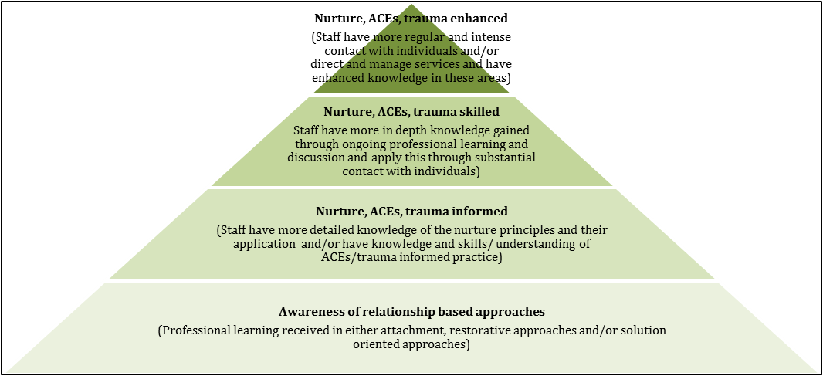

The Training - readiness
This training is not for everyone. It is aimed at teachers who already have experience of Nurture approaches and relationship based approaches in practice and are at level of the Nurture, ACEs and Trauma informed on the learning pyramid illustrated. It is particularly aimed at teachers who require more knowledge and training to work with children with significant ACEs and trauma, these could be Support for Learning Teachers, Nurture Teachers or Class Teachers and Principal Teachers with a specialist remit. It really requires the whole school approach to be right too and for school management to be supportive of staff enhancing and implementing their learning in this area.
The programme will involve three in-service days and three twilights across the academic year and there is an expectation that schools will apply to send up to 3 team members to facilitate peer learning and collaboration in completing the Practitioner Enquiry aspects of the course between training sessions.
In order to assist you in deciding if this course is right for you and your school, we ask that you consider the readiness questions below to help you decide. If you are not quite ready we suggest using the self-evaluation tool on nurturing approaches, Adverse Childhood Experiences and trauma informed practice. Nurture training can be accessed through Education Scotland and Falkirk EPS hope to be announcing further training opportunities in this area and on social and emotional behavioural needs approaches.
The professional learning consists of 6 components:
- Introduction/Setting the scene
- Prevalence and impact of trauma
- Responding to trauma
- Attachment and attunement
- Self-regulation
- Staff well-being

Session date: 20 Aug 9.30am – 5pm (in-service)
21 Oct 1.30pm – 5pm (in-service)
27 Nov 3.30pm – 6pm (twilight)
22 Jan 3.30pm – 6pm (twilight)
18 Feb 1.30pm – 5pm (in-service)
25 Mar 3.30pm – 6pm (twilight)

The Training – Booking on
Spaces on this pilot training are limited and applications should be made by schools who would like to put forward up to a maximum of 3 members of staff who are already familiar with and embedding nurture approaches within their establishments and who have a remit to take this approach forward within their school setting.
If you and you school are ready, please complete the attached application along with the completed readiness checklist and return to the Educational Psychology Service email address: educationalpsychologyservice@falkirk.gov.uk. Please apply by the 14th of June 2019.

Application - Compassionate and Connected Community Pilot
Please complete this application fully and return to us by the 14th June 2019 at educationalpsychologyservice@falkirk.gov.uk to assist us in prioritising the allocation of spaces on this training.
School: Leadership Team Link:

Staff Name | Staff Email | Staff Remit related to Nurture/ACES/Trauma

Individual/Team Readiness Questionnaire

- Do I/we have knowledge of the nurture principles and their application and/or have knowledge and understanding of ACEs/trauma informed practice?

- Do I/we have a specific remit to develop ACEs/trauma informed practice or nurture within my establishment?

- Will I/we be able to prioritise the time, skills and resources to implement the Compassionate and Connected Community effectively and carry out associated reading and tasks between training sessions?

- Are my/our Senior Management Team (SMT) willing to fully support the implementation of the Compassionate and Connected Community and recognise the support required to engage in the practitioner enquiry process?

- Am I/we happy to present information to all staff about the CCC programme (alongside our SMT) and to present to my training cohort as part of our ongoing learning?

- Do /we appreciate that evaluation of the course is a crucial part of this pilot and agree to complete the evaluation required to assist in this pilot stage?

Whole School Readiness Questionnaire

- Does the Headteacher, Senior Management Team (SMT) and staff actively promote a range of approaches to promote emotional wellbeing for all the young people and adults involved in the establishment and see Health and Wellbeing as being the responsibility of all?

- Do staff have knowledge and skills in one or more relationship based approach (e.g. Nurture, Solution oriented approaches, restorative approaches) and these approaches are implemented across the whole school?

- Are the Senior Management Team (SMT) are willing to fully support the implementation of the Compassionate and Connected Community (CCC) and recognise the support required to engage in the practitioner enquiry process?

- Will the Compassionate and Connected Community will be part of the school improvement plan?

- Are the SMT are able to commit to releasing staff to attend the CCC sessions?

All completed applications should be submitted by 14th June 2019.
Once selected we will add you to CPD manager and confirm your place by the 21st of June 2019 with the venue details for the first session. If you have any questions about this pilot please contact Kelly Robertson, Educational Psychologist on 01324 506600 or kelly.robertson@falkirk.gov.uk.

