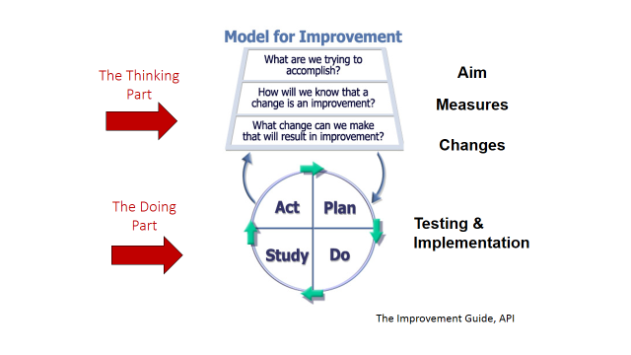



**Engagement and Motivation for Learning - For Learners with Complex Needs**

**Using Practitioner Enquiry to develop and improve teaching and learning**

**FALKIRK COUNCIL – Children’s Services**

**EDUCATIONAL PSYCHOLOGY SERVICE**

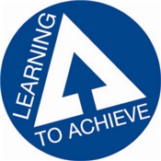



**Local Improvement Priority**

Wellbeing, equality & inclusion processes and support is enhanced and child outcomes are improved.

**Practitioner enquiry is an area of professional learning which was highlighted in Teaching Scotland's Future (Donaldson, 2011) as a way forward to support teachers to become more engaged with research to support their own learning and ultimately pupil experiences. (GTCS.org.uk)**

The Model for Improvement provides a framework for developing, testing and implementing changes leading to improvements.

**Why Engagement Model?** The Engagement Model (adapted by Lindsay Graham, Education Consultant, Your Learning Ability) was originally developed and researched by Barry Carpenter in association with the Special Schools and Academies’ Trust as a classroom tool which allows Practitioners “to focus on the child’s engagement as a learner and create personalised learning pathways,” (Carpenter 2010). Through an enquiring approach, the model is used to motivate and engage the most complex learners.

**Engagement and Motivation for Learning - For Learners with Complex Needs 2019/20**

Each session will be fully experiential. Come prepared to join in, be stretched and learn skills to use straight away.

**Session 1:** Introductory session

**Session 2:** Exploring Model for Improvement and Engagement Model

**Session 3:** Coach-consult session with sharing of good practice.

**Session 4:** Coach-consult drop in session.

**Follow Up Review Session and Dissemination Event**

**Dates and venues to be confirmed**

**What will I gain by attending?**

* Increased knowledge and skills in using the Engagement Model to motivate and engage learners with complex needs.
* Develop key strategies to create personalised learning plans by using the ways the learner engages.
* Opportunities to learn about and develop skills in Practitioner Enquiry using the Model for Improvement.
* Further development of skills related to monitoring and tracking for pupils with complex needs.
* Engage in self-directed professional learning using evidence informed resources.

*Small changes can lead to bigger change* **BOOKINGS VIA CPD MANAGER**

Any questions please contact Susi Wakely, Mairi Duncan or Kelly Robertson at Educational Psychology Services: Telephone 01324 506600