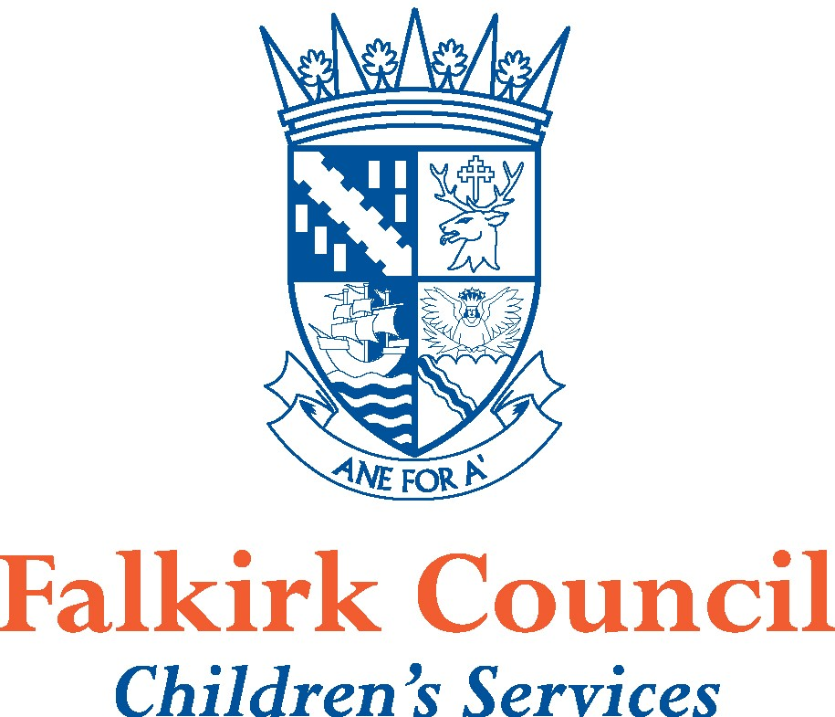
Placement Change Application – Front Cover

Child/Young Person’s Details:
Name |  |  |  | Known as
Date of Birth |  |  |  | Gender
Current Nursery / School / Placement |  |  |  | Nursery  (please tick) |  | Pre-school  Deferred Year
Date first attended |  |  |  | Year Stage
1. Child/Young Person’s current address |  |  |  | 1. Parent(s)/Carer(s) at same address as  child/young person:
Parent/Carer email address |  |  |  | Relationship to child/young person:

Parent/Carer email Tel No
2. Address if different from child/young person |  |  |  | 2. Parent(s)/Carer(s) at this address
Parent/Carer email address |  |  |  | Relationship to child/young person:

Parent/Carer email Tel No
3. Address if different from child/young person |  |  |  | 3. Parent(s)/Carer(s) at this address
Parent/Carer email address |  |  |  | Relationship to child/young person:

Parent/Carer email Tel No
Parent(s)/Carer(s) to be made aware of the decision following the Placement Change Meeting.
Please indicate by ticking the appropriate boxes 1. 2. 3.
Looked After by Falkirk Council |  | Status (tick as appropriate) At Home Away from Home
Looked After by other Local Authority - Name of Local Authority:
Agreement received from other local authority in support of PCP referral for specialist provision  If NO please contact your cluster ASN Adviser |  |  |  |  |  |  | YES / NO
Name of Educational Psychologist
Name of Social Worker (if applicable)
Please tick as appropriate Compulsory Supervision Order, Child Protection Register, CSP (Co-ordinated Support Plan), Health Care Plan |  |  | Compulsory Supervision Order CSP  Child Protection Register Health Care Plan

Provision requested:
Only one Provision should be selected | Please tick | Start date requested
Primary Enhanced Provision
Primary Additional Support Centre (ASC)
Primary ASL Wing (severe and complex needs)
Windsor Park - Primary
Secondary Additional Support Centre (ASC)
Carrongrange High (severe and complex needs)
Windsor Park - Secondary
Inclusion and Wellbeing Service (full-time / shared)

Resources/Supports:

Please tick ALL that currently apply for child/young person
Resources/Supports | Tick | Resources/Supports |  | Tick
Educational Psychology Service |  | Additional Support Needs (ASN) Outreach Service
Medical - Paediatrics |  | Social Work Children & Families (C&F)
Speech & Language Therapy Service |  | Social Work Children with Disabilities Team (CwDT)
Physiotherapy Service |  | Exceptional SfLA hours
Occupational Therapy Service (NHS) |  | NHS hours (complex care)
Child & Adolescent Mental Health Service |  | Youth Justice
Inclusion & Wellbeing Outreach Service |  | Other (please specify)
Community Mental Health Project  (Barnarados, Aberlour, FDAMH) |  | Other (please specify)

Supporting paperwork submitted, your checklist:
Please ensure that your application comprises all of the information below before submission. Should any of the information be missing this will delay the application being considered.
 |  | Date of Form / Document | Tick
Joint consideration of proposed placement | (Form 6 – Record of Team Around the Child (TAC) Meeting).
Joint planning and intervention by the TAC | (Form 4 – Child/Young Person’s Action Plan) This Form 4 must be evaluated
Joint planning by the TAC | (Form 4 – Child/Young Person’s Action Plan) This Form 4 must contain target setting to show continuous progress
Views of parents | Additional statement/letter included
Views of child | Additional statement/letter included
Agreement received from other local authority | Form 6 / letter / email
Other documents attached
(please list)

Content/detail of paperwork, your checklist – this application must evidence that:
The paperwork should provide clear evidence for the key areas that will form the discussion of the Placement Change Panel. Tick
There is a clear profile of additional support needs (assessment)
The approaches and strategies that have been used have been evaluated and analysed, whilst measuring their impact (analysis and evaluation)
Reference has been made to attendance trends, with evaluation of impact
There has been consideration and evaluation of any other factors that are significantly impacting this child/young person’s attainment and wellbeing
There has been a range of holistic supports discussed and planned to ensure this child/young person’s needs would be met in their mainstream catchment school
There is explanation as to how the child/young person’s needs meet the criteria for the requested placement
The child/young person’s views must be recorded in whatever format or by whatever means are appropriate
The parents/carers views must be clear in the Form 6 even if there is a written statement/letter attached
Additional assessments from other professionals must be current relevant and informative

Parent(s)/Carer(s) Consent
I have been given a copy of this application and agree with the recommendation.
I understand that my child meets the criteria for referral to the Placement Change Panel for consideration of a specialist provision placement.
I am also aware that places are allocated on the highest level of needs.

Name |  | Date
Signature |  | Relationship to child/young person

Child/Young Person’s Consent (obtained in whatever format is appropriate for the child/young person)
I have been given a copy of this application and agree with the recommendation.

Signature |  | Date

Person Submitting Request on behalf of the Team Around the Child:

Name |  | Date
Signature |  | Designation
Tel. No. |  | Email address

Consultation with Educational Psychologist

Consultation with Cluster Link ASN Adviser, if applicable

Referral discussed and paperwork approved by:

Name |  | Date
Signature |  | Designation | Headteacher / ASN Co-ordinator
*Electronic signatures acceptable

Please email to: edu.pcp@falkirk.gov.uk using the following ‘Subject’ heading in the email
PCP Referral – Name of Provision requested
eg “ PCP Referral – Primary Enhanced Provision”
Please send separate email for each type of Provision requested

