

**A Lyrical Genius?**

**Are You Musically Talented?**

**Can You Write Songs?**

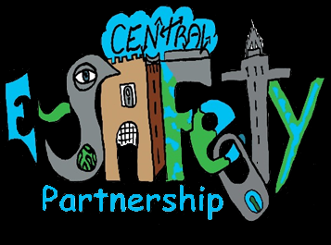





**Songwriting Competition 2015**

All you have to do is write a song or rap to help deliver a strong e-safety message and promote positive uses of technology.

**EXCELLENT PRIZES TO BE WON**

**Meet *The Voice’s***

**Stevie McCrorie!**

**For your chance to have your song recorded by ROCK THE TALK – Send your entry to** [**CEP@glowmail.org.uk**](mailto:CEP@glowmail.org.uk)

**By March 31**



For more details please see school office

or https://blogs.glowscotland.org.uk/fa/centralesafety/

**INC. IPAD MINIS**

**#StevieSelfie**