Introduction

What is the purpose of the booklet?

This booklet has been produced to give guidance to pupils and parents on how certain common Numeracy topics are taught in the mathematics classroom and throughout the school. Staff from all departments have been consulted during its production and will be issued with a copy of the booklet. It is hoped that using a consistent approach across all subjects will make it easier for pupils to progress.

How can it be used?

If you are helping your child with their homework, you can refer to the booklet to see what methods are being taught in school. Simply look up the relevant page for a step by step guide and useful examples. The booklet includes Numeracy skills useful in subjects other than Mathematics, such as Home Economics, Technical, Science, and Geography amongst others. For help with mathematics topics, pupils should refer to their mathematics textbook or ask their teacher for help.

Why do some topics include more than one method?

In some cases (e.g. percentages), the method used will be dependent on the level of difficulty of the question, and whether or not a calculator is permitted. For mental calculations, pupils should be encouraged to develop a variety of strategies so that they can select the most appropriate method in any given situation. Where appropriate we will attempt to indicate the preferred method which pupils ought to try and use.

Table of Contents

Topic Page Number

Basic Numeracy Skills 3

Estimation - Rounding 4

Estimation - Calculations 5

Measurement 6

Addition 8

Subtraction 9

Multiplication 10

Division 11

Order of Calculations (BODMAS) 12

Time 13

Fractions 15

Percentages 17

Ratio 21

Proportion 23

Information Handling - Tables 24

Information Handling - Bar Graphs 25

Information Handling - Line Graphs 26

Information Handling - Scatter Graphs 27

Information Handling - Pie Charts 28

Information Handling - Averages 29

Mathematical Dictionary 30
Basic Numeracy Skills

At Braes High School we expect pupils to demonstrate, acquire and regularly revise some of the more basic number skills such as their times tables and simple addition or subtraction. All pupils should know their times tables from 1 to 10, however it is well worth encouraging extra practice in the six, seven, eight and nine times tables.
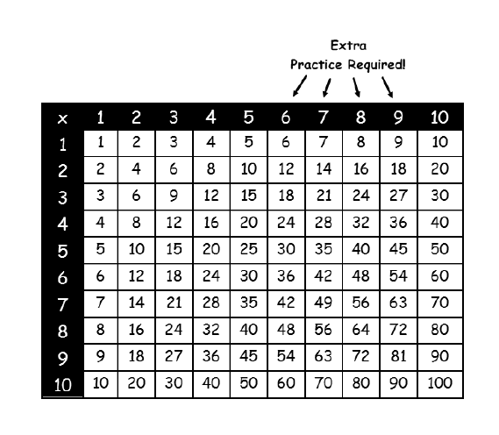
At primary school pupils will be taught about the importance of place value. This can be a difficult concept and should be reinforced at home.
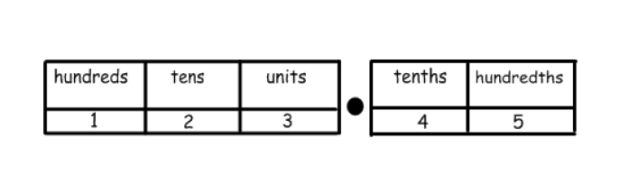
26.57 means 2 tens, 6 units, 5 tenths and 7 hundredths.

Estimation - Rounding

Numbers can be rounded to give an approximation

6734 rounded to the nearest 10 is 6730

6734 rounded to the nearest 100 is 6700

6734 rounded to the nearest 1000 is 7000
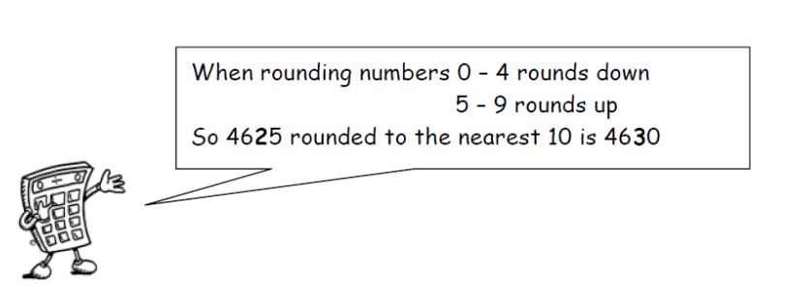
In general, to round a number, we must first identify the place value to which we want to round. We must then look at the next digit to the right (the “check digit”) - if it is 5 or more round up.

Example 1

Round 3 527 to the nearest thousand

3 is the digit in the thousands column - the check digit (in the hundreds column) is a 5, so round up.

3527 = 4 000 to the nearest thousand

Example 2

Round 1.2439 to 2 decimal places

The second number after the decimal point is a 4 - the check digit (the third number after the decimal point) is a 3, so round down.

1.2439 = 1.24 to 2 decimal places

Estimation - Calculations
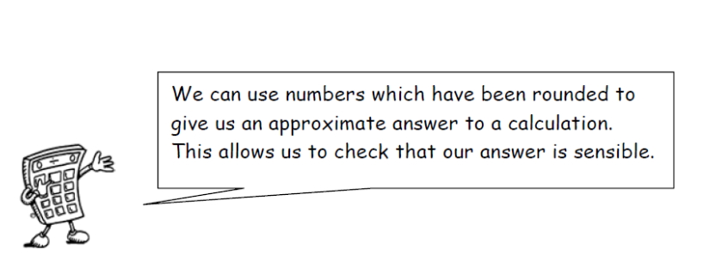
Example 1
Tickets for a concert were sold over 4 days. The number of tickets sold each day was recorded in the table below. How many tickets were sold in total?
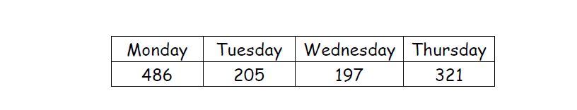
Estimate = 500 + 200 + 200 + 300 = 1200 tickets
Calculate: 486
205
197
+321
1209 Answer = 1209 tickets

Example 2

A bar of chocolate weighs 42g. There are 48 bars of chocolate in a box. What is the total weight of chocolate in the box?

Estimate = 50 x 40 = 2000g

Calculate:
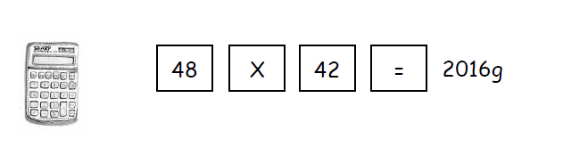
Measurement

At secondary school, pupils will work with a number of different units of measurement relating to lengths, weights, volumes etc.

In the Technical department, measurements are generally in millimetres (mm).
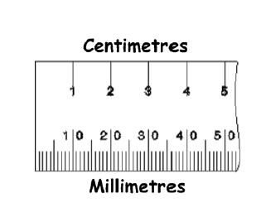
There are 10 mm in 1 cm, often rulers are marked in cm with small divisions showing the millimetres.

It is useful to be able to approximate sizes of familiar objects in mm.

Some examples

desk – 1200 mm wide person – 1700 mm tall

computer keyboard – 450 mm wide house – 8000 mm tall

In engineering and construction objects are still measured in mm even when they are very large, for example the height of a house.

Pupils should be able to identify a suitable unit for measuring objects given their relative lengths, i.e.

Index finger millimetres

Desk centimetres

Football pitch metres

Glasgow to Edinburgh Kilometres

Measurement

In Home Economics, pupils will work with a wide range of measurements when dealing with quantities of food or liquids.
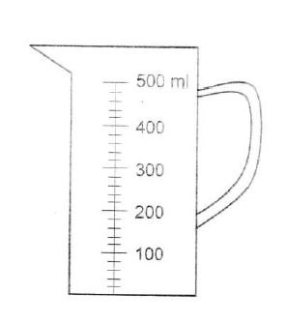

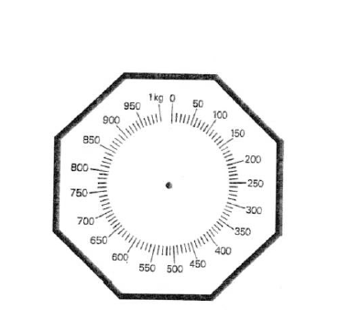
Measuring jugs allow liquids to be poured in millilitres (ml) or litres.

Kilograms and grams are used to weigh cooking ingredients.

In Mathematics pupils also look at converting between all of these different units. Here are some useful conversions to note;
Length Volume
10 millimetres = 1 centimetre 1cm3 = 1ml
100 centimetres = 1 metre 1000 millilitres = 1 litre
1000 metres = 1 kilometre
Weight
1000 grams = 1 Kilogram
1000 kilograms = 1 Tonne

Addition

Mental strategies
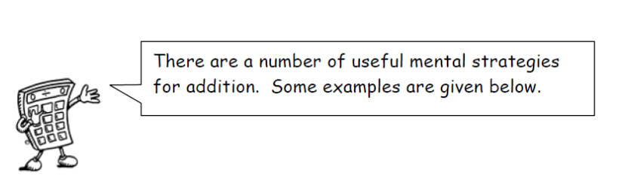
Example

Calculate 54 + 27

Method 1 Add tens, then add units, then add together

50 + 20 = 70 4 + 7 = 11 70 + 11 = 81

Method 2 Split up the number to be added into tens and units and add separately.

54 + 20 = 74 74 + 7 = 81

Method 3 Round up to nearest 10, then subtract

54 + 30 = 84 but 30 is 3 too many therefore subtract 3
84 - 3 = 81

Written Method
When adding numbers, ensure that the numbers are lined up according to place value. Start at right hand side, write down units, and carry tens.

Example Add 3032 and 589 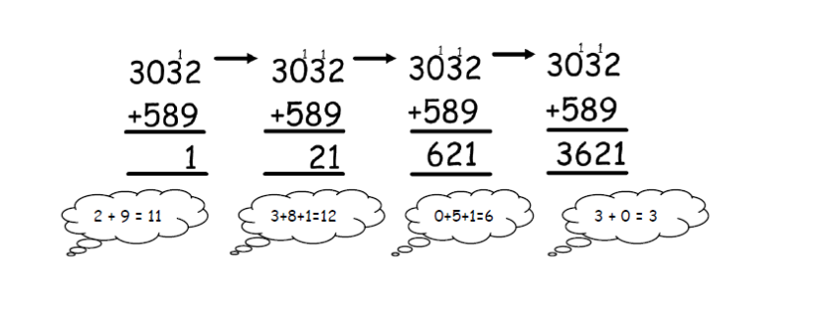

Subtraction

Mental Strategies
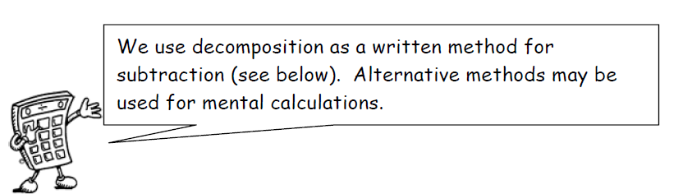
Example

Calculate 93 - 56

Method 1 Count on Count on from 56 until you reach 93. This can be done in several ways e.g. 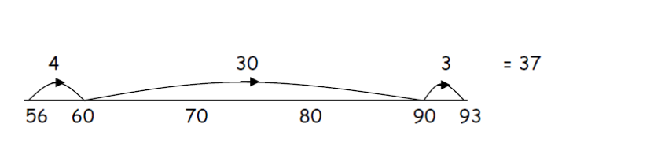
Method 2 Break up the number being subtracted
e.g. subtract 50, then subtract 6 93 - 50 = 43
43 - 6 = 37
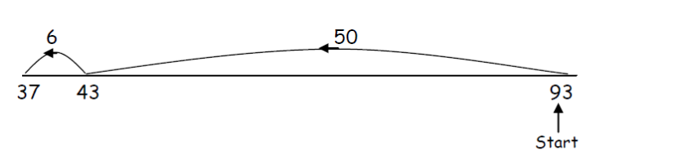Written Method
Example 1 4590 – 386 Example 2 Subtract 197 from 2000
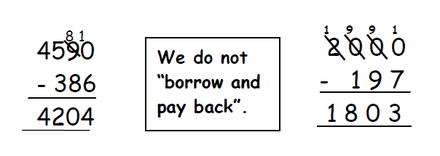
Multiplication
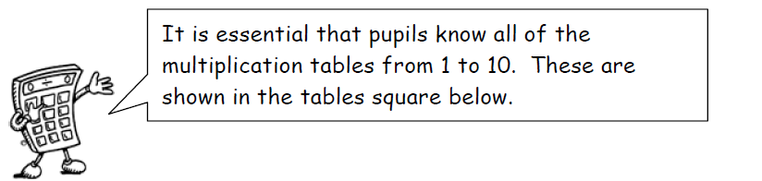
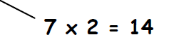
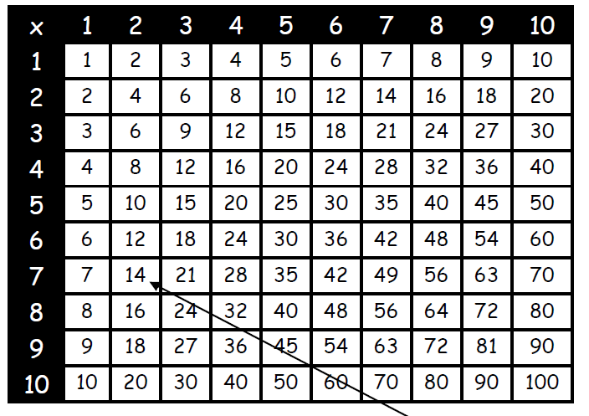

Mental Strategies

Example Find 39 x 6
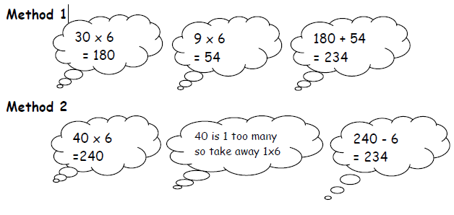

Division
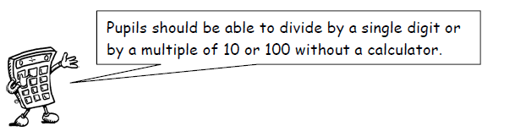
Written Method

Example 1 There are 192 pupils in first year, shared equally between 8 classes. How many pupils are in each class?

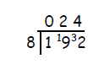There are 24 pupils in each class

Example 2 Divide 4.74 by 3

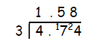
When dividing a decimal number by a whole number, the decimal points must stay in line.

Example 3 A jug contains 2.2 litres of juice. The juice is poured evenly into 8 glasses, how much juice is in each glass?

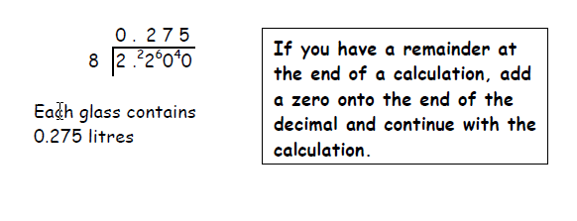

Order of Calculation (BODMAS)

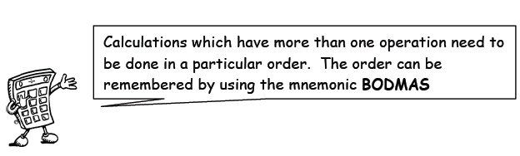

The BODMAS rule tells us which operations should be done first. BODMAS represents:

(B)rackets
(O)f
(D)ivision
(M)ultiplication
(A)ddition
(S)ubraction

Scientific calculators use this rule, some basic calculators may not, so take care in their use.

Example 1 15 – 12 ÷ 6 BODMAS tells us to divide first
= 15 – 2
= 13

Example 2 (9 + 5) x 6 BODMAS tells us to work out the
= 14 x 6 brackets first
= 84

Example 3 18 + 6 ÷ (5 - 2) Brackets first
= 18 + 6 ÷ 3 then divide
= 18 + 2 now add
= 20

Time

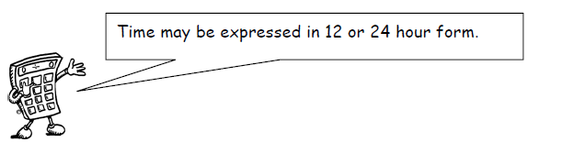
12-hour clock
Time can be displayed on a clock face, or digital clock.

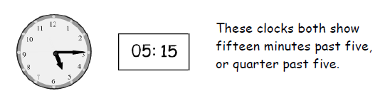

When writing times in 12 hour clock, we need to add a.m. or p.m. after the time. a.m. is used for times between midnight and noon (morning) p.m. is used for times between noon and midnight (afternoon / evening).

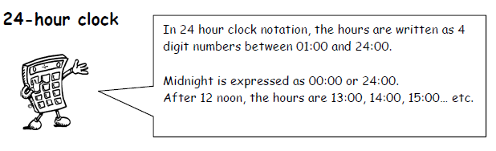
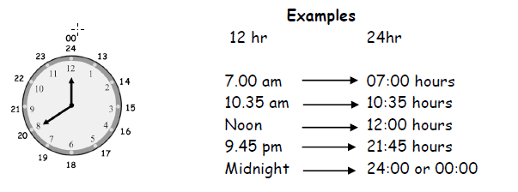

Time
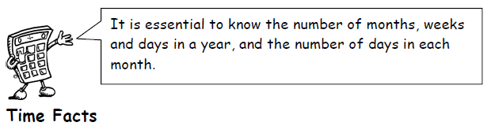
In 1 year, there are:
365 days (366 in a leap year)
52 weeks
12 months

The number of days in each month can be remembered using the rhyme:

“30 days hath September,
April, June and November,
All the rest have 31,
Except February alone,
Which has 28 days clear,
And 29 in each leap year.”

Distance, Speed and Time.

For any given journey, the distance travelled depends on the speed and the time taken. If speed is constant, then the following formulae apply:

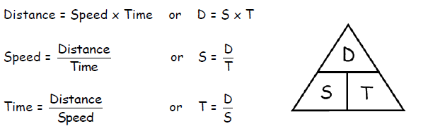

Pupils who study Physics will be expected to refer to an object’s speed as its velocity (v) and the distance travelled as displacement (s).

Fractions
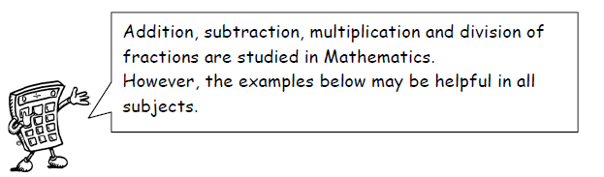
Understanding Fractions

Example
A necklace is made from black and white beads.
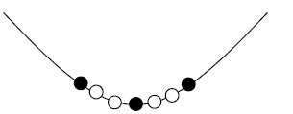
What fraction of the beads are black?
There are 3 black beads out of a total of 7, so $\frac{3}{7}$ of the beads are black.

Equivalent Fractions

Example
What fraction of the flag is shaded?
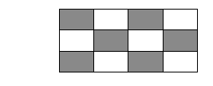
6 out of 12 squares are shaded. So $\frac{6}{12}$ of the flag is shaded.

It could also be said that $\frac{1}{2}$ the flag is shaded.

$\frac{6}{12}$ and $\frac{1}{2}$ are equivalent fractions.

Fractions
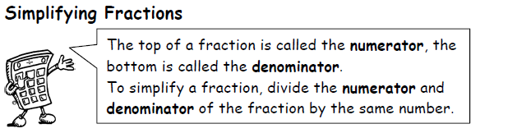

Example 1
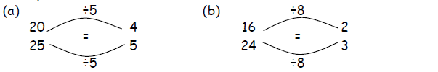
This can be done repeatedly until the numerator and denominator are the smallest possible numbers - the fraction is then said to be in its simplest form.

Example 2
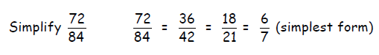
Calculating Fractions of a Quantity
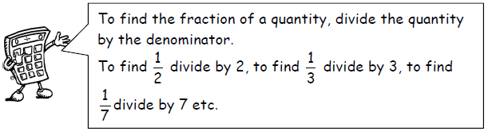
Example 1
Find $\frac{1}{5}$ of £150

$\frac{1}{5}$ of £150 = £150 ÷ 5 = £30

Example 2
Find $\frac{3}{4}$ of 48

$\frac{1}{4}$ of 48 = 48 ÷ 4 = 12

So $\frac{3}{4}$ of 48 = 3 x 12 = 36

Percentages

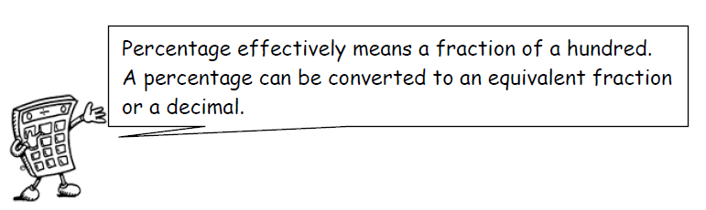

25% means $\frac{25}{100}=\frac{1}{4}$

25% is therefore equivalent to $\frac{1}{4}$which is 0.25.

Common Percentages

Some percentages are used very frequently. It is useful to know these as fractions and decimals.
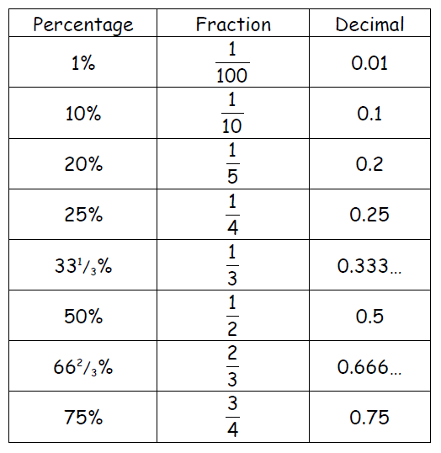

Percentages
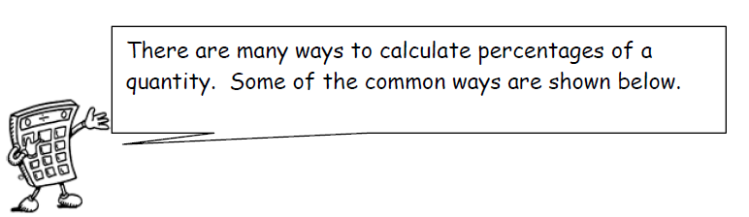

Non-Calculator Methods

Method 1 Using Equivalent Fractions

Example Find 25% of £640

25% of £640 = $\frac{1}{4}$ of £640 = £640 ÷ 4 = £160

Method 2 Using 10%

This method is similar to the one above. First find 10% (by dividing by 10), then multiply to give the required value. This is the most important method which we would expect all pupils to know and use.

Example Find 70% of £35

10% of £35 = $\frac{1}{10}$ of £35 = £35 ÷ 10 = £3.50
so 70% of £35 = 7 x 10% of £35 = 7 x £3.50 = £24.50

Method 3 Using 1%

In this method, first find 1% of the quantity (by dividing by 100), then multiply to give the required value.

Example Find 9% of 200g

1% of 200g = $\frac{1}{100}$ of 200g = 200g ÷ 100 = 2g
so 9% of 200g = 9 x 2g = 18g

Percentages

Calculator Method

To find the percentage of a quantity using a calculator, change the percentage to a decimal, then multiply.

Example 1 Find 23% of £15 000

23% = 0.23 so 23% of £15 000 = 0.23 x £15 000 = £3 450

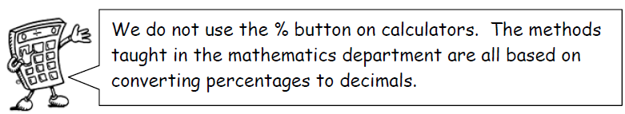

Example 2 House prices increased by 19% over a one year period. What is the new value of a house which was valued at £236 000 at the start of the year?

19% = 0.19 so Increase = 0.19 x £236 000 = £44 840

Value at end of year = original value + increase
= £236 000 + £44 840 = £280 840

The new value of the house is £280 840.

Percentages

Finding the percentage
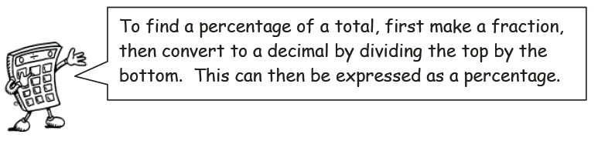

Example 1 There are 30 pupils in Class 3A. 18 are girls. What percentage of Class 3A are girls?

$\frac{18}{30}$= 18 ÷ 30 = 0.6 = 60%

60% of 3A are girls.
Which also means that 40% of 3A are boys!

Example 2 James scored 36 out of 44 his biology test.
What is his percentage mark?

Score = $\frac{36}{44}$ = 36 ÷ 44 = 0.81818… = 81.818..% = 82% (rounded)

Example 3 In class 1M, 14 pupils had brown hair, 6 pupils had blonde hair, 3 had black hair and 2 had red hair.
What percentage of the pupils were blonde?

Total number of pupils = 14 + 6 + 3 + 2 = 25

6 out of 25 were blonde, so,
$\frac{6}{25}$ = 6 ÷ 25 = 0.24 = 24%

24% were blonde.

Ratio
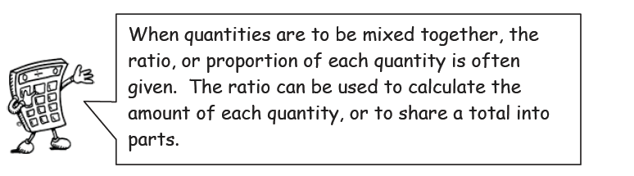
Writing Ratios
Example 1
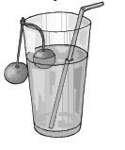
To make a fruit drink, 4 parts water is mixed with 1 part of squash.

The ratio of water to squash is 4 : 1 (said “4 to 1”)

The ratio of squash to water is 1 : 4.

Order is important when writing ratios.

Example 2
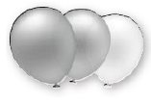
In a bag of balloons, there are 5 red, 7 blue and 8 green balloons.

The ratio of red : blue : green is 5 : 7 : 8

Simplifying Ratios
Ratios can be simplified in much the same way as fractions.

Example 1

A colour of paint can be made by mixing 10 tins of green paint with 6 tins of yellow.
The ratio of green to yellow can be written as 10 : 6

It can also be written as 5 : 3, as it is possible to split up the tins into 2 groups, each containing 5 tins of green and 3 tins of yellow.

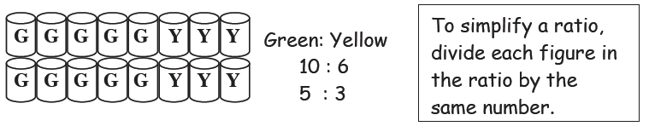

Ratio

Simplifying Ratios (continued)

Example 2 Simplify each ratio:

(a) 4:6 (b) 24:36 (c) 6:3:12

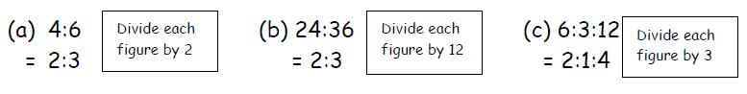

Example 3

Concrete is made by mixing 20 kg of sand with 4 kg cement.
Write the ratio of sand : cement in its simplest form

Sand : Cement = 20 : 4
= 5 : 1

Using ratios

The ratio of fruit to nuts in a chocolate bar is 3 : 2. If a bar contains 15g of fruit, what weight of nuts will it contain?

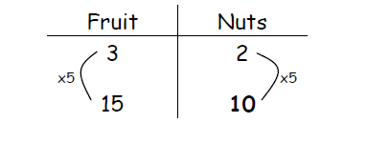
So the chocolate bar will contain 10g of nuts.

Proportion
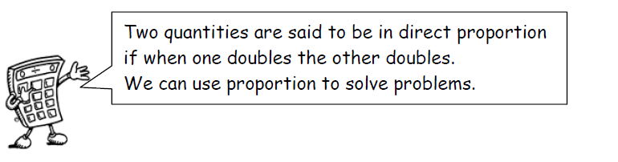

It is often useful to make a table when solving problems involving proportion.

Example 1
A car factory produces 1500 cars in 30 days. How many cars would they produce in 90 days?
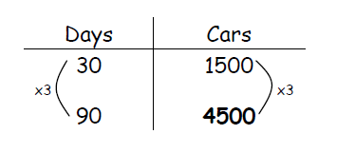
The factory would produce 4500 cars in 90 days.

Example 2
5 adult tickets for the cinema cost £27.50. How much would 8 tickets cost?
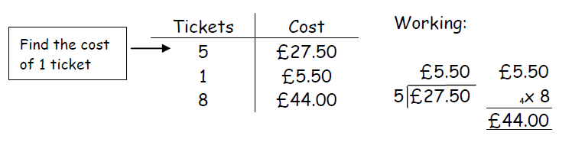

The cost of 8 tickets is £44.

Information Handling : Tables
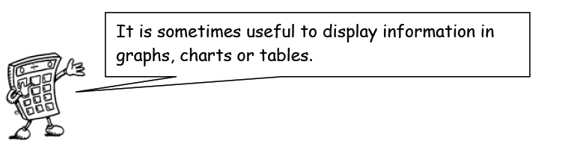

Example 1 The table below shows the average maximum temperatures (in degrees Celsius) in Barcelona over a 12 month period.

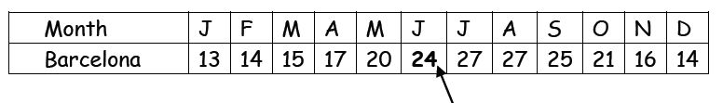
The average temperature in June in Barcelona is 24C.

Frequency Tables are used to present information.

Example 2 Shoe sizes for a class of pupils in S1
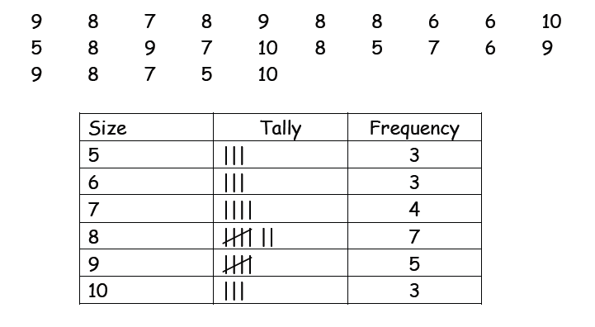
Each mark is recorded in the table by a tally mark. Tally marks are grouped in 5’s to make them easier to read and count.

Information Handling : Bar Graphs
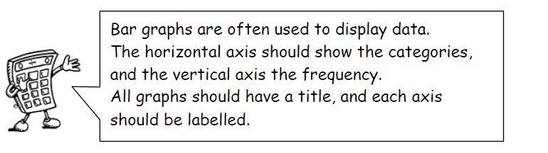

Example 1
The graph below shows urban populations as discussed in Modern Studies lessons.
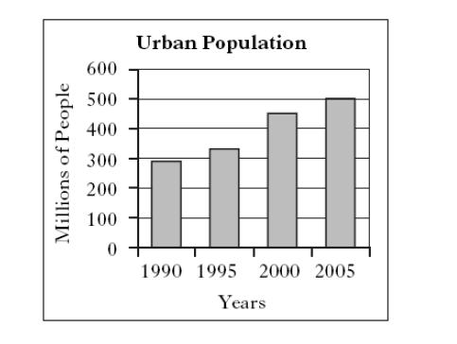

Example 2
School Enrolment Percentages
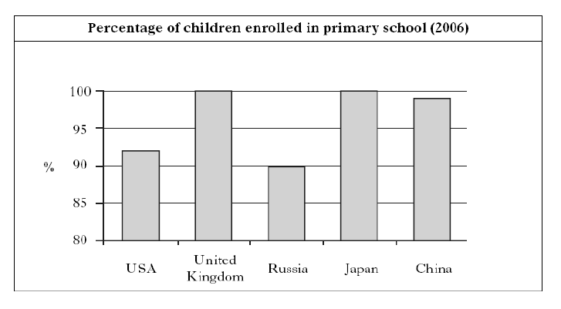

Information Handling : Line Graphs

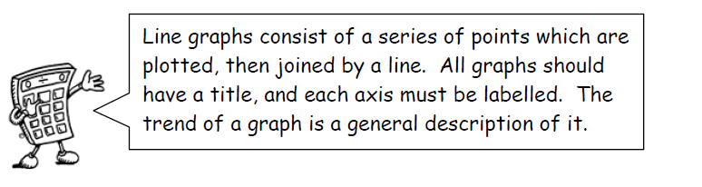
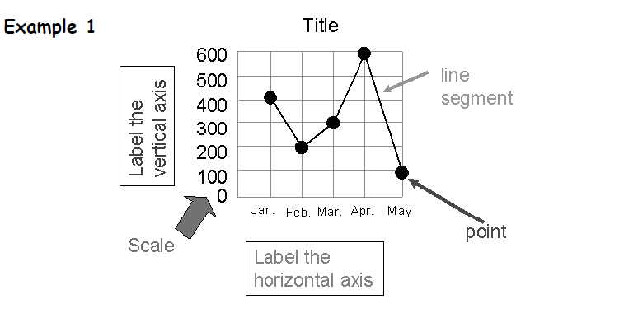

Example 2
The graph below shows the temperature every day at a park on a particular day in Rome.
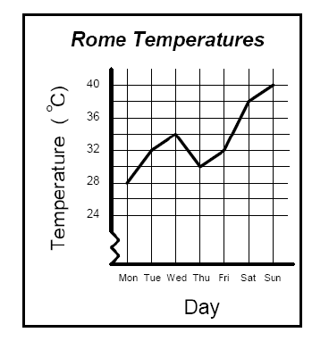
Although there was a small drop in temperature on Thursday the general trend is a rise in temperature over the week!

Information Handling : Scatter Graphs

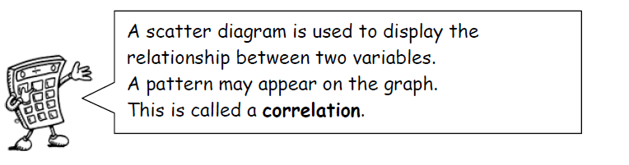

Example
The scatter graph below shows the heights and weights of ten members of a local Darts team.

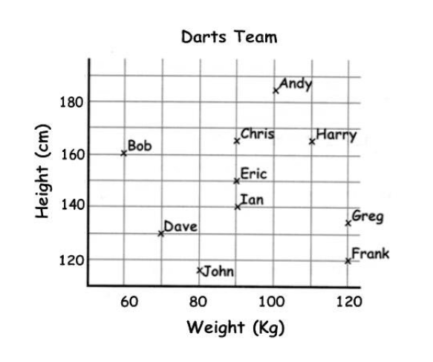
The graph illustrates that Eric is 90 kg in weight and 150 cm tall.

Note that in some graphs, it is a requirement that the axes start from zero.

Information Handling : Pie Charts

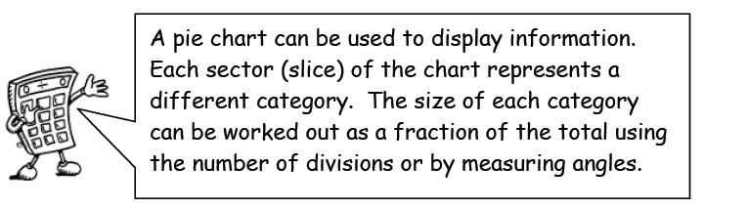

Example
30 pupils were asked the colour of their eyes. The results are shown in the pie chart below.
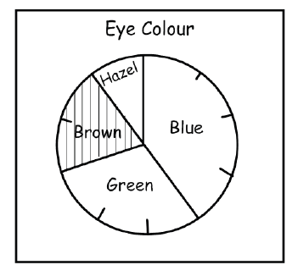

How many pupils had brown eyes?

The pie chart is divided up into ten parts, so pupils with brown eyes represent $\frac{2}{10}$ of the total.

$\frac{2}{10}$ of 30 = 6 so 6 pupils had brown eyes.

If no divisions are marked, we can work out the fraction by measuring the angle of each sector.
The angle in the brown sector is 72º.

so the number of pupils with brown eyes = $\frac{72}{360}$ x 30 = 6 pupils.

If finding all of the values, you can check that your answers total 30 pupils.

Information Handling : Averages

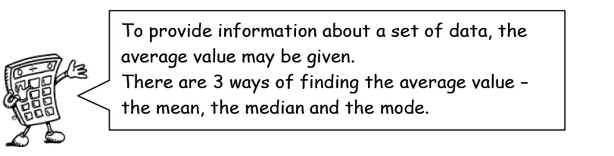

Mean
The mean is found by adding all the data together and dividing by the number of values.

Median
The median is the middle value when all the data is written in numerical order (if there are two middle values, the median is half-way between these values).

Mode
The mode is the value that occurs most often.

Range
The range of a set of data is a measure of spread.
Range = Highest value – Lowest value

Example
Class 1A4 scored the following marks for their homework assignment. Find the mean, median, mode and range of the results.

7, 9, 7, 5, 6, 7, 10, 9, 8, 4, 8, 5, 7, 10

$$mean=\frac{7+9+7+5+6+7+10+9+8+4+8+5+7+10}{14}$$
$mean=\frac{102}{14}=7.285….$ mean=7.3 to 1 decimal place.

Ordered values: 4, 5, 5, 6, 7, 7, 7, 7, 8, 8, 9, 9, 10, 10

Median = 7

7 is the most frequent mark, so Mode = 7

Mathematical Dictionary (Key words)
Add; Addition (+) | To combine 2 or more numbers to get one number (called the sum or the total) Example: 12+76 = 88
a.m. | Meaning ante meridiem. Any time in the morning (between midnight and 12 noon).
Approximate | An estimated answer, often obtained by rounding to nearest 10, 100 or decimal place.
Average | A number used to describe data such as the mean, the mode or the median.
Calculate | Find the answer to a problem. It doesn’t mean that you must use a calculator.
Data | A collection of information (may include facts, numbers or measurements).
Denominator | The bottom part in a fraction (the number of parts into which the whole is split).
Difference (-) | The amount between two numbers (subtraction). Example: The difference between 50 and 36 is 14
Division (÷) | Sharing a number into equal parts. 24 ÷ 6 = 4
Double | Multiply by 2.
Equals (=) | Makes or has the same amount as.
Equivalent fractions | Fractions which have the same value. Example $\frac{6}{12}$ and $\frac{1}{2}$ are equivalent fractions
Estimate | To make an approximate or rough answer, often by rounding.
Evaluate | To work out the answer.
Even | A number that is divisible by 2 (without remainder). Even numbers end with 0, 2, 4, 6 or 8.
Factor | A number which divides exactly into another number, leaving no remainder. The factors of 15 are 1, 3, 5, 15.
Frequency | How often something happens. In a set of data, the number of times a number or category occurs.
Greater than (>) | Is bigger or more than.  Example: 10 is greater than 6. 10 > 6
Least | The lowest number in a group (minimum).
Less than (<) | Is smaller or lower than. Example: 15 is less than 21 written as 15 < 21.
Maximum | The largest or highest number in a group.

Mean | The arithmetic average of a set of numbers (see p30)
Median | Another type of average - the middle number of an ordered set of data (see p30)
Minimum | The smallest or lowest number in a group.
Minus (-) | To subtract.
Mode | Another type of average – the most frequent number or category (see p30)
Most | The largest or highest number in a group (maximum).
Multiple | A number which can be divided by a particular number, leaving no remainder. Example Some of the multiples of 4 are 8, 16, 48, 72
Multiply (x) | To combine an amount a particular number of times. Example 6 x 4 = 24
Negative Number | A number less than zero. Shown by a minus sign. Example -5 is a negative number.
Numerator | The top part in a fraction.
Odd Number | A number which is not divisible by 2. Odd numbers end in 1 ,3 ,5 ,7 or 9.
Operations | The four basic operations are addition, subtraction, multiplication and division.
Order of operations | The order in which operations should be done. BODMAS (see p13)
Place value | The value of a digit dependent on its place in the number. Example: in the number 1573.4, the 5 has a place value of 500.
p.m. | Meaning post meridiem. Any time in the afternoon or evening (between 12 noon and midnight).
Prime Number | A number that has exactly 2 factors (can only be divided by itself and 1). Note that 1 is not a prime number as it only has 1 factor.
Product | The answer when two numbers are multiplied together. Example: The product of 5 and 4 is 20.
Remainder | The amount left over when dividing a number.
Share | To divide into equal groups.
Sum | The total of a group of numbers (found by adding).
Total | The final amount when a group of numbers are added.

